G3012: NEW ZEALAND RESEARCH PROJECT

Dr. Jonathan Carrivick, Dr. Katherine Arrell & Dr. Lee Brown

Module Information

Module outline

Summary
The New Zealand fieldtrip at the University of Leeds is a unique opportunity to get first hand experience and knowledge of conducting field-based research in Physical Geography, in an exotic and challenging environment. We visit the central Southern Alps, on South Island of New Zealand. This is a landscape with a diverse range of tectonic, glacial and fluvial landforms, and a wide range of vegetation and fauna. It has one of the highest sediment delivery rates in the World. There is therefore an incredible opportunity to dramatically understand processes that have formed, and are forming the landscape. We arrive in Queenstown (‘the outdoor adventure capital of the World’) and are based near Wanaka. We spend several days on a guided tour, visit a local academic and /or governmental research institute, and conduct our own field research.

Overview of the module structure, content and assessment
The New Zealand field trip is part of a level 3 module. In semester one, students are required to complete an online Virtual Field Course briefing and introduction. They must also produce a research proposal, including a budget and a full risk assessment, and defend this at an ‘interview’.

The fieldtrip normally takes place in early December, and lasts for two weeks. Travel and accommodation details are given below. Students will collect field data in groups but will be individually responsible for processing, interpreting and presenting that data themselves. Many different aspects of both modern and past glacial, fluvial and ecological phenomena can be investigated and advice towards topical research and staff research interests will be given.

In semester two, students are required to give an oral presentation, at ‘School of Geography Level 3 conference’. Additionally, the 3000 word final report will take the format of an academic paper or short communication, and will be included within a bound ‘proceedings’ volume. All student’s data and reports will be available via the online Virtual Field Course for subsequent students and interested persons to view.

The rest of this document contains the following information:
- Why New Zealand?
- Timetables
- Assessment
- Cost
- Structure and content

Why study environmental processes and systems in New Zealand?

New Zealand is a very long way away, and thus expensive to get to. So it is an obvious question to ask why go all that way?; why not the European Alps?; why not Scandinavia?

There are several very good reasons why environmental processes and systems in New Zealand are unique and thus deserve attention. In particular, we focus on the Southern Alps because:

(in no particular order!)
- New Zealand is surrounded by the World’s greatest oceans. It thus has a maritime-dominated climate. Environmental processes are different here, and landscape change (perhaps in response to global climate change) proceeds in a different manner, or at a different rate to that northern hemisphere locations. This is because the northern hemisphere contains vastly more land mass than the southern hemisphere, and land responds far faster to changing air temperatures than does an ocean.
- The Southern Alps is one of the most tectonically active regions of the world. It has uplift rates greater than the Himalaya, for example.
- Perhaps as a consequence of the above, the Southern Alps has one of the greatest sediment production rates in the world. Thus the effects of land-forming processes are extremely visible.
- There is a very strong west-east divide in climate across the Southern Alps. There is thus an incredible variety of landscapes in a relatively small space! For example, it gives rise to steep high-relief precipitation-dominated glaciers on the west coast, and hanging or down-wasting valley glaciers in the eastern side of the divide.
- Much of the Southern Alps remains unsettled, and of ‘wilderness’ status. This means that environments are in a relatively pristine and natural state.
- New Zealand is a biogeographically isolated country, so organisms have evolved in isolation from the rest of the gene pool. Thus there are literally hundreds of endemic species.

Plus:
- It is logistically easy. Many scientifically interesting areas are highly accessible by vehicle.
- Several members of staff have a research history in New Zealand, and have strong contacts at academic and regional authority institutions.
- It is an English-speaking country.
- It is relatively cheap (once you are there).

Module timetables

Overall module timetable

 | Activity | Assessment  (% of module grade)
Level 2, Semester 2
 | Via email upon request | Preliminary research proposal issued
June 8th |  | Preliminary research proposal due
By arrangement | Individual tutorial (1/2 hour) | Defence of preliminary research proposal (5%)
Level 3, Semester 1
Week 2 | Introductory lecture (1 hour) | Research Proposal issued
Week 6 |  | Research Proposal due (15%)
Weeks 11- | Fieldwork | (20%)
Level 3 Semester 2
Week 12  (exam period) | Lecture 2 (1 hour) | Oral presentation issued  Scientific paper issued
Week 16 |  | Conference presentation title and abstract due
early Week 17 | Conference | Oral presentation due (10%)
late week 17 | Individual tutorial (1/2 hour) | Review of writing-up progress
Week 18 |  | Scientific paper submission due
Week 19 |  | Paper reviews due
Week 20 |  | Paper corrections due (50%)

Field course timetable

Day | Date | Activity
1 | 4th | Arrive Queenstown airport, transfer to Glentanner, Mt Cook
2 | 5th | Guided tour, Mueller, Hooker and Tasman valleys
3 | 6th | Transfer to Wanaka and Wanaka orientation
4 | 7th | Data collection | Plan for contingency, i.e. bad weather and also time to review progress so far and to adapt approach if necessary
5 | 8th | Data collection
6 | 9th | Data collection
7 | 10th | Data collection
8 | 11th | Data collection
9 | 12th | Data collection
10 | 13th | Debrief and packing. Transfer to Queenstown
11 | 14th | Queenstown activity
12 | 15th | Depart from Queenstown airport

Assessment

Assessment for students taking the New Zealand Research Project module of study is diverse, analysing different skills and forms of communication and presentation. The assessment comprises:

Preliminary research proposal
- A short (one A4 side) of what you plan to do, why and how (5%).
- Issued week 15, due week 17, both Level 2 semester 2
- Help document issued via email, upon request

Research proposal
- Full research proposal of up to 4 sides of A4 including all tables, diagrams and references, detailing exactly what you plan to do, why and how (15%).
- Issued week 2, due week 6, both Level 3 semester 1
- Help document issed via email, after lecture 1

Individual and group field work
- Members of staff simply observe how well you get on in the field; attitude, time-keeping, efficiency, adaptability, resourcefulness etc. (20%).
- Weeks 11 for two weeks (end of semester 1)
- Field note book (not directly assessed, but very useful)
- Help document issued on keeping a field notebook

Conference seminar
- A formal presentation to your peers and invited students and staff, summarising your project and responding to questions. (10%).
- Weeks 17 (semester 2)
- Help on oral presentation techniques issued in semester 2, after lecture 2

Academic-style paper
- A formal report in the style of an academic paper. No more than 3000 words. (50%).
- Submission due week 18 (semester 2), reviews by week 19, with corrections by week 20.
- Help document on how to write reports issued

Module cost

How much will it cost? This is probably the first piece of information that you want to know. The costs per person are slightly variable, but in general: all flights (Leeds-Heathrow-L.A-Auckland-Queenstown, return) are approx. £1100, accommodation is £17 per night, transport is £6 per day. So we estimate a maximum of £1350, excluding your food and drink and any extra activities that you do. We will be in self catering accommodation, with a supermarket nearby.

Module structure and content

This page details the pre-departure, field course and post-return phases of the New Zealand Research Project module of study

It can be noted that all raw data collected in the field is available on this website, as are student’s posters and final reports. The valuable and novel learning and teaching experience offered by this module of study is reflected in student’s comments.

Pre-departure
1/ Students are informed as to the type of projects that they will be able to undertake, and the expected components of these. A pre-departure online virtual field course is an integral part of this. Each online section has to be completed before proceeding to the next, as is the case with submitting an online research proposal. For example, word-limited sections will include; summary, aims and objectives, kit list, equipment obtained, risk assessment, beneficiaries, etc. When all sections are complete a .pdf is generated for staff review, and for the students to use as detailed below. In other words, this online field course assists students towards the next stage.

2/ Students are expected to design their own projects with explicit aims and objectives. These will be incorporated into a thorough Expression of Interest (EOI) that is submitted on a single side of A4 to a hypothetical funding body for approval (staff-reviewed). Upon approval, students are asked to submit a full research proposal. All research proposals are subject to interview. This interview serves to discourage students from ‘simply coming along for the ride’, and it could be that research proposals that remain unacceptable after revisions will not be permitted to proceed on the field course.

3/ Students are encouraged to submit the same documents to attract funding for themselves by personal development and fieldwork-orientated organisations (for example a ‘young explorers’ grant, or equivalent). This encourages further effort at the research design processes. Students are able to propose fieldwork for their own projects, or else for members of staff research interests, although they will have to through the same procedures for approval at interview.

Field course
Students are away from the UK for two weeks, including travel time (4 days total). The proposed field course itinerary is given in Table 2. The ‘guided tour’, and day at a University library, regional authority or local governmental institution emphasises the application of research. The ‘guided tour’ introduces the climate, geology, geography and any previous relevant research in the area, and usually includes invited New Zealand-based researchers. During field work, students collect data in groups for health and safety reasons, but all analysis and reports are individual.

Day | Activity
1-2 | International flights and transit
3 - 5 | Field ‘guided tour’, and visit to academic and/or governmental research institute
6-11 | 5 days data collection, 1 day contingency
12-14 | Transit and International flights
Table 2. Overview of field course itinerary

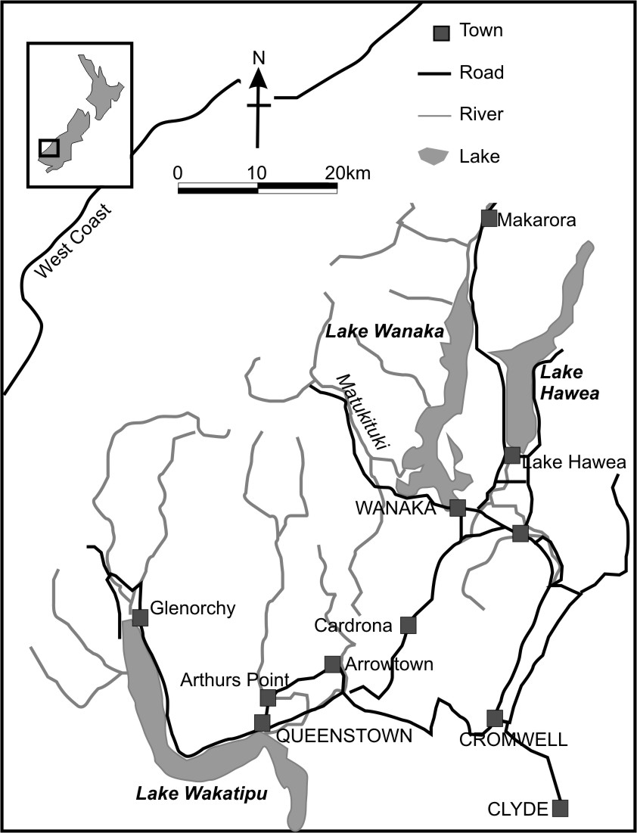

Figure 1. Location of the Matukituki valley (field site), Wanaka (facilities) and Queenstown (airport) within New Zealand.

The New Zealand Research Project field course is largely based around the Matukituki valley, immediately west of Wanaka (Figure 1). This site is chosen for its diversity of glacial and fluvial landscape, thereby fitting staff research interests. Additionally consideration is given to accessibility, and to proximity of resources and facilities (at Wanaka), particularly for emergency contingency.

Post-return
Within two weeks of returning students submit an abstract for an internal conference. Attendance at this conference is compulsory for level 2 students (as an advertisement as well as a learning experience), and all Faculty staff and postgraduates are invited. The submitted abstract is for an oral presentation (.ppt) and a short paper (3000 words) for a proceedings publication, which is ultimately lodged in the University of Leeds library. Students peer-review each other’s short papers, and convene and chair the presentations. Students are encouraged to produce a poster, for their own portfolio, although this is not assessed. As a research based module, students are encouraged and supported by staff to submit suitable papers to relevant academic journals.

