QMSS2 Immigration and Population Dynamics
Summer School on: PROJECTION METHODS FOR ETHNICITY AND IMMIGRATION STATUS
School of Geography, University of Leeds, UK , 2 – 9 July 2009
Practice with UK ethnic projections model Pia Wohland
Friday 3rd of July 2009, 1530-1730,

Demonstrators: Phil Rees, Pia Wohland, Jianhui Jin, Tom Wilson

The aim of this Practical is
To Understand Cohort component Projections
To see how the different components effect projections

In this practical you will explore a UK cohort component projection model. The model consists of 13 Regions (see map and small table) and 5 ethnic groups.

Data supplied for this practical:
JRFGOR_ALL.csv contains all the all the component data you for the model.
JRFGORmodel.R the script to run the model

JRFGORSubset s.R a script to subset your results
Timeseriesgraphs.R a script for explorative time series graphs
POPPyramids.R a function to create population pyramids

The model

The model is very simple! The fertility rates, migration rates and flows and survival probabilities do not change over time, they are constant. But they do vary between groups and regions.

Get familiar with the data:
How do survival probabilities, fertility and migration data vary between regions and ethnic groups?

Run the model
The model script is JRFGORmodel.R. You can run the model as it is. You can chose for how many years you want to run the model, by changing the years variable.

Scenarios
You can choose not to include some of the components. ( for example: What happens if everything is the same, but we would not allow any more people into the UK?). For that you have to set the corresponding variable to zero.

Explore results
The output is called “finresults”. The first eight columns contain the same information as the input file.
So if you are familiar with R, you can do your own investigation. The population data are in the columns starting with X. X1 would be the input year, 2001, women, then X2,X3....to X(the numbers of years).Next come the men data, X(number of years+1) to X(number of years times 2). The script JRFGORSubsets.R creates subsets from “finresults”, which then can be used to create graphs with Timeseriesgraphs.R
and population pyramids with POPPyramids.R.

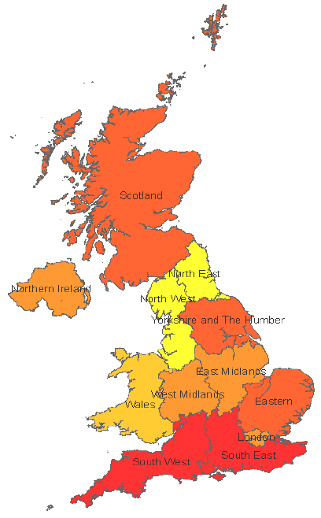 | Figure 1  Model regions

Table 1 Column names of JRFGOR_ALL.csv
Column name | Explanation
ID
ETHREGCD (numeric) | Combines Ethcode.RegCode | Group region codes
ETHREG (letters) | Combines Ethnic.Region | Group region codes
Ethcode (numeric) | 1 to 5 | See Table 3
Ethnic (letters) | Ethnic group (White....Chinese Other) | See Table 3
Region | Region (NE, NW....NI) | See Table 2
RegCode | 1 to 13 (see | See Table 2
Start.age | Births to 100
EndAge | 0 to 101
STPop.M | Population 2001 including births | men
Srv1998.M | survival probability 1998 | men
Srv2001.M | adjusted survival probability 2001 | men
Outrate.M | Outmigration rate 2001 | men
Emrate.M | Emigration rate 2001 | men
Inflow.M | In-migration flow 2001 | men
Immflow.M | Immigration flow 2001 | men
STPop.F | Population 2001 including births | women
Srv1998.F | Survival probability 1998 | women
Srv2001.F |  | women
Fert | Fertility rate 2001 | women
Outrate.F | Outmigration rate 2001 | women
Emrate.F | Emigration rate 2001 | women
Inflow.F | In-migration flow 2001 | women
Immflow.F | Immigration flow 2001 | women

Ethnic groups | Ethnic | Ethcode | Table 2  Ethnic groups
White | WH | 1 | Table 2  Ethnic groups
Mixed | MI | 2 | Table 2  Ethnic groups
Asian | AS | 3 | Table 2  Ethnic groups
Black | BL | 4 | Table 2  Ethnic groups
Chinese and other | CH | 5 | Table 2  Ethnic groups

Table 3Regions
RegCode |  | Region
1 | North East | NE
2 | North West | NW
3 | Yorkshire and The Humber | NE
4 | East Midlands | EM
5 | West Midlands | WM
6 | East of England | EA
7 | South East | SE
8 | South West | SW
9 | Inner London | IL
10 | Outer London | OL
11 | Wales | WA
12 | Scotland | SC
13 | Northern Ireland | NI

