GIS & Environment (GEOG5060)

Assignment 3 - Geomorphometrics

For the attention of: Andrew Turner

Word Count: 2,708

Date: 25/04/2007

Yasser Abdulghani (200239890)

Adewale Awojide (200294647)

Niall Cunningham (200270776)

Daniel Oyo-Ita (200152615)

Peter Lythe (010534720)

Kurt McLaren (200289813)

Siti Haji Mohamad (200292113)

Jamie Nunn (200279246)

Meesha Tandon (200279072)

Rory West (200299757)

1. Introduction

2. Understanding Geomorphometrics

2.1. What is Geomorphometry?
2.2. The Significance of Geomorphometrics
2.3. The Mechanics of Geomorphometrics
2.4. Kernel Size

3. Methodology and Source Data

4. Results and Analysis

4.1. Average llll (Peak Analysis)
4.2. Average hhhh (Pit Analysis)
4.3. Flatness

5. Other Applications of Geomorphometrics

6. Conclusion

7. References

1. Introduction

This paper presents a series of results obtained through application of GRIDS, a computer software package developed by Andrew Turner. The overall aim of the project was to highlight differences made to the quality of output data by altering the size of the kernel used in processing a Digital Elevation Model (DEM).

GRIDS produces a vast array of data for use in the analysis of landscape topography. In this investigation, a number of such outputs were selected to provide an illustrative assessment of the program’s functionality: Average Difference of llll for peaks; Average Difference of hhhh for pits; and Flatness for flatness. The paper also attempts to determine other useful applications for such a diverse and powerful tool. It is structured so that the reader will first gain an understanding of what is meant by geomorphometrics; its significance, mechanics and association with the use of variable kernel sizes (section 2). The methodology and data sources are then discussed (section 3) prior to analysis of the three selected outputs (section 4). Other environmental applications of geomorphometrics are also detailed (section 5) before the provision of a project conclusion (section 6).

2. Understanding Geomorphometrics

2.1. What is Geomorphometry?

Geomorphology is the investigation, understanding and characterisation of landforms and landscapes, their formative processes and the environment and system within which they exist (Arrell, 2002). In order to utilize and enhance such knowledge for environmental predictions, these forms and processes need to be quantified and considered together at a spatial scale. Historically, however, limited technological developments had restricted the practice to one of largely qualitative assessment. As such, morphometry evolved to enable the “extraction of surface measurements and mathematical characterisation of surfaces” thereby allowing the quantification of geomorphology to take place (Arrell, 2002). With the advent of Geographical Information Systems (GIS), and especially DEMs, morphometry was applied to landscapes to facilitate the mathematical measurement of shapes and surfaces; a process which Evans (1972 in Arrell, 2002) termed Geomorphometry.

Thus, geomorphometry is a science pertaining to the quantitative analysis of land surfaces (Wikipedia, 2007). It merges mathematical, statistical and image processing techniques to quantify the forms and processes that govern environments. This provides the analyst with the means to better understand, model and predict environmental parameters (e.g. vegetation) and processes (e.g. hydrology) through the use of DEMs (Albani et al., 2004).

2.2. The Significance of Geomorphometrics

The need for geomorphometrics arises, in part, from the shortcomings of GIS. DEMs and GIS provide a platform for the spatial analysis of environmental processes but they do not necessarily provide the level of quantification that might be required for environmental decision making and the study of specific disciplines. For instance, a DEM might show the lowland or high altitude areas in a region but it cannot tell a holiday resort owner which areas would be available for trekking given the location of the resort i.e. exactly which areas are higher or lower than a specific spatial entity. This lack of quantification could have serious management implications, consequences which geomorphometrics can remedy to enable the focusing of cost-effective environmental management procedures. In a similar way, geomorphometry can help to identify valleys with the highest number of surrounding ridges, for example, allowing soil conservation measures to be directed towards a particularly erosive terrain.
In order to understand a land surface and the processes which impact upon it, two important parameters are often used: slope and elevation (Arrell, 2002). Slope is significant in the assessment of factors influenced by gravity, such as mass movement and valley erosion. Elevation helps determine the underlying topography which will govern environmental processes in the region. Other parameters, including curvature and aspect, may also be significant, the latter being important for considering processes influenced by solar radiation e.g. heating, evaporation, moisture and wind. All landforms and processes are scale dependant and different landforms and processes operate or dominate at different scales (Arrell, 2002). The impact of a process such as landslides, which dominates at the catchment level, may be negligible at the scale of the entire mountain range. Thus, scale is also an important parameter in understanding natural processes and is strongly governed by the purpose of a given project. These aspects of the environment can be quantified using geomorphometry and can help to identify patterns across a wide range of scales. Matrices may then be generated that provide models to assist in the understanding and forecasting of environmental characteristics and potential future events (Turner, 2006a).

2.3. The Mechanics of Geomorphometrics

This paper concentrates on the application of geomorphometry using the GRIDS software package. In order to quantify a parameter, GRIDS employs an evaluation window or kernel to pass across the entire DEM measuring the value of all the cells within the kernel to that of its central cell. Geomorphometrics within GRIDS is based on the notion of equidistant orthogonal comparisons for the hhhh or llll functions, whereby each cell is compared to the cell opposite and two more cells which are equidistant and orthogonal from it. Although the equidistant orthogonal function may provide a systematic methodology for comparing cells in a kernel, the technique may be significantly constrained by the directional vector, especially in very steep terrains and for direction dependent analyses (like wind assessments or drainage patterns). This can lead to the interpolation of values in any direction other than that determined by the orthogonal pattern (Turner, 2006a). It therefore also employs an averaging function for the aved_hhhh or aved_llll parameters (Fig. 1).

B4
A4
E3
D4
C4
D3
B3
E4
A3
E2
C3

*
C1
A1
B1
D1
C2
D2
E1
A2
B2
Figure 1. All cells with the same alphabetic denominator are equidistant and
orthogonal and are thus compared with each other (Source: Turner, 2004).

This project focuses on peak and pit analyses which are a measure of the highness or lowness of cells from the central cell within a specified kernel size. Algorithms can be developed to count the number of adjoining cells within a kernel which are higher or lower than the central cell and then assigned weights based on the differences in elevation and distance from it, the highest weights being given to values closest to the central cell. The orientation of cells in the grid therefore determines its actual morphology e.g. a grid with two high and two low cells could be described as being saddle-shaped or planar (Turner, 2006a). Such ‘up’ and ‘down’ slope calculations are useful for several applications, such as hydrological or process-based landform modelling, and a large number of metrics can be generated to determine sum, minimum, maximum etc. depending upon their nature (Turner, 2006a).

2.4. Kernel Size

The elevation errors inherent in DEMs often become amplified through the application of geomorphometric algorithms (Wood, 1996 in Albani et al., 2004). Slope, aspect, profile and curvature, the paramount parameters for understanding natural processes, are the features most exaggerated when such inaccuracies are present (Albani et al., 2004). The multiplication of errors may be tempered, however, by the size of the evaluation window or kernel chosen. Very small kernel sizes are likely to be influenced by the intrinsic elevation and interpolation errors of the DEM (Fisher, 1998 and Florinsky, 2002 in Albani et al., 2004) yet if the kernel becomes too large, the topographic surface around the evaluation point might not be represented with sufficient accuracy. Large kernel sizes may also lead to a very high degree of generalisation which might give rise to significant errors, especially in the case of highly undulating surfaces (Albani et al., 2004). The modifying of evaluation window sizes allows various types and scales of landforms to be considered simultaneously (Arrell, 2002).

Another aspect of using different kernel sizes concerns the fact that many DEMs will contain an extra level of detail which might not be required for the specific application. It is therefore imperative to filter out such noise and refine the DEM to provide specific information relevant to the project. Pathmanabhan et al. (2007) used Gaussian blurring to remove noise, extremities and unwanted details from DEMs by causing the amalgamation of small regions with surrounding grey areas to reduce the level of detail. They found that by increasing the kernel size, peaks and pits diminish until a threshold level is reached (Fig. 2). Spurious peaks and pits which are generated in some DEMs because of elevation errors (leading to closed hydrological loops) can be removed by using higher kernel sizes to smoothen them and then clearly extract physical features such as mountains and watersheds.

Figure 2. Reduced number of peaks with increased kernel size (Source: Pathmanabhan et al., 2007).

Figure 3. Reduced RMSE (Root Mean Square Error) with increased window size until threshold level reached (Source: Albani et al., 2004).

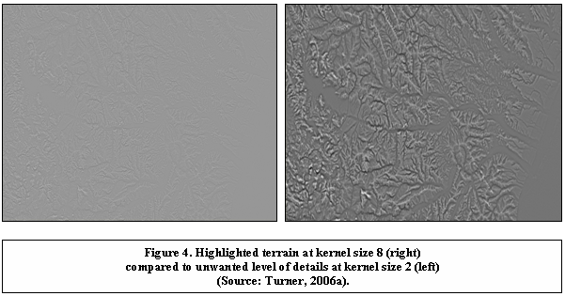

Thus, this work focuses on the use of different kernel dimensions (2 and 16) to highlight the significance of applying higher kernel sizes (16) in geomorphometry to accentuate low-lying areas, high areas and flat areas which are otherwise relatively ambiguous, both in the default source DEM and where kernel size 2 is specified. This in turn emphasises the utility of geomorphometrics as a decision-making tool for assessing environmental parameters.

3. Methodology and Source Data

A 50m DEM of part of the Wolds region of the East Riding of Yorkshire was used as the basis for this study (Fig 5.).

The project was conducted using the GRIDS computer software package developed by Andrew Turner of the Centre for Computational Geography at the University of Leeds, software developed using Java 1.5.0 (Java 2 Platform Standard Edition 5.0) and requiring the Java Virtual Machine to operate.

The original source code for the system was provided but, in order to test the effects of varying kernel size, the default 2 setting was altered to represent one of 16.

Original source code for kernel size:

for (int distances = 2; distances <= 8; distances *= 2)

The code included a for-loop to iterate through different kernel dimensions up to and including size 8 and produce outputs for each of these. The original code was therefore altered to remove the looping structure and replace it with a single kernel size of 16.

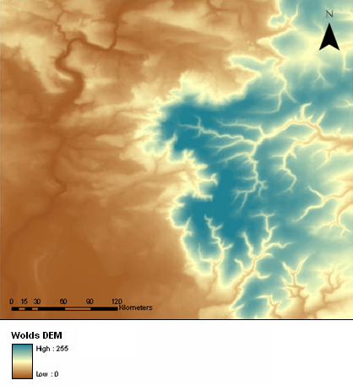
Figure 5. 50m DEM depicting part of the Wolds region of the East Riding of Yorkshire.

4. Results and Analysis

Part of the GRIDS program works on the principle of comparisons, specifically comparisons with the cell at the location for which the metric is being generated: for any given point of measurement, four other locations equally spaced at right angles to each other are used to provide readings. A filename containing a four character length part, such as
hhll or hhhl, is based on this equidistant orthogonal methodology e.g. measures of ‘slopeyness’. Other outputs are generated on the basis of averaged distances, whereby values are averaged to provide a central locational measurement. Where peaks are concerned, only places where all four of the surrounding orthogonally equidistant locations meet the requirement of being lower will qualify. Hence the logic of the output aved_llll; the average difference in the heights of all the surrounding lower locations. To record pits the process is simply repeated, amending the criteria so that all locations where the four orthogonally equidistant points are higher is specified. The output, aved_hhhh, is the average distance of the surrounding higher locations.

4.1. Average llll (Peak Analysis)

Comparing the outputs for the 2 and 16 kernel runs yielded a number of significant findings. When overlaid on the DEM, the 2 kernel output seemed to accurately depict the location of peaks in accordance with the original data. However, when compared to the 16 kernel output the results appeared to be less precise than was originally thought, since the size 16 type was highlighting longer transects that incorporated not only peaks but also valley troughs and other areas which did not correspond to the data in the DEM. After extensive discussion about such phenomena it was concluded that the 16 kernel was perhaps not as effective at detecting small-scale changes as it was identifying transformations over a larger area. This belief was influenced by recollection of Andrew Turner’s lecture in which the example of a drainage basin in an area of Andalucia, Southern Spain was used to highlight how accurately different kernel sizes can analyse wider areas of terrain. The 16 kernel takes an average over a larger number of pixels and would therefore be inferior at detecting small-scale variation (as per the 2 kernel output) given that the resulting change in average value is unlikely to be especially marked at this higher level of generalisation.

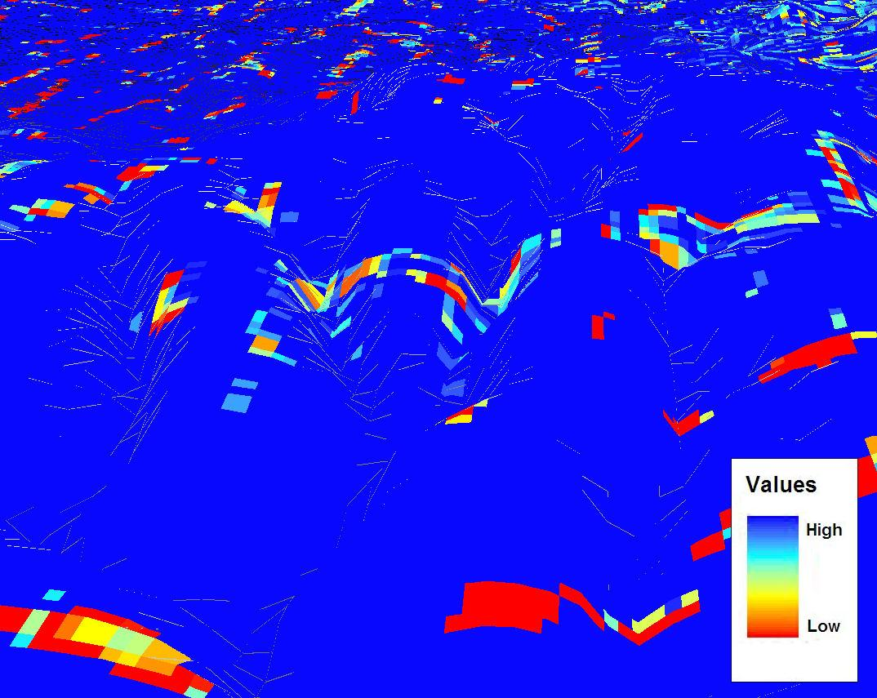

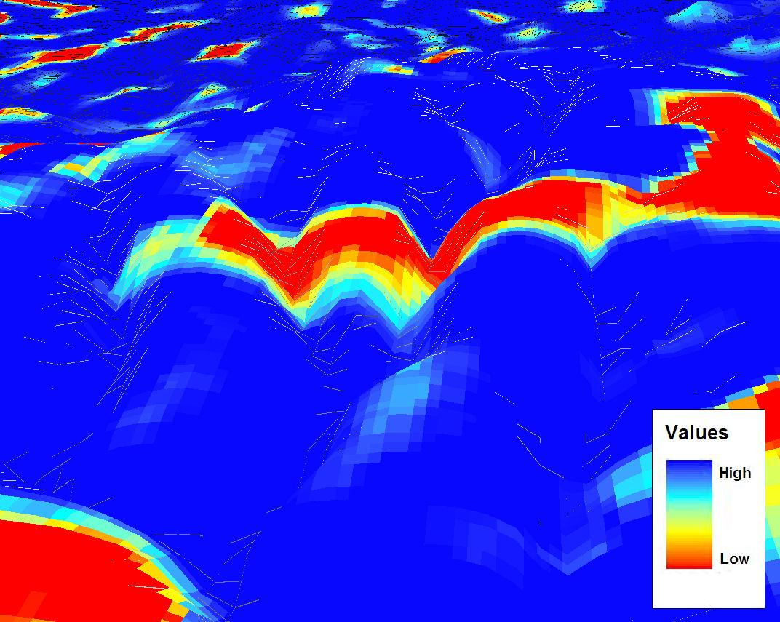

4.2. Average hhhh (Pit Analysis)

When we analysed the average hhhh for the 2 and 16 outputs to discern where pits could be found in the DEM, similar conclusions to that of the peak analysis were drawn. As the 2 kernel averaged a much smaller area it was better suited to detecting specific pit locations than that of the 16 type. However, because the window size of the 16 kernel was significantly larger than that of the 2, the latter was found to be less likely to capture the general trend of depressions across a broader area.

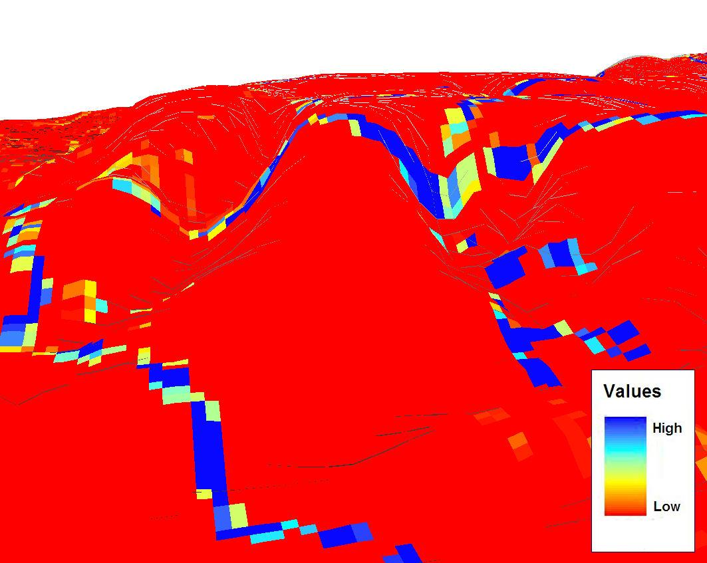

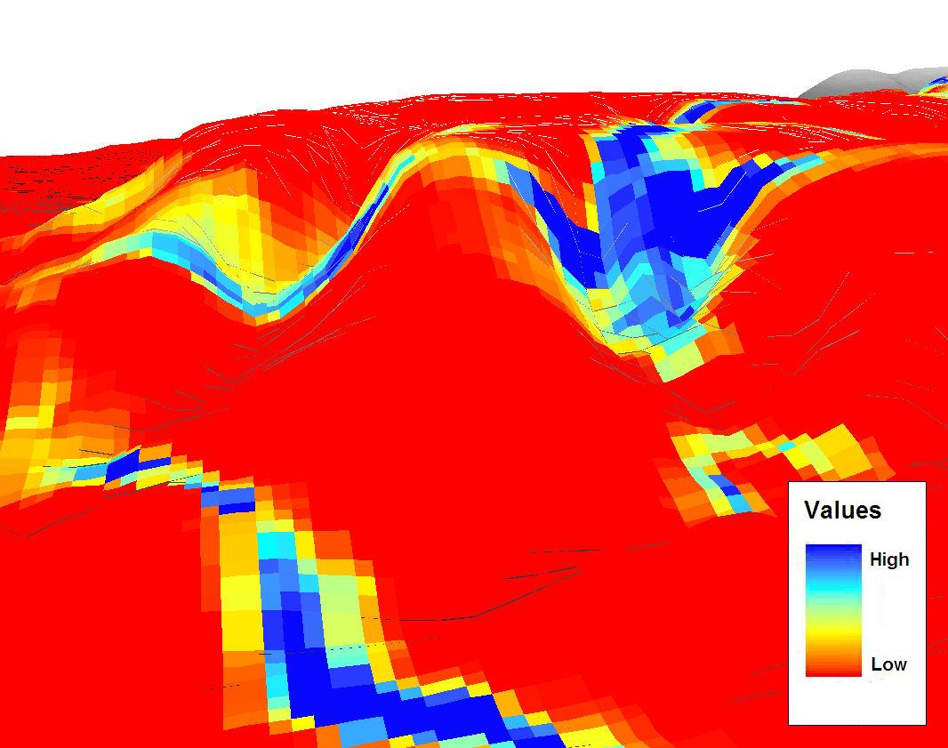

4.3. Flatness

This analysis was different to those detailed above since it was based upon an algorithm which defined degrees of flatness. The change in computational methodology resulted in the generation of outputs that corresponded very closely to the trends portrayed by the original DEM. As well as locating flat areas of land in general, the tool proved to be very useful in the detection of uncharacteristically level upland areas, most probably constituting water bodies such as tarns or reservoirs.

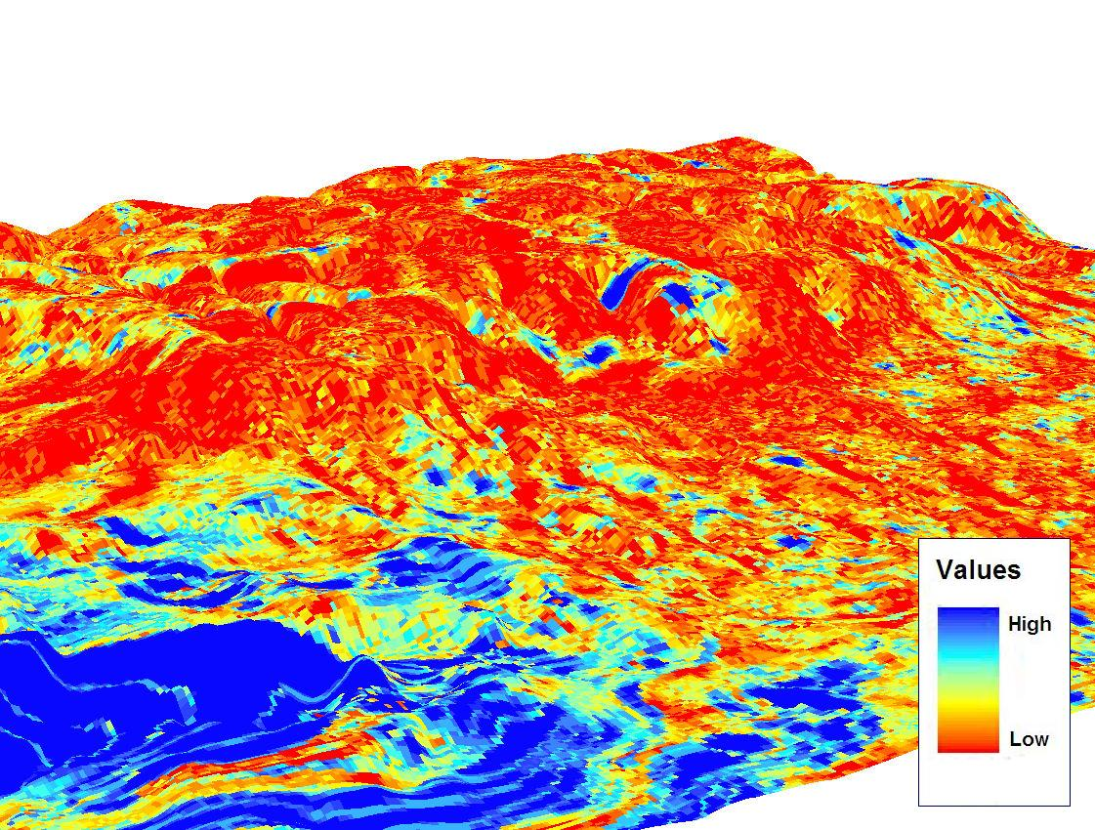

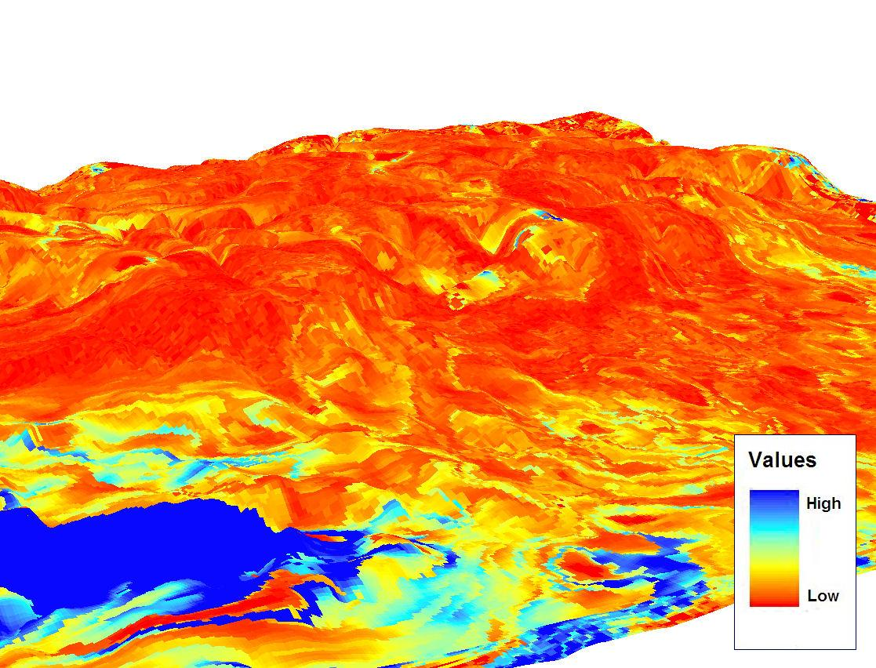

5. Other Applications of Geomorphometrics

There are further uses for geomorphometric applications such as GRIDS, especially in relation to environmental issues approached from the geographical and statistical analysis perspectives. Together with DEM modelling and GIS-based techniques, geomorphometrics can be used to support future decision-making in fields as diverse as engineering, resource development and land-use planning e.g. selecting suitable locations for road construction and tunnel excavations. It can also provide valuable assistance in relation to the determining of a suitable location for the construction of a dam on a river stream. Other practical applications may concern agriculture and the use of land classifications for soil types and also the analysis of problems related to geohazards, such as landslides, based on the measurement of slope and the degree of aspect. Monitoring water flows to prevent floods at the catchment area of the river drainage systems is another field in which, via the GRIDS software package, the application of geomorphometrics may be considered advantageous.

6. Conclusion

It was apparent from the aved_hhhh and aved_llll analyses that a lower kernel size provided for a distribution of peaks and pits that might be considered too numerous and widely dispersed to assist many real-life decision making processes. The use of kernel size 16 instead generalises such values over a wider range of cells and better assists in the identification of clusters or broader neighbourhoods of peaks and pits, potentially providing a more valuable reference for certain policy assessments. The identification of a zone characterised by pits, for example, might help determine an area suitable for the location of a reservoir (Fig. 9) whilst a cluster of peaks might signify the ideal site for a windfarm (Fig. 7). The application of a larger evaluation window therefore highlights more substantial topographical features which are likely to be lost in the high levels of intricate detail exhibited by the size 2 kernel.

However, as the kernel size increases, so too does the level of error. Fewer peaks were registered in valleys using kernel size 16 compared to kernel size 2 (Figs. 6 and 7) which could cause problems in the generation of hydrological models or for areas with a highly undulating or steep topography, where the difference between values of adjacent cells may be several hundred metres. These errors might be accentuated further if the cell size of the DEM is particularly high.

Measuring the relative usefulness of the 2 and 16 kernel sizes is not necessarily a binary phenomenon however; they may instead be considered in a complementary manner. A larger kernel size might be instrumental in identifying areas of peaks or pits (or other parameters) at a regional level whilst a smaller kernel size analysis can be executed to determine particular locations within those larger zones. For instance, a size 16 kernel output of peaks may be useful in identifying the best trekking regions across a mountainous area, whilst a 2 kernel analysis on these identified regions might then illustrate the optimal trekking slopes. Thus, the utilisation of a geomorphometric methodology may be described as providing a tool of critical importance to analysts in developing their understanding of the metrics of a particular landscape and the environmental processes with which it is comprised. Different scales may also be applied to further increase the potential for important environmental decision making to take place. Further exploration of its functionality in a future project of this kind, such as one that is hydrological in nature, may serve to verify this conviction and substantiate the belief that geomorphometrics is a multi-disciplined and highly effective geographical analysis technique.

7. References

Albani, M., Klinkenberg, B., Andinson, D. W. and Kimmins, J. P. (2004). The choice of window size in approximating topographic surfaces from Digital Elevation Models, International Journal of Geographical Information Science, 18(6), 577-593.

Arrell, K. E. (2002). Geographical Information Systems (GIS): A useful tool for Geomorphologists?, Journal of the Durham University Geographical Society.
URL: http://www.geog.leeds.ac.uk/people/k.arrell/GeomorphologyAndGIS.pdf
Accessed: 06/04/2007.

Pathmanabhan, A. and Dinesh, S. (2007). The effect of Gaussian blurring on the extraction of peaks and pits from Digital Elevation Models: Research Article, Discrete Dynamics in Nature and Society, Article Id: 62137, 12 pages.

Turner, A. (2006a). Geomorphometrics: Ideas for generation and use, CCG Working Paper, Version 0.3.1.

Turner, A. (2006b). Geomorphometrics, School of Geography, University of Leeds.
URL: http://www.geog.leeds.ac.uk/people/a.turner/research/interests/geomorphometrics
Accessed: 06/04/2007.

Wikipedia. (2007). Geomorphometry, Wikipedia Foundation Inc, 2007.
URL: http://en.wikipedia.org/wiki/Geomorphometry
Accessed: 06/04/2007.

