GEOG1300 Geography Tutorials, 2009/10, Level 1, Semester 2

Uploading a tutorial assessment to Turnitin using VLE

- Log into BB VLE and navigate to the GEOG1300 Geography Tutorials resources.
- Select ‘Turnitin Essay’ from the module menu (on the left hand side of the screen).
- Read the instructions for the Turnitin tool and also the School of Geography notice provided about "Declaration of Academic Integrity".
- When you are ready to submit your essay/literature review, click on ‘View/Complete’ link contained in the Turnitin tool:

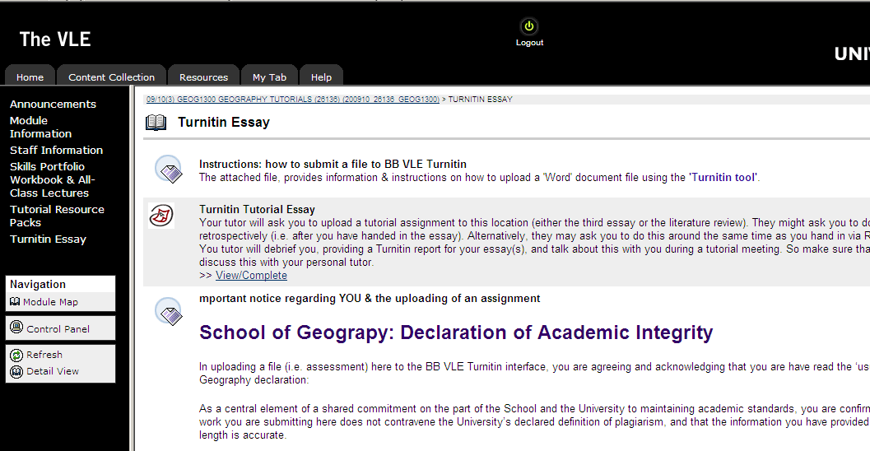

- Complete the following screen by adding your first name and surname (Jo Bloggs in the example below); submission title (e.g. “Tutorial Essay #3”; or alternatively “Sem 2 Literature Review” – as appropriate); and then browse your computer, navigating to the file you want to upload (do this by clicking on the ‘Browse’ button). Next click the ‘upload’ button located at the bottom of the screen. Just before doing this, the completed top part of the screen should resemble the following:

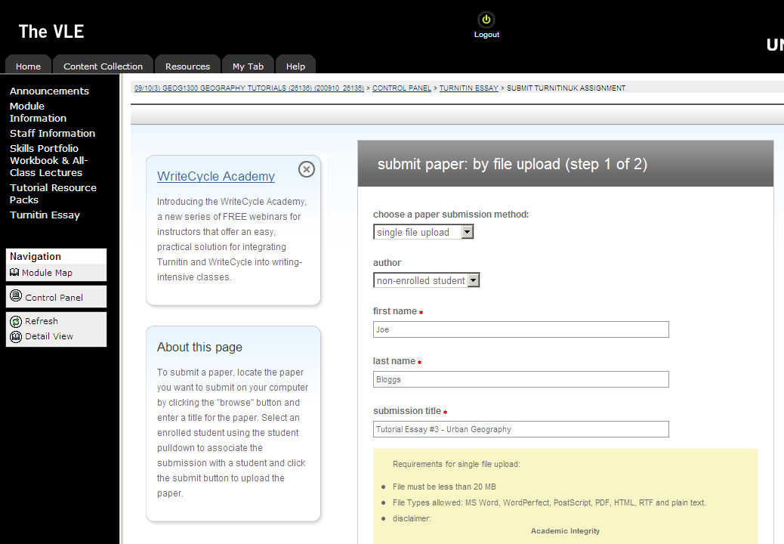

- Click on the ‘help’ button if you need some further online assistance (if available).

- Scrolling to the bottom of the screen will allow you to review the standard University disclaimer statement about academic integrity, and provide links to resources on avoiding plagiarism.

- Having done all of this, the screen should now resemble the following example. You should review all the text & instructions displayed before finally confirming upload by finally clicking “yes, submit” – assuming you have uploaded the right file / assessment:

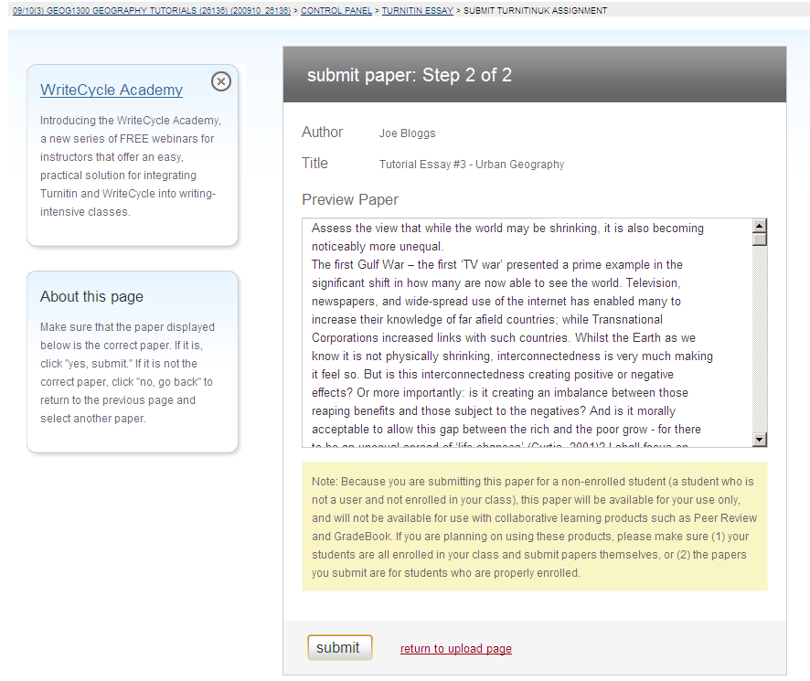

- You should then get the following on-screen message: “Paper Submitted: Paper successfully submitted”, which you can then accept by clicking the OK button.

- The process of uploading is now complete, and you should await feedback provided directly from your tutor. They will talk you through a paper copy of the Turnitin Report during a forthcoming tutorial meeting.

If at any time, there is an error, or the screen display does not resemble the examples shown above, just restart the process by returning to step 2 above – i.e. selecting the Turnitin Essay from the GEOG1300 menu options; and then run through steps 3-12 again.

January 2010

