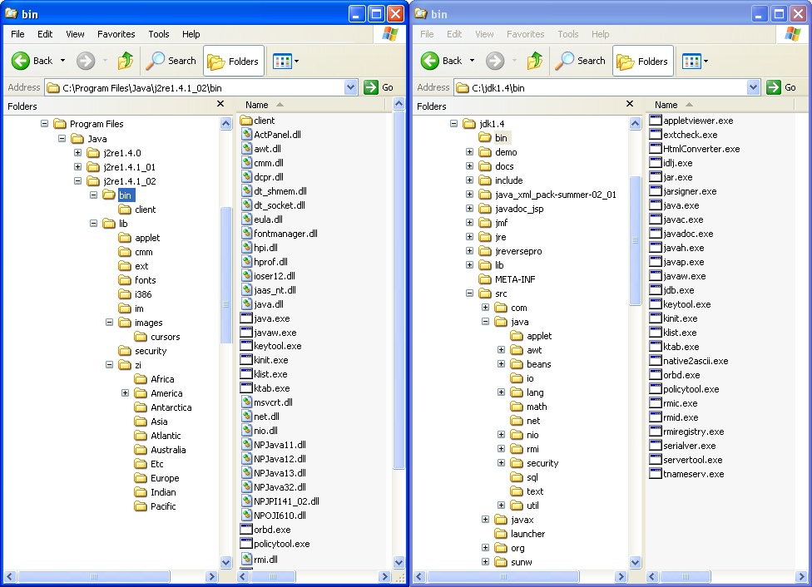

/**
* Program to calculate the mean of three numbers
* @author Andy Evans
* The next two lines are important for the code to run - we'll look at these
* in the practical
**/
class Calculate {
public void main (String args[]) {

// Get 3 numbers.
// "ints" are integer numbers.

int numberOne = 7;
int numberTwo = 23;
int numberThree = 42;

// Sum the numbers.
int sum = numberOne + numberTwo + numberThree;

// Divide the sum by 3.
// "doubles" are numbers with decimal places.

double result = sum/3;

// Print the result.

System.out.println(result);

}
}

