Raster Based Geographically Weighted Statistics for Studying the Spatial Change of Incidence Distributions Over Time:
An Application to Stats 19 Personal Injury Road Accident Data

PhD Working Paper
Version 0.2, February 2006

Andy Turner

Abstract

This paper charts an investigation of some raster based Geographically Weighted Statistics (GWS) methods developed to examine the spatial change in incidence distributions over time with specific reference to an example of personal injury road accidents in Great Britain.

1 Background

Source data:
- Ordnance Survey Meridian Road Data (OSMRD)
Meridian is an Ordnance Survey (OS) data product customised from a variety of other OS data sets. The data represent real world geographic objects as point and line vectors with associated attribute data. The data used here are the line vectors which represent four different types of road (Motorway, A-Road, B-Road and Minor-Road).
- Stats 19 Personal Injury Road Accident Data (SPIRAD)
Stats 19 data are held in three related data tables, one contains general records concerning individual road accidents, another concerns the casualties involved, the other concerns the vehicles involved. Each accident is temporally referenced (by a date and time stamp) and spatially referenced with coordinate variables that give the spatial location of the accident measured to approximately the nearest 10 metres. The spatial location and year in which each accident occurred are the key bits of data used in this work.

The locations of personal injury road accidents and the movements of road vehicles do not take place in two-dimensions although the data representations used here to approximate these are. Two data structures commonly used for storing such geographical data are raster and vector. In fact, all geographical data are values attributed to individual points, lines or regions in a spatial referencing system defined by a projection, axes and coordinates. The spatial definition of these points, lines or regions are stored as coordinate vectors except in special circumstance.

Geographical raster data are regularly distributed values. Commonly these are thought to form a continuous region divided into cells centred on each value. The spatial boundary of all these cells can be given in a few parameters and the values can be stored in a specific order. A key advantage of this is that a large amount of information can be coded, retrieved and modified very efficiently. Theoretically, to a specific precision, the same data can be stored in raster and vector formats, though often one or the other is far more efficient. Data can be converted between the two formats without generalisation or information loss, at a specific precision, however, converting vector data into raster often involves some form of generalisation such that the vector data cannot be precisely reconstructed from the raster data alone. There are numerous spatial analysis methods that can only be applied to raster data. Also, much geographical data is only available in raster forms having being converted during assimilation.

The most common distributions of two-dimensional (2D) spatial geographical raster data values are equal angled triangles and squares. For many geographical purposes, it is not the nature of this distribution of values, but their size or resolution which is of greatest importance.

Both SPIRAD and OSMRD can be converted into raster data. Think of a raster as a surface of cells. Now, at some low level of resolution, most cells are large enough so as to contain at least some road and some SPIRAD locations for the period 1992 to 2001. In general, for higher levels of resolution - the proportion of cells that contain neither road nor SPIRAD locations in the period 1992 to 2001 is higher. For square cells with widths of 20 metres (smaller than the widths of much road), the proportion of cells that do not contain any road is very large and the proportion of cells which do not contain any locations of personal injury road accidents in the period 1992 to 2001 is even larger. These proportions vary spatially and intuitively one might expect that the latter is also in some way related to the density and proximity of road.

Based on SPIRAD for a 10 year period from January 1st 1992 to December 31st 2001, consider two square celled rasters grids where each cell represents a count of the number or incidence of SPIRAD in two discrete five year chunks about the mid date. Let these be known as 9296_grid and 9701_grid respectively, and let us consider a 20 metre resolution for the region containing Leeds Bradford.

Now, the number of non-zero cells in both the 9296_grid and the 9701_grid is small (9,303) compared with the number of all cells which are non-zero in one or other grid (54,139). Both these counts are small given the total number of cells in the grids (6,376,875). This makes it hard to identify the general differences between the SPIRAD distributions at a local level without generalising some how. Subtracting 9296_grid from 9701_grid produces a grid where positive values indicate an increase in accidents between the two time periods, and negative values indicate a decrease in accidents between the two time periods. Simply mapping the resulting ‘simple difference grid’ is not sufficient for identifying local scale patterns. This is mainly because of the amount of zero valued cells with non-zero values. Nevertheless, it is possible to discern that positive and negative values of the result are both clustered in similar locations. This supports the assumptions that the SPIRAD distributions are broadly similar, but this does not help identify, confirm or deny the existence of general differences on a local or broader scale.

Eyeballing maps in detail is not a scaleable solution for identifying changes in the spatial distribution/concentration of accidents over time. What is arguably wanted is appropriate generalisation methods that aid the task.

Producing raster maps at a lower level of resolution does not help, although this would reduce the amount of non-zero cells, it increasing the Modifiable Areal Unit Problem (Openshaw, 1984). Another way of handling the problem is to generalise by generating local statistics without compromising the resolution of the analysis (and increasing the MAUP).

Local statistics, such as the sum (or mean) of all cells within a specific distance, can be produced at the same resolution for any grid. A local sum (or mean) produces a smoother grid surface where all the values are more similar, especially those that lie within each others locality. When mapped, local statistics grids can reveal more general changes that were hidden in the grids themselves. One reason this helps can be that a smoothed grid will contain far fewer non-zero values if the grid itself contained many non-zero cells. For example; local statistics of the grid obtained by subtracting 9296_grid from 9701_grid which take into account cells within 20 cell widths produces a surface where 30.92% of cell values are non-zero. Compare this percentage with the simple difference grid where a mere 0.99% of cells were non-zero. Mapping the smoothed result (even on a lower resolution display) can reveal general change on the local level. (This difference is illustrated in Section 4 by Figures 4.2 and 4.3.)

For the main raster GWS explorations reported here, Ordnance Survey Meridian Road Data (OSMRD) were rasterised into a grid called ‘road_grid’ which is coincident with 9296_grid and 9701_grid. OSMRD is generalised road centre line data which offers a close but imperfect representation of GB road. Each OSMRD is a line that is attributed a class defining whether it represents Motorway, A-road, B-road or Minor-road. Road_grid was assigned a default value of 0, then each cell was assigned a value of 1 if the majority of it was either within 10 metres of a Minor-road centre line, or the majority of it was within 15 metres of a B-road centre line, or the majority of it was within 20 metres of an A-Road centre line, or the majority of it was within 30 metres of a Motorway centre line.

As with all data, SPIRAD and OSMRD are only as accurate and precise as they have been recorded and the likelihood is that they are generalised and may contain errors. OSMRD is generalised and updated ad hoc, and furthermore, road_grid is a generalisation of OSMRD. Although road_grid broadly identifies where roads are, cells with a value of 1 may not contain road and cells with a value of 0 may actually contain road. For the Leeds region explored in this paper, for 1992 to 2001, 6,898 accidents (out of a total of 93,787) were recorded in road_grid cells with a value of 0. Some of these accidents can be seen to be located far away from any road_grid cells with a value of 1 whereas most are nearby. Some of these locations can be seen in Figure 2.1.

There are various forms of data pre-processing that might be considered for cleaning or enhancing the data. However, here no cleaning of SPIRAD is done, instead, road_grid cells that are coincident with SPIRAD grid cells with non-zero values are assigned a value of 1 regardless of the proximity to OSMRD. A map of road_grid for a part of Leeds is shown in Figure 2.1. The resolution of the image shown in the map is greater than that of the grid and some individual cell locations are (or should be) identifiable.

Figure 2.1. A Map of Road_Grid for a part of Leeds
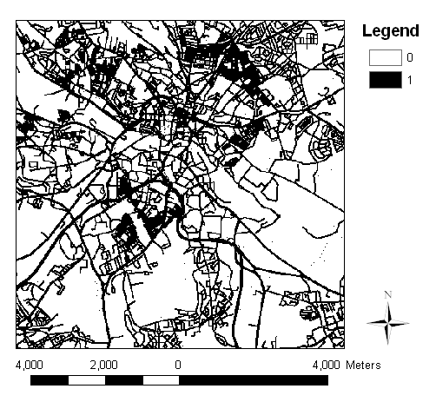

It is worth noting, that visualising grids for the entire Leeds region at the 20 metre resolution is challenging. Most contemporary display devices cannot display the entire grid without transformation to a lower resolution. This additional data generalisation can obfuscate patterns in the data, especially small scale patterns. Anyway, display generalisation is less of an issue when results are smooth as the display device transformation should have less of an effect.

The next section provides more details about the various GWS methods used to examine the change in the SPIRAD distributions over time.

To recap, the following report is based on an exploration of ten years of SPIRAD from 1992 to 2001 for the Leeds Bradford district and an unspecified version of OSMRD acquired in 1996.

The aim of the explorations was to develop a methodology with respect to comparing spatial distributions over time. Given insight into the capability and applicability of different methods a further aim was to set out a more detailed analysis to examine change in annual time aggregations for various classes of personal injury road accidents, such as accidents involving cyclists, or child pedestrians etc.

The inherent assumption for the explorative comparison of spatial distributions done here is that, despite all the complexity, aggregate exposure to risk allows a reasonable comparison of SPIRAD distributions to be made without needing to take into account other measures of the difference in environmental conditions. In reality the environmental conditions vary to a large degree, not only from minute to minute, hour to hour, day to day, week to week, month to month, year to year and so on. Some of the variation or difference may be quantifiable, (e.g. weather conditions), and at some level, quantifications may reasonably be used to ‘explain’ or map the change in the distribution of SPIRAD. In different years there are different amounts of exposure to higher risk conditions, for instance, some years the weather is worse than others. However, despite the large range and small scale variations in conditions, here we assume that over a year, things broadly balance out meaning that in one year a particular part of the road network has intinsic risk and exposure level that are similar to those in subsequent years. Clearly, this assumption is flawed, but it provides a basis for argument and identification of change. Changes in the levels of accidents that are observed may be a consequence of a general change in environemental conditions. Trends in changes over time are interesting further. For instance if an area keeps year on year experiencing an increase in the level of accidents, this is indicative of a problem that is persisting and getting worse. For example, it may be that the underlying problem is related to an increase in vehicle traffic at certain times.

2 Aims

- To compare various Geographically Weighted Statistics (GWS) methods with respect to the task of mapping and analysing change in the spatial distribution of personal injury road accidents over time.
- Develop an exploratory approach for a more detailed examination of change in the spatial distribution of different types of personal injury road accident data over time.

3 Introduction

Raster based GWS were developed specifically for this research from first principles, but applying spatial reasoning similar to that of Geographically Weighted Regression as presented in Fotheringham et al., 2002. The development of new raster based GWS was mainly driven by the following two ideas:
- Treating ‘road regions’ with zero SPIRAD count differently to ‘non-road regions’ with zero SPIRAD count would be beneficial in much the same way as measures of the density of land based human populations treats differently areas over land and water.
- That analysing large geographical regions at high levels of spatial resolution using a distance weighted approach to analyse cross-scale would be a good way to generalise and aid inference.

In another working paper I plan to detail a comparison of raster and vector based GWS. Vector based GWS being GAM/K and K^{th} Nearest neighbour et al.

Section 4 provides details on the various raster GWS methods. Section 5 presents and discusses outputs. Section 6 concludes with some ideas for further work.

4 Method Details

All GWS produce mapable outputs, most of which are rasters. Most statistics are calculated based on values in localised spatial regions, (the extent of which is usually defined by some distance metric), others are calculated for ‘adaptive’ locales, where the statistics are generated for regions with boundaries defined by other metrics, for example, the smallest circular region containing a fixed number of incidences.

It is worth noting that regions used for geographical weighting do not have to be circular or regular, or indeed apply distance weighting that is monotonic, however these are most common and are what are applied here. The details of the kernel, which defines the distance weighting is as follows:

For any value located at a distance ($D$) from the centre of a kernel, the weight for that value is given by Equation 4.1. If the Central Weight ($\text{CW}$) is 1, and the Weight Factor ($\text{WF}$) is 1, then Equation 4.1 simplifies to Equation 4.2. Figure 4.1 shows half the cross-sectional profiles of different kernels for different weight factors for a bandwidth ($B$) of 20. In Figure 4.1, the centre of the kernel is to the left and the edge is to the right. To imagine the kernel consider the shape obtained by the graphed line being rotated about the weight axis

Equation 4.1 A General Formula for Kernel Weight

$$\left({\left(1−\left(\frac{D^{2}}{B^{2}}\right)\right)}^{\text{WF}}\right)∗\text{CW}$$

Equation 4.2 A Simplified Formula for Kernel Weight

$$\left(1−\left(\frac{D^{2}}{B^{2}}\right)\right)$$

Figure 4.1 Cross-sectional Profiles of kernels for different weight factors for a bandwidth of 20 and a Central Weight of 1

Weight Factor

All the results displayed in Section 5 for fixed kernels are produced using ($B=\text{20}$, $\text{CW}=1$, and $\text{WF}=1$). For the adaptive kernels the bandwidth varies, though the shape of the surface is the same (with; $\text{CW}=1$, and $\text{WF}=1$) and the volume under it is fixed in an approximate way.

There are lots of ways of calculating both raster and vector GWS. As more variables are involved and as the complexity of the statistic increases then there are more options to do with how to calculate it. Additionally, (mainly for raster GWS) if some values in the region for which a statistic is being calculated are NoData then there are extra options to do with the treatment of NoData. Furthermore, if different variables have different NoData distributions then another set of complications arises in using GWS to compare them.

Consider the difference in the following sets of numbers:
- Set 1 = ( 0, 0, 1, 1, 2, 2 )
- Set 2 = ( 0, NoData, 1, 1, 2, 2 )
Now consider which is larger:
- The sum of Set 1 or the sum of Set 2?
- The mean of Set 1 or the mean of Set 2?
Now, consider the differences in the sum and means of localised sub-regions of 9296_grid if:
- All 9296_grid values of 0 are treated with a value of 0.
- All 9296_grid values of 0 are treated with a value of NoData.
- All 9296_grid values of 0 are treated with a value of 0 except if they are coincident with road_grid cells with a value of 0 in which case they are treated with a value of NoData.

Recall that 9701_grid subtracted from 9296_grid on a cell be cell basis, as seen in Figure 4.2, may not yield a map which clearly shows general changes at a local level.

Figure 4.2 The Simple Cell By Cell Difference

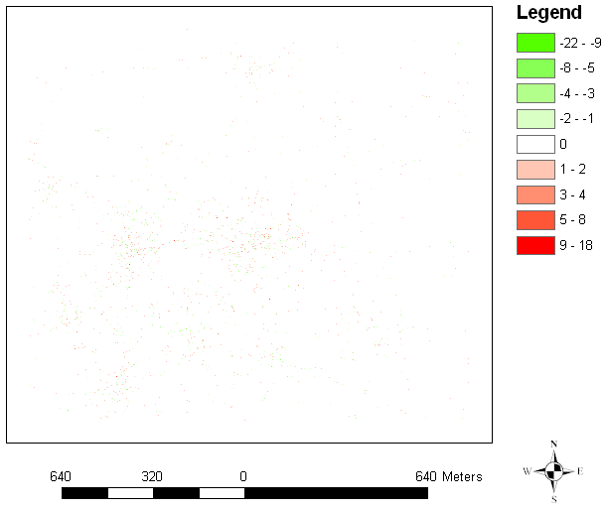

(N.B Scale bar hopelessly wrong! At the centre of this region is Leeds which covers about a ninth of the entire area.)

The digital map image shown in Figure 4.2 is at a lower resolution to that of the difference grid (regardless of further report formatting, printing etc.). On the device I am using to view the image it is very difficult to discern any pattern. However using the GIS which exported this map it is possible to discern that where there are clusters of positive values, there are also clusters of negative values. This assertion is backed up somewhat by Figure 4.3 which is effectively the same map as Figure 4.2 only a close up of somewhere near the centre.

Figure 4.3 The Simple Cell By Cell Difference Close Up

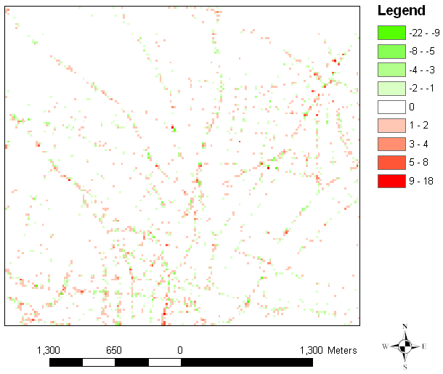

Now, a GWS such as the Geographically Weighted Sum (GWSUM) can give an indication of the absolute change by smoothing the result as discussed above. Figure 4.4 is a map of the GWSUM (for a kernel width equivalent to 20 cells) of the grid mapped in Figures 4.2 and 4.3.

Figure 4.4 The GWSUM of the grid shown in Figure 4.2

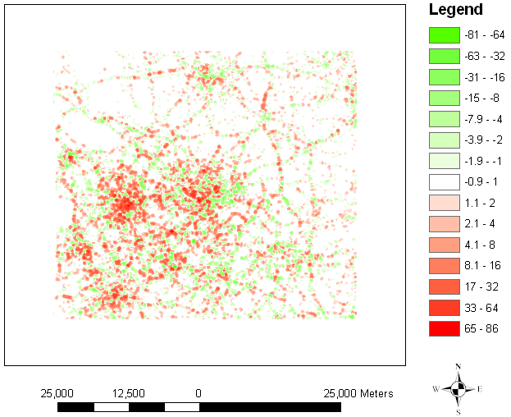

Patterns of where SPIRAD counts have increased and decreased can be discerned far easier with the map shown in Figure 4.4 than with that shown in Figure 4.2. Note that Figure 4.4 is going through the same display generalisation as that of Figure 4.2. Figure 4.5 is a close up of the map for the same region shown in Figure 4.3.

Figure 4.5 Close up of the GWSUM of the grid shown in Figure 4.2

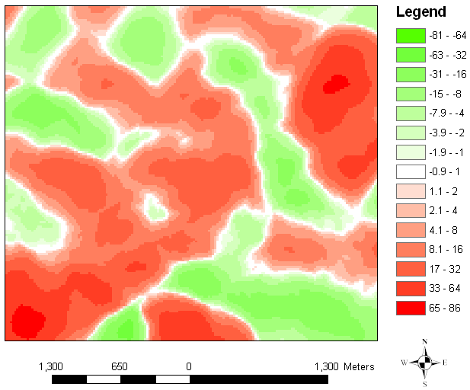

There is a lot of generalisation going on both with the GWSUM and with the display device. It is more than a challenge to identify from the pattern in Figure 4.3 what sub-region of the map shown on Figure 4.2 it is, it is not possible. Identifying what part of Figure 4.4 is shown in Figure 4.5 from the pattern is also not easy. This illustrates some of the issues of scale and resolution which makes visualisation and the reporting of results difficult.

Anyway, in the centre of Figure 4.3 the cells with non-zero values are generally positive rather than negative. This is not instantly recognisable from the pattern of green and red in Figure 4.3, but it is clear from Figure 4.5.

The map of differences in SPIRAD distributions shown in Figures 4.4 and 4.5 is of great interest. Parts of the map that are green show where there has been fewer recorded personal injury road accidents in 1997 to 2001 compared with 1992 to 1996. Conversely, parts of the map that are red show where the number of personal injury road accidents has increased. The map can be the start point for further investigation, however, this investigation is not reported here. To keep on track, this section continues with a consideration of more complex GWS, and the task of identifying smaller, potentially more interesting subsets of the data.

The GWSUM of 9296_grid and the GWSUM of 9701_grid can be generated and the cell by cell difference of these GWSUMs can be mapped. The map is very similar to the GWSUM of the cell by cell differences between 9296_grid and 9701_grid. Now, by dividing the GWSUM of 9701_grid by GWSUM of 9296_grid we can obtain a filter to help reveal different proportional increases. In the divided grid, values greater than 1 indicate where there is more SPIRAD count in 1997-2001, furthermore, values greater than 1.34 indicate where the GWSUM of SPIRAD count for 1997-2001 is more than four thirds the GWSUM of SPIRAD count for 1992-1996. Conversely, values of less than 0.75 indicate where the GWSUM of SPIRAD count for 1997-2001 is three quarters that of the GWSUM of SPIRAD count for 1992-1996.

The divided grid can be applied as a filter so as to identify not only where SPIRAD counts are increasing and decreasing, but where they are increasing and decreasing beyond certain proportions. Figure 4.6 is a map where the filter is set to filter cells for which the value of the 9701_grid GWSUM are between four thirds and three quarters that of the 9296_grid GWSUM. For Figure 4.6 the values of the filtered cells had been set to 0 and so are coloured like the background.

Figure 4.6 Filtered GWSUM of the difference between 9296_grid and 9701_grid

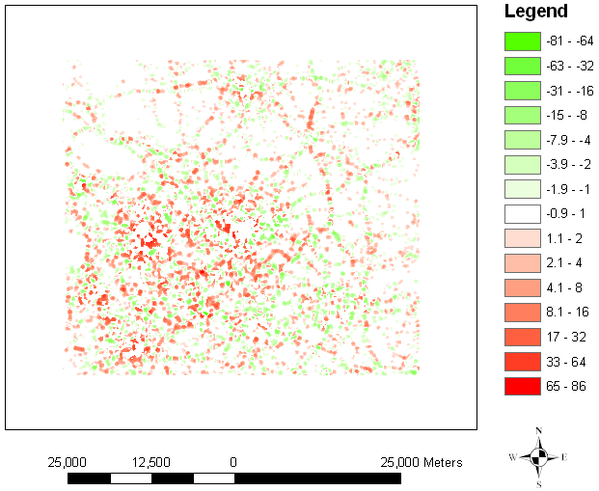

Figure 4.6 compliments Figure 4.4. Together they draw attention to areas which are observing increases and decreases in SPIRAD counts beyond a specific absolute level, and also where these differences are beyond a specific proportional level (and where they are not). It should be noted that the level of filtering and the absolute level around zero can be adjusted to show more or less of the pattern. Another important thing to note is that the filter produced by calculating the GWSUM of 9701_grid and the GWSUM of 9296_grid and dividing the former by the latter could not have been generated with some GWS of a division of 9296_grid and 9701_grid. This is because the locations of non-zero cells in 9296_grid and 9701_grid are very different at the cell level.

With respect to the three different treatments of zero valued cells that are to be investigated with the raster GWS, there are other orders of operations that need to be considered. Normalising for NoData can be done at different stages in processing and the resulting maps can be different. An investigation is therefore appropriate to see if the difference in normalised GWS has an effect on the maps of change from one time period to the next. The next part of this section provides more details on the internal workings of the GWSUM for raster GWS.

Normalising for NoData can be done in two slightly different ways in the calculation of the GWSUM. Both ways involve calculating; the total sum of weights for all cells in the kernel ($\text{tsumw}$), and for each location ($j$), the sum of weights for all data value cells at that location (${\text{sumw}}_{j}$). The Normalised GWSUM (NGWSUM) and the GWSUM Normalised (GWSUMN) are then given by Equations 4.3 and 4.4 respectively, where ($i$) represents each cell in the kernel, ($x_{i}$) is the value at $i$and ($w_{i}$) is the kernel weight at $i$:

Equation 4.3 The NGWSUM at cell$j$ $\sum_{i}{\left(x_{i}∗w_{i}∗\left(\frac{{\text{sumw}}_{j}}{\text{tsumw}}\right)\right)}$

Equation 4.4 The GWSUMN at cell$j$ $\left(\sum_{i}{\left(x_{i}∗w_{i}\right)}\right)∗\left(\frac{{\text{sumw}}_{j}}{\text{tsumw}}\right)$

Where $\left(\frac{{\text{sumw}}_{j}}{\text{tsumw}}\right)=1$, Equation 4.3 and Equation 4.4 simplify to Equation 4.5

Equation 4.5 The GWSUM at cell$j$ $\sum_{i}{\left(x_{i}∗w_{i}\right)}$

There is no difference between the NGWSUM and the GWSUMN where all 9296_grid and 9701_grid cell values of 0 are treated with a value of 0. If some 9296_grid and 9701_grid cell values of 0 are treated as NoData there are differences as will be shown in Section 5. Although these differences for the Leeds district might be subtle, the important thing is that they are different. It might be that rather than being subtle these differences have a more significant effect in more disaggregate breakdowns of the data.

Equation 4.5 is identical to one provided in Fotheringham et al., 2002, however there it is given in a slightly different context. Fotheringham et al. 2002 were not concerned with a rasterisation step, and so in that calculation of the GWSUM a weight is only used if there is a point of measurement. Now, in rasterising to generate 9296_grid and 9701_grid some SPIRAD were grouped so some cells contained multiple points. Instead of adding each points weight multiple times, in the raster GWSUM outlined above, it is effectively only added once. This makes no difference to the GWSUM, but it does effect the NGWSUM and the GWSUMN.

For the raster GWS there is a difference between the patterns of GWSUM statistics and geographically weighted mean GWMEAN statistics. Equations 4.6 to 4.8 are different types of GWMEAN statistics. Again one of the equations (Equation 4.6) is identical to one in Fotheringham et al., 2002, but yet again it is different owing to the context and how it is applied.

Equation 4.6 GWMEAN1 at cell$j$ $\frac{\sum_{i}{\left(x_{i}∗w_{i}\right)}}{{\text{sumw}}_{j}}$

Equation 4.7 GWMEAN2 at cell$j$ $\sum_{i}{\left(\frac{x_{i}∗w_{i}}{{\text{sumw}}_{j}}\right)}$

Equation 4.7 NGWMEAN at cell$j$ $\frac{\sum_{i}{\left(\frac{x_{i}∗w_{i}∗{\text{sumw}}_{j}}{\text{tsumw}}\right)}}{{\text{sumw}}_{j}}$

Equation 4.8 GWMEANN at cell$j$ $\left(\sum_{i}{\left(\frac{x_{i}∗w_{i}}{{\text{sumw}}_{j}}\right)}\right)∗\left(\frac{{\text{sumw}}_{j}}{\text{tsumw}}\right)$

Section 5 is concerned with comparing the GWS for 9296_grid and 9701_grid. In doing this, there is a particular interest in examining for effects due to the different NoData distributions.

5. Results

6. Conclusion and recommendations for further work

There are considerable differences in fixed and adaptive GWS.

Fixed GWS probably produce the most easily interpreted and comparable results.

The difference between fixed and adaptive GWS is a bit like the difference between GAM/K and a Kth nearest neighbour method for identifying clustering.

Effects of different treatment of NoData/Zero values can be considerable.

Effects of kernel size and shape can reflect the different scales at which patterns occur.

Irrespective of the origin and orientation of the raster and the shape of its cells, and accounting only for cells that represent areas mainly containing land surface.
From Easting 403200 Northing 412600 to Easting 456900 Northing 460100 of the Ordnance Survey Great Britain national grid coordinate system.
In dividing the two GWSUM grids, there is a special case of dividing a value through by zero which had to be accounted for. In this case, if the value being divided was greater than zero, the resulting value was set to -1. Any values of -1 were not filtered.

