1. Background

This paper is based on ongoing research undertaken by the authors on an European Union (EU) funded project, MEDALUS III, about Mediterranean desertification and landuse. MEDALUS III consists of a wide range of topics aiming to analyse and model various aspects of landuse change at different spatial scales in the Mediterranean region. The overall objective in our part of this project is to incorporate a socio-economic dimension to MEDALUS III physical models. Our approach involves creating surfaces of socio-economic variables for the EU and developing a modelling methodology able to link this synthetic socio-economic data with physical-climatic data in order to translate climatic and environmental landuse change impacts in socio-economic terms. The final goal is to package up the various components into an integrated Spatial Decision Support System which could be used both by EU politicians to help distribute funds to combat desertification and by landuse planners to evaluate and devise mitigation strategies to alleviate land degradation.

Deserts and their boundaries are hard to define and naturally fluctuate and the concepts of deserted and desertification have a wide variety of contexts. A desert could be defined as land which is incapable of supporting commercial or subsistence agriculture in a sustainable way. Nowadays there are few if any truely subsistent cultures, if there are any, they will have little power to resist economic change and as a result are somewhat at the mercy of the process of economic development which values land and greatly influences agricultural landuse patterns. Desertification in one context can be regarded as the process of land degradation in arid, semi-arid and dry sub-humid climates caused by complex dynamic interactions between the physical environment-climate and socio-economics. This process can be observed by monitoring dryland ecosystems, especially those sensitive to environmental change, as they undergo physical deterioration which reduces the carrying capacity of the land for the medium to long term. Our research is aiming to model this process in an agricultural context which should improve understand and enable us to develop strategies to mitigate the problem to ensure long-term productivity and sustainability of inhabited drylands.

Environmental change research has tended to neglect the human dimensions of environmental processes due to a lack of socio-economic data at appropriate levels of spatial and temporal resoultion which could be linked with environmental models, Clarke and Rhind (1991). This lack of socio-economic data is a major constraint to the development of proper integrated geographical models of environmental processes which includes models of land degradation and landuse change. Socio-economic data at increasingly detailed levels of spatial and temporal detail are being collected and stored by various governmental and commercial organisations as their importance and uses are realised. As this data becomes available methods to synthesise past values for certain variables at a comparable spatial scale will be extremely useful. Spatial interpolation is the name of the process which estimates the values of spatial variables at the required spatial resolution based on coarser resolution data, geographical understanding and the analysis of spatial patterns between correlated variables.

Our approach to both the spatial interpolation of socio-economic data and the development of landuse change scenarios involves the use of Neural Networks (NNs) and fuzzy technology. Both NNs and fuzzy technology are now widely used scientific tools, a general outline of their potential use and application for geographical analysis is given in Openshaw (1997), but some background information is provided in the following sub-sections.

Neural Networks (NNs)

NNs are capable of learning to recognise and generalise spatial data patterns. As such Exploratory Spatial Data Analysis tools they can be applied to model geographical processes provided sufficient data is available. They are a biologically inspired technology designed from studies of the workings of animal nervous systems which are generally made up of thousands of interconnecting nerve cells called neurons. Individual biological neurons themselves can have thousands of inputs and outputs and various scales and modes of operation. At one level neurons operate like simple summation devices converting a series of inputs signals into a series of output signals. The artificial neuron shown below would operate in this way by summing its inputs 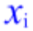 having multiplying them by a respective weighting , calculating the difference between this total and some threshold value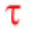, and finally an output signal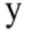would be sent determined by some function 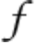of this difference.

Figure 1. An Artificial Neuron

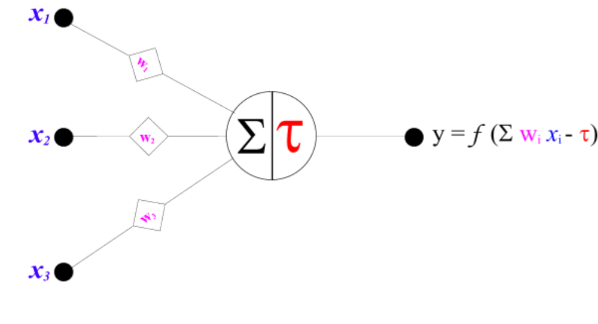
Single neurons, like the one shown above, can only perform very simple pattern recognition functions. The power of neuro-computing comes from assembling neurons into network structures capable of recognising (representing or modelling) complex non-linear patterns. The simplest structures consist of a single layer of receptors which acquire inputs for the system, and a single layer of neurons which connect to a single output layer.

Figure 2. A Simple 6x4x1 Neural Network

Output Layer
Hidden Layer
Input Layer

Generally the addition of extra numbers and layers of neurons increases the ability of a network to map a given set of inputs onto a given set of outputs and recognise complex patterns. The problem is that complex networks generally take a long time to train, so a balance/compromise between the complexity of the modelling task and NN complexity is required. There are various ways to train NNs, the most appropriate training scheme also depends on the pattern recognition task and the specific characteristics of the network. Training involves modifying the functional parameters (generally just the weights and threshold values) of the network so it improves its pattern recognition or mapping of inputs onto outputs. For both the interpolation of socio-economic data and the development of landuse forecasts, back propogating feedforward multi-layer perceptrons have been used. These are commonly used type of NN which read inputs in at one end and process them from layer to layer generating an output at the other end. Training involves comparing the expected output derived by the network from various inputs with observed values from a training dataset, this is known as supervised training. During training the difference between these observed and expected values is reduced iteratively by a small amount by adjusting the weights and threshold values of the network working backwards from the output layer towards the input layer. In general training is stopped completely when the network parameters converge and a final process of validation on non-training data then takes place.

The main generic advantages and disadvantages of NNs over more conventional technology are displayed in Table 1 of the appendix. Really you do not need to understand much about neural networks to read this paper, basically what is important is that you appreciate that NNs can be trained to recognise complex non-linear patterns by relating values of a dependent spatial variable with values of other independent spatial variables which makes them capable of predicting the value of the independent variable in new areas. These predictions can be at a more detailed spatial resolution (interpolations) and they can be made beyond the current spatial extent of the dependent variable.

Fuzzy logic and fuzzy modelling

Fuzzy logic is the basis of fuzzy set theory where an element belongs to both a set and its complement at the same time to some degree. This is different to more conventional set theory where an element either belongs to a set totally or it belongs to its complement totally.

As the complexity of a process, model or system increases it becomes more and more difficult to make precise statements about the inter-relationships between the constituant components, and fuzzy methods become superior to more conventional methods since they are more able to handle the imprecision. The main generic advantages and disadvantages of fuzzy approaches are displayed in Table 2 of the appendix.

Fuzzy models which map a given set of inputs onto a given set of outputs consists of a set of membership functions which define the fuzzy classes of inputs and outputs, a fuzzy rule base (a
collection of fuzzy IF-THEN rules), and an inference engine which parses the rules in response to system inputs. The diagram below represents the generic process of fuzzy inference.

Inference
Engine
O
U
T
P
U
T
S
De-Fuzzyfication
Fuzzyfication
Knowledge base

RulebaseMembership Functions

IF...THEN
IF...THEN
IF...THEN
I
N
P
U
T
S

Fuzzy membership functions define the degree of membership of values to a fuzzy set. It is easiest to consider this notion with a simple example. Imagine you want to define the class of tall people

(examples of tallpeople crisp and fuzzy sets)

Fuzzy variables consist of a series of overlapping membership functions which define fuzzy sets. They are also linguistic variables since they provide a systematic way of capturing vague and complex linguistic information.

(example)

The shape of the overlapping membership classes has only a small effect on the model provided the level of overlap between fuzzy classes and the number of fuzzy classes is about the same. The most appropriate number classes to use when defining a fuzzy variable depends on the complexity of the modelling task for which it will be used. Generally as the complexity of the modelling task increases so should the number of classes for each of the fuzzy variables included in the model.

Fuzzy rules can be expressed as IF-THEN statements, propositions or inferences of the form:

IF x is A THEN y is B where x and y are fuzzy variables and A and B are fuzzy classes in the variable membership function.

(example)

2 Introduction

Spatial interpolation is the process of estimating the values of a spatial variable for smaller zones than which it is currently available. Goodchild et al (1993) reviews a range of spatial interpolation methods which are relevant to creating surfaces of socio-economic data. These all suffer drawbacks many of which can be overcome by using a "smarter" approach, described in Deichmann (1996), which involves weighting other spatial variables which are in some way related to the dependent variable of interest. The following section provides an overview of the spatial interpolation problem, a review of various methods, and a report of some experiments which interpolate Eurostat socio-economic data to a much finer resolution using NNs.

3. The interpolation problem

Differences between existing physical environmental-climatic data socio-economic data present obstacles to the straightforward integration of socio-economic and physical models. Physical models of land degradation generally operate at more detailed spatial and temporal scales compared to existing socio-economic models. Socio-economic data generally relates to irregularly shaped zones that are historically unstable and subject to continuous change, whereas physical environmental-climatic models tend to use and produce data in regular gridded structures.

Using GIS most available environmental data for the EU can be manipulated into a regular grid orientated at a spatial resolution of approximately 1km². A grid was selected as the framework in which to store, manipulate and link the data since it offers the greatest flexibility in aggregating upwards and can provide a realistic representation of regional or local variation provided the grid squares are sufficiently small. A geographical latitude-longitude projection was chosen to compromise distance, direction and area distortion of the data caused by the curvature of the earth, and a 1-Decimal-Minute (1DM) resolution (approximately 1km²) was chosen
To create a population density surface variables like; the road network density, distance to the nearest train station, the location and size of settlements, the height above sea level, and such like would be combined to create probablility or "potential population" surfaces. Known uninhabited areas will have the lowest population potentials and locations close to physical features that attract settlements will have higher population potentials.

The basic idea described in Deichmann (1996) of using surrogate information to make a smart guess at the distribution of population has been developed by broadening the range of input variables to reduce subjectivity and training NNs to improve the population estimates.

NNs classification works on the basis of patterns which have been recognise between; measurements and estimates of the variable of interest (at a relatively coarse resolution), other spatial variables, and values of the variable of interest at the required resolution during training. The closer the training dataset represents the entire dataset and the more similar the combination of spatial variable data values of a cell and its location are relative to the training data, the smaller the degree of uncertainty in its prediction.

The first stage in the development of the socio-economic database was to create a European population surface. The next step will be to disaggregate population by age and other factors. The creation of various European population surfaces is outlined below. Modifications in the input data, alterations to the training scheme and the selection of more appropriate network configurations will enable us to improve the model performance iteratively. The following sub-section describes the input data, the training-validation scheme employed, and some map of the results.

Creating European population surfaces

Firstly, the Surpop census population surface for Great Britain was mapped in a geographical projection at a 1DM resolution using ArcView.

Figure 3. A map of the Surpop census population surface for Great Britain

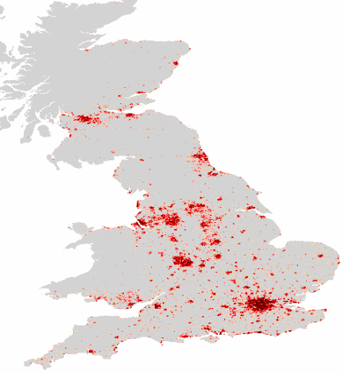

Further spatial data was acquired from a variety of sources, a list of these is provided in the appendix. Various transformations of this data providing the density, distance from and location of geographical features or spatial variables were created. Those transformations which appeared to correlate closest with the Surpop data and which were believed to be for the most part consistent across the EU were selected as inputs into the first NN. A selection of some of these layers are mapped below in Figures and a list of all the input layers (with a description) is displayed in Table in the appendix.
Figure 4. A map of communication network density

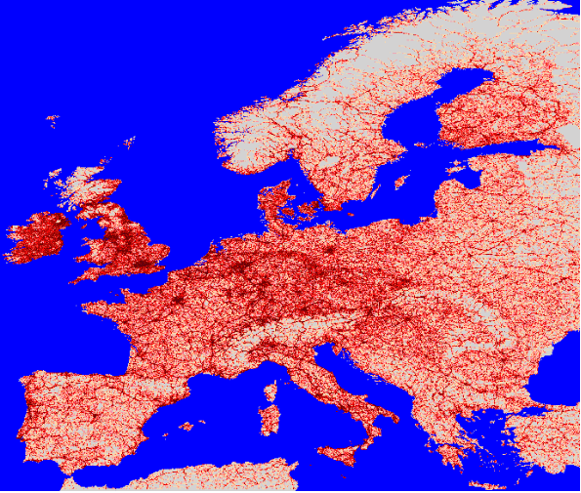

Figure 5. A map of distance from medium sized towns

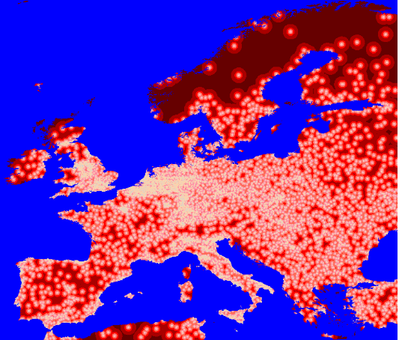

Figure 7. A map of night-time light intensity

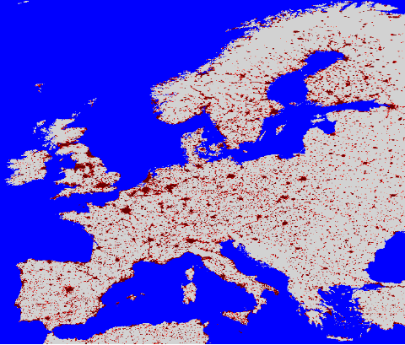
Vectors of values for the chosen spatial variables were created for each 1DM cell across the EU and a random selection of cells for which the target (surpop) data was available were selected. A simple network with 50 neurons in the hidden layer was trained on this selection until convergence in one of the training parameters occured. The trained network weights were then applied for the rest of the data across the EU. Nuts3 population totals from Eurostat, displayed in Figure 8 below, were used to constrain the predictions in each area, the result is displayed in Figure 9.

Figure 8. Nuts3 population totals for the EU

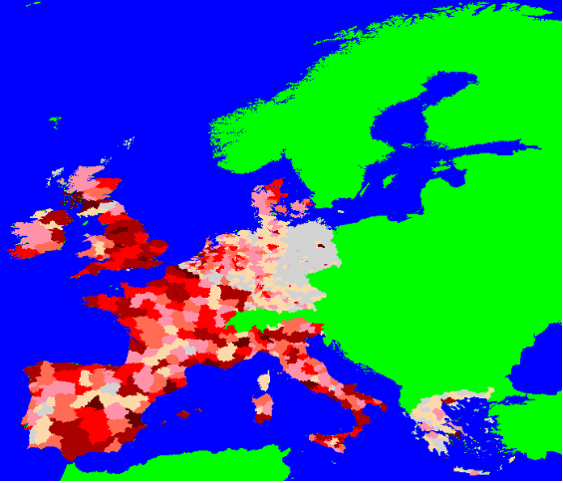

Figure 9. A map of the first estimate of population at a 1DM resolution for the EU

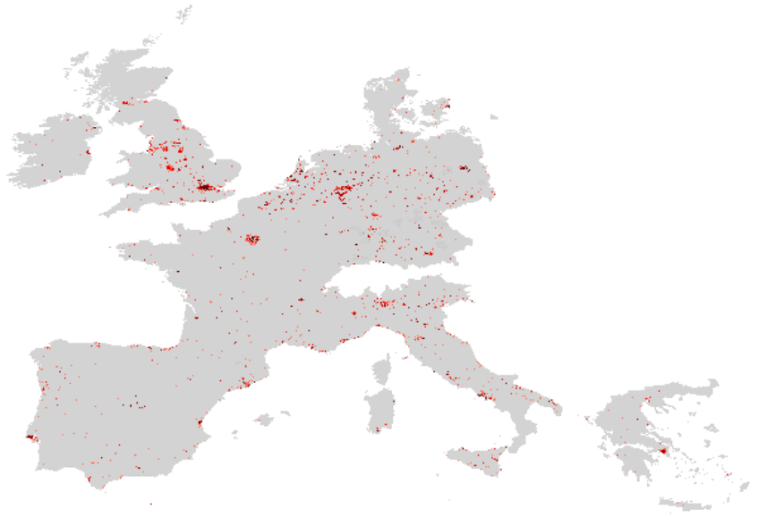

Errors were analysed for the surface at ward level in England and Wales and for registration zones in Italy, the relevant maps for England and Wales are shown in Figure 10. The ward level Small Area Statistics (SAS) population data and registration zone population data for Italy were then used to constrain estimates at this level of resolution. Maps of the original estimate, registration constraints and the new surface obtained using these constraints for Italy are shown in Figure 11.

Figure 10. Maps at ward level for England and Wales

SAS observed population
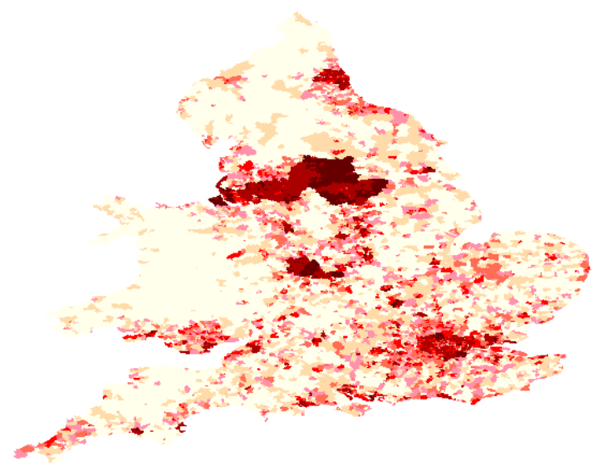
Model prediction
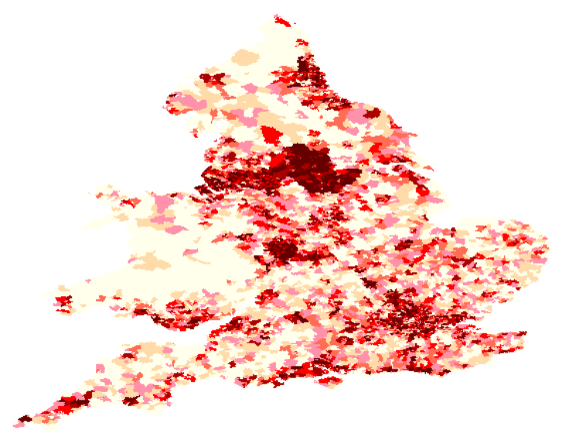
Errors
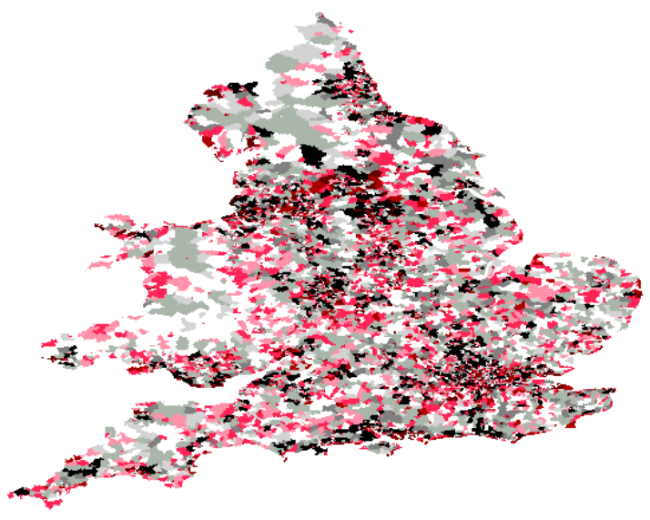
Figure 11. Population maps of Italy

The original predicted surface from Nuts3 constraints

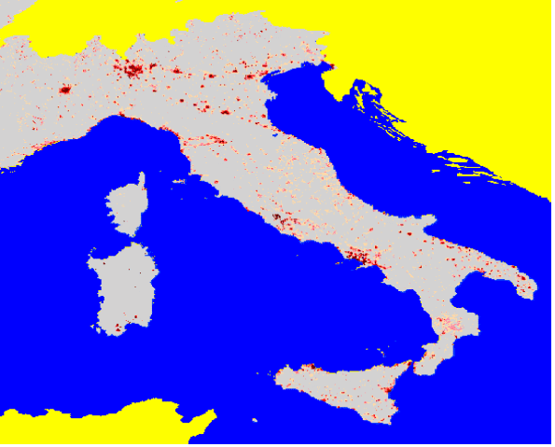

Observed population in reconstructed registration zones

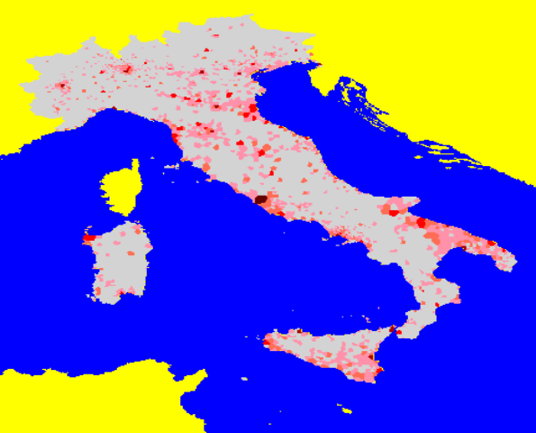

The predicted surface from registration zone constraints

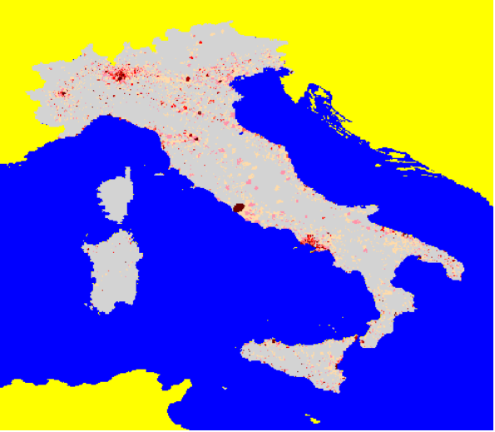

Three further NN models of EU population were created to examine the effect of network complexity on the outputs at various scales. The inputs were kept the same for this experiment, the best performing network of those tried was the most complex and had two hidden layers each with 20 neurons.

Notes etc

Fuzzy logic
- employed to obtain a necessary degree of realism.
- employed to improve the data inputs, especially the soil quality layer.
- The use of fuzzy logic in GIS, remote sensing and land evaluation is growing. -fuzzy classification of landcover using multispectral satelite imagery -fuzzy land suitability classification from soil profile observations and topography.
- Expressions which quantify the uncertainty of predicted values can be made based on; measures of the similarity between the combination of spatial variable data values and their relative location with respect to the data used in training, the fit of the trained model, data precision, other errors, and summary statistics of the entire (training and validation) dataset. It is important to try and develop neural net models with relatively even bias and uncertainty which involves carefully selecting the training data so that it dichotomises the range of different types of areas (in terms of location and combinations of input variable values).

NN
- A sigmoidal (non-linear) function was employed to calculate neuron outputs for the four network configurations used. (A network configuration written 23x25x1 represents a neural network with 23 neurons in the input layer followed by a hidden layer with 25 neurons which map to a single output neuron.)
- For each configuration the network was initialised using a genetic optimiser, this randomly assign values to the weights in the network a number of times and codes these values as bit strings, (a bit string is a concatenated binary string representation of the weight values concatenated in the same order and of equal length for each network configuration). For each bit string coded set of weights in turn the network makes a pass through the training data and measures the performance of each set using a fitness function (the sum of squared errors between the expected output and the target value). The genetic optimiser then selects a number of the best performing sets of weights and breeds their bit strings representations using the genetic operations of crossover, inversion and mutation. The process of evaluation-selection-breeding is repeated a number of times depending on the complexity of the network. (Experience has shown that generally more complex networks benefit by having a greater number of iterations through the genetic optimiser. The number of iterations through the genetic optimiser has little effect on the final network parameters it is basically just a clever trick to help help reduce the training times by initialising the network parameters closer their final values.) After the genetic optimisation is finished the best performing set of weights are assigned to initialise the network.

NN/Interpoation comments
- Finer scale population constraints reduced errors considerably
- There is a strong case for stratifying the selection of training data cells. It is presently thought that the largest errors are likely to be caused by an inappropriately small selection of densely populated cells in the training data.
- NNs presently predicts on the basis of UK settlement patterns (excluding Northern Ireland). Some regional variation in settlement patterns across Europe which is not like those in the UK is likely and presently these are not picked up by the model. As other small area European population data becomes available it can be added to the training/validation data and further training can be undertaken. This may help represent some of the regional variation in settlement patterns across Europe. As the training data dichotomises the range of regional settlement patterns throughout Europe the uncertainty in ANN predictions in all areas (especially those distant from the training data) should reduce.
- The NN modelling technique is generic and can be applied to predict the value of many spatial variables provided sufficient data is available. The data required includes both indicator variables which relate to the variable which is being attempted to be modelled as well as more detailed observed counts of the variable being modelled. It is best if the indicator variables are available for the whole area over which predictions are wanted. The target data should be available at a high resolution covering areas which dichotomise the range of the combined values of the indicator variables.
APPENDIX

Table 1. Advantages and disadvantages of neural networks

Advantages | Disadvantages
they are universal approximators  they are equation free  they are highly non-linear  they are robust and noise resistant  they probably offer the best levels of performance  they can model hard problems. | they are computationally intensive  they may require long training runs  the choice of network architecture is subjective (experience, experimentation and luck are needed to find an appropriate balance between the complexity of the modelling task and the neural network configuration)  they are essentially still a black box technology (there is no easy means to understand or communicate with the model).

Table 2. Advantages and Disadvantages of Fuzzy Logic

Advantages of Fuzzy Logic | Disadvantages of Fuzzy Logic
It enables us to deal effectively with uncertainty and imprecision associated with both the data and spatial concepts in general.  Fuzzy models can be produced both inductively from data and can be translated directly from existing knowledge.  It provides a means to integrate qualitative and quantitative data.  It can be used as a universal approximator. | No comprehensive integrated methodological framework for geographical fuzzy model formulation exists.  As the number of variables in a fuzzy model increases the number of potential fuzzy rules increases exponentially.

Table 3. Variables used to create European population surfaces

Digital Elevation Model
Night time lights intensity
Distance from built up areas
Distance from canal
Distance from international airport
Distance from national park
Distance from river
Communications network density
Motorway and dual carriageway road network density
Main and minor road network density
Railway network density
Distance from extra large towns
Distance from large towns
Distance from medium sized towns
Distance from small towns
Location of built-up areas containing extra large town centres
Location of built-up areas containing large town centres
Location of built-up areas containing medium sized town centres
Location of built-up areas containing small town centres
Location of named settlements and built-up areas
Regiomap population density at NUTS3 level
Tobler's pycnophylactic population density
RIVM's population density
Surpop Great Britain Census target population density

Table 4. Variables used for predicting/modelling contemporary agricultural landuse

Variable  source number (see below) | Description
Location of soil type 1  11 | This includes the following soil classes; cambisol, chernozem, luvisol, vertisol, plaggensols.
Location of soil type 2  11 | This includes the following soil classes; rendzina, gleysol, phaeozem, fluvisol, kastanozem, histozol, andosol.
Location of soil type 3  11 | This includes the following soil classes; arensol, ferralsol, ranker, planosol.
Location of soil type 4  11 | This includes the following soil classes; acrisol, podzoluvisol, greyzem, podzol, solonchak.
Location of soil type 5  11 | This includes the following soil classes; solonetz, xerosol.
Location of soil type 6  11 | This includes the following soil classes; lithosol, regosol, rock outcrops
Soil quality  11 | Physical properties of the soil were indexed in terms of their limitations or restrictions for agricultural capability and combined to produce a crude measure of soil quality.
Potential biomass  10 | Estimated potential biomass model output at 30DM resolution.
Average temperature in Spring  9 | Average monthly air temperature in March, April and May.
Average temperature in Summer  9 | Average monthly air temperature in June, July and August.
Average temperature in Autumn  9 | Average monthly air temperature in September, October and November.
Average temperature in Winter  9 | Average monthly air temperature in December, January and February.
Average monthly precipitation in Spring  9 | Average monthly precipitation in March, April and May.
Average monthly precipitation in Summer  9 | Average monthly precipitation in June, July and August.
Average monthly precipitation in Autumn  9 | Average monthly precipitation in September, October and November.
Average monthly precipitation in Winter  9 | Average monthly precipitation in December, January and February.
Digital Elevation Model  12 | Height above sea level.
Population | 1x10x10x1 Neural Network output.
Dominant agricultural landuse  11 | The dominant agricultural landuse categorised into the following groups; arable, olive groves and orchards, wasteland, and others.

Table 5. Variables used for forecasting future agricultural landuse

Variable  source number (see below) | Description
Location of soil type 1  11 | Assumed not to have changed from table 1.
Location of soil type 2  11 | Assumed not to have changed from table 1.
Location of soil type 3  11 | Assumed not to have changed from table 1.
Location of soil type 4  11 | Assumed not to have changed from table 1.
Location of soil type 5  11 | Assumed not to have changed from table 1.
Location of soil type 6  11 | Assumed not to have changed from table 1.
Soil quality  11 | Assumed not to have changed from table 1.
Potential biomass  10 | Assumed not to have changed from table 1.
Average temperature in Spring  9 | Predicted average monthly air temperature in March, April and May.
Average temperature in Summer  9 | Predicted average monthly air temperature in June, July and August.
Average temperature in Autumn  9 | Predicted average monthly air temperature in September, October and November.
Average temperature in Winter  9 | Predicted average monthly air temperature in December, January and February.
Average monthly precipitation in Spring  9 | Predicted average monthly precipitation in March, April and May.
Average monthly precipitation in Summer  9 | Predicted average monthly precipitation in June, July and August.
Average monthly precipitation in Autumn  9 | Predicted average monthly precipitation in September, October and November.
Average monthly precipitation in Winter  9 | Predicted average monthly precipitation in December, January and February.
Digital Elevation Model  12 | Assumed not to have changed from table 1.
Population | Population forecast from 1x10x10x1 Neural Network.

Data sources:
- Bartholomew European 1 Decimal Minute data.
- Digital Chart of the World.
- The Defence Meteorological Satellite Program (DMSP) Operational Linescan System (OLS) Night- time lights intensity dataset.
- RegioMap (Eurostat) CD-ROM data.
- Tobler's pycnophylactic (mass preserving) smooth interpolated population density surface.
- RIVM's raw population count for geographical regions.
- UK Census data: Surpop 200 meter total population and population seeking work surfaces of Great Britain; SAS Small Area Statistics.
- Italian National Statistical Institute Registration total population count point data.
- CRU temperature and precipitation data.
- Biomass estimations from Medalus at Leeds.
- Soils geographical database of Europe at scale 1:1,000,000 version 3.2.
- GLOBE: Global Land One-KM Base Elevation Data version 0.1.

References

The home page of MEDALUS III project 9.1: GIS based socio-economic modelling can be found at the following URL
http://medalus.leeds.ac.uk/SEM/home.htm

Spatial Interpolation References

Clarke J, Rhind D (1991) Population Data and Global Environmental Change. International Social Science Council Programme on Human Dimensions of Global Environmental Change, Working Group on Demographic Data.

Deichmann U, Eklundh L (1991) Global digital datasets for land degradation studies: A GIS approach. United Nations Environment Programme, Global Resource Information Database.

Deichmann U (1996) A Review of Spatial Population Database Design and Modelling. United Nations Environment Programme, Global Resource Information Database, and Consultative Group for International Agricultural Research initiative on the Use of Geographic Information Systems in Agricultural Research.

Goodchild M, Anselin L, Deichmann U (1993) A framework for the areal interpolation of socio-economic data. Environment and Planning A, 25, 383-397.

Sweitzer J, Langaas S (1994) Modelling population density in the Baltic States using the Digital Chart of the World and other small scale data sets. Technical Paper, Beiher International Institute of Ecological Economics, Stockholm.

Tobler W (1979) Smooth Pycnophylactic Interpolation for Geographical Regions. Journal of the American Statistical Association, 74, 519-529

Tobler W, Deichmann U, Gottsegen J, Maloy K (1995) The Global Demography Project. NCGIA Technical Report TR-95-6.

van Veidhuizen J, van de Veide R, van Woerden J (1995) Population mapping to Support Environmental Monitoring: Some Experiences at European Scale. Proceedings of the Joint European Conference and Exhibition on Geographic Information, March 1995, The Hague, Netherlands.

FAO (1980) Natural resources and the human environment for food and agriculture. Environment paper No 1, Rome, Italy.

Openshaw S, Perree T (1997) Methods for an intelligent continuous surface transformation of socio-economic data for Europe. Extended Abstract for 1st International Conference on Geocomputation, September 1997, Leeds, England.

Perree T (1997) Creation of a Frameless Spatial Database for Environmental and Socio-economic Modelling at a Regional Scale: A Review of Options. Unpublished CCG paper, School of Geography, University of Leeds, England.

Openshaw S, Openshaw C (1997) Artificial Intelligence in Geography. Wiley & son.

Fuzzy-neuro references

McNeill D, Freiburger P (1994) Fuzzy Logic: The Discovery of a Revolutionary Computer Technology. Simon and Schuster.

Ross T (1995) Fuzzy Logic with Engineering Applications. McGraw-Hill.

Kosko B (1994) Fuzzy Thinking: The New Science of Fuzzy Logic. Harper Collins.

Burrough P, MacMillan R, van Deurson W (1992) Fuzzy Classification Methods for Determining Land Suitability from Soil Profile Observation and Topography. Journal of Soil Science, 43, 193-210.

