

ECONOMIC AND SOCIAL RESEARCH COUNCIL

**POLARIS HOUSE**

**NORTH STAR AVENUE**

**SWINDON SN2 1UJ**

**Tel: 01793 413000**

**Fax: 01793 413001**

**GTN 1434**

|  |
| --- |
| REFERENCE NUMBER |
| RES-149-25-0034 |
| TITLE |
| Modelling and Simulation for e-Social Science (MOSES) |
| INVESTIGATORS |
| Mark Birkin, Haibo Chen, Martin Clarke,  Justin Keen, Phil Rees, Jie Xu |
| INSTITUTION |
| University of Leeds |

This is the ESRC End of Award Report Form. The form should be completed and returned on or before the due date to: Evaluation Reports Officer, Communications & Information Directorate, ESRC, Polaris House, North Star Avenue, Swindon, SN1 1UJ.

Please note that the Report can only be accepted if all sections have been completed in full, and all award holders have signed Declaration One.

Award holders should also submit **seven additional copies** of this Form, and eight copies of the research report and any nominated outputs to be evaluated along with the Report.

A copy of the complete Report, comprising this form and the research report, should be formatted as a single document and sent as an email attachment to **reportsofficer@esrc.ac.uk***.* Please enter the **Award Reference Number** as the email subject.

REPORTING REQUIREMENTS

|  |  |
| --- | --- |
| **The ESRC End of Award Report is a single document comprising the following sections:** | |
| **End of Award Report Form** | Declaration 1: Conduct of the Research  Declaration 2: ESRC Society Today  Declaration 3: Data Archive  Project Details  Activities & Achievements Questionnaire |
| **Research Report** | c5000 words free text (guidelines attached) |
| **Nominated Outputs** **(Optional)** | A maximum of two (fully referenced) |
| **Eight copies of the End of Award Report document and any Outputs must be submitted to ESRC.** | |

# Award holders should note that:

1 The final instalment of the award will not be paid until an acceptable End of Award Report is received.

2 Award holders whose reports are overdue or incomplete will not be eligible for further ESRC funding until the reports are accepted.

ESRC reserves the right to take action to reclaim up to **25%** of the value of awards issued after November 1999 in cases where submission of an acceptable End of Award Report is more than six months overdue.

DECLARATION ONE: CONDUCT OF THE RESEARCH

This Report is an accurate statement of the objectives, conduct, results and outputs (to date) of the research project funded by the ESRC.

# 1. Award Holder(s) Signature

NB. This must include anyone named as a co-applicant in the research proposal.

|  |  |  |  |
| --- | --- | --- | --- |
| **TITLE** | **INITIALS** | **SURNAME** | **SIGNATURE** |
|  |  |  |  |
|  |  |  |  |
|  |  |  |  |
|  |  |  |  |
|  |  |  |  |
|  |  |  |  |

# 2. Administrative Authority Signature

|  |  |
| --- | --- |
|  | **DATE:** |

# 3. Head of Department, School or Faculty Signature

|  |  |
| --- | --- |
|  | **DATE:** |

**Photocopies of this page are acceptable in the seven additional printed copies of the report. This page should be left blank in the email copy.**

DECLARATION TWO: ESRC SOCIETY TODAY

|  |
| --- |
| **ESRC Society Today is a publicly available online research database, containing summary details of all ESRC research projects and their associated publications and outputs. This includes Summary and Full reports from End of Award Reports since 2005. ESRC Society Today provides an excellent opportunity for researchers to publicise their work; the database has a large user base, drawn from Higher Education, government, voluntary agencies, business and the media.**  **Summary details of publications and/or other outputs of research conducted under ESRC funded awards must be submitted to the ESRC Society Today Awards and Outputs Database.**  **For queries relating to ESRC Society Today, please contact:**  [**societytodaysupport@esrc.ac.uk**](mailto:societytodaysupport@esrc.ac.uk) **or 0871 641 2115 (technical queries, eg uploading outputs)**  [**societytoday@esrc.ac.uk**](mailto:societytoday@esrc.ac.uk) **or 01793 413108 (general queries)** |

# Please sign at either A or B below.

**A. Details of relevant outputs of this award have been submitted to ESRC Society Today and details of any ensuing outputs will be submitted in due course.**

Signature of Principal Award Holder

|  |  |
| --- | --- |
|  | **DATE:** |

**B. This award has not yet produced any relevant outputs, but details of any future publications will be submitted to ESRC Society Today as soon as they become available.**

Signature of Principal Award Holder

|  |  |
| --- | --- |
|  | **DATE:** |

Award holders should **note** that the end of award report cannot be accepted, and the final claim cannot be paid, until either ESRC has received confirmation that details of relevant outputs have been submitted to ESRC Society Today or the award holder has declared that the award has not so far produced any relevant outputs

**Photocopies of this page are acceptable in the seven additional printed copies of the report. This page should be left blank in the email copy.**

DECLARATION THREE: DATA ARCHIVE

|  |
| --- |
| **A machine-readable copy of any dataset arising from the research must be offered for deposit with the Economic and Social Data Service (ESDS) at the UK Data Archive within three months of the end of the award. All enquiries should be addressed to the Acquisitions Team, ESDS, University of Essex, Wivenhoe Park, Colchester CO4 3SQ or by email to** [**acquisitions@esds.ac.uk**](mailto:acquisitions@esds.ac.uk)  **ESDS maintains an informative website at** [**http://www.esds.ac.uk/**](http://www.esds.ac.uk/)  **Award holders submitting qualitative data should refer to the ESDS Qualidata website at** [**http://www.esds.ac.uk/qualidata/**](http://www.esds.ac.uk/qualidata/) |

# Please sign at either A or B below.

**A. Machine-readable copies of datasets arising from this award have been, or are in the process of being, offered for deposit with the ESDS.**

Signature of Principal Award Holder

|  |  |
| --- | --- |
|  | **DATE:** |

**B. There are no relevant datasets arising from this award to date.**

Signature of Principal Award Holder

|  |  |
| --- | --- |
|  | **DATE:** |

Award holders should **note** that the ESRC will withhold the final payment of an award if a dataset has not been deposited to the required standard within three months of the end of award, except where a modification or waiver of deposit requirements has been agreed in advance.

**Photocopies of this page are acceptable in the seven additional printed copies of the report. This page should be left blank in the email copy**

PROJECT DETAILS

|  |
| --- |
| ESRC END OF AWARD REPORT: PROJECT DETAILS |

|  |  |  |  |
| --- | --- | --- | --- |
| **AWARD NUMBER:** | **RES-149-25-0034** | | |
| **AWARD TITLE:** (the box will accommodate up to 4 lines of text) | **Modelling and Simulation for e-Social Science (MOSES)** | | |
| **AWARD START DATE** | **01/04/2005** | **TOTAL AMOUNT EXPENDED:** | **£610,028.14** |
| **AWARD END DATE** | **30/09/2008** |

# AWARD HOLDER(S):

**NB. This must include anyone named as a co-applicant, as originally listed in the research proposal.**

|  |  |  |  |  |
| --- | --- | --- | --- | --- |
| **TITLE** | **INITIALS** | **SURNAME** | **DATE OF BIRTH** | **No HOURS PER WEEK/ % TIME ON PROJECT** |
| Dr | MH | Birkin | 08/02/61 | 50% |
| Dr | H | Chen | 06/07/64 | 20% |
| Prof | M | Clarke | 08/02/54 | 5% |
| Prof | J | Keen | 19/07/58 | 5% |
| Prof | PH | Rees | 17/09/44 | 5% |
| Prof | J | Xu | 14/09/61 | 5% |

|  |  |
| --- | --- |
| **Principal Award Holder's FULL OFFICIAL ADDRESS** (please list other addresses on a separate sheet if necessary) | **EMAIL** |
| m.h.birkin@leeds.ac.uk |
| School of Geography  University of Leeds  Woodhouse Lane  Leeds LS2 9JT | **FAX NUMBER** |
| 0113 343 3308 |
| **TELEPHONE NUMBER** |
| 0113 343 6838 |

ACTIVITIES AND ACHIEVEMENTS QUESTIONNAIRE

# 1. Non-Technical Summary

A 1000 word (maximum) summary of the main research results, in non-technical language, should be provided below. The summary might be used by ESRC to publicise the research. It should cover the aims and objectives of the project, main research results and significant academic achievements, dissemination activities and potential or actual impacts on policy and practice.

|  |
| --- |
| In the most straightforward non-technical language, MoSeS is about trying to build a ‘SimCity’ for real urban and regional systems. A representative simulation for an urban area would allow planners and policy-makers to make reasonable estimates of changing demographics and the use of infrastructure and services, such as housing, roads, and hospitals. Furthermore, an effective simulation would permit the evaluation of alternative scenarios, from the quite specific (what happens if we close a hospital?) to the rather general (what are the effects of discontinued economic migration from Eastern Europe?). Urban simulation has been a multi-disciplinary domain of social science research for the last 50 years, involving geographers, regional scientists, sociologists, economists, transport engineers, and many others.  The three major outputs from MoSeS are a Population Reconstruction Model (PRM) for the whole of the United Kingdom; a forecasting model (MoSeS Dynamic Model) for the city of Leeds; and a spatial decision support system which is accessed through a web browser (the “MoSeS portlet”).   * The PRM is a spatial microsimulation model which utilises an unusual approach to the problem of generating a synthetic population of individuals by using a genetic algorithm, and the distinctive feature of this research is that it enumerates the entire population of a country with 60 million residents, including occupants of both households and communal establishments. * The MoSeS Dynamic Model is a highly disaggregate forecasting model which projects the population of Leeds forwards to 2031. We have sought to enhance an established technique – microsimulation – with richer behavioural metaphors drawn from a much more recent literature on *multi-agent systems* to achieve this challenging objective. * The MoSeS portlet is designed to allow users, whether from an academic or applied perspective, to access outputs from the simulation models with a minimum of difficulty. A major obstacle to this process is that robust building blocks for such a portlet – what computer scientists would refer to as *services* – are not yet readily available. To a large extent it has therefore been necessary to design and implement appropriate services in the context of the project.   MoSeS has been funded as a node within the ESRC’s National Centre for e-Social Science (NCeSS). The main purpose of the project in this context has been to act as a demonstration that e-social science has relevance to important academic and policy problems. In the domain of urban simulation modelling, we have aimed to prove that the provision of e-social science frameworks for the integration and sharing of remote data sources, and access to powerful resources for computational processing, e.g. for visualisation as well as simulation, are significant developments. The project has also contributed to the NCeSS effort to establish the backbone of an e-infrastructure for social science in the UK, in particular through the development of generic mapping services, and our work on security within the e-social science architecture. We have engaged in NCeSS’ international mission through our involvement in the EUAsiaGrid project with partners in fourteen countries in Europe and South-East Asia.  Research on the project has been disseminated through a wide array of contributions to conferences and workshops. MoSeS long-term imprint in terms of peer-reviewed academic literature will reflect the multi-disciplinary of the project, with a combination of journal articles (the preferred outlet for social scientists) and refereed conference papers (the mechanism favoured by computer scientists). International awareness of this work has been fostered with the help of additional funding from the Social Science Research Council of North America, the National Institute for Social and Economic Modelling (Australia) and the Royal Society. The unpublished outcomes of the research also include a baseline version of the PRM (which we are in the process of depositing at the ESDS), a suite of modules for dynamic modelling, and two versions of the MoSeS portlet which are available to users online.  MoSeS impact has also extended beyond traditional academic boundaries, and we have engaged with policy users, primarily but not exclusively in our chosen domains of transport, housing and health care. In addition to an exchange of ideas, these collaborations include data sharing, needs analysis and financial support. In the future, this simulation work will continue as part of the GENeSIS project, in which we intend to add further sophistication to our models of agent behaviour, to develop applications in new economic sectors, and to improve the user experience of social simulation tools. |

# 2. Dissemination

A. Please outline any specific plans you have for further publication and/or other means of dissemination of the outcomes and results of the research.

|  |
| --- |
| Two journal papers which summarise the achievements of the project from different perspectives have been completed in draft format:   1. A paper which presents an overview of MoSeS as a contribution to the literature on spatial modelling and geosimulation as a focus for strategic analysis, planning and resource allocation within cities and regions (target journal: Annals of the Association of American Geographers) 2. A definitive methods paper, with particular emphasis on the Population Reconstruction Model in relation to other approaches to synthetic data generation (target journal: International Journal of Microsimulation)   We also plan to submit an abstract, followed by a full paper, to the Fifth International Conference on e-Social Science:   1. Application of the MoSeS model in planning the delivery of social care services in the city of Leeds (ICeSS, Cologne, June 2009). |

B. Please provide names and contact details of any non-academic research users with whom the research has been discussed and/or to whom results have been disseminated.

|  |
| --- |
| A number of non-academic users are identified in Annex 5 of the Final Report. The name and contact details of a non-academic rapporteur are suggested at Section 10 of this EOA form. |

# 3. Nominated Outputs (see Guidelines 1.4)

Please give full details of the two nominated outputs which should be assessed along with this report. Please provide **one** printed copy of publicly available web-based resources, **eight** copies of any nominated outputs **must** be submitted with the End of Award Report.

|  |
| --- |
| Wu B, Birkin M, Rees P (2008) A spatial microsimulation model with student agents, *Computers, Environment and Urban Systems, Vol. 32 (6)*, pp. 440-453.   * This recently published paper outlines the MoSeS approach to individual-based dynamic modelling which combines microsimulation with agent-based modelling.   Birkin M, Turner A, Wu B, Arshad J, Townend P, Xu J (2009) MoSeS: A Grid-enabled Spatial Decision Support System, *Social Science Computer Review*, in press.   * This paper discusses various aspects in the development of the MoSeS portlet and will shortly appear in print. |

# 4. Staffing

Please detail appointments and departures below for ALL staff recruited for this award. Where possible, please note each person's name, age, grade; and for departing staff, destination type on leaving.

(Destination types: Academic post, Commercial, Public Sector, Personal, Other).

**NB. This section must not include anyone who is an award holder.**

|  |  |  |  |  |  |  |  |
| --- | --- | --- | --- | --- | --- | --- | --- |
| **Title** | **Initials** | **Surname** | **Date Of Birth** | **Grade** | **Appointment Date** | **Departure Date** | **Destination Type & Post** |
| Dr | H | Chen | 06/07/64 | Grade 9 Point 48 | 01/04/05 | 30/09/08 | Academic post, Principal research fellow |
| Mr | A | Turner | 16/07/75 | Grade 7 Point 36 | 01/07/05 | 30/09/08 | Academic post, |
| Dr | P | Townend | 08/17/78 | Grade 7 Point 33 | 01/08/05 | 30/09/08 | Academic post, |
| Ms | M | Wu | 08/09/73 | Grade 7 Point 33 | 01/09/05 | 30/09/08 | Academic post, |
| Dr | D | Smith | 05/01/79 | Grade 7 Point 30 | 15/09/07 | 15/12/07 | Academic post, Post-doctoral research assistant |
| Mr | J | Arshad | 22/04/82 | Grade 6  Point 1 | 01/11/07 | 30/09/08 | Academic post, |

# 5. Virements

Since 1st April 1996 investigators may vire between grant headings without reference to Council, except where major capital items are being provided for. Please detail below any changed use of resources and the benefits or problems this brought.

|  |
| --- |
| We have vired money from overseas travel, equipment and other staff to research staff, UK travel and overheads. This has allowed us to appoint Dianna Smith and Junaid Arshad on short-term contracts to help address specific work packages within the project. Overseas travel has been lower than expected because of a number of substantial grants (from SSRC, NeSC, British Academy and NATSEM) which have funded a number of important overseas trips.  The underspend on ‘exceptions’ is deceptive. In practice, we have conducted workshops as anticipated, but the costs have not been isolated from broader budgets for travel and consumables: which is one reason that UK travel appears to be overspent. |

# 6. Major difficulties

Please detail below any major difficulties, scientific or administrative/logistical, encountered during your research and comment on any consequent impact on the project. Further details should be included in the main report, including any advice you might have for resolving such problems in future projects.

|  |
| --- |
| As ESRC Research Resources Board has noted in its recent review of the ‘NCeSS Roadmap’ (3rd November 2008), the e-social science programme has developed in a fast-changing technical environment. Rapid shifts in the underlying technology and the consequently slow development of stable building blocks for the development of e-social science applications (i.e. ‘e-infrastructure’) has presented challenges to MoSeS to the extent that we have been obliged to invest in the development of appropriate systems from the ground up. The two major practical consequences which flow from this are a) that we have probably spent more time wrestling with technology and less time on substantive development of spatial modelling methodologies than we would have liked; and b) that the MoSeS portlet(s) do not have the professional ‘look and feel’ that we would like e.g. if the equivalent of Windows development tools were available on The Grid. The clunky nature of the applications could have affected the way in which they are perceived by (potential) users.  Continued development of higher quality interfaces to e-science simulation tools remains an important objective in the GENeSIS project as successor to MoSeS. |

# 7. Other issues and unexpected outcomes

Please describe any outcomes of your research, beneficial or otherwise that were not expected at the outset or other issues which were important to the research, where these are not addressed above. Further details should be included in the main report.

|  |
| --- |
| We have made extensive use of ESRC data investments, and in particular the Household Sample of Anonymised Records (HSAR). We hope that HSAR will continue to be available under Special Licence following the 2011 Census. |

# 8. Contributions to ESRC Programmes

If your project was part of an ESRC Research Programme, please describe your contributions to the Programme’s overall objectives, and note any impacts on your project resulting from your involvement.

|  |
| --- |
| “The role of NCeSS is to investigate specific applications of e-Social Science, develop tools to support them and to advise on the future strategic direction of e-Social Science and e-Science.”  We have always considered that main function of MoSeS within the e-Social Science programme has been as a demonstrator of the value of eResearch technologies within the context of a specific application domain. The positive feedback we have received from many disciplinary and trans-national audiences indicates that this message has been well-received. At a global scale, the number of e-Research applications to real social science problems remains alarmingly small.  MoSeS has developed its own eResearch tools for data integration, mapping, computation, security and archiving. We have contributed to NCeSS efforts to develop eResearch tools, particularly in relation to mapping, data management and security, through the ESRC e-Infrastructure project, and collaborations with GEMEDA (grid-enabling census datasets) , and SEE-GEO (a JISC-funded project for grid-enabling map data at EDINA, with whom we have an institutional collaboration agreement). We have also helped NCeSS to raise its international profile through our involvement in the EU-funded EUAsiaGrid project, and have contributed to evolving international standards for handling map data through involvement with OGC (Open Geospatial Consortium).  In common with the other nodes and NCeSS Hub, we have shared responsibility as members of the NCeSS Strategy Board for the ongoing and future development of e-Social Science in the UK. |

# 9. Nominated Rapporteur

Please suggest the name of one person who would be suitable to act as an independent rapporteur for your project. Please state full address and telephone number.

|  |
| --- |
| Chris Brunsdon  Professor of Geographic Information  Department of Geography  University of Leicester  LE1 7RH  cb179@leicester.ac.uk  0116 252 3854 |

# 10. Nominated User Rapporteur (Optional)

Please suggest the name of one non-academic user who would be suitable to act as an independent rapporteur for your project. Please state full address and telephone number.

|  |
| --- |
| Jonathan Weller  Three Cities and Counties Programme Officer  The Guildhall  Nottingham  NG1 4BT  jonathan.weller@nottinghamcity.gov.uk  Tel: 0115 915 4753 |

GUIDELINES

PART ONE: THE RESEARCH REPORT

### 1.1 Use of the Guidelines

The purpose of these guidelines is to set out the requirements for End of Award Reports. Award holders should consider them carefully before preparing the report. If in doubt, award holders should contact the Evaluation Team, quoting the reference number of the award.

### 1.2 Use of EOA Report Form

The form provided must be used. All parts of the report must be completed as instructed in these Guidelines.

### 1.3 Layout of EOA Report

The report is comprised of the following sections:

* **Form**

Signed Declarations

Project details

Activities and achievements questionnaire.

* **Free Text**

Full report of activities and research results.

* **Directly Submitted**

Outputs submitted to ESRC Society Today.

### 1.4 Additional Materials

Up to two outputs from the research, whether published or in draft form, **may** be nominated for assessment with the End of Award Report. If nominated, eight copies of these outputs must be supplied together with the End of Award Report. The majority of nominated outputs tend to be in printed form, but Award Holders are welcome to nominate outputs in any media, such as datasets, software and websites, subject only to any practical difficulties which may be presented in making them available to Rapporteurs. If nominating a website a printed hard copy of the information on the site must be provided. The research will be assessed on the basis of the content of the End of Award Report and the nominated outputs. **Researchers not submitting outputs with their Report are not penalised in any way.**

### 1.4.1 Additional Materials: Annexes

Additional material, such as statistical tables, copies of questionnaires or other material clearly necessary to support the report may be included as an annex to the End of Award Report. With the exception of confidential material, which genuinely cannot be placed in a public document, annexes containing significant amounts of additional text and/or publications will not be acceptable. **Any confidential annex, which should not be copied to ESRC Society Today, must be indicated clearly as such.** Award Holders should note that the **complete** End of Award Report will be sent to Rapporteurs and that the ESRC will take appropriate advice, before accepting the Report, in any case where disseminating a confidential annex may raise a question of the ESRC becoming exposed in the area of libel.

### 1.5 Responsibility for Report

Three months prior to the end of the Award, notification is sent to the Principle Award Holder advising when the End of Award Report is due and the information on where to download the form itself. The completed final report is due three months after the project terminates. The responsibility for preparation and submission of the report is that of the Principal Award Holder. In most cases, the original Principal Applicant for the award is the Principal Award Holder. In some circumstances, ESRC will agree a change of Principal Award Holder during the course of the award; it **would be helpful if this could be noted** in the covering letter when submitting the report. On occasion, awards will be made to joint award holders; in such cases the report is a shared responsibility.

### 1.6 Research Report

A full report on the research should accompany the completed report form. The length of this should not exceed 5,000 words. The report should be a succinct, self-contained document, giving a straightforward and critical appraisal of the research in, as far as possible, non-technical language. **The following standard headings should be used:**

* **Background**

Including, for example, relevant previous or parallel research. Theoretical positions and hypotheses where relevant.

* **Objectives**

Aims and objectives of the research and any changes to these. You should state clearly how each objective has been addressed and whether the objective has been met or not, referring to other parts of the report as required. Where an objective has not been addressed or has not been met successfully, you should state the reasons for this. This will ensure that genuine difficulties faced in the course of the research are recognised and taken into account by the evaluators.

* **Methods**

Specific reference to methods used, including survey design, special equipment, new methods and analysis of results.

* **Results**

A report of the results of the project and analyses to date.

* **Activities**

To include related activities such as conferences, networks etc.

* **Outputs**

Publications, other dissemination, datasets (with confirmation of deposit at the ESDS where applicable), software etc. These should not duplicate the Society Today return but may be used to highlight particularly important outputs.

* **Impacts**

Are there instances of the research results being used or applied outside of the project, including commercial exploitation, either actual or proposed? Please detail any links with, or interest shown by, users of the research.

* **Future Research Priorities**

Are there lines of research arising from this project which might profitably be pursued (not necessarily with ESRC funding)?

### 1.7 Ethics

Where ethical considerations have arisen in the course of the research these should be explicitly detailed in the full report of research activities and results in the End of Award Report. Details of Codes of Ethics which have been referred to in the course of the research should also be included and, if necessary, appended to the Report form.

### 1.8 Confidentiality

If the report needs to refer to material which may be sensitive, this should be put in an annex clearly marked as confidential. A covering letter should be added to the report emphasising this.

### 1.9 ESRC Society Today

ESRC Society Today is a publicly available online research database, containing summary details of all ESRC research projects and their associated publications and outputs. This includes Summary and Full reports from End of Award Reports since 2005. ESRC Society Today provides an excellent opportunity for researchers to publicise their work; the database has a large user base, drawn from Higher Education, government, voluntary agencies, business and the media.

Summary details of publications and/or other outputs of research conducted under ESRC funded awards must be submitted to the ESRC Society Today Awards and Outputs database.

For queries relating to ESRC Society Today, please contact:

[societytodaysupport@esrc.ac.uk](mailto:societytodaysupport@esrc.ac.uk) or 0871 641 2115 (technical queries, eg uploading outputs) or

[societytoday@esrc.ac.uk](mailto:societytoday@esrc.ac.uk) or 01793 413108 (general queries)

It is necessary for the Principal Award Holder to sign the ESRC Society Today declaration on page 4 of the End of Award Report form.

### 1.10 Acceptance

Once the End of Award Report has been formally accepted, no additions or revisions will normally be acceptable, other than in cases of genuine error. Award holders noticing an error in their report at a later stage should contact Evaluation without delay. Such cases will usually be addressed by means of an erratum slip.

GUIDELINES

PART TWO: THE EVALUATION OF ESRC PROJECTS

# 2 The Evaluation of ESRC Research

### 2.1 ESRC Evaluation

The ESRC is committed to the evaluation of all the research it supports. These evaluations typically involve an examination, through peer and merit review, of the effectiveness of research, the academic quality of the research achievement and the impact of that achievement on decision-makers in the private and public sectors. ESRC’s evaluation activities are managed by the Evaluation Team within the Council’s Communications and Information Directorate.

### 2.2 The End of Award (EOA) Report

The first stage of any project or programme evaluation is the End of Award Report. The report, completed by the named investigators, is used to provide an assessment of individual projects. The report is intended to reflect on the organisation of, and activities pursued during, a research project and on the substantive research achievements and impacts to date.

### 2.3 Evaluation of the EOA Report

Each Report is processed through the following stages:

* **Submission**

The report is completed by the named investigator(s) and must be submitted to ESRC no later than three months from the end of the award. **Researchers not submitting a report do not receive the final payment of the award and are barred from future ESRC funding until an acceptable report is submitted.**

* **Acceptance**

If the Report is acceptable, the Evaluation Team acknowledges receipt and the final payment on the award is released. If it is unacceptable, revisions are required. The most common reasons for the Evaluation Team being unable to accept a report are: lack of necessary signatures; lack of ESRC Society Today declaration; insufficient copies of documents.

* **Rapporteurs**

Rapporteurs are selected by the ESRC’s Research Support Teams. Each rapporteur receives a copy of the Report, nominated publications when provided, the original proposal, references and other relevant information. Rapporteurs are asked to comment on the conduct, scientific contribution and impact of the project and to assign a grade reflecting the achievements of the project.

* **Grading**

The Evaluation Team considers the Rapporteurs comments and assigns an overall grade on the following scale:

**O** - Outstanding

**G** - Good

**P** - Problematic

**U** – Unacceptable

Grades assigned to individual awards are confidential to the ESRC.

* **Confirmation of Grade**

A suitable member of the ESRC Board which commissioned the project is asked to confirm or reconcile grades where Rapporteurs are not in agreement.

* **Feedback and comment**

The grade and anonymised rapporteurs’ comments are sent to researcher(s) for information. Researchers may comment within four weeks.

* **Reporting**

The Evaluation Team reports grades for all projects, in confidence, to the funding Boards through the ESRC Research Evaluation Committee Annual Report.

* **Additional Action**

All Reports are kept on file at the ESRC and since 2005, made available on the ESRC Society Today website. Reports are reviewed by the ESRC’s Communications team for dissemination opportunities. Reports graded Unacceptable are retained within the ESRC.

* **Updating**

Where a Problematic grade has been assigned, the Evaluation Team may consider re-grading upon the submission of substantial new evidence. Where an Unacceptable grade has been assigned a re-grading will be considered if a new End of Award Report is submitted. In both cases a Board Member and the Research Evaluation Committee will confirm any change of grade.

### 2.4 Failure to Submit an EOA Report

The ESRC has a responsibility to ensure the proper expenditure of public funds. No further awards will be made to any award holder whose End of Award Report is overdue (see the ESRC Research Funding Guide, available from the Registrar’s Office at HE institutions and at <http://www.esrcsocietytoday.ac.uk/RFG>)

As the ESRC makes awards to the host institutions to which the award holder is attached, it is necessary to notify the host institution if the End of Award Report becomes overdue. If you are unable, for any reason, to submit the report on time please contact the Evaluation Team immediately.

### 2.5 Deadline Extensions

In exceptional circumstances, the Evaluation Team may agree to extend the deadline for submission of an End of Award Report, if requested prior to the report due date. Requests for extensions, stating full reasons, should be sent to [**Anna.Billingham@esrc.ac.uk**](mailto:Anna.Billingham@esrc.ac.uk)

### 2.6 Further Evaluation

The Evaluation Team commissions evaluations of Programmes and groups of responsive mode grants. All such evaluations build on the End of Award Report as a first stage of evaluation. The Evaluation Team also reviews the factors that support and inhibit successful research with a view to advising ESRC policy. So we are concerned to know about the difficulties and problems encountered as well as the successes and achievements.

### 2.7 Publicity, Publication and Dissemination of Results

The attention of all award holders is drawn to the ESRC Research Funding Guide which contains the requirements for publicity, publication and dissemination of results. One of the principal requirements is that the Council’s support, including the award reference number, must be acknowledged in all publications and announcements.

### 2.8 Datasets

A machine-readable copy of any dataset arising from the research must be offered for deposit with the ESDS at the UK Data Archive within three months of the end of the award. The ESRC will withhold the final payment of an award if the dataset has not been deposited to the required standard within three months of the end of award, except where a modification or waiver of deposit requirements has been agreed in advance. All enquiries should be addressed to the Acquisitions Team, ESDS, University of Essex, Wivenhoe Park, Colchester, Essex, CO4 3SQ. Email: [acquisitions@esds.ac.uk](mailto:acquisitions@esds.ac.uk)

The ESDS maintains an informative website at [**http://www.esds.ac.uk/**](http://www.esds.ac.uk/)

### 2.8.1 Qualitative Data

Award holders submitting qualitative data should refer to the ESDS Qualidata website at [**http://www.esds.ac.uk/qualidata/**](http://www.esds.ac.uk/qualidata/)

### 2.9 Research Outputs

Summary details of ESRC awards and their associated outputs are uploaded to ESRC Society Today, ESRC’s publicly available online research database. You will be contacted periodically after the award has ended to ensure that this data is correct and to allow you to add details of further outputs. ESRC Society Today is at [**http://www.esrcsocietytoday.ac.uk**](http://www.esrcsocietytoday.ac.uk)

**CHECKLIST**

# BEFORE SENDING YOUR REPORT, PLEASE CHECK THAT THE FOLLOWING ARE INCLUDED:

1 8 x Completed EOA form X

2 8 x Full Report X

3 8 x Any nominated outputs X

4 All necessary signatures are provided X

on page 3 of the EOA form

5 The ESRC Society Today declaration on X

page 4 of the EOA form is signed.

6 The Data Archive declaration on page X

5 of the form is signed

### PLEASE NOTE THAT THE EOA REPORT WILL NOT BE ACCEPTED UNLESS YOU HAVE MET ALL THE ABOVE REQUIREMENTS.

### Non-acceptance often results in lengthy correspondence which inevitably leads to delay in payment of the final award instalment. Additionally, as with award holders whose reports are overdue, award holders who have submitted incomplete reports will not be eligible for further ESRC funding until the report has been completed and accepted.

**MoSeS: Modelling and Simulation for e-Social Science**

**RES-149-25-0034**

**Final Report to the Economic and Social Research Council**

1. **Background**
   1. This is a report on the MoSeS project, which was funded from April 2005 until September 2008 by ESRC as a research node of the UK National Centre for e-Social Science (NCeSS).
   2. MoSeS builds on previous ESRC-funded research within the HYDRA project (Health Care Decision Making and Resource Allocation: RES-149-25-0020) in which network optimisation tools for the deployment of health care facilities were deployed within the context of the e-Science grid (see paragraph 2.2.6).
   3. Amongst the expected benefits of grid-enabled simulation modelling for social scientists are the ability to share data, to apply high performance computing for complex and detailed social models, and to permit application sharing amongst a community of interested users (or ‘virtual organisation’).
   4. Simulation models have begun to appear in both the academic and policy literature as possible tools for forecasting and impact analysis. Such tools are typically oriented towards short-term ‘what if?’ scenarios, for example the spread of an outbreak of HN51 (Asian bird flu), or the effect of reconfiguring a road junction on local traffic flows. MoSeS simulations are characterised by a distinctive interest in medium-term strategic impacts, looking at the interaction between changing demographics and the need for infrastructures such as health care, housing and transport. Medium-term means a 30 year planning horizon, from 2001 until 2031. Simulations are rooted in 2001 for reasons of data quality.
   5. In the remainder of this report, we recap the aims and objectives of the project (Section 2) and review the extent to which they have been achieved (Sections 3-7). In Section 8, we look at future directions which build upon and exploit the research which has been completed to date.
2. **Objectives**

The MoSeS funding proposal to ESRC contains (aims and) objectives which are reproduced in full within Annex 1 of this report. In this section, we comment on the extent to which each of these objectives has been realised.

*2.1 Objective 1. Vision: Creation of a Modelling and Simulation Node.*

This is an overarching aim, which is demonstrated by the achievement of the component parts as described below (2.2 - 2.6). However, we have also interpreted this statement as a wish to use the Moses funding as a core for a more extensive programme of research. We have sought to leverage the core funding in a number of ways:

* By making links to other research projects and programmes within ESRC (e.g. the Real Lives node of the National Centre for Research Methods) and elsewhere (e.g. to EPSRC’s Spatially Embedded Complex Systems Engineering: SECSE)
* By exploring common research themes with NCeSS partners and others (for example, workshops on Future Cities, Grids and GIS, Agents in social simulation)
* Through related activities, such as work on the EUAsiaGrid project and the Open Geospatial Consortium’s ‘GIS Experiment’
* By building a base of research students (Burns, Jordan, Shulman, Zuo) around the Moses activity

More detail on all of these activities is provided at paragraph 5.5.

*2.2 Objective 2. Provide a Suite of Modelling and Simulation Tools.*

The modelling and simulation tools have been provided in the form of a national baseline model, a local dynamic model, and a grid- and web-based decision-support system. We have sought validation from non-academic users in the form of agreed needs analysis. Most progress has been made on joint projects with Leeds City Council Social Services and Leeds Regeneration Partnership.

We have sought validation through the academic community in the usual way: feedback from journal referees, conference papers and workshops. Our contribution under all of these headings has been extensive. These outputs are reviewed in detail at paragraphs 5.1 - 5.4.

*2.3 Objective 3 Development of Capability.*

Through Moses, we have developed an architecture for the deployment of decision support ‘services’ within a grid environment, so that complex entities such as the Storage Resource Broker, virtualised data stores and High Performance Computing resources can be accessed within the framework of a simple web portal. This means that the technology is accessible to anyone who understands how to access information on the internet. However the scope of the system has been limited to an extent by the lack of access to real-time resources which can allow simulations to be defined by users in real-time, and by difficulties with licensing access to system components (including data) for decision support applications.

*2.4 Objective 4. Global Profile.*

We have set out to demonstrate the notion of a ‘flagship’ activity through global collaborations, and through contributions to a scientific literature under international peer review. Our global collaborations include efforts to develop Moses for the country of Taiwan (as part of the EUAsiaGrid project), exploratory discussions with the Chinese Academy for Social Sciences regarding possible contributions to the first national Social Simulation Collaboratory for China, our participation in the OGC GIS Experiment, and a plan to deploy Moses over European Grid Infrastructure (EGEE) (paragraph 5.5) Dissemination to an international audience has been facilitated by funding from the National e-Science Centre (NeSC), Worldwide Universities Network (WUN), Social Science Research Council of North America (SSRC), University of Canberra and the British Academy, for visits, presentation of Moses work and to collaborate with leading international colleagues in the microsimulation field. Moses has been showcased to a multi-disciplinary academic audience including transport, sociology, regional science, rural studies and economics as well as geography and computer science/ informatics, on four continents (paragraphs 5.2/ 5.3/ 5.4).

*2.5 Objective 5. Implementation and Case Study Applications.*

We have created a ‘Virtual Society’ based on a synthetic UK population, and this is being prepared for deposit as a resource with the Economic and Social Data Service (ESDS).

Detailed experiments have been conducted on a dynamic simulation of the population of Leeds, with results that have been published quite extensively. Experimental versions of the dynamic simulation model were also constructed for the cities of Sheffield, Newcastle, Manchester, Birmingham, Bristol and Southampton, within the Version 0.1 Moses demonstrator.

Case Study applications for health, transport and housing have all been developed. Extensions to applications like retailing and construction have also been demonstrated (paragraphs 7.1 - 7.3).

*2.6 Objective 6. Multidisciplinary Impact.*

One of the highlights of our project has been that it has involved a close collaboration between geographers and computer scientists. Our applicants also include a health scientist and a transport engineer. More than forty of our papers involve a combination of authors from social science and computer science. The forecasting model is dynamic and based on households and their individual members; we have also demonstrated the power of agent-based approaches in modelling population dynamics and spatial structure. The models have proved too complex, and computational technologies too inefficient, to support real-time dynamic modelling, even for a single city-region (see paragraph 3.4.6). The functionality of the architecture includes reporting and data access, GIS, forecasting and model outputs within a secure environment (Section 3.4). Optimisation has not been explicitly considered as a Moses capability, although this was explored thoroughly with the preceding Hydra project (paragraph 1.2) and this service could therefore in principle be added to the Moses architecture (paragraph 3.4.3) subject to ‘user’ demand.

**3 Methods**

*3.1 Overview*

The four fundamental components of the project are a Population Reconstruction Model (PRM), a dynamic spatial forecasting model, a series of domain specific application modules, and a supporting e-Science architecture (the MoSeS portal). The applications are considered in Section 4 of this document. The other components are discussed next.

*3.2 Population Reconstruction Model*

3.2.1 A number of authors have considered methods for the reconstruction of baseline populations, in both the UK and elsewhere. Methods include simulated annealing, Monte Carlo estimation, and a variety of hill-climbing approaches.

3.2.2 The method deployed within MoSeS is distinctive in four respects. First, it adopts a methodology based on a genetic algorithm which is computationally expensive, but robust and flexible. Second, it includes both residents in private households and institutional populations. The latter are particularly important for health care applications, since they include residential care homes. Third, the description of the population is extremely rich. We have implemented a method for linkage between synthetic records drawn from the census data Sample of Anonymised Records (SARs), the General Household Survey (GHS), and the British Household Panel Survey (BHPS). This allows spatial profiling of a very wide range of individual and household characteristics, from health status to political voting behaviour, leisure time preferences to experiences of social cohesion. Fourth, base populations have been derived for a complete national population of individuals and households. In other words, we have produced a synthetic population (what agent-based modellers might call a ‘virtual society’) for the entire United Kingdom.

3.2.3 The PRM is not a perfect mirror for the real population which it represents. In common with other microsimulation methods, performance is dependent on the ‘constraints’ (data) which are used explicitly in the synthetic generation process. Therefore some distributions in the PRM are less reliable than others. This drawback can be mitigated by fine-tuning the synthetic model within different application contexts, or by regenerating the synthetic population with an application-specific constraint set.

3.2.4 A particular issue with the PRM is that area populations are reconstructed in accordance with 2001 Census Small Area Statistics, which provide the most reliable source of data on local neighbourhoods. The problem of updating to present day populations is an important one, since although high quality census data is lacking, much more is known about the present than about the future! This is an area where further research is still required (see paragraph 4.2.3).

*3.3 Dynamic Spatial Forecasting Model*

3.3.1 The objective of the forecasting model is to take the baseline population of individuals and households and to project it forwards in time.

3.3.2 The dynamic model represents changing individual and household attributes by sampling from state transition probabilities, representing the key demographic processes of ageing, fertility, mortality, partnership (including marriage), household formation, change in health status and migration. The model uses small area data (2001 census Special Migration Statistics and ONS Vital Statistics), spatially aggregate longitudinal data (BHPS) and time series data (International Passenger Survey) to estimate transition rates.

3.3.3 The individual based modelling approach within MoSeS combines elements of microsimulation, agent-based simulation, and spatial interaction models of flows between areas. We believe that the insights offered by agent-based simulation are particularly interesting and allow the simulation to exploit ‘rules’ which are embedded within the entities (households and individuals) created by the PRM (paragraph 3.2).

3.3.4 The dynamic models are rather complex. In order to be made tolerably convincing, they need to incorporate local information, such as future housing plans and land-use allocations, which are typically enshrined within local authority development plans. The dynamic model has been implemented in a sophisticated form for the Metropolitan District of Leeds. ( A simpler version of the dynamic model has also been deployed for six other cities: see paragraph 2.2.5). Dynamic simulation for other local areas is perfectly feasible, but would require investment of resources for individual cases (see Annex 5, in particular the examples of Landmark Information Group and the Three Cities and Counties Programme). Complete generalisation of the dynamic model on a national basis is not realistic with current resources.

*3.4 The Moses Portal*

3.4.1 The objective of this stream of work is to use e-Science technologies to provide a decision support tool which can be used by researchers and practitioners of strategic urban analysis without concern for the underlying computational infrastructure.

3.4.2 Version 1 of the MoSeS portal is based on a ‘grid services’ architecture, and a beta release of the portal was first showcased at SuperComputing, Tampa Bay, 2006. (Supercomputing is the premier meeting of the international HPC community, with more than 20,000 delegates. MoSeS participation was supported by the National e-Science Centre). The current release of the portal version 1 can be found online at <http://www.comp.leeds.ac.uk/moses/portal>.

3.4.3 The MoSeS portal is constructed with a highly modular architecture. The fundamental components of the architecture include a data layer, a mapping layer, a simulation layer, and a (high performance) computation layer, including a Storage Resource Broker (SRB) cluster which permits distributed access and sharing of simulation data and results. Within this overall architecture, individual services or modules are used to construct a specific instance of the portal. These services include activities like data selection, scenario identification, mapping, tabulation and charting of simulation outputs, and archiving the results of previous analyses. The intention has been to develop a set of components which can be easily reconfigured into application-specific variants of the portal i.e. health users get something slightly different to transport users, and so on. To have a platform which is completely generic would be an unrealistic ambition for a project of this size.

3.4.4 Version 2 of the MoSeS portal is constructed with a web-services architecture. Since the start of our project, computational technologies have evolved rapidly in favour of web services, or Web 2.0. In this version of the portal, we seek to leverage the power of Web 2.0 for MoSeS, while retaining access to grid computing resources for both HPC and data provision. As well as being in line with evolving standards, the use of Web 2.0 allows a more flexible deployment of the MoSeS services, for example it makes much easier the construction of *workflows* for different users and applications.

3.4.5 Both versions of the MoSeS portal have been documented extensively (paragraph 6.3).

3.4.6 An important design feature of the portal has been to allow interrogation of key scenarios, but not their definition. It is the system-owner, rather than the user, who ultimately determines which scenarios can be designed and evaluated. This metaphor is necessary in part because it is still not possible to access sufficient computational resources to implement complex simulations in real time. However to allow users free access to the generation of scenarios would also be dubious social science. Some knowledge of the model dependencies and assumptions is inevitably a pre-requisite for quality control over model outputs.

3.4.7 Security is an important part of the architecture, because some of the datasets used by MoSeS are licensed, to protect both commercial interests and individual privacy within the data. Individual users may be granted access to the portal using a credential which is issued by the system administrators once they are satisfied that the user has the necessary rights. MoSeS is configured for role-based access, so that different users can be granted access to varying levels of functionality or data access. Research into more flexible methods for security, including the deployment of shibboleth (shifting the burden of registration from the provider towards user organisations) is still in progress.

**4 Results**

*4.1 Overview*

Moses has been primarily methods-oriented. The discovery of substantive new facts about the dynamics of the population has not been high on the list of research objectives. However our proposal does refer to application scenarios in the domains of housing, transport and health (paragraph 2.1.5). In this section we review applications to such *vertical* problem domains. Some more detailed illustrations are provided in Annex 2.

*4.2 Housing*

4.2.1 Housing is a problem which is of interest to planners in both commercial and public sector organisations (paragraph 7.1).

4.2.2 Housing is a uniquely important commodity in the Moses dynamic simulation model. In one sense, housing needs to be considered as a model output – as the population grows, more housing is required. Yet in a second sense, housing behaves as a model input – local demographic movements within an urban area depends on the availability and quality of housing. In the Moses hybrid model (paragraph 3.3.3) we have combined an agent-based model of housing choice with a dynamic spatial interaction model of housing market structure which combines these notions of short-term behaviour and long-term evolution. One of the most interesting results from this simulation is a rule-based model of student migration in Leeds (Annex 2, Figure 1). Student migration is widely recognised to be one of the most difficult processes to model effectively in the context of changing neighbourhood demographics.

4.2.3 In building a set of models to forecast over a 25-year planning horizon (paragraph 1.4), we also found ourselves to be hamstrung by the reconstruction of a synthetic population to a census base year i.e. 2001 (paragraph 3.2.2). Experiments have been conducted with data sources such as BHPS, Pupil Records data, and independent market research (National Shoppers Survey) with a view to improving base year estimates to the present day. This remains work in progress (paragraph 8.1.1). An example output from this research is shown at Annex 2, Figure 2).

4.2.4 Moses dynamic models are able to reproduce the process of suburbanisation at a metropolitan scale in a highly plausible way (although validation of spatial forecasts remains an important research question – see paragraph 8.1.6). An example is shown at Annex 2, Figure 3, in which the long-term spatial distribution is maintained by an appropriate shift of elderly populations into the suburbs through the process of search and selection in the housing market.

*4.3 Transport*

4.3.1 Applications of the Moses model within a transport domain was explored as a separate Moses sub-project through a research collaboration with the University of Northern Jiaotang. We established that transport engineers have many sophisticated means for exploring the effect of transport networks on movement patterns within cities, but have not developed suitable means for estimating trip generation through changes in the composition, distribution and behaviour of users. In this way, Moses can make a direct contribution. We therefore explored the means of linking demographic simulations to transport activity analysis. Two fundamentally different strategies which we explored were macroscopic simulation and mesoscopic simulation.

4.3.2 In the macroscopic simulation, we used Moses to project forward socio-demographic characteristics of the city of Leeds to 2031. For example, the population by age, social composition, education, and transport mode preference. This was used to provide key inputs to a system dynamics model of urban traffic behaviour originally developed for the city of Beijing. Predictions of road speed, congestion and urban traffic pollution were generated from this model (Annex 2, Figure 4).

4.3.3 In the mesoscopic simulation, Leeds was divided into a large number of traffic zones. A model of trip generation based on individual household characteristics was applied to each synthetic household in each area. These trip origins were then fed into an established trip distribution model (OMNITRANS), together with assumptions about likely change in employment and leisure activities, in order to determine likely utilisation of local transport networks in the medium-term future (Annex 2, Figure 5).

*4.4 Health*

4.4.1 In common with housing, health is a problem of interest to both commercial and public sector organisations (paragraph 7.1).

4.4.2 Our most productive collaboration has been with Leeds City Council Social Services with whom we have agreed a ‘needs analysis’ for the analysis of the impact of future (elderly) populations on health care requirements in the city.

4.4.3 Example outputs from the needs analysis include assessments of co-dependency, multiple deprivation, minority populations and limiting long-term illness (Annex 2, Figure 6).

4.4.4 Using the Moses technology, data can be made freely available to (authorised) users across a client organisation. This is a much more efficient way of sharing and updating information than the current process of burning and sharing compact discs.

4.4.5 Development work on applications of Moses to healthcare remains work-in-progress (paragraph 8.2).

*4.5 Other domains*

4.5.1 The creation of a generic capability for application modelling is an important goal for Moses (paragraph 2.1.5).

4.5.2 Related work has been undertaken in retailing and construction (paragraphs 5.5, 8.1.2). Work on retailing has been partially supported through a collaboration with the EPSRC SECSE programme, and work on construction has been partially supported through a joint studentship with the British Geological Survey (BGS).

4.5.3 More work on retail dynamics in particular is an important part of our plans for ongoing research (paragraph 8.1.4).

**5 Activities**

*5.1 Overview*

Members of the MoSeS project team have engaged extensively with other researchers through conferences, workshops, seminars and linked activities such as related research on independently-funded projects. A complete list of events attended is provided at Annex 3.

*5.2 Conferences*

We have participated in many conferences both at home and abroad. International highlights include the Association American Geographers meetings in San Francisco and Boston; e-Research meetings in Melbourne and Ann Arbor; Supercomputing at Tampa Bay; the International Symposium on Grid Computing, Taipei; Open Geospatial Consortium in Potsdam and San Diego; and IEEE events in Dallas and Seattle.

*5.3 Workshops*

Workshops have proved an important part of our activities in such a fast-moving field as e-Social Science. We have variously attended, organised and contributed to more than 20 workshops over the lifetime of the project. Highlights include two workshops organised by Moses with support from the Worldwide Universities Network on the theme of Future Cities; a Grids and GIS workshop organised with support from NCeSS/ ESRC; and the workshop on agent-based social simulation in association with NCeSS and GeoVue.

*5.4 Seminars*

Seminars have formed part of our output in the UK, Europe, North America and Australia. Dissemination of our research in this way has been assisted by a joint ESRC/ SSRC Fellowship to San Diego Supercomputer Centre in 2006, and a Visiting Fellowship at the National Centre for Social and Economic Modelling, Canberra in 2008.

*5.5 Related activities*

As noted above (paragraph 2.4) dissemination has been facilitated with funding from the British Academy, NeSC, WUN, SSRC, NATSEM as well as ESRC. In addition to our core activities on MoSeS, we have participated in the Open Geospatial Consortium (OGC) ‘GIS Experiment’ in which Open Source Geographic Information Systems software has been shared internationally across the e-Science Grid; MoSeS is a member of the EUAsiaGrid project funded by the EC and involving four European and ten Asian partners, through which we hope to develop ‘MoSeS Taiwan’ and to deploy a version of the simulation on the European EGEE Grid infrastructure; we have been a partner in the NCeSS e-infrastructure project with responsibility for mapping applications, security, and simulation workflows; and the development of MoSeS as a teaching aid has been supported with a grant from the University of Leeds Academic Development Fund. We have also promoted links to the ESRC National Centre for Research Methods through joint investigations on the Real Lives Research Node, and to the ESRC Visual Methods programme.

We have begun to build a network of research studentships around core MoSeS activities. Postgraduate students whose work relates closely and explicitly to MoSeS include:

* René Jordan, 2007-2010, studentship funded by the Centre for Spatial Analysis and Policy (the Research Cluster to which the project is linked within the School of Geography). Topic: “Large number individual-level modelling of society: Regeneration and the housing market”. Supervisors: Mark Birkin and Andy Evans.
* Chengchao Zuo, 2007-2010, studentship funded by the British Geological Survey. Topic: “Big Feet? Reducing the carbon footprint associated with primary aggregate mineral consumption in SE England “. Supervisors: Mark Birkin and Graham Clarke.
* Holly Shulman, 2008-2011, studentship funded by the University of Leeds. Topic: “Needs versus provisions in terms of the location of health care institutions”. Supervisors: Mark Birkin and Graham Clarke.
* Luke Burns, 2008-2012 (1+3), studentship funded by ESRC linked to the GENeSIS project. Topic: “Agent-based simulation of crime”. Supervisors: Mark Birkin, Alison Heppenstall and Linda See.

**6 Outputs**

*6.1 Overview*

6.1.1 For ease of reference, the outputs from the project are enumerated at Annex 4, together with web-links for major publications (where available). Information on the key outputs is reproduced at the ESRC Society Today website. The publications are grouped in the table below.

|  |  |  |  |
| --- | --- | --- | --- |
|  | Publications | Conference papers | Workshops & meetings |
| Spatial Decision Support Systems and GIS | 102, 103, 104, 105, 108, 109, 120, 121, 202 | 302, 305, 307, 311, 317, 318 | 401, 402, 408, 415, 418, 423 |
| e-Science & e-Social Science | 101, 113, 115, 116, 117, 118, 119, 124 | 301, 303, 310, 315, | 407, 411, 416, 421, 422 |
| Population Reconstruction Model | 106, 107, 204 | 316 | 406 |
| Dynamic Simulation Model | 110, 112, 122, 123, 203 | 304, 306, 312, 313, | 404, 405, 412 |
| Applications | 111, 114, 201 | 308, 309, 314, 319 | 403, 409, 410, 413, 414, 417, 419, 420 |

6.1.2 Annex 4 reveals a high level of productivity from the project in relation to delivered outputs, with 42 presentations at workshops and conferences, 24 publications in peer reviewed journals and conference proceedings, and 4 book chapters and other unpublished papers. The most prestigious conference proceedings in e-Science are rigorously refereed, and are seen to be on a par with high impact journals, in common with the accepted research tradition in computer science.

*6.2 Spatial decision support systems and GIS*

6.2.1 This category includes a substantial number of papers reflecting on the overall nature and goals of the project. Many of the papers are directed towards end-users, but members of an evolving e-social science community, keen to understand what can actually *be done* with technology, are also an important group.

6.2.2 The outputs include a published paper in the Social Science Computer Review (108), which we have appended as one of the nominated outputs from this project.

6.2.3 We plan to complete one more paper for a leading journal in the geographical literature (104) dealing with the substantive objectives and achievements of the project.

*6.3 e-Science and e-Social Science*

6.3.1 Most of the outputs under this heading relate to the development of the architecture which underpins the Moses portal (paragraph 3.4). Much of the material is directed towards a mainstream computer science/ e-science community, but e-social scientists with an interest in shared technology developments are a significant secondary target.

6.3.2 A paper based on our submission to the 2008 All Hands Meeting and discussing MoSeS portal Version 2 (see paragraph 3.4.4) is currently in revision for a high impact scientific journal (120). Our submission to a previous All Hands Meeting based on MoSeS Version 1 was winner of a best paper prize for submissions in 2007 (121).

6.3.3 Project outputs include two versions of the Moses portal, and a web-site on the NCeSS e-Infrastructure portal which includes software, meeting notes, blogs and a MoSeS ‘wiki’ of project contributions.

*6.4 Population Reconstruction Model*

6.4.1 Many of the outputs in this category are targeted towards application researchers in geography and related disciplines.

6.4.2 Documentation of the PRM is relatively limited. In part this reflects the fact that the modelling has been rather difficult and taken most of the lifetime of the project to complete to our satisfaction.

6.4.3 The key output from this workstream comprises a series of 24 million lookups in which records from the individual and household SAR are attached to small geographical areas across the UK. The results from this simulation will be deposited with ESDS in the very near future.

*6.5 Dynamic Simulation Model*

6.5.1 Outputs from this section of the research are of great interest to specialists in the field of microsimulation. Dynamic modelling has been recognised for a long time as one of the most important research challenges in (spatial) microsimulation.

6.5.2 Our contribution has particularly emphasised dynamic spatial behaviour with an agent twist. Agent-based simulation represents a natural complement to microsimulation, although bringing two traditionally disparate research traditions together presents an ongoing challenge (e.g. Santa Barbara and Manchester workshops, 404, 405, 406, 412). One of the outputs, a recent paper in the journal Computers Environment and Urban Systems (123), has been identified as the second nominated output from the MoSeS project.

6.5.3 The development of a dynamic model of intra-urban migration has also been an important outcome from this workstream (112).

6.5.4 We are uncertain as to the value of depositing the outputs from a local dynamic model with the national data centre (ESDS), and our present strategy is therefore to leave these as forecasts embedded within the MoSeS application portal (see above, paragraph 3.4.2, 6.3.3).

*6.6 Application Models*

6.6.1 Outputs are directed to geographers and social scientists in relevant application domains.

6.6.2 Work on MoSeS applications is still ongoing, and in particular a number of linked research activities are seeking to leverage the investments to date (paragraph 8.2).

**7 Impacts**

7.1 In Annex 5, we provide details of third party organisations with whom we have discussed grid-based social simulation methods, and an inventory of media and other stories about the project. Together these provide an indication of the impact of MoSeS to date in applied environments.

7.2 It can be seen that a wide variety of institutions and potential users have expressed interest in the MoSeS project.

7.3 The ability to maximise the value of these contacts is constrained by resources. We are seeking to consolidate the interest of third party users through linked PhD studentships, and we have arrangements in place with three external groups: Leeds Teaching Hospitals Trust, Leeds Regeneration Partnership, and the British Geological Survey (BGS). Extending these relationships, perhaps through individually funded pieces of research, remains a research priority for the future (see paragraph 8.3).

7.4 The project has made extensive use of secondary data. The Household Sample of Anonymised Records (HSAR) has been of particular value, and much more useful that the Individual SAR because it embeds the real relationships between household members which are difficult to simulate. We have provided inputs to the business case for 2001 census microdata in the hope that HSAR data can be maintained in future.

**8 Future Research Priorities**

8.1 MoSeS has extended funding through GENeSIS until September 2011. The following are all research priorities for GENeSIS:

8.1.1 Updating models from a base year to the present day

8.1.2 The continued development of agent-based modelling techniques

8.1.3 The development of neighbourhood profiling tools to examine how the overall character of small areas might change into the future, and how this impacts on specific users and interest groups (e.g. transport versus health care)

8.1.4 An extension of MoSeS applications to new sectors, especially retail

8.1.5 Improved visualisation of MoSeS outputs, possibly in relation to Virtual Reality

8.1.6 Investigation of alignment and validation methods for testing simulation results within a more rigorous framework.

8.2 We will continue to pursue and develop linked activities, including existing studentships with support from the British Geological Survey, Leeds Regeneration, Leeds Teaching Hospitals Trust.

8.3 We will build our activity on related research programmes, including EUAsiaGrid, NCeSS e-infrastructure project, ESRC’s Retail Industry Business Engagement Network; and possible new activities such as JISC’s Innovation in Teaching and the ESRC Follow On Funding scheme to promote knowledge transfer to third party users.

**Annex 1. MoSeS Aims and Objectives**

*Objective 1. Vision: Creation of a Modelling and Simulation Node.*

“The overall vision which underpins this proposal is the creation of a Research Centre with a focus on Modelling and Simulation as a Node on the UK e-social science programme.”

*Objective 2. Provide a Suite of Modelling and Simulation Tools.*

“The Node will provide a suite of modelling and simulation tools which will be thoroughly grounded in a series of well-defined policy scenarios. The scenarios will be validated by both social scientists and non-academic users.”

*Objective 3 Development of Capability.*

“We will provide this capability in the form of a service with sufficient flexibility that it allows interesting scenarios to be articulated and interpreted by technically naïve users across a wide range of social science disciplines.”

*Objective 4. Global Profile.*

“One of our specific aims is to create a flagship modelling and simulation node, in which the capabilities of Grid Computing are mobilised to develop tools whose power and flexibility surpasses existing and previous research outputs. We also seek to demonstrate the applicability of grid-enabled modelling and simulation tools within a variety of substantive research and policy environments; to provide a generic framework through which grid-enabled modelling and simulation might be exploited within any problem domain; and to encourage the creation of a community of social scientists and policy users with a shared interest in modelling and simulation for e-social science problems.”

*Objective 5. Implementation and Case Study Applications.*

“The objectives of the proposal are directed towards a research programme which is centred on the representation of the entire UK population as individuals and households, together with a package of modelling tools which allows specific research and policy questions to be addressed. Thus our objectives are to create a synthetic model of the whole UK population; to demonstrate a forecasting capability for the population model; to develop case study applications with specific reference to health, business and transport, including evaluation of wider-ranging policy scenarios; and to create a generic framework for the application of policy and simulation tools to social science problem domains.”

*Objective 6. Multidisciplinary Impact.*

“Our programme seeks to combine methodological advances within core social science domains, particularly geography, with the development and application of a sophisticated Grid infrastructure for decision support systems. The advances which we will seek to achieve include the creation of a dynamic, real-time, individually-based demographic forecasting model; for defined policy scenarios, to facilitate integration of data and reporting services, including GIS, with modelling, forecasting and optimisation tools, based on a secure grid services architecture; to use hybrid agent-based simulations to articulate the connections between individual level and structural change in social systems; and to provide high level capability for the articulation of unique evidence-based user scenarios for social research and policy analysis.”

**Annex 2. Examples and Illustrations**

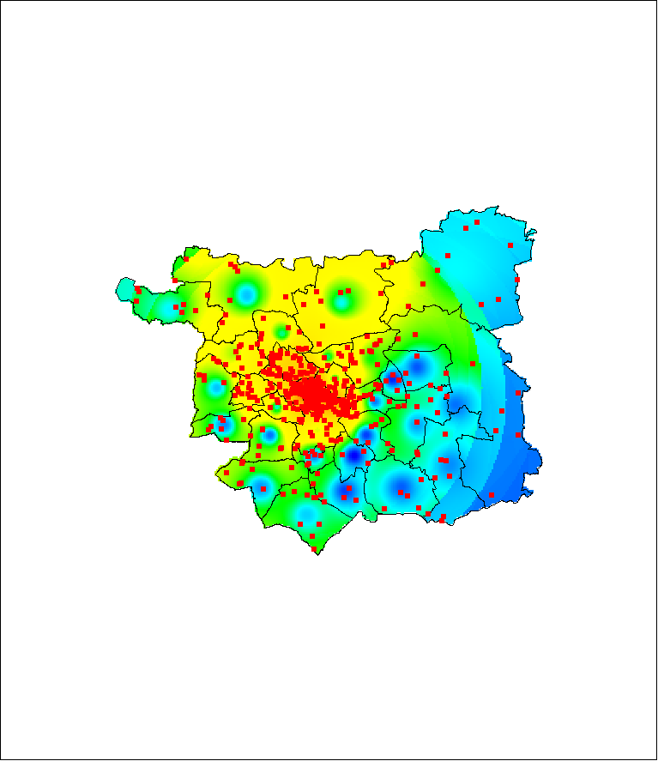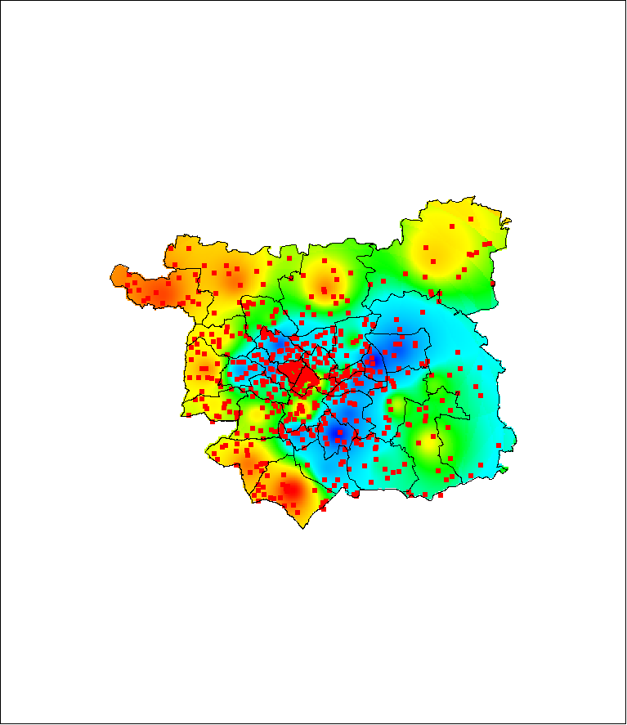

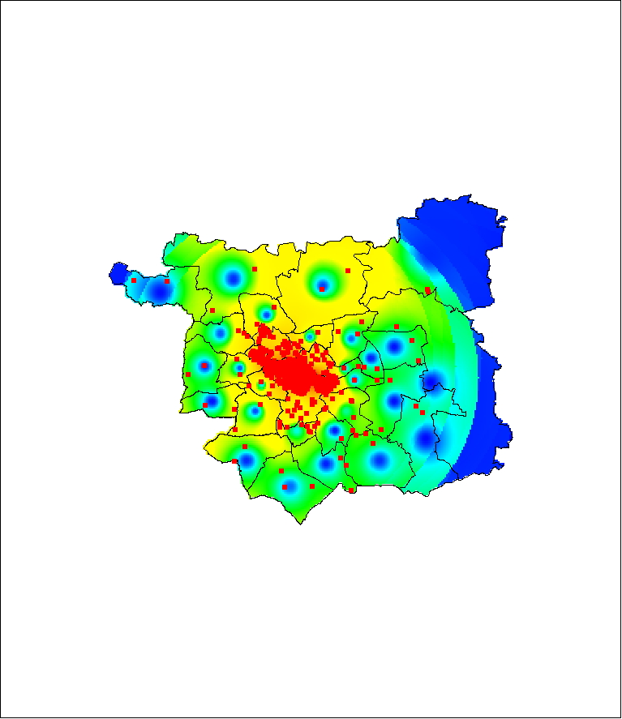

**Figure 1. Student agents.** A comparison between two models of student migration, and the pattern observed in the 2001 census. The top figure compares a simple cohort survival model (top right) with actual student numbers (top left). Each square represents 10 students. The actual distribution is far more concentrated than the simulation. The bottom figure compares a model with student agents (bottom right) to the same actual distribution (bottom left). This comparison is much more satisfactory. The distributions are contoured from red (high) to blue (low). For more information, see Wu, Birkin, Rees (2008), reference 123.

ethnic_change

**Figure 2. Population updates.** The map uses data from the census of school pupils (2001 and 2006) to assess change in ethnic minority populations in the EASEL (East And South East Leeds) study area. Our expectation would be to see strong growth following high in-migration flows in the early years of the decade. The illustration shows that this pattern is actually quite mixed, with increasing ethnic concentrations in the central areas (Gipton and Harehills – shown is yellow and red) but increasing domination of white populations in peripheral areas like Crossgates and Chapeltown (shown in blue). Data provided by Education Leeds.

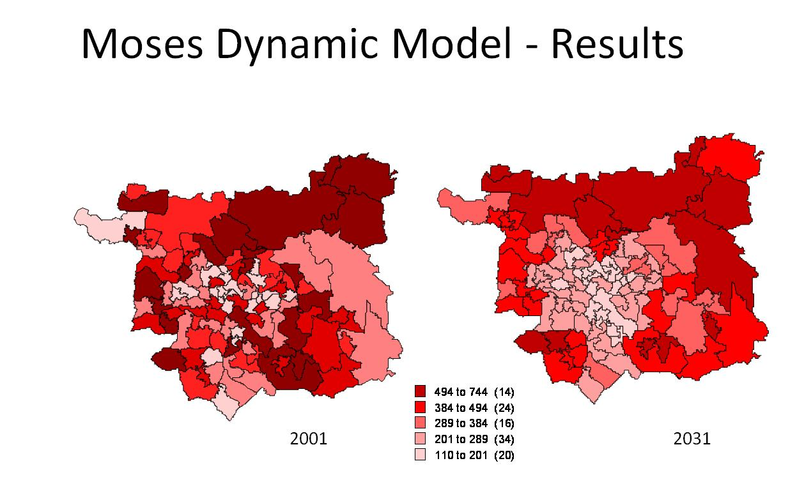

**Figure 3. Simulation of demographic change.** The maps show the number of people aged 65 and over living in mid-layer super-output areas (MLSOA) in Leeds in 2001 (according to the census) and in 2031 (according to the dynamic MoSeS model). The population does not age in situ, but is moved around by the model in a convincing way, our from the centre and towards the suburbs. For more information, see Birkin and Wu (2008), reference 110.

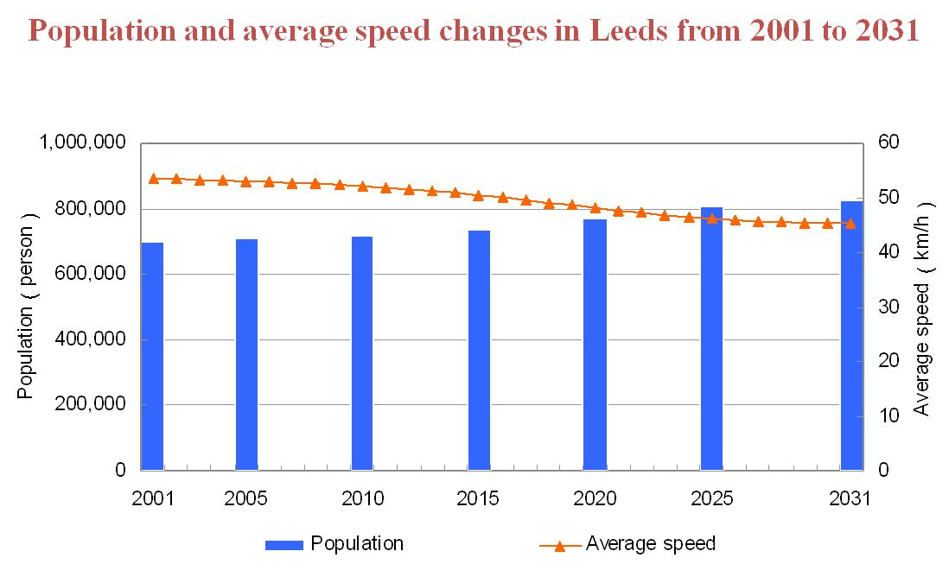

**Figure 4: Transport model – macro-scale.** The illustration shows declining average speeds as a key performance indicator from a macroscopic dynamic model of urban transportation, in contrast to an expanding urban population. Secondary outputs link average speed to other attributions such as congestion and airborne pollution. Source: Birkin et al (2008), reference 403.

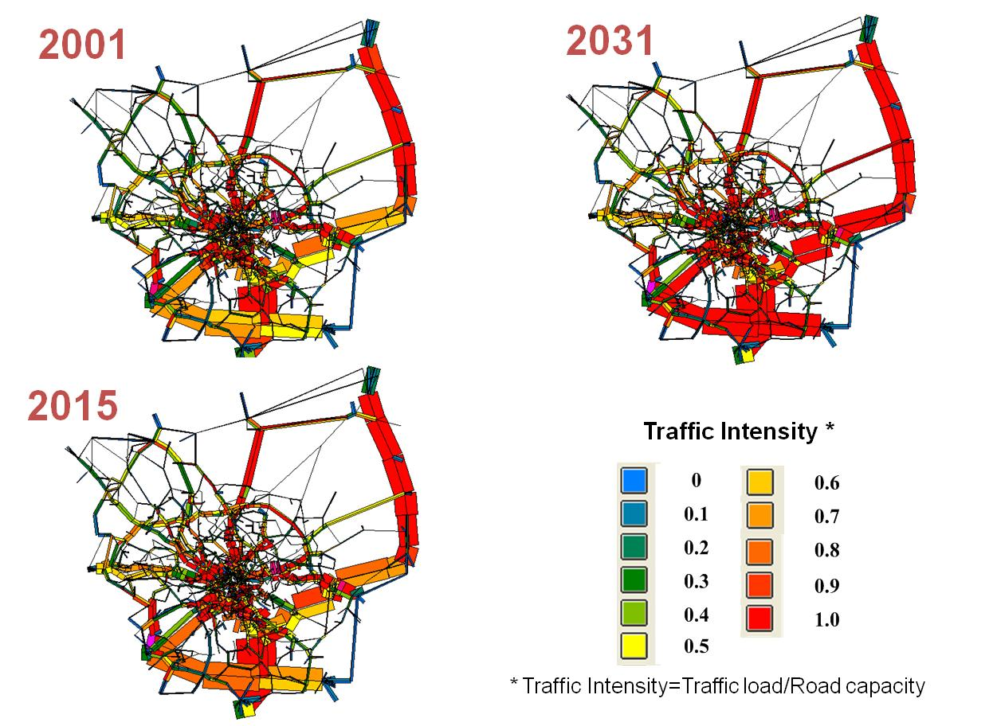

**Figure 5. Transport model: meso-scale.** The figures show changing traffic intensity from a mesoscopic dynamic urban traffic model. The width of the lines shows the number of vehicles on each link, and the colours show the intensity or congestion, from high (red) to low (blue). The major road to the north-east of the area is the A1 and the road to the south is the M621. The two are connected by the new A1/M1 link road. Source: Birkin et al (2008), reference 403.

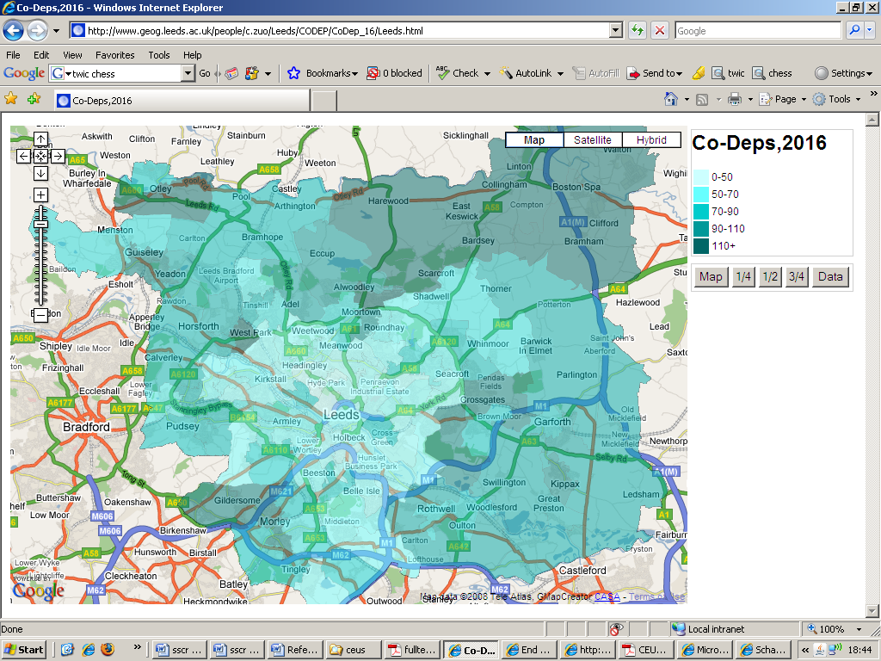

**Figure 6. Health care needs analysis.** This figure is a ‘google maps’ representation of co-dependency in Leeds. The legend shows the number of households with two elderly residents (both aged at least 65) in the year 2016. The distribution is overlaid on a google map which allows an easy connection to the underlying geography, which allows easy interpretation of the light and dark areas on the map in relation to the underlying geography. In the MoSeS portlet, the maps are generated from separate data feeds from google, GeoTools (an open source mapping engine) and the simulation database. For more discussion, see Townend et al (2007), (reference 121).

**Annex 3. MoSeS Activities**

*A3.1 Conference attendance*

|  |  |  |  |  |
| --- | --- | --- | --- | --- |
| **Event** | **Location** | **Date** | **Attendee** | **Paper?** |
| The Oxford e-Research Conference | University of Oxford | September 2008 | Andy Turner | Yes |
| eResearch Australasia | Sebel and Citigate, Melbourne | September 2008 | Mark Birkin | Yes |
| UK e-Science All Hands Meeting | Edinburgh | September 2008 | Paul Townend  Andy Turner | Yes |
| RGS/IBG  Annual Meeting | Royal Geographical Society, Kensington | August 2008 | Mark Birkin | Yes |
| ESRC Research Methods Festival | University of Oxford | July 2008 | Mark Birkin  Martin Clarke | Yes |
| Sixth International Summer School on Grid Computing | Lake Balaton, Hungary | July 2008 | Mark Birkin | Yes |
| 4th International Conference on e-Social Science | Manchester | June 2008 | Mark Birkin  Andy Turner  Paul Townend | Yes |
| Association of American Geographers | Boston Mass. | April 2008 | Mark Birkin | Yes |
| International Symposium on Grid Computing | Academica Sinica, Taipei | April 2008 | Mark Birkin | Yes |
| IEEE STP | Edinburgh | March 2008 | Junaid Arshad | Yes |
| NCeSS Showcase | University of Manchester | January 2008 | Mark Birkin | Yes |
| 10th IEEE Symposium on High Assurance Systems Engineering (HASE) | Dallas | November 2007 | Paul Townend | Yes |
| 3rd International Conference on e-Social Science | University of Michigan | October 2007 | Mark Birkin  Belinda Wu | Yes |
| UK e-Science All Hands Meeting | Nottingham | September 2007 | Andy Turner  Paul Townend | Yes |
| Geocomputation | Maynooth | September 2007 | Belinda Wu | Yes |
| RGS/IBG | Royal Geographical Society, Kensington | August 2007 | Belinda Wu | Yes |
| Association of American Geographers | San Francisco | April 2007 | Mark Birkin  Martin Clarke | Yes |
| Supercomputing | Tampa | November 2006 | Mark Birkin  Paul Townend | Yes |
| Symposium on Reliable Distributed Systems | Leeds | September 2006 | Paul Townend | Yes |
| UK e-Science All Hands Meeting | Nottingham | September 2006 | Andy Turner  Paul Townend | Yes |
| Regional Science Association British and Irish Section | Jersey | September 2006 | Mark Birkin | Yes |
| ESRC Research Methods Festival | Oxford | July 2006 | Mark Birkin  Belinda Wu | Yes |
| 2nd International Conference on e-Social Science | Manchester | June 2006 | Mark Birkin  Andy Turner  Belinda Wu | Yes |
| UK e-Science All Hands Meeting | Nottingham | September 2005 | Mark Birkin  Paul Townend | Yes |
| RGS/IBG  Annual Meeting | Royal Geographical Society, Kensington | September 2005 | Mark Birkin | Yes |
| 1st International Conference on e-Social Science | Manchester | June 2005 | Mark Birkin | Yes |
| Ninth International Conference on Computers in Urban Planning and Urban Management (CUPUM) | University College London | June 2005 | Mark Birkin | Yes |
| Eighth IEEE International Symposium on Object-Oriented Real-Time Distributed Computing (ISORC 05) | Seattle, USA | May 2005 | Paul Townend | Yes |

*A3.2 Participation in workshops*

O = Organised; C = Made formal contribution

|  |  |  |  |  |  |  |
| --- | --- | --- | --- | --- | --- | --- |
| **Event** | **Location** | **Date** | **O** | **C** | **Attendee** | **Notes** |
| Small Area Estimation | University of Canberra | September 2008 | N | Y | Mark Birkin | National Institute for Social and Economic Modelling (NATSEM) and the Australian Bureau of Statistics |
| EUAsiaGrid  Kick-Off Meeting | Academica Sinica, Taipei | April 2008 | N | Y | Mark Birkin | Special Event at the International Symposium on Grid Computing (ISGC) |
| White Rose Grid: e-Science Challenges and Perspectives | University of Leeds | March 2008 | N | Y | Paul Townend |  |
| Digital Geography in a Web 2.0 World | Barbican, London | February 08 | N | Y | Mark Birkin  Martin Clarke |  |
| Digital Geography in a Web 2.0 World | Manchester | September 2008 | N | Y | Martin Clarke |  |
| Mapping Futures | London | October 2008 | N | Y | Martin Clarke | Organised by the Society for Location Analysis |
| Agent-based models for the spatial and social sciences | Manchester Business School | June 2008 | Y | Y | Mark Birkin  Andy Turner  Belinda Wu |  |
| Spatial data infrastructures: | Edinburgh | August 2008 | N | N | Andy Turner |  |
| Forecasting | St Kath’s College, University of Oxford | July 2008 | Y | Y | Mark Birkin  Martin Clarke | Two sessions organised for the ESRC Research Methods Festival |
| Open Geospatial Consortium Technical Committee | Postdam | June 2008 | N | N | Andy Turner |  |
| NCeSS Workshop on Secure Access to Confidential Data | Manchester | June 2008 | N | N | Andy Turner |  |
| Geospatial resources use in tertiary education - Shaping the future, Edinburgh, UK, | Edinburgh | May 2008 | N | N | Andy Turner |  |
| Using OGSA-DAI to Grid enable data for the Arts, Humanities and Social Sciences | Web-based | April 2008 | N | N | Andy Turner |  |
| White Rose Grid e-Science Centre Workshop: e-Science Challenges and Perspectives | Leeds | March 2008 | N | Y | Andy Turner |  |
| UPTAP Workshop (Understanding Population Trends and Processes) | Leeds | March 2008 | N | N | Mark Birkin  Andy Turner |  |
| Taverna Workshop | Leeds | February 2008 | N | N | Andy Turner |  |
| NCeSS Showcase | Manchester | January 2008 | N | Y | Mark Birkin  Andy Turner |  |
| NCeSS Portal Useability Workshop | Manchester | November 2007 | N | N | Andy Turner |  |
| Doctoral Colloquium, International Conference on eSoc Science | University of Michigan | October 2007 | Y | Y | Mark Birkin  Belinda Wu |  |
| Leeds City Council Chief Executive’s Leadership Forum | Leeds | September 07 | N | Y | Mark Birkin |  |
| NCeSS Node Jamboree and e-Infrastructure Project Away Day 2007 | Oxford | June 2007 | N | Y | Mark Birkin  Andy Turner  Belinda Wu |  |
| ESRC Visual Methods Workshop | Leeds | June 2007 | N | Y | Mark Birkin |  |
| NSF/ ESRC Workshop Agent Based Modelling of Complex Social Systems | Santa Barbara | March 2007 | N | Y | Mark Birkin  Andy Turner |  |
| NCeSS Showcase | Manchester | March 2007 | N | Y | Andy Turner |  |
| UPTAP Workshop | Leeds | March 2007 | N | N | Mark Birkin  Andy Turner |  |
| NCeSS Social Simulation Workshop | Birmingham | February 2007 | N | Y | Mark Birkin |  |
| National Institute for Environmental e-Science Grid Working Grp | London | January 2007 | N | N | Andy Turner |  |
| NCeSS Agenda Setting Workshop on Combining and EnhancingData | Manchester | January 2007 | N | N | Andy Turner |  |
| NCeSS e-infrastructure workshop | Manchester | January 2007 | N | N | Andy Turner |  |
| Open Geospatial Consortium Technical Committee | San Diego | December 2006 | N | N | Andy Turner |  |
| National Institute for Environmental e-Science Grid Working Group | Nottingham | November 2006 | N | N | Andy Turner |  |
| Free and Open Source Software for Geoinformatics | Lausanne, Switzerland | November 2006 | N | N | Andy Turner |  |
| Inaugural International Workshop on Dependability in Service-oriented grids | Leeds | October 2006 | N | Y | Paul Townend |  |
| ZUMA Simulation workshop | University of Koblenz | September 2006 | N | N | Belinda Wu |  |
| Portals and portlets | Edinburgh | July 2006 | N | N | Andy Turner |  |
| Arts and Humanities e-Science Support Centre Workshop: Geographical Information Systems (GIS) e-Science: Developing a roadmap | Belfast | July 2006 | N | N | Andy Turner |  |
| Open Geospatial Consortium Technical Committee | Edinburgh | June 2006 | N | N | Andy Turner |  |
| NCeSS Visualisation workshop | Manchester | June 2006 | N | N | Andy Turner |  |
| Expanding cyber-communities | University of California Humanities Research Institute | April 2006 | N | Y | Mark Birkin | Organised by HASTAC (Humanities, Arts and Social Sciences Technical Advisory Committee), Global Grid Forum (GGF) |
| Introduction to e-infrastructure: enabling the research of the future | Leeds | March 2006 | N | Y | Andy Turner | White Rose Grid e-Science Centre of Excellence |
| UPTAP Workshop | Leeds | March 2006 | N | N | Mark Birkin  Andy Turner |  |
| NCeSS Node Jamboree | Manchester | March 2006 | N | N | Mark Birkin  Andy Turner  Belinda Wu |  |
| NCeSS Winter Training School | Manchester | March 2006 | N | N | Andy Turner |  |
| National Institute for Environmental e-Science Grid Working Grp | Edinburgh | February 2006 | N | N | Andy Turner |  |
| Workshop on Grid Middleware and Geospatial Standards for Earth System Science Data | Edinburgh | September 2005 | N | N | Andy Turner |  |
| Future Cities | University of Chicago | September 2005 | Y | Y | Martin Clarke | With support from the Worldwide Universities Network (WUN) |
| Geographical Information Systems on the Grid | University of Leeds | September 2005 | Y | Y | Mark Birkin  Andy Turner | NCeSS Agenda-Setting Workshop |
| Frontiers in Transportation: Social and Spatial Interactions | Amsterdam | July 2005 | N | Y | Mark Birkin  Andy Turner | World Congress on Transportation Research Society Special Interest Group on Transport and Spatial Development (WCTRS SIG-1) |
| Future Cities | Manchester Business School | June 2005 | Y | Y | Mark Birkin  Martin Clarke | With support from the Worldwide Universities Network (WUN) |
| Rural Economy and Land Use Data Integration | Kings Manor, York | May 2005 | N | Y | Mark Birkin | Rural Economy and Land Use (RELU) Project |
| What is The Grid and How Can it Help Your Research? | ICoSS, University of Sheffield | April 2005 | N | Y | Mark Birkin |  |
| ESRC/ JISC Awareness Raising Workshop | University of Lancaster | April 2005 | N | Y | Mark Birkin |  |

*A3.3 Seminars*

* See Annexe A4, Section 5

*A3.4 Related Activities*

|  |  |  |  |
| --- | --- | --- | --- |
| **Project** | **Funder** | **Lead investigator** | **Notes** |
| EUAsiaGrid | European Union | Marco Paganoni, University of Milan | The project involves partners in ten Asian countries and four European countries, with a spectrum of e-Science applications. MoSeS participated in the kick off meeting at ISGC, Taipei 2008 and is committed to the development of a demographic planning model for Taiwan. |
| Visual Methods | ESRC | Jon Prosser, University of Leeds | MoSeS has been responsible for providing e-Science input to the development of a programme of workshops. |
| Social Science e-Infrastructure project | ESRC | Rob Procter, University of Manchester | Mark Birkin is a co-investigator on this project and Leeds has responsibility for work packages relating to simulation. Also input on security and workflows. |
| Multidimensional methods for real lives research | ESRC | Jennifer Mason, University of Manchester | Mark Birkin is a co-investigator. MoSeS link on geodemographics and neighbourhood profiling. |
| Simulation for teaching | University of Leeds Academic Fund | Mark Birkin, University of Leeds | Applications using MoSeS simulation outputs have been repurposed for Level 2 teaching at the University of Leeds. |
| Secure Access to Geospatial services (SEE GEO). | JISC | Chris Higgins, University of Edinburgh | Project which has involved integration of grid-enabled census data with Open Source mapping tools. Andy Turner has been involved in a number of technical meetings and workshops. |
| Spatially Embedded Complex Systems Engineering | EPSRC | Seth Bullock, University of Southampton | Large project (£1.5 million) under EPSRC’s Novel Computation initiative. Leeds has been looking at simulation of complex (agent-based) retail systems. Mark Birkin is a co-investigator. |

**Annex 4. Moses Outputs**

*A4.1 Refereed publications*

101 M. Argüello, P. Ekin, A. Turner, S. Peters, P. Townend, M. Fraser, P. Halfpenny, R. Procter, A. Voss, and M. Jirotka (2008) Highlighting e-Infrastructure patterns in Grid-based e-Social Science applications. *UK e-Science All Hands Meeting 2008* (AHM 2008), Edinburgh, UK

102 M. Birkin, M Clarke, H Chen, P Dew, J Keen, P Rees, J Xu (2005) MoSeS: Modelling and Simulation for e-Social Science, *Proceedings of the First International Conference on e-Social Science*, National Centre for e-Social Science, Manchester.

<http://www.ncess.ac.uk/events/conference/2005/papers/papers/ncess2005_paper_Birkin1.pdf>

103 Mark Birkin, Martin Clarke, Haibo Chen, Pete Dew, Justin Keen, Phil Rees, Jie Xu (2005) MOSES: Modelling and Simulation for e-Social Science, Simon Cox and David Walker (eds) *Proceedings of the UK e-Science All Hands Meeting 2005.*

<http://www.allhands.org.uk/2005/proceedings/papers/341.pdf>

104 Birkin M, Clarke M, Townend P, Turner A, Wu B (2009) A hybrid spatial microsimulation model for decision support in demographic planning, *Annals of the Association of American Geographers*, first draft.

105 M. Birkin, P.M. Dew, O. Macfarland, J. Hodrien (2005) Hydra: A Prototype Grid-enabled Spatial Decision Support System, *Proceedings of the First International Conference on e-Social Science*, National Centre for e-Social Science, Manchester.

<http://www.ncess.ac.uk/events/conference/2005/papers/papers/ncess2005_paper_Birkin.pdf>

106 Birkin M, Turner A (2009) A Synthetic Reconstruction Model of the Entire UK Population, *International Journal of Microsimulation*, final draft.

107 Birkin M, Turner A, Wu B (2006) A Synthetic Demographic Model of the UK Population: Methods, Progress and Problems, *Proceedings of the Second International Conference on e-Social Science*, National Centre for e-Social Science, Manchester.

<http://www.ncess.ac.uk/events/conference/2006/papers/papers/BirkinSyntheticDemographicModelOfUKPopulation.pdf>

108 Birkin M, Turner A, Wu B, Arshad J, Townend P, Xu J (2009) MoSeS: A Grid-enabled Spatial Decision Support System, *Social Science Computer Review*, in press.

109 Birkin, M., Turner, A.; Wu, B.; Townend, P.; and Xu, J. (2007) An Architecture for Social Simulation Models to Support Spatial Planning, *Proceedings of the Third International Conference on e-Social Science*, October 7–9, 2007 at the University of Michigan, Ann Arbor, USA.

<http://www.ncess.ac.uk/events/conference/2007/papers/paper214.pdf>

110 Birkin, M. and Wu, B. (2008) Dynamic Social Simulation Models Enabled by e-Research, *Proceedings of the 4th International Conference on e-Social Science*, 18 - 20 June, 2008, Manchester, UK

<http://www.ncess.ac.uk/events/conference/programme/workshop1/?ref=/programme/thurs/2aBirkin.htm>

111 Birkin M, Wu B, Chen H, Chen S, Guo J, Chen S (2009) Traffic planning and the evaluation of transport sustainability with dynamic spatial microsimulation, *Applied Spatial Analysis and Policy*, in review.

112 Birkin M, Wu B, Rees P (2009) Moses: Dynamic spatial microsimulation with demographic interactions, in Zaidi A, Harding A, Williamson P (eds) *New Frontiers in Microsimulation Modelling*, Ashgate, in press.

113 Daw M., Proctor R., Lin Y., Hewitt T., Jie W., Voss A., Baird K., Turner A.G.D., Birkin M., Miller K., Dutton W., Jirotka M., Schroeder R., de la Flor G., Edwards P., Allan R.J., Crouchley R. (2007) Sustaining an e-Infrastructure for Social Science. *Proceedings of the Third International Conference on e-Social Science*, October 7-9, 2007, Ann Arbor, USA.

<http://www.ncess.ac.uk/events/conference/2007/papers/paper127.pdf>

114 Birkin M, Heppenstall A (2008) Modelling spatial market dynamics with retail agents, in Bullock, S., J. Noble, R. Watson, and M. A. Bedau (eds.) (2008). *Artificial Life XI: Proceedings of the Eleventh International Conference on the Simulation and Synthesis of Living Systems*. MIT Press, Cambridge, MA. ISBN: 978-0-262-75017-2

<http://www.alifexi.org/papers/ALIFExi-abstracts-0012.pdf>

115 Townend P, Groth P, Xu J (2005) A provenance aware weighted fault tolerance scheme for service-based applications, *Proceedings of the Eighth IEEE International Symposium on Object-Oriented Real-Time Distributed Computing*, 258-266. IEEE Computer Society, ISBN:0-7695-2356-0

<http://www2.computer.org/portal/web/csdl/abs/proceedings/isorc/2005/2356/00/23560258abs.htm>

116 Townend P, Huai J, Xu J, Looker N, Zhang D, Li J, Zhong L (2007) CROWN-C: A High Assurance Service-oriented Grid Middleware System, *Proceedings of the 10th IEEE High Assurance Systems Engineering Symposium*, 35-44, IEEE Computer Society, ISBN ~ ISSN:1530-2059 , 0-7695-3043-5

<http://ieeexplore.ieee.org/xpls/abs_all.jsp?arnumber=4404725>

117 Townend P, Huai J, Xu J, Looker N, Zhang D, Li J, Zhong L (2008) CROWN-C: A High Assurance Service-oriented Grid Middleware System, *Computer*, 41, 8, 30-38. ISSN: 0018-9162.

<http://www2.computer.org/portal/web/csdl/doi/10.1109/MC.2008.288>

118 Townend P, Xu J (2005) Dependability in Grids, *IEEE Distributed Systems Online*, 6, 12. ISSN: 1541-4922.

119 Townend P.M., Xu J., Birkin, M.H., Turner A.G.D., Wu B. (2008) 'Modelling and Simulation for e-Social Science through the Use of Service-Orientation and Web 2.0 Technologies'., *Proceedings of the 4th International Conference on e-Social Science,* Manchester, 18 - 20 June 2008.

<http://www.ncess.ac.uk/events/conference/programme/workshop1/?ref=/programme/fri/4ctownend.htm>

120 Townend P, Xu J, Birkin M, Turner A, Wu B (2009) Modelling and Simulation for e-Social Science, *Philosophical Transactions of the Royal Society Series A*, in revision.

121 Townend P, Xu J, Birkin M, Turner A, Wu B (2007) Modelling and Simulation for e-Social Science: Current Progress, in SJ Cox (ed) *Proceedings of the UK e-Science All Hands Meeting 2007*, Nottingham, UK, 10th-13th September 2007, ISBN 978-0-9553988-3-4

<http://www.allhands.org.uk/2007/proceedings/papers/889.pdf>

122 B. M. Wu, M. H.Birkin and P. H. Rees (2007) Bringing agents into the spatial microsimulation, *Geocomputation 2007, Proceedings* (CD-ROM), NUI Maynooth, Ireland, 3rd to 5th September 2007

123 Wu B, Birkin M, Rees P (2008) A spatial microsimulation model with student agents, *Computers, Environment and Urban Systems, Vol. 32 (6)*, pp. 440-453.

<http://dx.doi.org/10.1016/j.compenvurbsys.2008.09.013>

124 Xu J, Townend P, Looker N, Groth P (2008) FT-Grid: A System for Achieving Fault-tolerance in Grids, *Concurrency and Computation: Practice and Experience*, 20, 3, 297-309. ISSN: 1532-0626.

<http://portal.acm.org/citation.cfm?id=1345491.1345500&coll=GUIDE&dl=GUIDE&CFID=15215785&CFTOKEN=16380620>

*A4.2 Other publications*

201 Birkin, M. (2007) Hybrid geographical models of urban spatial structure, in S. Albeverio, D. Andrey, P. Giordano, and A. Vancheri, eds *The Dynamics of Complex Urban Systems: An Interdisciplinary Approach,* Physica-Verlag, Heidelberg

202 Birkin M (2009) GeoComputation, in R Kitchin, N Thrift (eds) *The International Encyclopaedia of Human Geography*, Elsevier, forthcoming.

203 Evans A, Birkin M, Heppenstall A (2009) Understanding simulation results, in Moss S, Edmonds B (eds) *Handbook on Simulating Social Complexity*, Springer, New York.

204 Turner A (2008) *Geodemographic modelling*, National Grid Service, Didcot.

*A4.3 Conference papers*

301 Andy Turner (2008) Experience of e-Social Science: a case of Andy Turner and MoSeS, Oxford eResearch, 16th September.

302 Mark Birkin (2008) An architecture for urban simulation enabled by eResearch, eResearch Australasia, Melbourne, 30th September.

303 Paul Townend (2008) Modelling and Simulation for e-Social Science, UK e-Science All Hands Meeting 2008 (AHM 2008), Edinburgh, UK, September.

304 Mark Birkin (2008) Modelling the dynamics of UK society: the Moses project, The e-Social Science agenda: challenges and opportunities for geographers, Royal Geographical Society AC 2008, 29th August.

305 Mark Birkin (2008) Moses: Modelling, Simulation and e-Social Science, Sixth International Summer School on Grid Computing, Lake Balaton, Hungary, July 7th.

306 Mark Birkin, Martin Clarke (2008) Spatial forecasting with Moses, ESRC Research Methods Festival, Oxford, July 3rd.

307 Mark Birkin (2008) Grid-enabled simulation for urban and regional planning, International Symposium on Grid Computing, Academia Sinica, Taipei, April.

308 Mark Birkin, Dianna Smith (2008) A dynamic microsimulation model of urban housing markets, Annual Meeting of the Association of American Geographers, Boston, April.

309 Mark Birkin, Alison Heppenstall (2008) Extending spatial interaction models with agents for understanding relationships in a dynamic retail market, Annual Meeting of the Association of American Geographers, Boston, April.

310 Junaid Arshad, Paul Townend (2008) Security within the context of e-social science, IEEE STP, March.

311 Mark Birkin (2008) Moses: Modelling and Simulation for e-Social Science, NCeSS Showcase, University of Manchester, January.

312 Belinda Wu, Mark Birkin, Phil Rees (2007) Spatial Microsimulation Model of the UK Population in 2030, IMA2007 Conference, Vienna, Austria, August.

313 Belinda Wu, Mark Birkin, Phil Rees (2007) A Spatial MSM with an ABM insight, RGS-IBG Annual Conference, London, 29 August - 31 August.

314 Mark Birkin, Martin Clarke (2007) A spatial microsimulation model of residential location, AAG, San Francisco, April.

315 Mark Birkin, Paul Townend (2006) SimCity for Real. Supercomputing, Tampa. November 06.

316 Mark Birkin, Justin Keen, Andy Turner, Belinda Wu (2006) Moses: A hybrid microsimulation model for social policy analysis, Regional Science Association (British and Irish Section), Jersey.

317 Mark Birkin (2006) Real Simulations for Real Cities: From Computer Gaming to an Infrastructure for Research, Policy and Teaching, ESRC Research Methods Festival, Oxford, July.

318 Mark Birkin (2005) Modelling and Simulation for e-Social Science (MOSES): A Research Agenda and Progress Report, Royal Geographical Society/ Institute of British Geographers, London, September 2005.

319 Mark Birkin (2005) A Multi-Agent “Model of Metropolis”, Ninth International Conference on Computers in Urban Planning and Urban Management, University College London, June 29th.

*A4.4 Presentations at Workshops*

401 Martin Clarke. Moses: SimCity for Real, The Society for Location Analysis, Mapping Futures, London, October 27th 2008.

402 Martin Clarke. MoSeS: SimCity for Real Modelling and simulation for the e-social sciences. Digital Geography in a Web 2.0 World, Manchester, Monday 15th September 2008.

403 Mark Birkin. Traffic planning and the evaluation of transport sustainability with dynamic spatial microsimulation, Small Area Estimation Workshop, University of Canberra, 19th September 2008,

404 Mark Birkin. Microsimulation and agent-based models, Workshop on Agent-based models (ABM) for the spatial and social sciences, Fourth International Conference on e-Social Science, Manchester, June 22nd, 2008.

405 Belinda Wu. MoSeS Dynamic Model. Workshop on Agent-based models (ABM) for the spatial and social sciences, Fourth International Conference on e-Social Science, Manchester, June 22nd, 2008.

406 Andy Turner. Population Reconstruction with MoSeS. Workshop on Agent-based models (ABM) for the spatial and social sciences, Fourth International Conference on e-Social Science, Manchester, June 22nd, 2008.

407 Paul Townend. Modelling and Simulation for e-Social Science Through the Use of Service-Orientation and Web 2.0 Technologies, White Rose Grid e-Science Centre Workshop: e-Science Challenges and Perspectives, University of Leeds, March 2008.

408 Martin Clarke. Moses: SimCity for Real, Digital Geography in a Web2.0 World, Barbican, London, February 2008.

409 Belinda Wu. Planning for the next generation: developing a generic social science model for UK planning in the next 10-15 years, Doctoral Colloquium of the Third International Conference on e-Social Science, Ann Arbor, USA, October 7th – 9th, 2007.

<http://www.ncess.ac.uk/events/conference/2007/dc-papers/Wu-paper.pdf>

410 Mark Birkin. The demographic profile for Leeds: the next twenty-five years, Presentation to the Chief Executive’s Leadership Forum, Leeds, September 2007.

411 Mark Birkin. Grid, e-Social Science and Visual Research, ESRC Visual Methods Workshop, Leeds, June 27th 2007.

412 Mark Birkin. Multi-agent systems, mathematical modelling and microsimulation, NSF/ESRC Workshop, Santa Barbara, April 2007.

<http://www.ncgia.ucsb.edu/projects/abmcss/docs/birkin_paper.pdf>

413 Mark Birkin. Some Issues in the Construction and Validation of a Large-Scale Social Simulation Model , NCeSS Social Simulation workshop, Birmingham, February 2007.

414 Mark Birkin. MOSES: Modelling and Simulation in e-Social Science, NHS Information Centre, Marriott Hotel, Leeds, June 2006.

415 Mark Birkin. Modelling and Simulation for e-Social Science (MOSES), Expanding Cyber-Communities, HASTAC Workshop, University of California Humanities Research Institute (UCHRI), April 2006.

416 Mark Birkin. Enabling e-Social Science Research, Introduction to e-Infrastructure: Enabling the Research of the Future, White Rose Grid e-Science Centre of Excellence Event, Leeds, March 18th 2006.

417 Martin Clarke. Future Cities, WUN Future Cities Workshop, Chicago, October 2005.

418 Mark Birkin. Applications of Grid GIS: Moses. GIS and The Grid, NCeSS Workshop, Leeds, September 2005.

419 Mark Birkin. Modelling and Simulation for e-Social Science (MoSeS), Frontiers in Transportation: Social and Spatial Interactions, World Congress on Transportation Research Society Special Interest Group on Transport and Spatial Development (WCTRS SIG-1), Amsterdam, July 4th 2005.

420 Mark Birkin. Modelling and Simulation for e-Social Sciences, Future Cities Workshop, First International Conference on e-Social Science, Manchester, June 22nd, 2005.

421 Mark Birkin. e-Social Science, Rural Economy and Land Use Data Integration Workshop, Kings Manor, York, May 19th 2005.

422 Mark Birkin. The National Centre for e-Social Science, What is the Grid and How Can it Help Your Research?, White Rose Grid workshop, 14th April 2005, ICOSS, University of Sheffield.

423 Mark Birkin. Grid-based Spatial Planning Services, JISC/ ESRC Awareness Raising Workshop, Lancaster, 6th April, 2005.

*A4.5 Seminars*

501 Mark Birkin. MoSeS: Dynamic Simulation for Urban Planning, Chinese Academy of Social Sciences, Leeds, October 2008.

502 Mark Birkin. Microsimulation and agent-based modelling, NATSEM, University of Canberra, 11th September 2008.

503 Mark Birkin. MoSeS: A synthetic spatial model of UK cities and regions, University College London, December 2007.

504 Mark Birkin. Simulation modelling, grid computing and GIS, School of Geography, University of Nottingham, April 2007.

505 Andy Turner. Andy Turner on MoSeS, NCeSS Showcase, University of Manchester, 28/3/07 (Andy Turner).

505 Mark Birkin. MoSeS: Spatial Modelling, Demographics and Economic Planning, Chinese Academy of Social Sciences, Manchester, January 2007.

506 Belinda Wu. MoSeS: Modelling and Simulation of e-Social Science, Invited Seminar at University of Bonn, Bonn, Germany, 25th September 2006.

507 Mark Birkin. SimCity for Real: The Application of Simulation Models for Strategic Planning within Urban Areas, Virginia Biotech Institute, Blacksburg, May 2006.

508 Mark Birkin. Putting some “e” into Regional Science, University of Illinois at Urbana-Champaign, May 2006.

509 Mark Birkin. SimCity for Real: Can Grid Computing Support Decision-Making within Live Urban Environments?, San Diego Supercomputer Centre, March 2006.

510 Belinda Wu. MoSeS: A way through the wilderness, Invited Seminar at University of Durham, 8th February 2006.

511 Mark Birkin. Grid Computing and GIS: the Next Big Thing? National Centre for Geocomputation, NUI at Maynooth, October 2005.

512 Mark Birkin. Putting the ‘e’ into GI Science, WUN GIS Academy, Leeds, October 2005.

513 Mark Birkin. e-Social Science, Leeds Social Sciences Institute Seminar, April 21st 2005.

*A4.6 Media Stories about MoSeS*

Grid Computing will let Town Planners Play “SimCity” for Real, *Science Daily*, 6th November 2006. <http://www.sciencedaily.com/releases/2006/11/061113173241.htm>

SimCity for Real, *fark.com*, November 2006. Link no longer available.

City Building. Today’s Science and Discovery in Brief, *Metro Newspaper*, 14th November 2006.

MoSeS Interview (Mark Birkin), *Radio 5 Live Drive*, November 2006.

Planners play SimCity with real towns, *Vnunet*, November 14th 2006. <http://msn.vnunet.com/articles/send/2168584>

Coming soon: SimCity for real, *Playfuls*.*com*, November 2006. Link no longer available.

Sims Put Real Cities to the Test, *New Scientist*, November 23rd 2006.

Reality City, *Scienceagogo*, 17th November 2006. <http://www.scienceagogo.com/news/reality_city.shtml>

SimCity, social engineering, and 60 million “people”, *International Science Grid This Week*, July 2007. <http://www.isgtw.org/?pid=1000537>

The Real SimCity, *Geographical Magazine*, August 2008.

**Annex 5. MoSeS Impacts and Collaborations**

|  |  |  |  |
| --- | --- | --- | --- |
| **Organisation** | **Contact**  **name** | **Notes** | **Status/**  **Next steps** |
| HEFCE | Mark Corver  (Analytical Services Group) | Teleconference with senior managers, Spring 2008 | Workshop timetabled November 2008 (postponed until 2009) |
| Dr Foster  Consultancy and market intelligence for health care providers | David Ashby  (Head of Product Development and Delivery) | Meeting December 2007  Conference call March 2008  Interest in local authority demographic forecasts | Dormant |
| Leeds Education Authority | Heather Eyre  (Head of ICT and Information Management) | Have provided pupil data (PLASC) for regeneration project (population updates) | No immediate actions planned |
| Leeds Regeneration Partnership | Stephen Boyle (Chief Regeneration Officer),  Maggie Gjessing | Providing data for regeneration project (EASEL).  Maggie has joined RSG for Rene Jordan | Project ongoing until September 2010 |
| Leeds Teaching Hospitals Trust | Brian Derry  (Director of Informatics) | Agreed data specification, January 2007.  Ethical clearance obtained, May 2008 Awaiting data. | Ongoing. Possible link to Holly Shulman project |
| Leeds City Council, Social Services | John England (Deputy Director)  Dennis Holmes | Agreed Needs Analysis, Spring 2007  Version 1 model complete September 2008. | Meet to discuss model outputs and next steps.  Produce ‘Moses health’ portal. |
| Department of Communities and Local Government | Richard Goodwin, (Deputy Director) | Interest following SuperComputing, November 2006.  Telephone conversation.  Possible joint meeting with RTPI. | Interest in Moses as a ‘planning game’ for community regeneration.  Not prioritised. |
| Royal Town Planning Institute | Rynd Smith  (Director of Policy)  Jenny Crawford (Director of Research) | Interest following SuperComputing, November 2006.  Telephone conversation. | Produced ‘Moses Briefing Note’, January 2007. Unable to obtain feedback. |
| Nottinghamshire County Council. | Jonathan Weller  (Three cities and counties Programme Officer) | Meeting in Leeds, March 2008. Interest in impact of ‘Eco-Towns’. | Postponed pending development of dynamic model (for Midlands Region?) |
| Landmark Information Group | Mike Williams  (Managing Director) | Interested in impact analysis for the new town of Cranbrook. Commuting patterns/ demand for housing. Neighbourhood profiles. | Proposal in response to tender document. Suspended re ‘credit crunch’ |
| Boots | Ian Wood,  Steve Bell  (Site Research team) | Meeting Leeds April 2008 and London, October 2008.  Interest in city centre GP/ retail locations.  Possible analysis of Advantage Card data.  Demographic change and activity analysis. | Outline proposal in circulation. Possible follow-up through RIBEN. |
| Academetrics  Housing market consultant and information provider. | David Pickles  (Consultant) | Ongoing discussions (via Martin Clarke). | Dormant. |
| Strategic Location Academy (SLA) | Peter Sleight  (Director) | Presentation at October meeting. | Probable direct follow-up with partner organisations (e.g. Boots) |
| Chinese Academy for Social Sciences | Li Ping  (Deputy Director) | Meetings in Manchester (Jan 07) and Leeds (Oct 08).  Looking for input to National Collaboratory for Social Simulation.  Briefing note for visit of Michael Arthur (Leeds VC) to Beijing/ Shanghai in Nov 08. | Definite interest.  Possible business model unclear. |
| University of Auckland | Peter Davis  (Professor of Sociology, Health and Well-being)  Nick Jones  Manager, Centre for eResearch) | Meetings June 08 (Manchester), September 08 (Melbourne).  Trying to develop dynamic simulation for New Zealand health care. | Ongoing exchange of research papers. Possible visit/ joint workshop |
| Academica Sinica | Ly-Yun Chang  (Executive Director, Centre for Survey Research) | Possible deployment of Moses Taiwan | Audit of Taiwanese census data.  Andy Turner visit proposed, April 2009. |
| British Geological Survey | Fiona McEvoy (Project Manager)  Andrew Bloodworth  (Head of Science - Minerals) | Joint project regarding provision of infrastructure re demographic and social change.  BGS providing data, funding, and advice. | Ongoing until September 2010. |