ESRC NATIONAL CENTRE FOR E-SOCIAL SCIENCE

FULL PROPOSAL FORM FOR CENTRE NODE

 | Economic and Social Research Council  Polaris House  North Star Avenue  Swindon, SN2 1UJ  Telephone No. 01793 413000  IN CONFIDENCE | The original, with all relevant signatures, plus 15 copies of this proposal form should be sent to: The Registrar at the address shown on the left hand side postmarked no later than 5pm on Monday 19th July 2004. Applications postmarked after this time will not be accepted. A copy should, also be emailed to suzanne.tanner@esrc.ac.uk
ESRC USE ONLY | Date:  Acknowledged: | Reference No.

1. Applicant

Title Initials Surname Date of Birth
|D|R| |M|H| |B|I|R|K|I|N| |0|8|0|2|6|1|
DD MM YY
Post held: Director of the Informatics Institute

Signature

Applicant's Department: Geography & Computing

Applicant's telephone: 0113 343 6838 E-mail: m.birkin@geog.leeds.ac.uk

2. Administering Institution

Institution: University of Leeds

Address: Woodhouse Lane
Leeds

Post Code: LS2 9JT

Authorising Signature:__________________________________ Date: ____________

Official Designation: _______________________________________________________

3. Co-Applicants

i) Title Initials Surname Date of Birth
|P|R|O|F| |P| |D|E|W| |3|0|0|1|4|7|
DD MM YY

Post held: Professor of Computer Science

Department: Computing

Institution: University of Leeds

ii) Title Initials Surname Date of Birth
|P|R|O|F| |P| |R|E|E|S| |1|7|0|9|4|4|
DD MM YY

Post held: Professor of Population Geography
Department: Geography
Institution: University of Leeds

iii) Title Initials Surname Date of Birth
|D|R| |H| |C|H|E|N| |0|6|0|7|6|4|
DD MM YY

Post held: Senior Research Fellow
Department: Institute for Transport Studies
Institution: University of Leeds

iv) Title Initials Surname Date of Birth
|P|R|O|F| |M| |C|L|A|R|K|E| |0|8|0|2|5|4|
DD MM YY

Post held: Professor of Geographical Modelling
Department: Geography
Institution: University of Leeds

Title Initials Surname Date of Birth
v) |P|R|O|F| |J| |K|E|E|N| |1|9|0|7|5|8|
DD MM YY

Post held: Professor of Health Politics and Information Management
Department: Nuffield Institute for Health Care Studies
Institution: University of Leeds

Title Initials Surname Date of Birth
vi) |P|R|O|F| |J| |X|U| |1|4|0|9|6|1|
DD MM YY

Post held: Professor of Computing
Department: Computing
Institution: University of Leeds

- Signatures of Co-Applicants at Section 21.

- Proposed Title of Node: (120 Characters Max.)

Modelling and Simulation for e-Social Science (MOSES)

5. Amount Requested from ESRC: (Total over 3 years) £ | 5 | 7 | 4 | 7 | 7 | 2 |

6. PROPOSAL FOR NODE FUNDING
Please set out your detailed proposal (up to a maximum of 7,000 words typed single spaced). The number of words used should be given at the end. (References may be added as an appendix). The proposal should begin with a one side A4 executive summary (included in the word count).
Executive Summary

The overall vision which underpins this proposal is the creation of a Research Centre with a focus on Modelling and Simulation as a Node on the UK e-social science programme.

The Node will provide a suite of modelling and simulation tools which will be thoroughly grounded in a series of well-defined policy scenarios. The scenarios will be validated by both social scientists and non-academic users.

We will provide this capability in the form of a service with sufficient flexibility that it allows interesting scenarios to be articulated and interpreted by technically naïve users across a wide range of social science disciplines.

One of our specific aims is to create a flagship modelling and simulation node, in which the capabilities of Grid Computing are mobilised to develop tools whose power and flexibility surpasses existing and previous research outputs. We also seek to demonstrate the applicability of grid-enabled modelling and simulation tools within a variety of substantive research and policy environments; to provide a generic framework through which grid-enabled modelling and simulation might be exploited within any problem domain; and to encourage the creation of a community of social scientists and policy users with a shared interest in modelling and simulation for e-social science problems.

The objectives of the proposal are directed towards a research programme which is centred on the representation of the entire UK population as individuals and households, together with a package of modelling tools which allows specific research and policy questions to be addressed. Thus our objectives are to create a synthetic model of the whole UK population; to demonstrate a forecasting capability for the population model; to develop case study applications with specific reference to health, business and transport, including evaluation of wider-ranging policy scenarios; and to create a generic framework for the application of policy and simulation tools to social science problem domains.

Our programme seeks to combine methodological advances within core social science domains, particularly geography, with the development and application of a sophisticated Grid infrastructure for decision support systems. The advances which we will seek to achieve include the creation of a dynamic, real-time, individually-based demographic forecasting model; for defined policy scenarios, to facilitate integration of data and reporting services, including GIS, with modelling, forecasting and optimisation tools, based on a secure grid services architecture; to use hybrid agent-based simulations to articulate the connections between individual level and structural change in social systems; and to provide high level capability for the articulation of unique evidence-based user scenarios for social research and policy analysis

6.1 Overview and Vision

The objective of this proposal is to create a Research Centre with a focus on Modelling and Simulation as a Node on the UK e-social science programme.

The Node will provide a suite of modelling and simulation tools which will be thoroughly grounded in a series of well-defined policy scenarios. The scenarios will be validated by both social scientists and non-academic users.

We will provide this capability in the form of a service with sufficient flexibility that it allows interesting scenarios to be articulated and interpreted by technically naïve users across a wide range of social science disciplines.

One of the key capabilities of Grid computing is that it allows connections to be made between databases, in such a way that users may access unique or complementary data sources relating to a particular phenomenon or question. In the ideal world of a well-established semantic grid, users would be able to ask questions like ‘where can I find a brown dwarf in the vicinity of the Milky Way?’ or ‘which UK cities have the highest level of deprivation?’ without becoming overly concerned about the definition of concepts i.e. brown dwarf, Milky Way, city or deprivation. In this research we seek to go even further, and instead of asking ‘where’, ‘how many’ or ‘what is’, to ask questions such as ‘what will happen (in future)’, ‘what happens if’, and ‘what is the best’. Through a combination of database integration and model-based Grid services, our research seeks to address the ‘so what?’ question for e-social science. Why is it useful to mobilise diverse data sources for social science? In order to address a whole range of analytical and policy-related questions which go beyond the factual and descriptive towards the explanatory and prescriptive.

Social scientists from many disciplinary backgrounds share an interest in modelling and simulation. Examples include sociology (Gilbert, 2003), business and economics (Zledewski, 1996), anthropology (Murphy, 2003), geography and planning (Ballas et al, 2001), and health care studies (Williamson, 1996). In the past, the ability to realise full value from these approaches has been frustrated by a number of considerations, including a lack of available data to feed the models, an absence of accessible tools with which to implement the models, and a shortage of the computer power to push forward from proof of concept to full scale applications. Grid Computing holds the promise of progress in each of these areas.

6.2 Background to the Proposal

This proposal seeks to establish an e-Social Science node at the University of Leeds with a specific focus on Modelling and Simulation (MOSES – Modelling and Simulation for e-Social Science). The cornerstone of our proposal is the creation of a dynamic simulation model of the UK population, represented as a series of richly disaggregated individuals and households. We aim to use the power of e-Science Technologies to deliver a complete representation of the population which draws on attributes from a diverse portfolio of databases. The simulation model will be applied to address research questions in three social science domains, relating to healthcare policy and practice, transport & environmental sustainability, and the business impacts of socio-demographic change.

Social modelling and simulation has had a somewhat chequered history as both an academic and applied discipline, ever since Lee’s (1973) damning early critique. And yet the value of scenario-based approaches to policy development, evaluation, planning and research remains widely recognised (e.g. Masser et al, 1992; Ravetz, 2000). The advent of e-Social Science provides an obvious impetus for a re-evaluation. Social modelling and simulation therefore represents a hugely appropriate subject domain for the e-Social Science Programme. Modelling approaches provide an effective means for the integration of data from diverse sources; they provide the means by which social processes can be not only hypothecated, but rounded in hard evidence (evidence-based social science); they are of direct value not just to researchers but also to policy-makers and commercial users; and industrial-strength simulations are dependent on high performance computational technology. A Modelling and Simulation node would make a major contribution to ESRC’s e-Social Science programme in terms of the provision of new methods and techniques, and a second substantial contribution to the e-Society and e-Government agenda by providing innovative frameworks for policy evaluation and scenario planning. The substantive focus of the research connects directly to the thematic priority areas of Economic Performance and Development (Geo-Business applications), Environment and Human Behaviour (Environmental Sustainability applications), Governance and Citizenship (all applications, especially Health), and Knowledge, Communication and Learning (all applications, especially Health).

6.3 The Research Programme

6.3.1 Methodology

6.3.1.2 Base populations

The objective of the baseline modelling component is to represent the UK population at the level of individuals and households for the base year 2001. In other words, we wish to create a database of 24.6 million households and 59 million people which simulates the UK population. The starting point for the modelling process is the 2001 Sample of Anonymised Records. The SARs are individual selections from the 2001 census records which are anonymised through the incorporation of high level spatial codes, so that each individual can be located only to the detail of a Local Authority Area or Government Office Region. The integrity of the data is not compromised through any other form of randomisation or corruption.

In summary, the steps involved in the creation of a synthetic population for the UK from the SARs are:

- Reweighting of the data, including the addition of small area spatial codes
- The introduction of spatial interaction and activity patterns, which connects the population to the economic infrastructure of cities and regions
- Forecasting demographic change
- The incorporation of additional social, demographic and economic variables from outside the census
- Application of the models to address research and policy questions

6.3.1.2 Reweighting the data

The process of reweighting can be described as follows. The SARs constitute a parent database of records for individual households. How can a subset of records be selected from this parent database in order to maximally represent the constituents of area j with population N ?

The extent to which the characteristics of the subset represent the characteristics of the area can be evaluated through comparison of the marginal totals (derived through appropriate aggregations of the subset) with published census cross-tabulations for each small area. The variables to be included in this part of the process would include age, gender, economic activity and employment, household composition, long-term limiting illness, and others.

Recent academic opinion favours the use of simulated annealing as a technique for reweighting the data (Williamson and Voas, 2000; Ballas, 2001). In this process, the weightings applied to each member of the parent population (i.e. probability that it is included in the area subset) are successively updated in such a way that the overall fit of the model may improve or deteriorate. As the simulation progresses, the likelihood of ‘uphill’ (improving) moves increases relative to the likelihood of downhill moves. This is the part of the process which is analogous to a reduction in temperature which promotes annealing in the physical analogue to this simulation process (Press et al, 1992).

In this research, we will use simulated annealing as the means for creation of a set of UK base populations. We will also conduct a series of experiments with the use of genetic algorithms for the same purpose. The use of GAs in this context has a strong intuitive appeal. The weights applied to individuals in the parent population is naturally represented as a string of zeroes and ones, and similarity between marginal totals from the sample and census populations for a small area can be readily evaluated as a fitness function.

Outcomes from the two methods will be evaluated in terms of goodness of fit, robustness, flexibility and efficiency for a representative selection of pilot areas prior to recommendation of a preferred strategy.

This problem demands the application of high performance computation in view of the size of the datasets involved, and this will be true whether simulated annealing or genetic algorithms are employed, bearing that the problem is in the order of:

- select 300 individuals from a parent population of 59 million for each of 230,000 small geographical areas. The small geographical areas in question being the output areas from the 2001 census.

This part of the research builds on previous research to the extent that small area synthetic populations have been generated for individual cities like Leeds (Williamson, 1996) and York (Ballas et al, 2004), but have never previously been generated for the whole of the UK. The availability of a national model extends the range of application from local economic and geographical analysis to a full range of social science and policy research questions, as we will demonstrate in Section 6.3.2 below.

Figure 6.1 Creation of the population. Each of the 59 million individuals in the UK population is represented by a series of residential attributes; the individuals are also allocated to one of 24.6 million UK households. The individuals and households are drawn from the Sample of Anonymised Records, subject to constraints for small areas derived from the census statistics.

6.3.1.3 Activity models

The primary purpose of this section of the research is to demonstrate the relevance of the Modelling and Simulation Node in addressing real policy problems.

The objective is to add further variables which link members of the population through activities with specific economic actors or service providers. A key feature of these assignments is they are dependent on the nature of provision of the product or service. For example, the assignment might involve identifying a local school for child x. What happens if that school is closed? This feature makes the models applicable for impact analysis of a range of potential future actions.

The key technology required to enable such a set of applications is the creation of a hybrid model framework which combines the behaviour of individuals, or ‘agents’, with a mechanism which regulates the provision of stock variables like housing, roads, hospitals or schools. For example, suppose that individuals working in Leeds have a propensity to live in Wetherby. If there is an expansion of employment opportunities in Leeds, but no change in the housing stock in Wetherby, what happens next?

The way this would be approached in practice would be to apply a set of behaviours for individuals in the micro-database. This would include their propensity to travel, preference for housing, skills and qualifications, and so on. At the same time, an aggregate model would be used to relate employment and housing stocks at the level of a whole city or region. The behaviour of the individuals is then modified according to some appropriate set of rules in order to provide consistency between the two models. This hybrid approach to modelling at different scales has been demonstrated for a specific retail market by Heppenstall et al (2004).

We propose to build hybrid models relating to the key sectors of housing, labour market and service provision. Such a model could be used to update the classic ‘interacting fields’ model of Lowry (1964) into a context with contemporary policy-relevance. As an example, we would consider possible strategies for the development of the so-called ‘Northern Conurbation’. What needs to be done to promote such a concept – better housing in Halifax? More jobs in Huddersfield? The addition of four new lanes to the M62, or a new runway at Leeds-Bradford airport? We also propose to explore a variety of other policy scenarios which will be articulated through dialogue with our partners in the Office for the Deputy Prime Minister (ODPM) and the Yorkshire and Humberside Development Agency (Yorkshire Forward).

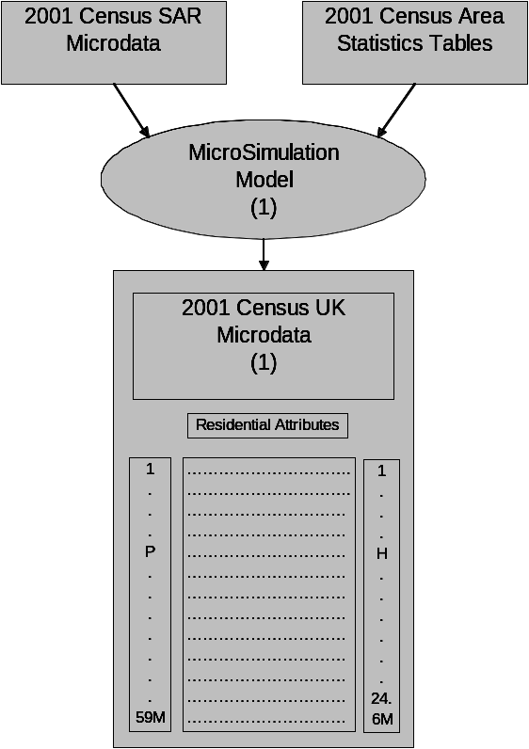

Figure 6.2. The hybrid simulation model. We need a hybrid simulation model to add activity attributes to the residential attributes which have been individually generated.

6.3.1.4 Forecasting

The objective of this stream of the research is to provide enhanced long-term value of the results by ensuring that the results are updateable rather than instantaneously obsolete, and to provide a suitable backcloth for further policy testing and evaluation.

The key research question in this section is how to link the future population of an area in (say) five years time, to its current population. There are two basic approaches to this question, based on dynamics and comparative statics. Dynamic approaches rely on the application of models and rules relating to demographic and economic change, which are of varying complexity e.g. ageing, probability of marriage, parenthood, entry into the labour market, and so on. Comparative statics is an extension of the synthetic approach to population creation. Aggregate variables are projected on the basis of expected trends, and a completely new future population is created, which can then be differenced from the current population in the assessment of change. (Again a good recent example is the work of Ballas et al, 2004).

Of these two approaches, dynamic microsimulation is the more demanding, has been the less popular, and offers the greater potential rewards, not least because it offers the prospect of representing the process of change in addition to its manifest outcomes. We propose to develop a dynamic approach to forecasting the future population based on an extension of the hybrid modelling approach described above (Section 6.3.1.3). Individual transition probabilities will be defined at the same time that aggregate models of demographic and economic change are applied as constraining influences. The transition probabilities over time will then be updated to provide consistency with aggregate forecasts.

In this context, generation of the aggregate constraints is in itself a highly non-trivial process. We will exploit synergies with the EPSRC WaND project to provide spatially aggregate demographic projections, achieving further spatial disaggregation through a fuzzy geodemographic modelling methodology which has been tested in the demonstrator phase (Hydra II).

Complete projections of the UK population will be provided at five year intervals from 2006 to 2031. We will also generate two long range scenarios (2051, 2101) for use in scenarios involving long-term trends (environmental change, super-ageing of the population).

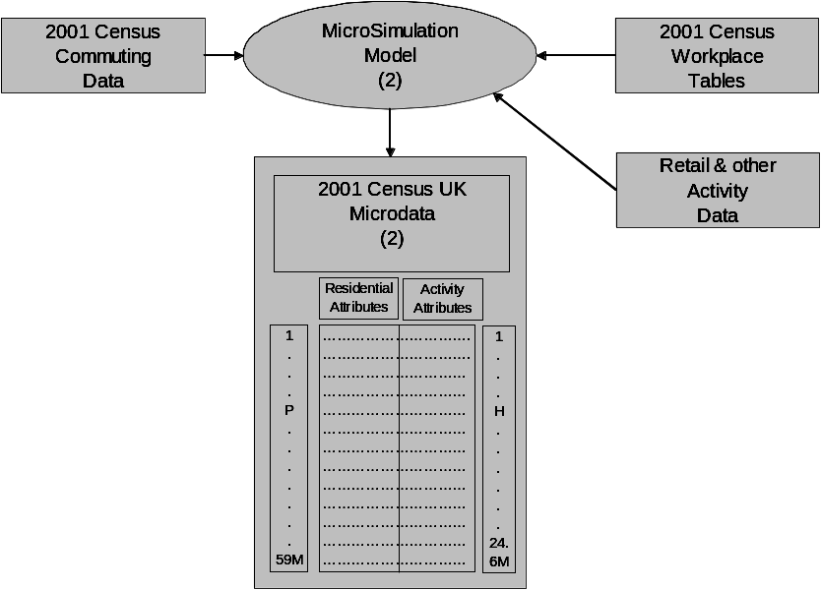
Figure 6.3 The forecasting model. The diagram shows the way in which individuals and households are ‘rolled forward’ subject to the influence of demographic change.

6.3.1.5 Incorporation of new variables

In this part of the research, the objective is to extend the coverage of the population model through the addition of data from third party sources. We will use specific examples drawn from the domains of health, business and transport.

Secondary data sources have been introduced to census-based microsimulation models in previous research, notably in the work of Ballas et al, in which data from the BHPS is introduced to add a wider range of social variables to the demographic and economic variables from the census. The primary purpose of the examples in this research is to articulate a high level general-purpose methodology for the integration of third party data. The value in this approach is that it allows the models to be shared by the whole community of social scientists in the UK, and that these scientists will be able to merge information from their own sources, whether it relates to crime, social exclusion, attitudes to Europe or ownership of mobile telephones. It will provide a basis for further demographic and economic profiling of such information, and to forecast future patterns based on socio-demographic and economic change (see below, Section 6.3.2).

The process of merging micro-databases is well-established for individual applications (e.g. Orcutt et al, 1986). The procedures simply demand a knowledge of the common features of two databases, such that a linkage can be established. For example, if a survey database shows that people vote according to their age, occupation and family status, and age, occupation and family status are all contained within a micro-database, then the addition of likely voting behaviour to the micro-database is straightforward. In developing a general methodology, however, a number of problems will need to be overcome:

  - How can the structure and content of the two databases be described in a general way (meta-data content?)

  - Consistency of definitions between sources (e.g. cohabitation in one, marriage in another)

  - Consistency of class intervals between sources (e.g. age 10-14, 15-19 in one; 11-16, 17-18 in another)

  - Nature of the spatial definition within the data (could be defined to local authority areas, primary care trusts, counties, standard regions, parliamentary constituencies etc etc)

  - Consistencies in the timing of data capture (April 2001, July 2004, …)

6.3.2 Applications

In the substantive part of this research, the robustness of this methodology will be tested through the incorporation of information from a variety of sources:

- working in partnership with colleagues in the Nuffield Institute for Health, and in Bradford District Health Authority, we will merge morbidity profiles and health utilisation characteristics;
- working with ITS and users in Nottingham, Leicester and York, we will examine the adoption of different travel behaviours amongst the population;
- working with data from Skipton Information Group, we will establish patterns of variation in house prices, ownership of stocks and shares, household income, and behavioural preferences ranging from holidays to the ownership of pets.

We now describe each of these application streams in a little more detail, and then discuss the development of a generic application model for social science users.

6.3.2.1 Business Applications

We propose using the outputs from the MOSES core research program of activity to develop simulation models of what we believe are two fundamental business/policy issues facing the UK over the next decade. These are:

- The dynamics of the retail financial services industry

- The automotive and personal mobility industry

In application area (i) we propose building a model that sits on top of the individual and household microsimulation model and simulates the effects of a number of critical personal financial service events and scenarios to examine their potential impact both at a national but also, importantly, at a local level. The events we propose exploring relate to the increased level of personal indebtedness in the UK. Latest Bank of England estimates suggest that personal indebtedness have reached £1 trillion, equivalent to annual GDP. Several key factors come in to play looking towards the future :

  - The pensions timebomb: as individuals recognise that their pension is unlikely to fund their current lifestyle they will look to liquidate assets (mainly property) to top up the shortfall in pension payments
  - Relating to this the increased use of Equity Release Products to generate annuity incomes
  - The reduction of inter-generational transmission of wealth
  - Potential crash in house prices
  - Potential rise in interest rates
  - Increase in household formation (more smaller households)

We propose building a simulation model that would explore the interdependencies of these potential events over the next decade. We would embellish the core MOSES microsimulation model with unique data on the financial circumstances of UK individuals (suitably anonymised ) that will be provided by Skipton Information Group (see attached letter of support at Section 15). We argue that the impacts of a fall in house prices/Increase in interest rates will have substantively different impacts in different regions/localities of the UK that the simulation model should be able to detect and predict.

In application area (ii) we propose building a model that sits on top of the MoSeS microsimulation model to investigate the potential impacts of changes in the personal mobility market which include:

  - continued rises in the level of car ownership in the UK. Note that car ownership is still below the EU average
  - as evidenced by the 2001 census a continued dislocation between residence and workplace leading to longer journey to work trips
  - increased levels of congestion and longer journey times
  - potential widening of congestion charging to more UK cities
  - increases in general car and fuel tax in attempts to dampen down car usage and reduce CO2 and NOX pollution

Again we would propose making use of unique lifestyle databases from Skipton Information Group that would augment the core data available from the Census and SWS. This SIG data includes information on types of vehicle owned, household income and other variables that can be appended to the core population model. This application area would also link to the transportation and environment themes of this research application. We envisage producing a model that would look at both the micro and macro-level implications of various policy/economic scenarios, again both at a national and local level.

6.3.2.2 Transport Applications

This research stream would aim to explore the environmental consequences of demographic change, and in particular the impact of the evolution of populations and their social and economic behaviour on the sustainability of urban environments. The Institute for Transport Studies at the University of Leeds has strong working relationships with policy-makers in the cities of York, Leicester and Nottingham. For each of these cities, scenarios for demographic and social change would be used to simulate and forecast traffic change and thus the impacts on congestion and emissions episodes and hotspots which have significant effects on health.

In terms of integration, the demographic and economic activity forecasts would be fed into the SATURN traffic assignment model to determine the anticipated traffic flow on each link of the network simulated. The resulting data can then be input into a microscopic traffic model (e.g. AIMSUN, PARAMICS or DRACULA) to generate vehicle emissions factors to be used by a dispersion model, together with traffic policy and management strategies. The results can then be used to study pollution episodes and hotspots, and also to simulate population exposure patterns based on population time-activity patterns specified by the simulation models. The implementation of such a solution for an entire city requires excessive computational power to achieve the integration of sub-models, and we would therefore envisage this as a suitable application for grid-computing.

6.3.2.3 Health care applications

In this research strand, we will use Grid technology to combine population-based data held on different servers across Bradford, which it would otherwise be impractical to merge. Specifically, we will seek to investigate differences in access to services for people with different clinical conditions, e.g. diabetes, coronary heart disease. The objective of this part of the project would be to merge individual patient data with synthetic demographic data from the micro-population database. Although the demographic data is very fine-grained its synthetic character provides a basis for highly realistic modelling without prejudicing the confidentiality of individual patients. We see this technology as a potentially high value resource for the anonymisation of high value but sensitive NHS data resources. These data will be cross-tabulated with demographic data, eg from the GHS, to establish relationships between household status and morbidity. The simulation modelling capability will also be used to forecast future changes in patient morbidity.

6.3.2.4 Generic social science applications

We are now in a position to add an applications layer to our description of the modelling process. In order to build problem-focused applications on top of the microsimulation model, it seems that two types of inputs are required – data about individual characteristics and behaviours (morbidity, propensity to own a personal pension, preferred mode of transport) and information relating to infrastructure and service provision (hospital treatment rates, house price data, trip cost by mode). This general structure is illustrated at Figure 6.4.

There seems no reason why a general model of this type might not be applied to a wide range of problems. For example, a user with an interest in crime patterns might access data on propensities to commit crimes (or the likelihood of falling victim to crime) together with intelligence relating to the crimes reported to various local police forces. This could lead to a model which allows the effectiveness of crime prevention to be benchmarked.

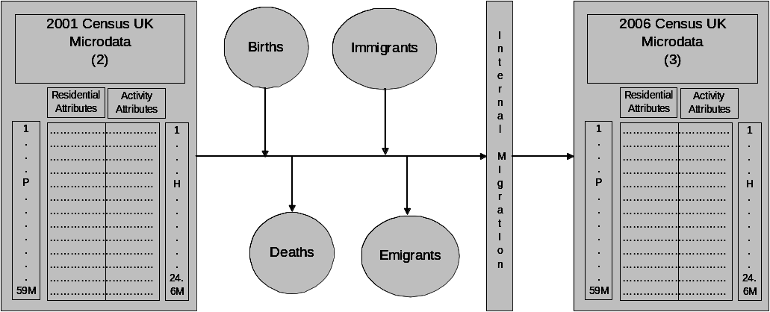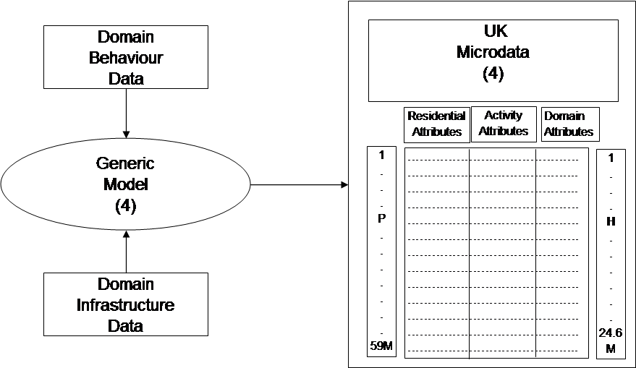

Figure 6.4 Shows how attributes from any social science domain could be added to the model.

6.4 Grid Architecture for e-social science modelling

If successful, this project will build on an architecture for e-social science modelling which has been developed at Leeds through ESRC demonstrator funding.

The existing Hydra architecture is shown at Figure 6.5. Legitimate users can access Hydra resources via the White Rose Computational Grid through a single sign-on and authentication procedure. The resources available within the system include services for ‘what if’ modelling, forecasting, access to simulation libraries, reporting, mapping, and data access and integration. The main functional components are represented as Grid Services within Globus 3, meaning that the same modules can be applied to a range of resource planning problems, including locating health clinics, new house construction and building new retail outlets. Existing data services are not grid-enabled within Hydra, since the data suppliers are as yet unable to support access via Grid services. We are just beginning to explore the possibility to access census data (via Mimas) and map data (via Edina) through a grid service link.

User
Application
Manager
Service
History
Data
( Cache )
Modelling
Service
Computation
Services
Data
Services
MIMAS
81/91/01
Digimap
Leeds
Data
Land Registry
Data
Grid Service

Local or web query

Figure 6.5 The existing Hydra architecture

The following developments to the Hydra architecture will be implemented through the MOSES e-social science node:

- the modelling tool will be scaled up from a small geographic area to UK population
- generalisation from specific modelling services to a generic modelling capability
- integration of data from a wide variety of sources within a grid services wrapper
- extended user interface to provide access to modelling tools for users anywhere in the UK social science community

We would seek to develop the Hydra architecture further using the Leeds Grid Tier System. The Leeds Grid Tier System provides a flexible framework for software services from a range of loosely connected organisations, to be used in conjunction with each other, in order to provide generic decision support facilities.

The Leeds software architecture is a fusion of Grid services technology and a Service oriented Architecture (SOA). The Grid services technology provides secure distributed software components and middleware to support flexible resource sharing in a heterogeneous computing environment. The SOA underpins processes such as service orchestration, workflow management and resource brokering.

The Grid Tier System has been fully tested and validated on the DAME (Distributed Aircraft Maintenance Environment). This is an EPSRC e-Science testbed, which demonstrates how a complete Grid system can be built and demonstrated in a realistic environment where four partners are responsible for their own services. The Grid services are supported by the compute and data resources of the White Rose Grid.

6.5 Management of the Node and its Relationship to the Hub

In this section, we discuss how the Node will build upon existing e-Science and e-social science activities and infrastructure.

The participation of Leeds in the National e-Science programme is mediated through its partnership with Sheffield and York in the White Rose Grid (WRG). The WRG is recognised as a Centre of Excellence within the e-Science Programme. One of the applicants, Professor Dew, is the founder and Director of the White Rose Grid Consortium.

The WRG at Leeds is founded on an investment in excess of £2 million from SRIF, with matching contributions from the University of Leeds and industrial partners including Sun, Esteem and Streamline Computing. This investment has been used to provide both a physical and computational infrastructure for e-science at Leeds. The physical infrastructure includes an impressive Informatics Research Laboratory (opened January 2003) which forms the centre of Leeds own hub-and-spoke Informatics Network. Our Grid infrastructure includes Access Grid, high performance Onyx workstations and holobench as well as high performance machines on the White Rose Grid proper.

The activities of the informatics network include an MSc in Multi-disciplinary informatics which is supported by an EPSRC Masters’ Training Package, with partners in health, biochemistry, geography, mechanical engineering and education. The present cohort of 12 students as the course nears the end of its second year is expected to grow towards 30 as the programme matures. The University of Leeds is also launching an undergraduate informatics teaching programme commencing September 2004.

The research activities of the network include a major contribution to the DAME project, on which Dew is an investigator. DAME is a cross-disciplinary project between Computing and Mechanical Engineering involving the Universities of Leeds, Oxford and York, in partnership with Rolls Royce. Xu is an investigator on e-Demand, funded by the EPSRC/DTI e-Science Core Programme; GOLD, an EPSRC e-Science pilot project; and Virtual Universe, funded through the PPARC e-Science Programme. Birkin is Principal Investigator and Dew the Co-Investigator on Hydra, an e-social science demonstrator funded by ESRC and DTI. Leeds also has an EPSRC Novel Computation programme grant with a multi-disciplinary programme including geography and linguistics as well as engineering and bioscience, to which both Birkin and Evans are contributors. E-Science funding also supports projects in core computer science (Brodlie, COVISA) and biology/ medicine (Bulpitt and Westhead).

In addition to physical and computational infrastructure, the University of Leeds has demonstrated a commitment to informatics/ e-science through a number of academic and academic-related appointments. These include joint academic appointments between Computing and Geography (Birkin, April 2002) and Computing and Biology (Dr Martin Richards, January 2004), and the appointment of a WRG Technician (Jason Wood, July 2004), all of which are permanent appointments. The University of Leeds has also provided three years support for a post-doctoral research fellowship in computational approaches to medical imaging (jointly supervised by Birkin, Westhead and Professor Quirke, Pathology).

The University of Leeds is a founding partner of the Worldwide Universities Network (WUN) consortium, and Birkin is a member of the WUN Grid Advisory Board. WUN is currently in the process of establishing a worldwide data grid, with a major focus on both geographic information systems (GIS) and e-social science. WUN Grid provides an opportunity for UK e-social science to assume international leadership, and to exploit potential funding from organisations such as NSF and the Mellon Foundation.

e-science activities at Leeds are supported by an Industrail Advisory Board which includes membership from real end-users such as GlaxoSmithKline, NHS University, Metaldyne and Skipton Information Group, as well as business partners like IBM, BT Exact, and HP Labs.

More information about e-science activities at Leeds can be found at www.informatics.leeds.ac.uk.

6.6 Commitment to training and capacity-building

In this section, we discuss our current activities relating to training and awareness raising, and also our plans for the development of specific activities relating to the e-social science node.

The Informatics Institute at Leeds has an established multi-disciplinary postgraduate teaching programme with an EPSRC Masters Training Package (MTP) in Multidisciplinary Informatics. At present, half of our students are concentrating on topics with a social science focus, including healthcare (4), geography (1), and health/ geography (1). We expect the MSc MDI to grow organically in the coming years and to continue as now with both an e-science and an e-social science focus. Our financial proposals include the allocation of specific bursaries in association with the UK e-social science programme and to use this as part of the host contribution i.e. two bursaries per year with projects relating to the eSS programme at Leeds (or elsewhere). We would also be willing to offer free participation in informatics modules for researchers in the UK eSS community at any appropriate career stage.

We have an established informatics seminar series with visiting national and occasionally international speakers addressing a multi-disciplinary audience which typically attracts an attendance in excess of 30 for lunchtime meetings. Some of these lectures are available online at www.informatics.leeds.ac.uk. An opportunity here would be to invite key speakers within the UK modelling and simulation community to address seminars at Leeds either in person or via access grid and to promote attendance amongst the whole community of e-social scientists. We imagine that such an activity is likely to fit with a broader seminar programme within the National Centre. Ideal target speakers within the modelling community might include Batty (CASA), Gilbert (Surrey), Haining (Cambridge), in addition to the project investigators, and internationally Nagel (Zurich), Wegener (Dortmund), Holm (Umea), and Caldwell (Cornell).

We believe that the best way to promote awareness of e-social science is through the traditional routes of high status international conferences and publication within prestigious academic journals. Work from the Hydra programme has been showcased domestically at London, Manchester, Sheffield and Nottingham, and internationally at Cork, New York and Port Elizabeth (South Africa). For the future, in addition to participation at mainstream e-Science and e-social science events, we would wish to promote e-social science into organisations which represent both our substantive and methodological interests as social scientists – for example, Regional Science Association, Institute of British Geographers, Association of American Geographers, Institute of Transport Engineers (ITE), and the International Health Economics Association (iHEA). Most importantly, we envisage at least six contributions to peer-reviewed academic journals addressing both methodological issues (population estimation, forecasting and dynamics, sub-system model and scenario-building) and applied research questions (health care systems, transport systems, business systems).

The School of Geography at the University of Leeds has an established programme of Online Distance Learning for Masters students. We propose to use our established protocols to create a learning module in modelling and simulation for long-term use within the academic community at large. Whilst this could be provided on our existing delivery platform, it would be more appropriate to link this material with either the National Centre or ReDress, at the discretion of the NCeSS Management Board. The individual components of this programme would also be offered in a workshop format with components under the direction of individual workstream leaders e.g.

- Overview and introduction to modelling and simulation (Birkin)
- Demographic modelling techniques and issues (Rees)
- Grid architectures for e-social science modelling (Dew and Xu)
- Forecasting and scenario-building (Birkin)
- Modelling and simulation for health care systems (Keen)
- Modelling and simulation for transport systems (Chen)
- Modelling and simulation for business systems (Clarke)
- Modelling and simulation for generic applications (Birkin & Dew)

The investigators have a good record in attracting CASE funding for PhD research, and we would explore this route in tandem with our user partners as a means to deliver PhD studentships linked to this proposal, with an aspirational target of two studentships in each of the first two years of this project (i.e. commencing September 2005, September 2006).

  - Human Resources

    - Leadership

In this section, we describe the relevant expertise and experience of collaborators named in the proposal and describe their role in the Node.

The Director of the Leeds e-Social Science node will be Dr Mark Birkin. Mark is currently Director of the Informatics Institute at the University of Leeds. The Informatics Institute is a multi-disciplinary research grouping with members drawn from the Faculties of Engineering, Mathematics, Earth & Environment, Biological Sciences, Law, Business and Medicine. Dr Birkin’s academic appointment is shared between the Schools of Geography and Computing. He is a member of the Advisory Group for the ReDRESS programme, and a member of the WUN Grid Advisory Board. Mark Birkin has been the Principal Investigator on two ESRC e-Social Science demonstrator projects – Health Care Decision Support Systems for Resource Allocation (HyDRA) and Hydra II – Spatial Planning Services.

Dr Birkin’s main research interests are in mathematical and computational models of social systems. He will have overall responsibility for the management and distribution of resources on the project, and will direct the modelling research stream. He will have prime responsibility for management of the relationship with the hub, and will attend monthly meetings and make such other contributions as are agreed to be desirable to the research activities of the hub. If this application is successful, Dr Birkin would be appointed as Director of the node on a 50% basis.

Pete Dew is Director of the White Rose Grid Consortium and collaborator on a number of e-Science projects, including DAME (Distributed Aircraft Maintenance Environment) and HYDRA. He has research interests in grid service architectures. He will be responsible for the design and maintenance of the MOSES computational architecture, and will also lead the design and development of tools for third party data integration.

Jie Xu is a member of the White Rose Grid Executive and has also been a member of the North Eastern e-Science Centre, and a collaborator on research projects within the main e-Science programme. He has research interests in dependable distributed systems, fault tolerance and secure Grid computing for large-scale e-science applications. Professor Xu will support Professor Dew in the provision of a computational architecture.

Justin Keen is a member of the Informatics Strategy Board and provides teaching and research supervision on the MSc Multi-disciplinary Informatics. He is also academic adviser to the NHS-University Informatics programme. He is a Professor of Health Economics in the Nuffield Institute for Health Studies, and has particular research interests in the social impacts and obstacles to information sharing within the health service. He is the leader of a joint research initiative with Bradford Health Authority. His role in the project will be to lead research into the health care exemplar.

Martin Clarke is a member of the Informatics Industrial Advisory Board at Leeds. He is Professor of Geographical Modelling at the University of Leeds, and also Principal Consultant to Skipton Information Group. His interests are in the extraction of intelligence from business data in order to support action and change. His role in the project will be to lead research into the geo-business exemplar. Professor Clarke will also act as Deputy Director of this e-social science node.

Phil Rees is Professor of Population Geography at the University of Leeds. He is co-Director, with Adrian McDonald of EPSRC’s WaND Project, which seeks to build demographic forecasting models to support water demand assessment. He is also a member of ESRC’s Research Resources Board. His main role in the project will be to support the development of the base populations and demographic scenarios.

Haibo Chen is a Principal Research Fellow in the Institute for Transport Studies. His main research interests are in intelligent transport systems, transport informatics and the future sustainability of transport systems. Dr Chen's main role in the project will be to direct the transportation exemplar.

6.7.2 Staffing

The node will be staffed by three research assistants, one in the School of Computing and two in the School of Geography. Line management in the School of Computing will be provided by Professor Dew, and in the School of Geography by Dr Birkin.

The Director and co-applicants will form an Executive management team which will meet on a monthly basis to review progress on the project. We will also establish a Research Node Advisory Board which will comprise the Director, Deputy Director and a third applicant, one of the researchers, one representative of the e-Social Science hub, and three user representatives – one each from Bradford Health Authority, Skipton Information Group and North Yorkshire County Council (Highways Division).

We envisage that the main axis of integration into the overall management structure of NCeSS will be through the participation of the Node Director (Birkin) in monthly meetings of the Hub Research Board. We also see strong links to ReDress through Birkin’s existing membership of the Advisory Board. The Leeds Group would be keen to be involved in the organisation of workshops of BOF (‘Birds of a Feather’) sessions within the e-Social Science All Hands Programme, or to convene events with a dedicated focus on modelling and simulation in Leeds or elsewhere, at the discretion of the Hub Management Team.

The University of Leeds has a well-established Access Grid Node, and we would be willing to participate at any time in meetings involving discussions with remote partners in the UK and elsewhere.

6,983 words

References

Ballas, D. (2001), A spatial microsimulation approach to local labour market policy analysis, unpublished PhD thesis, School of Geography, University of Leeds
Ballas, D. and Clarke, G. P. (2001), Towards local implications of major job transformations in the city: a spatial microsimulation approach, Geographical Analysis 33, 291-311
Ballas, D, Rossiter, D, Thomas, B, Clarke, G P and Dorling D (2004), Geography matters: simulating the local impacts of national social policies, Joseph Rowntree Foundation, York (forthcoming)

Birkin, M. and Clarke, M. (1989) The generation of individual and household incomes at the small area level using Synthesis. Regional Studies, 23, 535-548.

Birkin, M. and Clarke, M. (1988) SYNTHESIS: A SYNTHetic Spatial Information System for urban modelling and spatial planning. Environment and Planning A, 20,1645-1671.

Gilbert, N. (2003) Multi-agent based simulation, ESRC Research Methods Workshop, Leeds, 2003.

Heppenstall A, Evans A, and Birkin, M (2004) A hybrid multi-agent/spatial interaction model system for petrol price setting, Transactions in GIS, forthcoming.

Lee, D.B. (1973) Requiem for Large Scale Urban Modelling, Journal of the American Institute of Planners, 39, 163-178.

Masser I. Suiden O., Wegener M. (1992) The geography of Europe’s futures, Belhaven, London.

Middleton, E. (1995), Samples of Anonymized Records, in S. Openshaw (ed.) Census Users’ Handbook, GeoInformation International, London, 337-362
Murphy, M. (2003) Including feedback in demographic microsimulation models, ESRC Research Methods Workshop, Leeds, 2003.

Orcutt, G.H., Mertz J., Quinke, H. (eds) (1986), Microanalytic Simulation Models to Support Social and Financial Policy, North-Holland, Amsterdam

Ravetz J. (2000) City region 2020, Earthscan Publications, London

Voas, D. W. and P. Williamson (2000) An Evaluation of the Combinatorial Optimisation Approach to the Creation of Synthetic Microdata, International Journal of Population Geography, 6, 349-66 6, 349-66.
Williamson, P. (1996), Community care policies for the elderly, 1981 and 1991: a microsimulation approach, in G.P. Clarke (ed.) Microsimulation for Urban and Regional Policy Analysis, Pion, London, 64-87
Williamson, P., Birkin, M., Rees, P. (1998), The estimation of population microdata by using data from small area statistics and samples of anonymised records, Environment and Planning A, 30, 785-816
Zedlewski, S. (1990) The development of the Dynamic Simulation of Income Model (DYNASIM), in Lewis, G. and Michel, S. (eds.) Microsimulation Techniques for Tax and Transfer Analysis. Washington, D.C.: The Urban Institute Press, 109-136.

7. Financial Details (See Annex A)
7.1 SUMMARY OF FUNDS REQUESTED FROM ESRC | Year 1  £ | Year 2  £ |  |  | Year 3  £ | Total  £
Staff (Section 2) | 103,495 | 108,661 |  |  | 112,979 | 354,193
Travel and Subsistence (Section 3) | 8,080 | 8,740 |  |  | 9,830 | 26,650
Consumables (Section 4) | 3,000 | 3,000 |  |  | 3,000 | 9,000
Exceptional items (Section 5) | 6,350 | 8,750 |  |  | 2,550 | 7,650
Equipment (Section 6) | 4,352 | 0 |  |  | 0 | 4,352
SUBTOTAL | 125,277 | 129,151 |  |  | 128,359 | 401,843
INDIRECT COSTS (at 46%) | 47,608 | 49,984 |  |  | 51,970 | 162,929
GRAND TOTAL | 172,885 | 179,135 |  |  | 180,329 | 574,772

At the time of writing, it is expected that the SARs will be released in December 2004. In the unlikely event that SARs are unavailable prior to the commencement of the project, then a combination of individual records from the GHS and BHPS would be used in the first instance.

