AIMS AND OBJECTIVES

As in most other semi-arid regions, desertification in the Mediterranean region is largely a society-driven problem which can be effectively managed only through a thorough understanding of the principal ecological, socio-cultural and economic driving forces associated with land use and climate change, and their impacts.

For this reason, MEDACTION adopts an integrated, multi-disciplinary approach, involving social and natural scien-tists as well as the principal stakeholders in the region to:
- Develop land use change scenarios at various scales
- Analyse effects of past policies in four target areas
- Analyse the costs of land degradation and benefits of mitigation measures
- Develop options for land use policies, mitigation strategies, and incentives to combat desertification

MEDACTION will develop an information and decision-support base on land degradation to assist decision-makers from the local to the European level in the formal and informal decision and policy making process to combat desertification in the Northern Mediterranean Region.

The specific problems of land degradation, desertification and mitigation measures are addressed at the European, Mediterranean and local scale.
At the local scale, four target areas will be investigated in greater detail: Alentejo (Portugal), Guadalentín (Spain), Val d`Agri (Italy) and Lesbos (Greece).

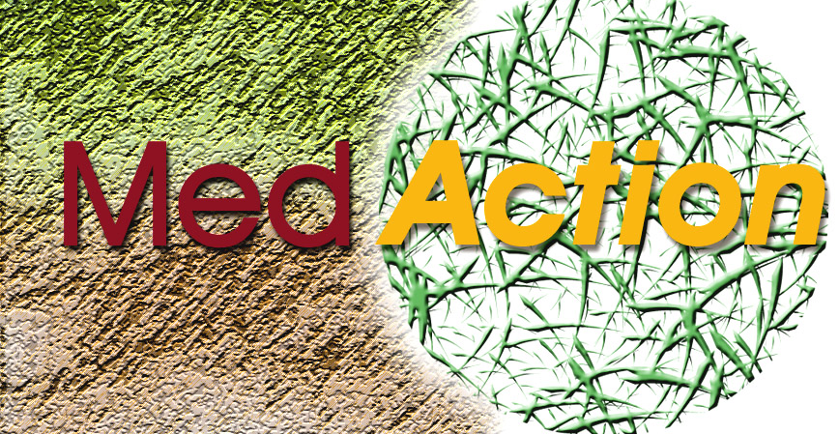
PROJECT PARTNERS

Module 1 (Land use change scenarios)
Leader: Dolf de Groot, International Centre for Integrative Studies (ICIS), Maastricht University, The Netherlands.
www.icis.unimaas.nl d.degroot@icis.unimaas.nl

Module 2 (Effects of past policies)
Leader: Geoff Wilson, King’s College, London, UK.
www.kcl.ac.uk/kis/schools/hums/geog/top.html geoff.wilson@kcl.ac.uk
- Miguel Vieira, IDRGA, Lisbon, Portugal

- Andrea Povellato, INEA, Italy
www.inea.it
- Leonidas Louloudis, Agr. Univ. of Athens, Greece www.aua.gr/diames.htm
- Begoña Peco, UAM, Madrid, Spain
www.uam.es
- Juan-José Oñate, UEM, Madrid, Spain
www.uem.es
- Jose Sumpsi, UPM, Madrid, Spain
www.upm.es

Module 3 (Decision Support Systems)
Leader: James Bathurst, Univ. of Newcastle upon Tyne, UK. www.ncl.ac.uk/wrgi j.c.bathurst@ncl.ac.uk
- Guy Engelen, RIKS, The Netherlands
www.riks.nl
- Andy Turner, University of Leeds, UK
www.ccg.leeds.ac.uk

Module 4 (Desertification Policy Support Framework)
Leader: Helen Briassoulis, Univ. of the Aegean, Lesbos, Greece. www.aegean.gr/geography e.briassouli@aegean.gr
- Apostolos Papadopoulos, EKKE, Athens, Greece
www.ekke.gr

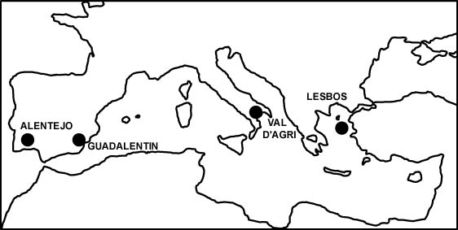
CONTACT ADDRESS
International Centre for Integrative Studies (ICIS),
P.O. Box 616, 6200 MD Maastricht, Netherlands. Website: www.icis.unimaas.nl/medaction
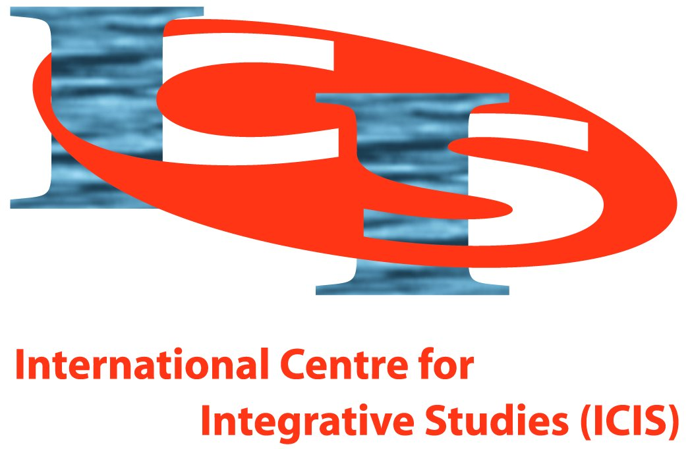

Tel: +31-(0)43-3883748,
Fax: +31-(0)43-3884961
Project leader: Jan Rotmans
Project coordinator:
Dolf de Groot
(d.degroot@icis.unimaas.nl)

Policies for land use
to combat desertification
(January 2001 until January 2004)

MEDACTION is a multi-disciplinary research project
aiming to:
- Assess the main issues underlying the causes and effects of land degradation
- Develop integrated policy options and mitigation strategies to combat desertification in the Northern Mediterranean region

MEDACTION involves 13 partners from 6 European countries: Greece, Italy, Portugal, Spain, United Kingdom and the Netherlands (see back page).

MEDACTION is funded by the European Commission,
DG Research and Development
It is part of the EC Fifth Framework Programme,
Key Action 2: Energy, Environment and Sustainable Development, focusing on Global Change, Climate and Biodiversity.
Area 2.3.3: Fighting Land Degradation and Desertification.

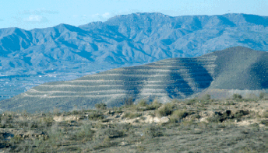
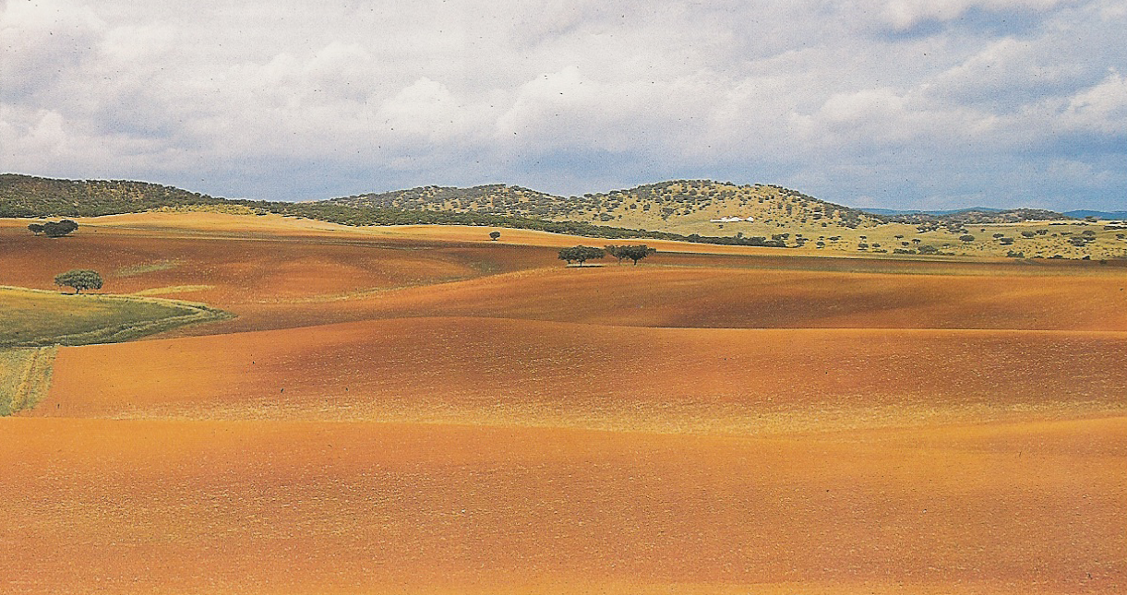
APPROACH AND DELIVERABLES

The process of designing land use change scenarios, mitigation options, incentives and policy tools will be highly participatory, involving a wide range of stakeholders.

The most important among the more than 35 MEDACTION deliverables are:
- European, Mediterranean and local land use
change scenarios
- Reports on the effects of past desertification
policies in the four target areas
- Decision Support Systems to analyse the effects of land use change scenarios, management and proposed policies in the target areas
- Overview of the costs of land degradation and benefits of mitigation measures
- CD ROM and user manuals with guidelines for
sustainable land management at local scales
- An interactive Internet interface based modelling
system for estimaing land degradation risk
- A Desertification Policy Support Framework with guidelines for policy design at the level of the European Union and the four Mediterranean countries

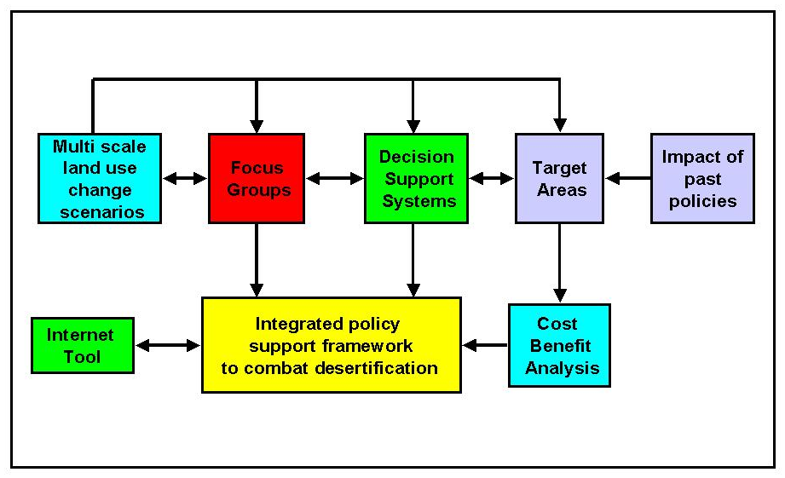
Interconnections between MEDACTION modules.

Alentejo

Module 1: Land use change scenarios
In this module land use change scenarios are developed
at the European, Mediterranean, and local scale to aid
local decision-making with regard to policy formulation for sustainable land management in the target areas.

Module 2: Effects of past policies
In this module the effects of the implementation of a variety of past policies on land use and land degradation across the physically, culturally and economically diverse four target areas are analysed.

Module 3: Decision Support Systems
Decision Support Systems will be used to develop
guidelines on, and contribute towards, policy
formulation for land use in the four target areas.

Module 4: Policy Support Framework
This module analyses policies affecting land use, and
desertification in the EU and the four countries – Greece
Spain, Italy and Portugal, and aims to produce a framework for their improvement, integration and synthesis.

Val d’Agri

Guadalentín

Focus Groups
To facilitate involvement of stakeholders in MEDACTION, Focus Groups will be formed in the four target areas including local land managers, professional associations, NGOs and policy representatives.
In each of the four target areas a series of workshops will be organised, designed to address the following topics:
- Public perception of driving forces and effects of land degradation and desertification, in order to develop a set of common indicators and integrated scenarios
- Particular traditional and contemporary land management practices applied in the target areas, their costs and benefits, and the factors influencing management decisions
- Successful land management practices for preserving natural heritage, resources and ecosystems, and development of a checklist of indicators to measure mitigation effectiveness
- Strategies for implementation and wider dissemination of project research results and presentation of the Desertification Policy Support Framework

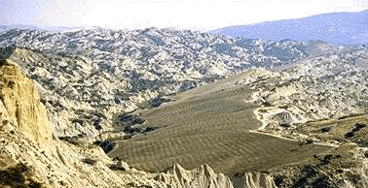
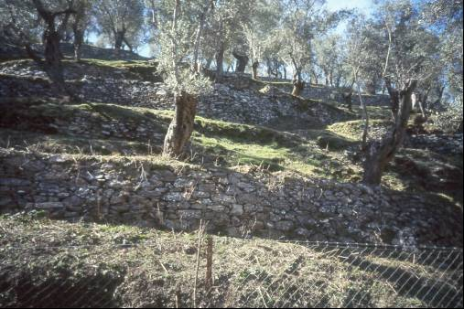

Lesbos

