Application of a Hybrid Multi-Agent Model to Petrol Price Setting

A.J. Heppenstall, A.J. Evans and M.H. Birkin
School of Geography, University of Leeds, Woodhouse Lane, Leeds, England, LS2 9JT.
Email: a.heppenstall@geog.leeds.ac.uk

Abstract
The power of agent-based modelling, when integrated with other AI-based and conventional approaches, can be greatly enhanced. The resulting hybrid systems offer a flexible modelling environment that exploits the benefits of each individual in a synergistic fashion. This research concentrates on the application of such a model to petrol prices. Petrol price data is characterised by being spatially and temporally variable. Variations within this data can be attributed to both external (crude oil prices) and local factors (location of other stations). Conceptually, petrol stations can be seen as discrete objects with control over their own pricing. These prices are set using rules dictated by corporate policy.

This conceptual framework lends itself to being represented by an Intelligent Agent (IA) structure developed in an object-orientated environment. A multi-agent structure (MAS) was created and a small section of the data selected for initial analysis. A spatial interaction model (SIM) was developed and linked to the model to simulate customer behaviour. To evaluate how effective this hybrid model was, a comparison was made with an existing data set of real petrol prices collected over a two month period. This was achieved both statistically and visually with the use of a geographical information system (GIS). Investigation into the behaviour of the system (how prices diffuse spatially) and whether a urban-rural divide could be produced was undertaken by employing idealised simulations.

1. Introduction
Petrol is one of the most valuable oil derived commodities valued by retailers and customers alike. Despite pressures on natural resources there is a rising demand for petrol associated with an ever increasing individual mobility. At the end of 2002, there were 11,707 sites retailing over 36 billion litres of motor fuel in the UK. This equates to an average of approximately 1,350 litres of fuel consumed by each car/van per annum. Consumers are becoming ever more aware of petrol prices; internet sites such as the AA Price Watch enables the consumer to have almost perfect knowledge of prices within their area. This has created both a highly competitive and sensitive market, with organisations employing strategies to maximise profits. This sensitivity to petrol prices was fully borne out in the UK during August – September 2000 with the “Petrol Crisis” and the associated fuel protests that precipitated in reaction to soaring fuel taxes.

The literature concerned with the examination of petrol prices and its relationship with other variables is vast. Concentration is mainly focused on the transmission of positive and negative changes in a variable in relation to the price of petrol (for example, crude oil prices or exchange rates). These studies generally differ in one or more of the following aspects; the country under scrutiny; the time frequency and period of data used; the focus on wholesale and retail gas prices or oil and petrol prices and finally the dynamic model employed in the empirical investigation (Galoetti et al. 2003). Examples of work within this area include Bacon (1991), Manning (1991), Shin (1994), Reilly & Witt (1998) and Mitchell et al. (2000). High frequency cycles (whether there is a weekly or monthly variation within petrol prices) are another area that occupies substantial amounts of the literature. These have been thoroughly investigated and re-investigated by Castanias & Johnson (1993), Noel (2002) and Eckert (2002, 2003).

Typically, the models developed by researchers to represent the relationship between petrol and a variable are empirically based, set up with mathematical relationships between variables. Despite numerous advances made in theory and practice (Pave, 1994), these models do present certain problems. For example, mathematical models link up parameters that are all on the same scale of analysis. It is not possible to make the behaviours executed at the ‘micro’ level correspond with the global variables measured at the ‘global’ level. The equations that are used are generally complex, containing large numbers of parameters that are both difficult to estimate and lacking realism. Very little, if any, account of any geographical effects are taken. One of the largest criticisms of mathematical models is that it is difficult to take into account the actions of individuals and therefore the modifications to the environment which result from their behaviour. As Ferber (1999) highlights, “If we consider actions only in terms of their measurable consequences at the global level, or of their probability of appearance, it will be difficult to explain phenomena emerging from the interaction of these individual behaviours, in particular all those relating to intra- and interspecific cooperation”. The final criticism that can be addressed at these models is that by their nature, mathematical models only consider quantitative parameters. Vast amounts of valuable information can be input to a model by use of qualitative data.

The research presented here differs from previous studies in several ways. Firstly, the technique employed is not empirically based; it is taken from the field of artificial intelligence (AI). Instead of aiming to examine relationships between variables, it aims to model the behaviour of individual petrol stations, the rules that they employ and strategies implemented. Within this paper, we present a hybrid-multi-agent model that seeks to represent the rules and patterns governing real petrol markets by the use of self-interested agents that are fed important system behaviour by a spatial interaction model. The behaviour of the system is further tested by use of idealised simulations. This will be used to specifically examine the spatial diffusion of price changes within the system. Finally, the hypothesis that local optimisation of profit leads to region-wide increase in the market profits is examined.

2. Agent-Based Systems

Agent systems are a relatively new paradigm for developing software applications. Their vast potential in designing and building complex systems (Jennings, 2000) coupled with the increase in computing power and the advantages that they offer over traditional approaches has resulted in agent-based models becoming an increasingly popular and powerful tool within geographical applications (O'Sullivan, 2000). There is no universally agreed definition of an intelligent agent (see Franklin, 1996 for further discussion) with researchers continually debating whether definition should be by an agents’ application or environment (Goodwin, 1993; Brenner 1998). With an ever-increasing list of agents appearing (Nwana, 1996), the most useful characterisation comes from Wooldridge (1997):

"An agent is an encapsulated computer system that is situated in some environment and that is capable of flexible, autonomous action in that environment in order to meet its design objectives".

Applications of agents can be found in many areas from electronic commerce, the gaming industry through to industrial applications. Examples of agent models currently within the geographical domain are SprawlSim (designed to help public planners experiment with ideas about suburban sprawl); STREETS and SWARM (both modelling pedestrian movement within public areas) and TRANSIM (a tool for simulating traffic levels). These applications readily exploit the ease of decomposition allowing several processes to be modelled at different temporal and spatial scales.

2.1. Petrol Stations as Agents

The petrol pricing market can be viewed as a complex system. Many processes combine at different temporal and spatial scales to affect the overall petrol price. For example, internal costs (cost of production, fixed costs e.g. staff pay), external influences (price of crude oil and levels of taxation) and effects of locality (rural versus urban areas). More importantly, it is hypothesised that competition within the local neighbourhood exerts the greatest influence on setting of price. For example, it is well publicised that ESSO operate a “PriceWatch” policy that aims to match all prices within 3km.

Agent-orientated approaches advocate decomposition of the problem to be solved. This results in multiple agents being able to engage in flexible, highly-detailed interactions. This decomposition offers two main advantages in modelling complex systems. Firstly, the amount of system control is reduced which results in a lower degree of coupling between components. Secondly, decisions about actions to be performed are devolved to autonomous entities based on the agent’s state of affairs rather than an external entity's perception of this state (Jennings, 2000). This approach is well suited to geographical applications, such as the petrol pricing market, where there are a discrete set of spatially distributed entities, in this case petrol stations that interact with each other and their environment.

The agent model was developed with an object-orientated language (Java). Individual petrol stations were created as objects and supplied with knowledge of their own price and sales and the price of those stations within their neighbourhood. Each petrol agent can be characterised as being heterogeneous, possessing a fixed location and a petrol price – with the assignment of different rule sets differentiating them; communicative and cooperative with pricing information shared between the agents for competition and reactive, making decisions and changing their prices based on information supplied to them. Diagrammatically, a set of petrol agents within the system may be represented as:

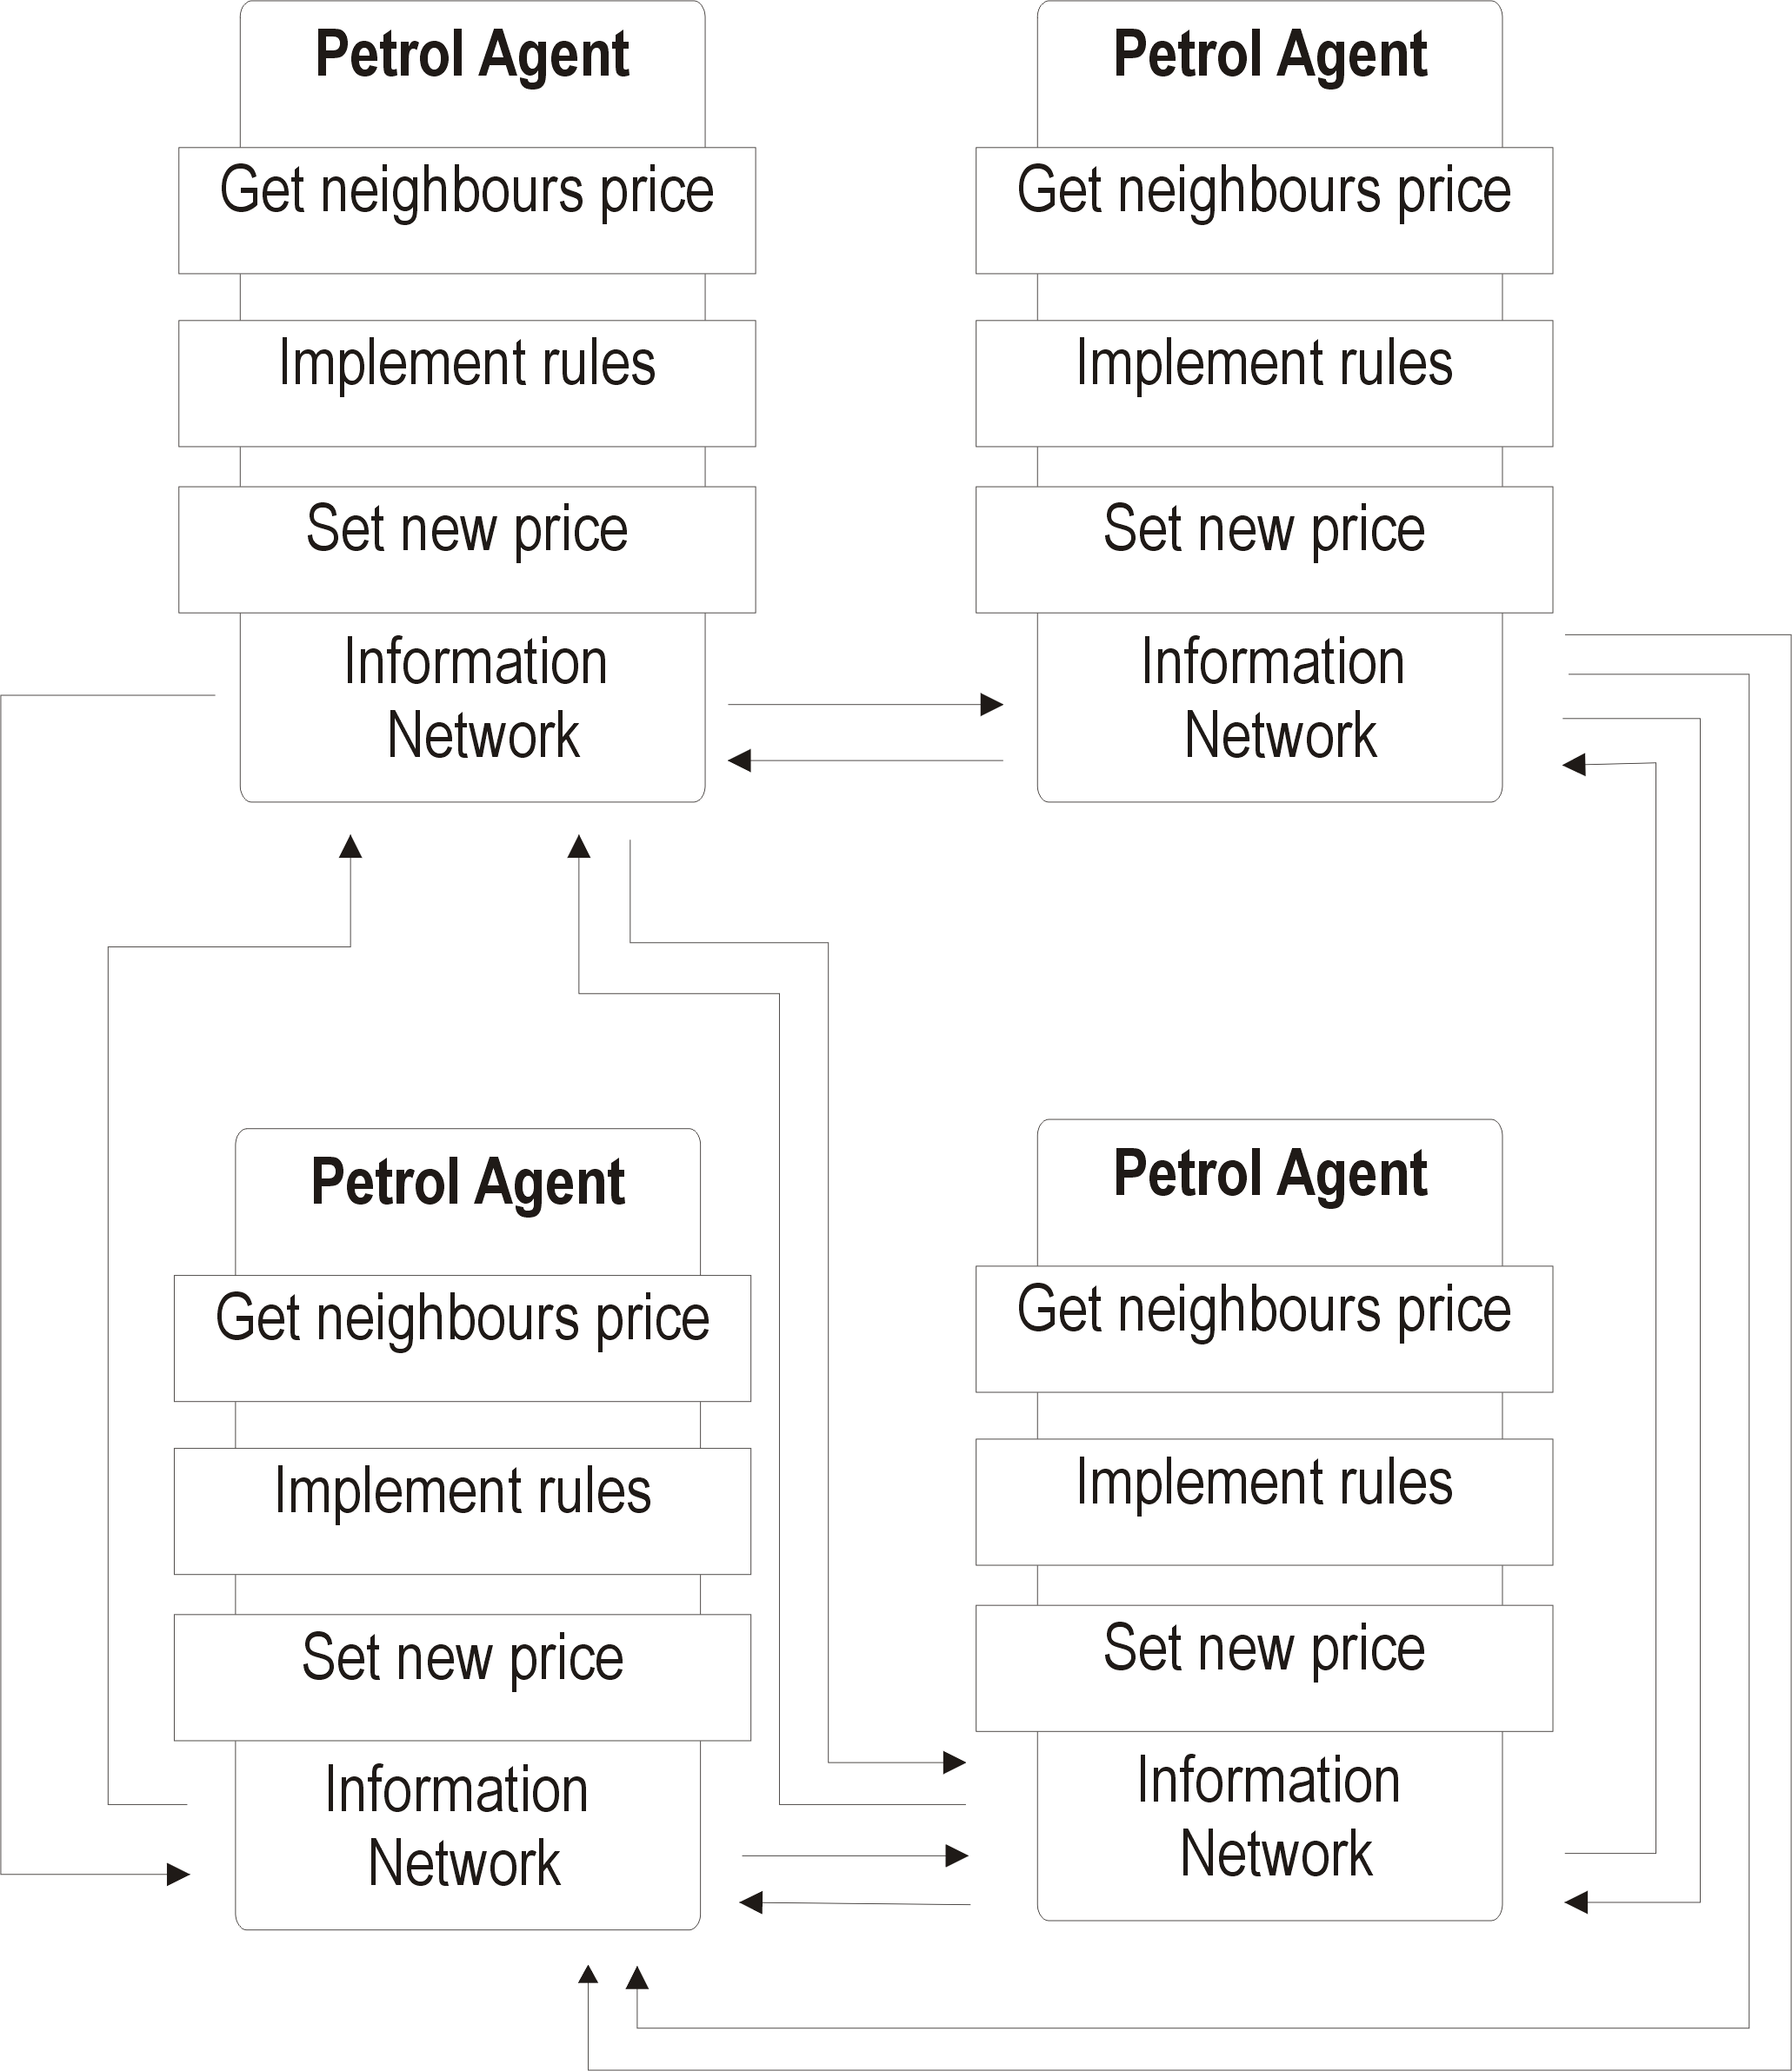

Figure 1: A set of petrol agents (following the style of Tsvetovat and Carley, 2002)

The mechanism that an individual agent operates is:

For each neighbour {
get price of neighbour()
get distance to neighbour()
}
Calculate new price based on pre-defined rules;
Repeat until simulation finished.

Figure 2: Pseudo code representing the mechanism of the petrol agent.

2.2. Decision Making

The price of petrol that a station sells is decided via a set of rules. These rules can be assigned to either a group of stations, for example ESSO brand, all the stations contained within an area or to all the stations. They are based on industry knowledge and implemented after experimentation with differing parameters. The parameters that form the basis of the rules and an example rule used by a petrol agent are:
- Minimum and maximum price.
- Undercutting price.
- Overprice (the amount by which a petrol station can be more expensive than its neighbours)
- Neighbourhood.
Example:
- Am I more expensive by Xp than the competition in my neighbourhood (Ykm)? If yes, drop my price by Xp.

Interplay of different rules sets allow the stations to be competitive and implement behaviour (e.g. price cutting wars) that leads to profit maximisation. The stations update their prices once per day after a decision has been made. Although one of the advantages of using a MAS is the allowance of asynchronous behaviour, the petrol market simulation is based on a synchronous response, i.e. petrol stations are hypothesised to update their prices once per day in response to corporate instructions or reaction to local competition.

2.3. Self-interest

The petrol agents within the system are designed to be self-interested. In making a decision (deciding what price to set), the agents are only concerned with their own immediate profit. This profit maximising behaviour can be seen as a dominant strategy thereby driving out all secondary ones (e.g. attaining market share, collusion for market saturation). It is possible that these behaviours are in fact the dominant or at least equally influential within the system. This paper will concentrate on using the profit maximisation strategy. Further research will investigate the other strategies outlined.

3. Multi-Agent Systems (MAS) for Simulations

Agent architectures supply a methodology for building agent systems that specify how agents may be decomposed into component modules, and how these modules interact with their environment (Maes, 1994). This decomposition allows multiple agents to engage in high-level interactions. One of the most common architectures are multi-agent systems (MAS). These systems are heterogeneous and no strong assumptions regarding their cooperation exist (further assumptions that these models are based upon are presented in Figure 3). Agents in a MAS environment exist with no global control or globally consistent knowledge. This gives an obvious advantage in that the system is not constrained by global rules or knowledge. In complex systems such as petrol pricing this is advantageous trait because petrol stations are discrete entities with own price setting strategies, this lends itself to be modelled by an agent approach. Using this framework, it is easy for individual petrol stations to implement different price setting strategies, to model for example, the pricing policies of different multinationals or supermarket chains.

- The simulation consists of agents.
- Agents are independent autonomous entities endowed with some intelligence.
- Agents are cognitively limited.
- Agents do not have accurate information about the real world.
- Agents do not have accurate information about other agents.
- Agents communicate asynchronously and deal with any resulting complications in an autonomous manner.
- Unless required by the simulation domain, there is no central mediating entity to resolve the conflicts.
- Unless required by the simulation domain, the agents do not use predefined geometrical locations or neighbours.

Figure 3: Assumptions that MAS’ are built upon (adapted from Tsvetovat and Carley, 2002).

MAS inherently possess several properties that are invaluable in simulating complex systems. For example:

- Spatial realism: Many AI based simulations are built on the concept of agents/cellular automata operating on a grid of a specified shape. Interactions are based on the concept of proximity, defined by agent neighbourhood on the grid. However, the choice of grid shape and type of neighbourhood is often arbitrary and often does not carry any recognition of realism. Within MAS the agent’s are governed by the formal structure of the organisation and the agent’s belief’s about the informal structure. This allows modelling of ideas/concepts to be based on what is found.

- Temporal realism: The majority of simulations are synchronous – based on the idea of time periods and “turn-taking”. This does provide an adequate approximation of simple interactions, but does not model simulations of protracted interactions. More realistically, real world interactions are of an asynchronous nature. MAS structures allow this behaviour.

- Information flow realism: In MAS, agents do not have perfect knowledge about the world. The way to obtain this knowledge is to ask other agents – or obtain the information via an exchange interaction. This type of behaviour is especially important in a simulation where the agents are competitive.

- Task realism: To be successful in modelling a complex system and completing an assigned task, the MAS must accurately represent the processes present in the subject of study. In modelling emergent phenomena such as market behaviour, a simulation environment that contains large numbers of agents is required. If the agents are too “simple” not possessing enough knowledge of processes within the system, they will not be able to replicate the processes.

4. Analysis Tools

The data is characterised by being both spatially and temporally dynamic. Assessment of the results has to take these characteristics into account. A combination of two methods (statistical and visual) will be used to assess the performance of the agent model. Firstly, the difference between the real and model data at each petrol station will be calculated. This can be achieved by using basic statistical measures such as the mean and standard deviation. To understand patterns and processes over time and within different geographical areas of the study, a method of visualisation need to be employed. A geographical information system (GIS) provides the ability to map changes over an area and add in useful contextual information, e.g. roads. Additionally, interpolation can be achieved within a GIS thus producing price surfaces. Although the result is isotropic, it is a valuable visualisation tool for assessing patterns spatially.

5. Real Data

The data set consists of daily petrol price readings taken throughout the months of July, August and September 1999. Geographically, the data set covers the UK and many of the main petrol retailers, for example internationals such as ESSO, BP, TEXACO and SHELL; supermarket garages such as Sainsbury's, ASDA, TESCO and Morrisons, and numerous "independents". The prices of the four main petrol types of unleaded, super unleaded, diesel and four star are recorded; in total, there are over 16,000 data points. As every outlet sells unleaded and is therefore the largest group of data, this will be used within the experiments.

6. Initial Experiments with an Agent Model of Petrol Pricing

In the experiments conducted with the agent model, all the petrol stations within two selected areas (West and South Yorkshire) were assigned a list of rules. Initially, all the stations operated the same rules (parameters selected after experimentation). The experiments were initialised with the real data and the simulations were run to equilibrium (defined as the stage when all the prices within the area remained static for 3 days). The measure of success of a simulation was primarily based on the mean and standard deviation. This was calculated by comparing the real and model price at the same petrol station.

Figure 4 shows the mean price difference (p) between the real and agent data over the course of the data set. In terms of price, the agent model under-predicts the prices, a factor that increased over time. However, the agent model only took 2 days (iterations) to reach equilibrium. This is clearly not enough time for the model to operate the rule set. It was therefore concluded that any variations in the difference between the real and model data were actually due to changes within the real data. Additional analysis indicated that the agent model was not accounting for geographical variations (for example, different pricing strategies within rural and urban areas) within the study area and the rules did not make the petrol station strategies competitive enough. The principal aim of a petrol station, as with any business, is to maximise its profit. The rules described so far only look at fuel price rather than the overall profit. The final and perhaps the greatest deficiency in performance were attributed to the lack of consumer behaviour within the model. Essentially, the agents were too “simple”, i.e. they did not possess enough knowledge of processes within the system to be able to replicate the patterns.

7. Spatial Interaction Model

One of the strategies employed to counter the failure of the agent model was the use of a spatial interaction model. Traditionally, spatial interaction models are used for what-if? scenarios (Birkin et al., 2002). For example, what will happen to the sales of supermarket X if supermarket Y locates nearby? Within this model, they are used to calculate volume of sales information which will be fed to each agent (station). This information will be used to calculate the amount of profit that is being made.

Figure 4: Comparison of the mean price difference within West and South Yorkshire for the agent results.

The petrol station will then implement profit maximising strategies based on this information. The model will be implemented in two stages. Equation (1) calculates the relative amounts of fuel sold by each garage to each UK census ward. The amount sold decays exponentially with distance between the ward centroid and the garage and with price. The exponential function was chosen to give garages closer to the ward centroid a higher attractiveness then petrol stations at a distance. This results in stations which are at a distance and/or selling highly priced petrol having low sales. Equation (2) represents the normalising process to ensure that the total volume of each fuel sold to each ward equals the demand $H_{i}F^{m}$(the amount of fuel m required by car owners in ward i per day). This gives the actual amount sold in each ward. $λ$and $β$are two coefficients to be determined.

${\hat{S}}_{\text{ij}}^{m}=δ_{j}^{m}\text{exp}\left[−{βd}_{\text{ij}}−{λp}_{j}^{m}\right]$ (1)

$$S_{\text{ij}}^{m}=\frac{{\hat{S}}_{\text{ij}}^{m}}{\sum{{\hat{S}}_{\text{ij}}^{m}}}H_{i}F_{m}$$
(2)
where:
- $S_{\text{ij}}^{m}$is the amount of fuel m sold by garage j to ward i.
- $δ_{j}^{m}$is 1 where garage j sells fuel m and 0 otherwise.
- d_{ij} is the distance between ward i and garage j.
- $p_{j}^{m}$is the price of fuel m at garage j.
- H_{i} is the number of households within the ward i.
- F^{m} is the amount of fuel of type m required per household per day.

The probability that a consumer will purchase petrol from any of the stations is hypothesised to depend on the price of the petrol in that sub-market relative to the prices charged at the other sites. There are two elements to petrol prices, the cost of the petrol and the transportation costs incurred by the consumer going to the garage. This model assumes that these transport costs are negligible; this can be justified where journeys are short and other purchases are being made. Plummer et al. (1998) hypotheses that this is the case for most petrol sales because they are made in the consumer’s immediate neighbourhood during the course of other activities rather than as the results of special trips.

The main driver within the model is profit. All stations are trying to maximise their own profits. To realistically model the behaviour of petrol stations, the following rules were implemented after experimentation:

- If the profit is increasing then carry on with the current price change strategy (i.e. Keep track of the profit and last change of price, don't change anything unless the profit is falling).

- If the profit is falling, change the strategy to either:
  - Increase the price.
  - Decrease the price.
if either of these improves the situation, then return to step 1.

- If the profit between the last two iterations hasn't changed much (i.e. It has reached the peak of its profit curve), then keep the price constant until the profit falls again.

To account for this, three equations were built into the model (Equations (3), (4), (5)). The income for garage j from fuel type m is given by

$$D_{j}^{m}=\sum_{i}{S_{\text{ij}}^{m}}P_{j}^{m}$$
(3)
where
- $D_{j}^{m}$is the amount of money that garage j takes from fuel m.
- $S_{\text{ij}}^{m}$is the amount of fuel bought by ward I from garage j.
- $p_{j}^{m}$is the price of fuel m at garage j.
- The total cost of production is:
(4)
$$C_{j}^{m}=\sum_{i}{S_{\text{ij}}^{m}}P_{j}^{m}(0)+Q_{j}^{m}$$
where
- $C_{j}^{m}$ is the amount that it costs the garage j to produce the petrol.
- $P_{j}^{m}(0)$is the cost per litre to produce and sell fuel m at garage j.
- $Q_{j}^{m}$ is the fixed cost to the garage of selling fuel m at garage j. This might include for example the cost of staffing the station and maintaining the buildings which do not depend on the amount of fuel sold.

The profit from fuel m at garage j is then given by:
(5)
$Π_{j}^{m}=(D_{j}^{m}−C_{j}^{m})$

7.1. Linking the Agent and Spatial Interaction Model

The interaction between the agent model and spatial interaction model can be summarised as:

- The agent model is initialised with the real data (Day 0).
- Additional data e.g. ward data is read in.
- The fuel price and station location data is passed to the spatial interaction model.
- The spatial interaction model calculates fuel sales for each station.
- The fuel sales are passed to each station. Different garages can use this information in different ways depending on rule assignment.
- Each agent calculates its new price and the simulation is returned to step 4 until equilibrium or a set time limit is reached.

The interaction between the two models is diagrammatically expressed in Figure 5.

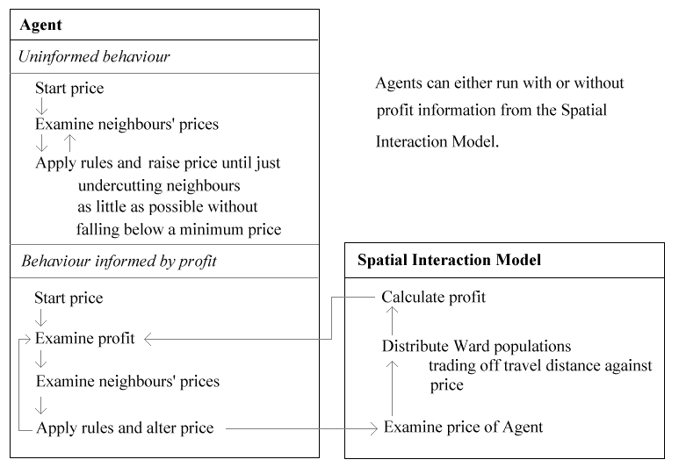
Figure 5: Conceptual representation of the interaction of the agent and spatial interaction model.

8. Comparison of the Agent and Hybrid Model Performance

The hybrid model was tested against known data for pump prices in the West Yorkshire area in the months of July and August 1999. The results using strategies based solely on the price of the neighbouring stations (no involvement of the spatial interaction model) showed that the agent model was representing some of the processes within the system. The best model performances came from simulations that hit equilibrium rapidly. In these cases, the agent model was not modifying the prices so the results were effectively the same as doing nothing (Figure 6). In reality the primary motivation for a petrol station is the maximisation of profit which these strategies cannot capture. This information on sales (and hence profit) was incorporated by building and attaching a spatial interaction model to the agent model. This hybrid agent model has a sounder theoretical basis (it models real processes), but by solely assessing Figure 6 does not appear to improve on the performance of the agent model. However, this is misleading.

Figure 6: Graph showing the comparison of the trends of the mean price difference for the agent and hybrid model over time.

A better test of the performance of the two models is to assess whether they can reproduce the spatial variations in price observed in the real data. The agent and hybrid model were run with all the petrol stations being assigned the same initial price. The model was allowed to run to equilibrium. No price changes were observed with the agent model (Figure 7 (a)), since the rules used assumed that this was a stable situation. The hybrid model performs much better (Figure 7 (b)), and is beginning to reproduce price variations similar to that observed in the real data (Figure 7 (c)), for example between high priced rural areas and cheaper urban areas. The model still needs to produce a little more price differentiation within the urban areas. This might imply that the rules for rural and urban agents need to be differentiated in future experiments.

9. Spatial Diffusion of Price Changes

Experimentation was undertaken with the hybrid model to assess the spatial diffusion of price changes through the system. Idealised conditions were employed to standardise location distribution effects and allow an easier understanding of the patterns produced by the hybrid-model. A grid was constructed over a 20km x 20km area. At 0.5km intervals, petrol stations were located. Each square represents a ward (the ward centre is located at the centre of the square) and contains a population of 2000. Every petrol station was assigned the same price (68p) with the centre station set to 63p. It is hypothesised that the cheaper price at the centre station would diffuse through the system at different rates according to the neighbourhood size.

The initial price drop at the centre station was found to gradually spread out to the surrounding area (Figure 8). By the end of the simulation, the price change has diffused
Figure 7: Interpolated price surface maps showing the final equilibrium state of the agent model (a), hybrid model (b) and the real data for the first day (c) as a comparison.

out to all of the stations. Figure 9 shows the total price change as a function of distance from the centre station at various times. This illustrates that for a given time there is a relatively sharp interface between the region which has been strongly affected by the price drop and the more distant region where there is only a small drop in price. The rate at which this interfaces propagates through the system is relatively constant with a value of about 0.1km per day in this simulation. For distances less than the interface the price change is more or less constant at about -6.5p. At greater distances the price change slowly drops during the simulation, but in this case never reaches less than about -3p.

 |  |  | 
t = 1 | t = 40 | t = 60 | t = 132
Figure 8: Spatial diffusion of price changes across the surface at different time (t) stages using a 1km neighbourhood.

Figure 9: Plot of total price change against distance for various times (t) using a 1km neighbourhood to illustrate the propagation of price changes throughout the system.

Varying the size of the neighbourhood had the effect of increasing the rate of dispersion (Figures 10 and 11). The larger the neighbourhood, the faster the price change dispersed. For example, within a neighbourhood of 1km, the prices diffused out at 0.1km per day. With a 5km neighbourhood, the rate of diffusion had increased to 0.9km per day.

 |  | 
1km  Diffusion rate = 0.1km per day | 3km  Diffusion rate = 0.5km per day | 5km  Diffusion rate = 0.9km per day

Figure 10: Comparison of the spatial diffusion of different neighbourhood sizes at
t = 20.

Figure 11: Comparison of the spatial diffusion (and rates) of different neighbourhood sizes at t = 20

10. Re-creation of Rural-Urban Divide: Idealised Simulations

Examination of the real data provided evidence of a rural – urban price difference. Within rural areas, the prices were generally more expensive than those of petrol stations located in urban areas. This is hypothesised to be related to several factors; the density (and therefore level of competition) of petrol stations within an area; the different population densities within rural and urban areas and the different rural – urban policies that petrol station companies may operate. The study area, West Yorkshire, contains non-uniform distributions of both population and petrol stations. These conditions make it difficult to understand which factors are important in the formation of this rural-urban divide. Idealised simulations were therefore used. The first simulation was constructed over a 20 x 20 grid (each square representing 4km² with a population of 2000 per km²). Within the centre a 144km² area (6x6 squares) was selected and the population was doubled to 4000 per km² thus creating an artificial “city”. Each of the (evenly spaced) petrol stations was assigned the same price (68p) and rules and the model was run to equilibrium.

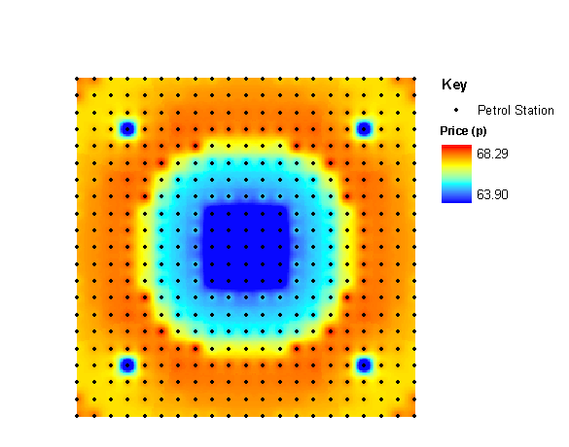

Figure 12: Re-creation of the rural-urban divide within a 20 x 20km grid with one “city”.

Figure 12 clearly shows that under idealised conditions and with the application of identical rules to all of the stations, a clear rural – urban divide is produced. The prices within the highly populated urban areas are much cheaper than those found within the less populated rural areas. However, one major criticism of this procedure is that it is difficult to distinguish between the rural and edge effects. The higher prices within the rural areas may in fact be due to these edge effects. To explore this further, a second idealised simulation was run on a larger grid (40 x 20km) with two “cities” (Figure 13).

The patterns in Figure 13 are similar to those seen in Figure 12. However, the rural region situated between the two cities has a higher price than the centre of either city. As this region is also situated away from the edge of the grid, this suggests that the urban-rural divide is a result of the different population densities rather than the edge effects. Further work will be concentrated on running simulations on larger grids and cutting out the areas of potential edge effects as well as experiments with a non-uniform distribution of petrol stations.

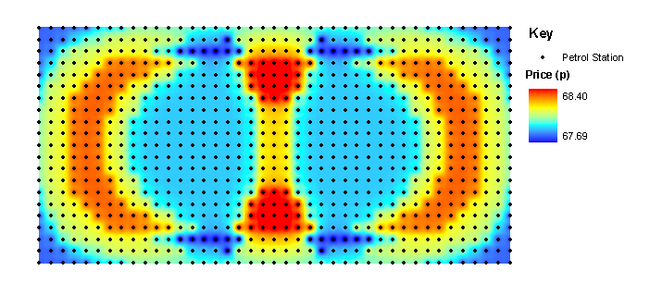
Figure 13: Re-creation of the rural-urban divide within a 40 x 20km grid with two “cities”.

11. Re-creation of Rural-Urban Divide: Real Data

Experiments were also undertaken with the real data to see if the rural – urban divide could be recreated. A larger area with mixed urban and rural sectors was selected (West and South Yorkshire). Each petrol station was given the same price (68p) and rule set and run to equilibrium. Figure 14 shows that the areas with the highest population densities (urban areas) have the lowest petrol prices and in general, rural areas have higher prices. These results add further substance to the argument that the rural - urban divide is due to the effect of the rules and population densities and not edge effects. However, the results in Figure 14 are not perfect, for example, Sheffield, one of the largest cities in the region, sustained some of the highest prices. The city of Sheffield spans South Yorkshire and North Derbyshire, and possesses one of the highest population densities within the study area. It is likely that due to the city being isolated geographically within this experiment (i.e. it is cut off from its rural hinterland), the majority of people are buying petrol from the nearest station. These stations will carry on increasing their price (to increase their profit) if there is no competition. This would result in higher prices being sustained in this area. A natural extension to this work would be to increase the area over which the experiment is being conducted.

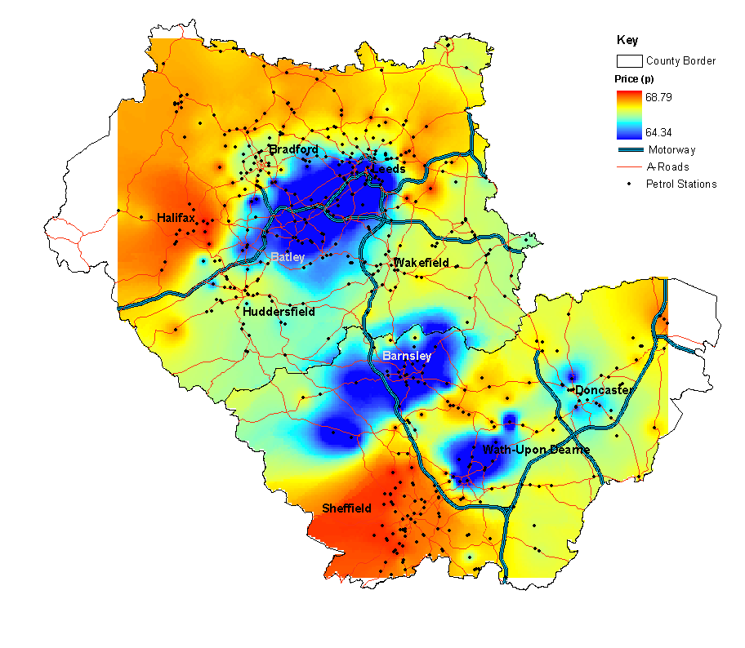
Figure 14: Recreation of the rural and urban areas within the real data (West and South Yorkshire).

Conclusions

In this paper we have demonstrated a hybrid multi-agent model of a petrol market populated by self-interested (profit maximising) agents. This model was found to outperform a multi-agent model that did not account for important customer behaviour, for example the movements and patronage of consumers. Despite the good performance of the hybrid model, further experimentation with the assignment of different rules to individual brands is required to reproduce the interactions that occur within real markets. Further experimentation possibilities include temporal variations in external factors, such as crude oil prices.

Idealised experiments with a regular distribution of petrol stations and population showed how the prices diffused throughout the system. The rate of diffusion was relatively constant and dependent on the size of the neighbourhood for each of the experiments. The system reached an equilibrium state where there was little variation in price across the stations.
Determining whether a rural-urban divide could be reproduced by application of the same rule set to each petrol station was tested using idealised and real simulations. A rural – urban divide was found, with highly populated areas sustaining lower prices (urban areas) than sparsely populated (rural) areas. This phenomenon could not have been achieved without the incorporation of the sales information that the inclusion of the spatial interaction model provides.

Multi-agent systems provide an ideal framework in which a retail market can be accurately described. Individual agents (petrol stations) can be successfully supplied with detailed knowledge of the market by the attachment of more specialised models, such as spatial interaction models. This type of model can be extremely valuable when modelling trends at a regional level. The outcome of local interactions can be easily seen at a global level. This flexibility, coupled with the upsurge in readily available computing power makes agent-based modelling an incredibly valuable tool. This has empowered researchers with the ability to both model complex systems at a finer resolution and to extend theoretical ideas to real world problems.

Acknowledgements

The work reported within this paper is funded by the ESRC and G-Map. All digitised boundary data are Crown and ED-Line Copyright.

References

ABHARAT, R.J. and SEE, L., 2000, Comparing Neural Network and Autoregressive Moving Average Techniques for the Provision of Continuous River Flow Forecasts in Two Contrasting Catchments, Hydrological Processes, 14, pp. 2157 – 2172.

BACON, R. W., 1991, Rockets and Feathers; the Asymmetrical Speed of Adjustment of UK Retail Gasoline Prices to Cost Changes, Energy Econ. 1, pp. 211 – 218.

BIRKIN, M., CLARKE, C. and CLARKE, M., 2002, Retail Geography and Intelligent Network Planning. Wiley.

BRENNER, W., ZARNEKOW, R., and WITTIG, H., 1998, Intelligent Software Agents: Foundations and Applications. Springer-Verlag.

CASTANIAS, R. and JOHNSON, H., 1993, Gas Wars: Retail Gasoline Price Fluctuations. The Review of Economics and Statistics, 75, pp. 171 – 174.

DEKRUGER, D. and HUNT, B.R., 1994, Image-Processing and Neural Networks for Recognition of Cartographic Area Features, Pattern Recognition, 27(4), pp. 461 – 483.

DIPLOCK, G. and OPENSHAW, S., 1996, Using simple genetic algorithms to calibrate spatial interaction models. Geographical Analysis, 28:262–279.

ECKERT, A., 2002, Retail Price Cycles and Response Asymmetry. Canadian Journal of Economics, 35, pp. 52 – 77.

ECKERT, A., 2003, Retail Price Cycles and the Presence of Small Firms. International Journal of Industrial Organisation, 21, pp. 151 – 170.

FERBER, J., 1999, Multi-Agent Systems: An Introduction to Distributed Artificial Intelligence. Addison – Wesley.

FISCHER, M.M., 1994, Artificial neural networks: a new approach to modelling interregional telecommunication flows. Journal of Regional Science, 34, pp. 503–527.

FRANKLIN, S. & GRAESSER, A., (eds)., 1996, Is it an agent, or just a program? Proceedings Third International Workshop on Agent Theories, Architectures and Languages, Budapest, Hungary, pp. 193 - 206.

GALOETTI, M., LANZA, A. AND MANERA, M., 2003, Rockets and Feathers Revisited: An International Comparison on European Gasoline Markets. Energy Econ, 25, pp. 175 – 190.

GAGARIN, N AND FLOOD, I. AND ALBERT, P., 1994, Computing Truck Attributes with Artificial Neural Networks, Journal of Computing in Civil Engineering, 8(2), pp. 131 – 148.

GOODWIN, P. & WRIGHT G., 1993, Improving judgmental time-series forecasting - a review of the guidance provided by research. International Journal of Forecasting, 9(2), pp. 147-161.

JENNINGS, N.R., 2000, On Agent-based software engineering. Artificial Intelligence, 117, pp. 277 – 296.

LEK, S. AND GUEGAN, J. F., 1999, Artificial Neural Networks as a tool in Ecological Modelling, an Introduction, Ecological Modelling, 120(2 – 3), pp. 93 – 102.

MAES, P., 1994, Agents that reduce work and information overload. Communication of the ACM, 37, pp. 68-71.

MANNING, D.N., 1991, Petrol Prices, Oil Price Rises and Oil Price Falls: Evidence for the UK since 1972. Applied Economics, 23, pp. 1535 – 1541.

MITCHELL, J.D., ONG, L.L. and IZAN, H.Y., 2000, Idiosyncrasies in Australian Petrol Price Behaviour: Evidence of Seasonality’s. Energy Economics, 28, pp. 243 – 258.

NOEL, M., 2002, Edgeworth Price Cycles in Retail Gas Markets, PhD Thesis.

NWANA , H.S., 1996, Software Agents: An Overview The Knowledge Engineering Review, 11(3), pp. 205 – 244.

O'SULLIVAN, D. AND HAKLAY, D., 2000, Agent-based Models and Individualism: Is the World Agent-Based?, Environment and Planning A, 32(2), pp. 1409 – 1425.

PAVE, A., 1994, Modelisation en biologie et en ecologie. Lyon, Aleas.

RECKNAGEL, F., FRENCH, M., HARKONEN, P. AND YABUNAKA, K-I., 1997, Artificial Neural Network Approach for Modelling and Prediction of Algal Blooms, Ecological Modelling 96, pp. 11- 28.

REILLY, B. and WITT, R., 1998, Petrol Price Asymmetries Revisited. Energy Economics, 20, pp. 297 – 308.

SCHELHORN, T., O'SULLIVAN, D. AND HAKLAY, M., 1999, STREETS: An Agent-Based Pedestrian Model, CASA Working Paper 9, University College London, Centre for Advanced Spatial Analysis.

SEE, L. AND OPENSHAW, S., 1997, An introduction to the fuzzy logic modelling of spatial interaction. In: Proceedings of the Joint European Conference and Exhibition on Geographical Information, 16-18 April 1997, Vienna, Austria, IOS Press, pp. 809-818.

SHIN, D., 1994, Do Petrol Prices Respond Symmetrically to Changes in Crude Oil Prices? OPEC Review, 32, pp. 137 – 157.

TORRENS, P. M. AND O'SULLIVAN, D., 2000, Cities, Cells, and Complexity: Developing a Research Agenda for Urban Geocomputation 2000.

TSVETOVAT, M. AND CARLEY, K., 2002, Emergent Specialisation in a Commodity Market: A Multi-Agent Model, Computational and Mathematical Organisation Theory, 8, pp. 221 – 234.

WOOLRIDGE, M., 1997, Agent-based Software Engineering, IEE Proc. Software Engineering 144, pp. 26 – 38.

