First NetLogo Model
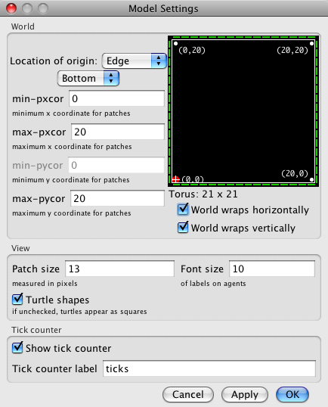
This document will take you through how to create a simple model using NetLogo. The model will have a few turtles (agents) in it who wander around aimlessly eating grass.
- Open NetLogo!
- Set up the environment
  - Right-click on the display and choose ‘Edit’
  - Set the world to be a 20x20 grid (max-xcor, max-ycor) that wraps both horizontally and vertically with the origin in the bottom-left corner. All other defaults are OK (see image on right).
  - Click OK. Now the world is ready.
- Create a button which will set-up the environment.
  - Click on the drop-down list next to “Add” and select “Button”
  - Move the mouse to where you would like the button to be and left-click to place it.
  - In the new menu that appears you can specify what the button should do. Enter “setup” in the commands box – this will mean that a procedure called “setup” is called when the button is clicked (we will create this procedure in a minute). The “Display Name” is a label for the button, you set this to be whatever you want to.
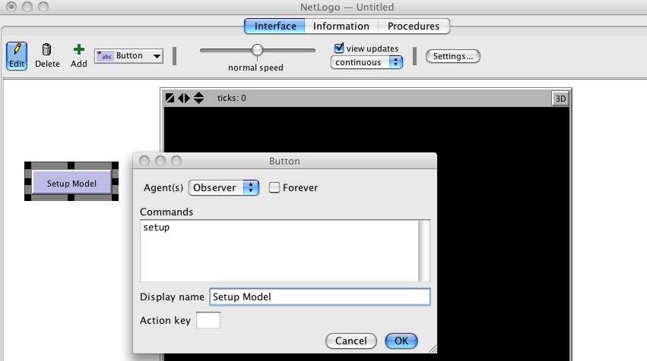
  - Click on OK to finish the button. You can see that the button is red which means it refers to a procedure that hasn’t been created yet, let’s do that now.
- Create the “setup” function
  - Click on the “Code” tab. This is where we add all the model code.
  - Enter the following text to define the “setup” function:

to setup
print "Setting Up Model"
end
  - All the function does so far is print a message.
  - Check this works by clicking on the “Interface” tab and then clicking on the button, you should see a message displayed in the console and the bottom of Netlogo.
- Creating a slider for the number of turtles.
  - Let’s add a slider so we can set the number of turtles to create. This is the basically the same as creating a button, you choose where to add the new slider and then configure it.
  - The “Global variable” box is where you type in the name of the variable that the slider will change, call it “initial-number-of-turtles”. We can then refer to this global variable in our procedures.
  - You can set the minimum and maximum values and the amount the values should change as you move the slider around. Set the minimum to be 0 (no turtles) and the maximum to be 100. We don’t make use of this slider yet, but we will do in a few steps.
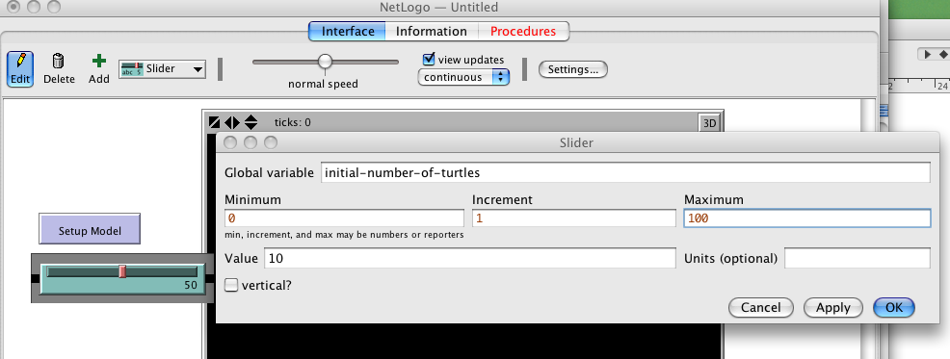
- Setting up the patches and turtles.
  - Now we’ll improve the “setup” function so that it does something useful. Change your setup function so it now reads:
to setup
print "Setting Up Model"
clear-all
reset-ticks
setup-patches
setup-turtles
end
  - “clear-all” is a NetLogo command that clears up everything ready for us to create a new model. “reset-ticks” resets the “ticks” counter that you can use to count iterations.
  - The other two lines actually call two new functions that will setup the turtles and the patches. Here is the code for these two new functions, paste it after the “setup” function (note that anything after a ‘;’ is a comment and won’t be read by NetLogo).

to setup-patches
ask patches [ set pcolor green ] ; Set all the patches' colour to green
end

to setup-turtles
; Create the number of turtles specified by the slider
create-turtles initial-number-of-turtles [
; Here we can set the values for each of our turtles
set shape "turtle" ; Make them look like turtles
setxy (random 20) (random 20) ; Set the turtle's x,y coord
set color blue ; Set its colour
]
end
  - Now if you press the setup button you should see a few turtles created around the grid.
- Create a ‘go’ button which will run the simulation
  - To finish the model we need to create a go button which will run the model. Create the button in the same way you created the setup button, but this time check the “Forever” box, this will call the function repeatedly.
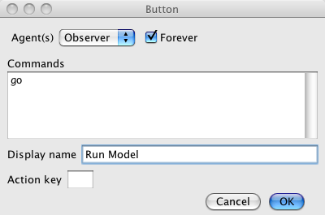
  - Add the code for the button by adding this with the other procedures:
to go
; Go through each turtle, tell them to move around and to eat grass
ask turtles [
; Move one step in a random direction
rt random 360 ; Rotate a random amount between 0 and 360
fd 1 ; Go forward one step
; If the turtle is on a patch of grass, eat it.
if pcolor = green [
set pcolor brown ; set the patch colour to brown
]
]
tick ; Increment the time counter
end

That’s it! We now have a very simple simulation with some turtles moving around eating grass. When you click on the “go” button you should see the turtles move. If the grass disappears too quickly you can slow the simulation down by using the slider at the top. To restart the simulation, press the setup button.
There are loads of possible extensions to the model. For example we could also add a graph to show how much grass is left in the environment, we could make the grass grow and we could make the turtles die if they don’t have enough energy. The Wolf Sheep Predation model in the Models Library has lots of these functions, but we have also included a slightly more advanced version of our turtles model which you can have a look at for ideas. All the new functionality has been added with only a few extra lines of code! Both the advanced version and the simple version are also available on the VLE.
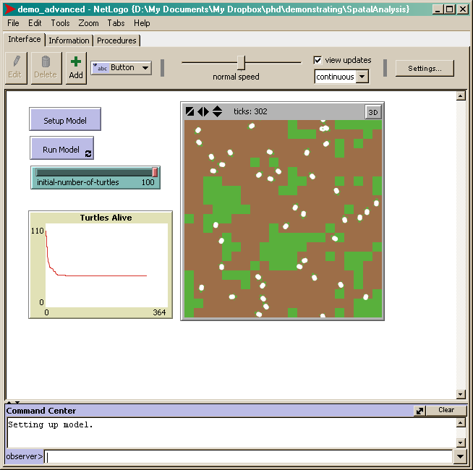
A slightly more advanced version of the demo model. Grass grows and can be eaten, turtles die if they do not eat enough grass and there is a graph to show how many turtles are alive. This is available on the VLE.

