QCA: Key Stage 2

Unit 10

‘A Village in India’

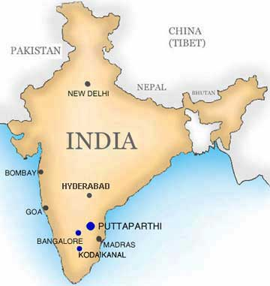

Contents

Title Page

Contents 2-3

1. Introduction 4

2. Lesson Plans

2.1 Lesson Plan One- What is India like? 5-7
2.1.1 Lesson Plan
2.1.2 WALT: ‘Map of Asia’ worksheet

2.2 Lesson Plan Two- What is a city in India like? 8-11
    - Lesson Plan
    - City slideshow (on accompanying CD 2)
    - ‘A Day in the Life of Shakeel’ powerpoint presentation (on accompanying CD 2)

2.3 Lesson Plan Three- How is India connected to other places? 12-16
2.3.1 Lesson Plan
2.3.2 ‘Flying to India’ worksheets
2.3.4 Aeroplane template

2.4 Lesson Plan Four- What is the landscape of Chembakolli like? 17-20
2.4.1 Lesson Plan
2.4.2 WALT: ‘The Landscape of Chembakolli’ worksheet
2.4.3 ‘Chembakolli Village’ map

2.5 Lesson Plan Five- What is the landscape of Chembakolli like? 21-24
2.5.1 Lesson Plan
2.5.2 ‘Chembakolli Village’ map with grid system overlain
2.5.3 WALT: What’s Where? worksheet

2.6 Lesson Plan Six- What are the home of the children in Chembakolli like? 25-28
    - Lesson Plan
    - Photo slideshow (on accompanying CD 6)
    - ‘WALT: Similarities and differences of homes in Chembakolli compared to Bramley’ worksheet

2.7 Lesson Plan Seven- What are the home of the children in Chembakolli like? 29-30
    - Lesson Plan

2.8 Lesson Plan 8- What is the main type of work in Chembakolli? 31-33
2.8.1 Lesson Plan
2.8.2 Photos of the type of work in Chembakolli (on accompanying CD 8)
2.8.3 ‘Farming in Chembakolli’ passage

2.9 Lesson Plan 9- What is daily life like in Chembakolli? 34-40
2.9.1 Lesson Plan
2.9.2 ‘Going Places’ worksheet
2.9.3 ‘A Day in the Life of Chanda: a woman from Chembakolli village’

2.10 Lesson Plan 10- How does your life compare to a child growing up in Chembakolli? 41-43
    - Lesson Plan
    - WALT: Similarities and Differences between Bramley and Chembakolli

3. WPCP Report 44-46
4. Resources/References 47-49

1. Introduction

The following document contains a comprehensive set of teaching resources relating to the QCA Unit 10 module, ‘A Village in India’. Although this module was developed by QCA, as part of the Year 4 syllabus, it has been adjusted so that it can be used in Year 5 classes as well. Each lesson plan is presented in an easy to follow format that was requested by the school involved in the placement.

There are ten lesson plans presented, detailing the learning objectives, outcomes, resources required, and instructions on how the lesson is intended to be used. All worksheets, slideshows and PowerPoint presentations used in this module are either provided in the written document or attached separately. A list of resources and references used in developing the teaching materials can be found at the end of the document. Other informative materials can be found in Appendicles A, B, C, D and E

No time constraints were given to the structure of the lesson plans. However, in general, the introduction was limited to 10-15 minutes and consisted of class activities, the main activities were prepared with a time framework of 40 minutes in mind and centred on group work. The plenary was designed to last approximately 10 minutes and again, involved group work.

2.1 Lesson One

2.1.1 Lesson Plan One – What is India like?

Enquiry Questions

- Which countries and seas boarder India?
- What shape is India?
- What are the main physical features of India?
- What is the climate like in India?

Learning Objectives

- To investigate places
- To respond to geographical question
- To use and interpret globes, atlases and maps
- To use secondary sources
- To use ICT to access information
- To identify physical features

Learning Outcomes

- Locate UK and India
- Draw maps

Resources

- Atlas 2
- Globes
- Maps of India (different scales)- Wall map available (green folder)-PCET
- Children’s blank maps (annotated with dots and dotted lines)
- Smart notepad (map of Asia)
- The World Factbook (2006) http://www.cia.gov/cia/publications/factbook/geos/in.html#Intro, ISSN 1553-8133

2.1.1 Lesson Plan One – What is India like?

Introduction

- Whole class activity
- Brainstorm about what the children already know about India and annotate on to the blackboard. Use the pre-set homework information to do this.
- Look at maps of India – Atlas 2 page 36 add extra information to brainstorming session.
- Introduce the physical map of India and again, add more details.

Main activity

- This is to be done in pairs.
- Using maps and atlases of India on a variety of different scales, locate the following places and features on to the blank map of India;
  - India
  - New Delhi
  - Calcutta
  - River Ganges
  - Himalayas
  - Chembakolli
  - Thur Desert
  - Bangalore
  - Mumbai (Bombay)
  - Pakistan
  - China
  - Bangladesh
  - Nepal
  - Bay of Bengal
  - Indian Ocean
  - Arabian Sea
  - Sri Lanka

Plenary

- Use interactive white board to get the pupils to indicate the location of selected places and features that have been mentioned in the lesson.

2.1.2- Map of Asia

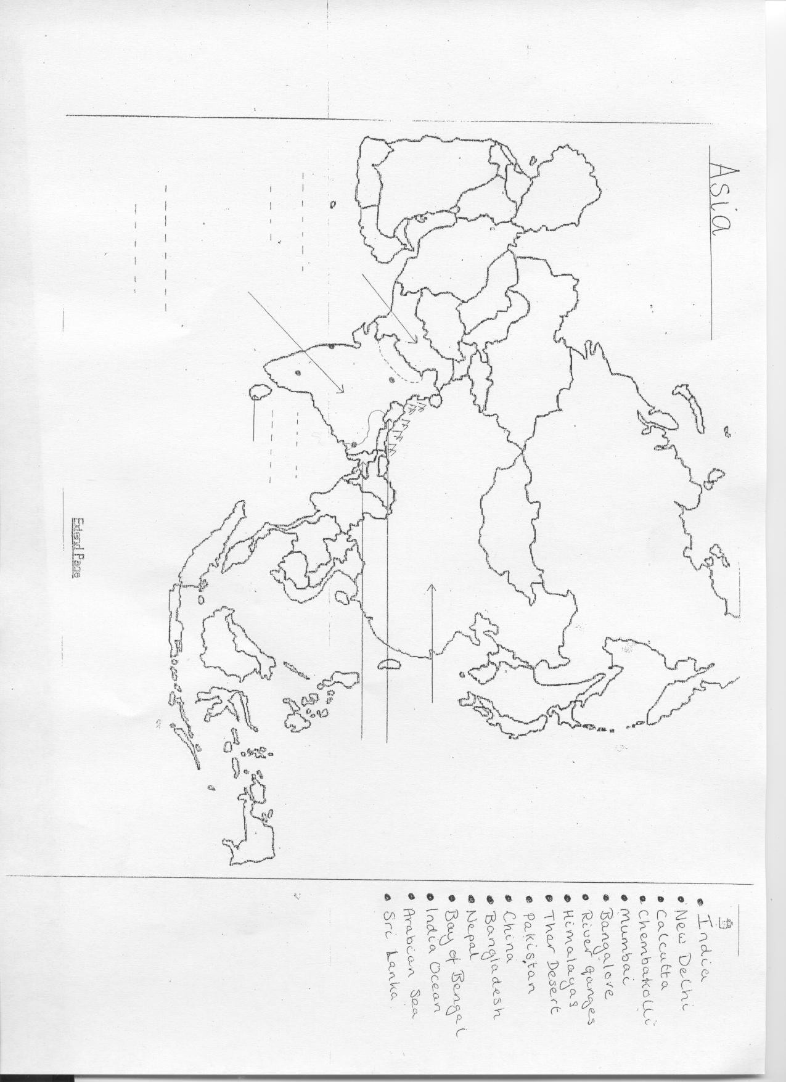

2.2 Lesson Plan Two

2.2.1 Lesson Plan– What is a city in India like?

Enquiry Questions

- What is life like for a child living in India?

Learning Objectives

- To identify similarities and differences between places
- To investigate places
- To use secondary resources
- To identify physical and human features

Learning Outcomes

- To understand what life is like as a child growing up in India
- To overcome stereotypes of cities in less economically developed countries.

Resources

- Slideshow of cities in the UK and India
- PowerPoint presentation of A day in the life of Shakeel
- Worksheet of similarities and differences between their life and Shakeel
- Cards labelled ‘India’ and ‘UK’
- Smartboard

2.2.1 Lesson Plan – What is a city in India like?

Introduction

- General brainstorm about the city- What would you expect to see in a large city? Use smartboard notepad.
- Slideshow of cities from the UK and India. Students, in pairs, decide whether the city on the whiteboard is in the UK or India, using pre-prepared cards which read UK on one and India on the other they vote. They hold up the card depending on their choice. Ask questions about the children’s reasoning.

Main Activity

- PowerPoint presentation of ‘A Day in the life of Shakeel’ who lives in a suburb of a large city.
- Picture first then caption.
- Ask the children what activity they think Shakeel is doing in the picture.
- Afterwards, the students identify similarities and differences between their lives and Shakeel’s on a worksheet, in pairs.

Plenary

- Brainstorm about what it would be like to live in an Indian city on the smartboard.

(Section 2.2.2 and 2.2.3 are on accompanying CD ‘2’)

    - WALT: Similarities and Differences and between your life and Shakeel’s

YOUR LIFE SHAKEEL’S

2.2.6- Cards (to be laminated)

UK

India

2.3 Lesson Plan Three

2.3.1 Lesson Plan - How is India connected to other places?

Enquiry questions

- How would you travel to India?
- What are the advantages of travelling by sea rather than air?

Learning Objectives

- How places relate to each other
- Use and interpret atlases and maps
- Draw routes
- Use secondary resources

Learning Outcomes

- Follow a route to India on a map
- Identify countries and capitals

Resources

- Atlases
- Internet- Expedia (search-‘India’)
- World map, wall/smartboard
- Aeroplane template
- Blank World map

2.3.1 Lesson Plan Three- How is India connected to other places?

Introduction

- Look at the world map on the smartboard or wall, identify India, Chembakolli and the nearest airports with the students.
- Discuss the distance from London to the nearest airport in India.
- How could you travel to India?
  - Vote on best transport method
- Identify any continents or areas (oceans) that would have to be crossed.
- Using an aeroplane template get the students to track across the map from the UK to India.

Main activity

- In pairs, using atlases, track the most efficient route on to the map (P21 & 33).
- Colour in different colours, the countries which have been crossed on route.
- Construct a list of countries and capitals that have been crossed.

Plenary

- Bring in a guest speaker for the students to ask questions about how she/he travelled to India, and possibly a general question and answer session depending on time constraints.

  - Possible guest speaker- Susannah Flexer, Medical Student at the University of Leeds who travelled to India in the summer of 2005 to work in an Indian hospital in the city but lived in a village outside with a family. Tel no: 07977432914. Has agreed to come in and speak if required.

2.3.2 Flying to India

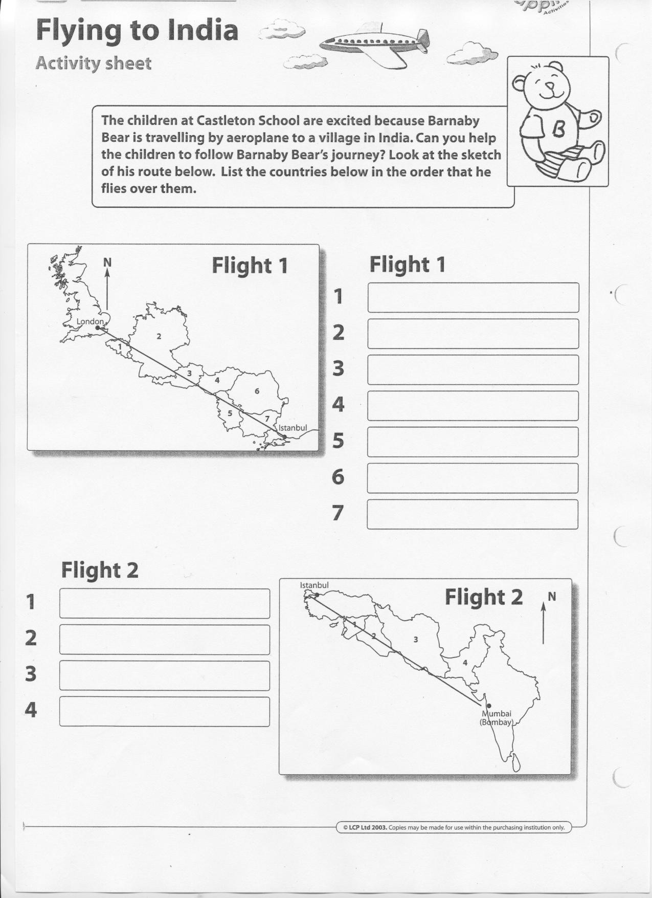

2.3.3- Aeroplane Template



2.3.4- Map used on Smartboard

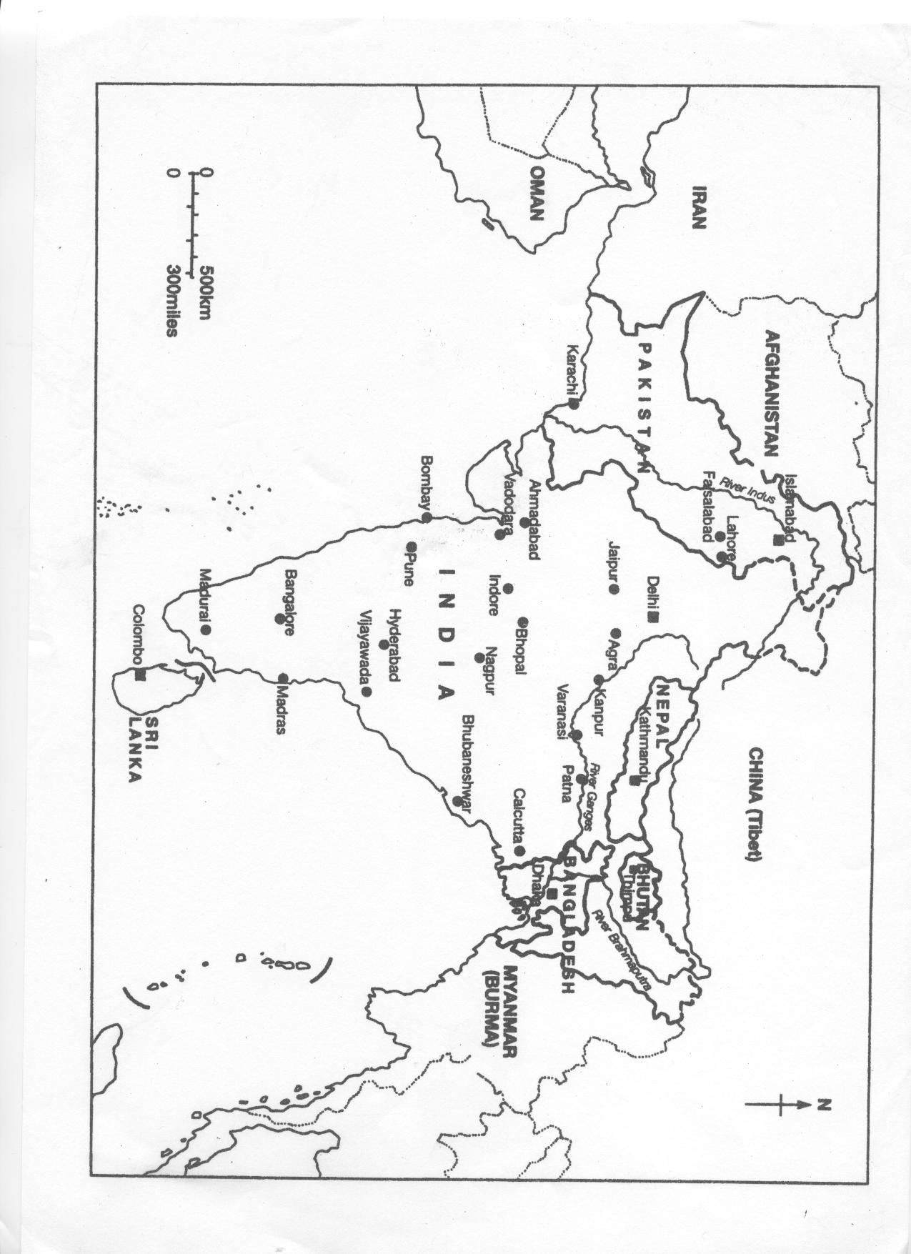

2.4 Lesson plan 4

2.4.1 Lesson Plan 4- What is the landscape of Chembakolli like?

Enquiry questions

- What can photographs tell us about a place?
- What is the landscape of Chembakolli like?

Learning objectives

- To identify the main physical and human features of Chembakolli
- To complete a map to show the main features of

Learning Outcomes

- Recognise main physical and human features of the landscape
- Complete a map to show the main features of the settlement

Resources

- Map with annotations blanked out
- List of features to be labelled
- Photographs of Chembakolli and surrounding landscape
- Whiteboard

2.4.1 Lesson Plan 4- What is the landscape of Chembakolli like?

Introduction

- Look at one photograph of Chembakolli on the whiteboard and brainstorm features of the photo.
  - Activity involving the whole class.
  - List the answers the students suggest.

Main activity

- Working in pairs students complete the worksheet entitled, ‘The Landscape of Chembakolli’, marking the boxes which best describe their photograph.
- In groups of four, each pair discusses their photograph i.e. they describe what the place looks like and the functions (school, cinema, market) that are represented in their photograph.
- Using the whiteboard, select pairs of students to discuss what they have found out about the landscape.
- Brainstorm with the students possible functions and features that would be found in Chembakolli, and list on the whiteboard.
- Using a blanked out map of Chembakolli, and working in pairs, annotate the map with the words listed on the whiteboard and complete the rest of the worksheet, creating a key for the map.

Plenary

- Compare students’ maps with the original and discuss.

WALT: The Landscape of Chembakolli- using your photograph of Chembakolli, mark the boxes that best describe what you can see and answer the following questions.

Wet- Houses-

Dusty- Parks-

Crops- Huts-

Flat-

People-

Green-
Roads-

Tall buildings-

Hills-

Cars-
Trees-

Bicycles-

Question 1- What do you like most about the landscape of Chembakolli?

Question 2- What do you think is missing from the picture?

2.4.3- ‘Chembakolli Village’ Map

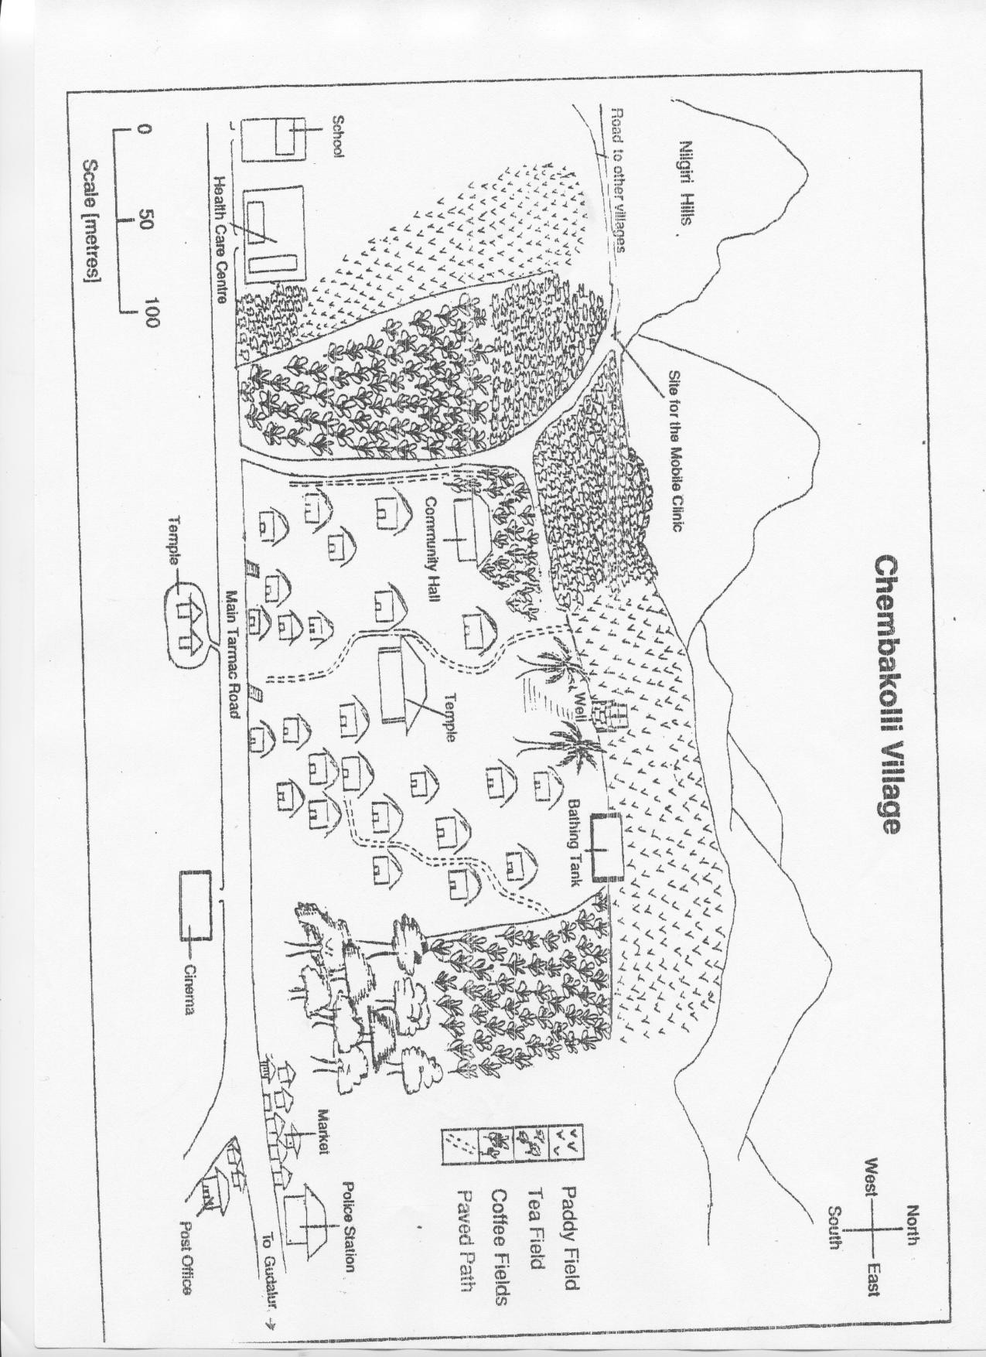

2.5 Lesson Plan Five

2.5.1 Lesson Plan - What is the landscape of Chembakolli like?

Enquiry Questions

- What can a sketch map tell us about a place?
- What can a sketch map tell us about how people live?
- How is the land used in Chembakolli?

Learning Objectives

- To identify the main physical and human features of Chembakolli, including land use
- To ask geographical questions
- To use a simple sketch map
- To use direction and distance

Learning Outcomes

- Describe the main features of the village
- Use a map to follow directions and routes
- Give reasons for location of facilities in the village

2.5.1 Lesson Plan- What is the landscape of Chembakolli like?

Introduction

- Brief revision of co-ordinates. This could be done using the sketch map provided for this lesson plan and asking the students where certain features of the map are located. Alternatively the students could be given grid references and collectively they find what land use is at the given co-ordinates.

- Identify the scale on the sketch map and explain how to use it

  - It may be useful to demonstrate the explanation using examples from the sketch map e.g. How far is it to the temple from the bathing tank?

Main Activity

- Individually complete the activity sheet, ‘What’s Where?

Plenary

- Go through the worksheet, the students can mark their own answers
- Teacher gives direction and the students have to follow

  - For example, leave the school-turn left-continue down the street and turn left etc the students have to identify the correct destination

2.5.2- ‘Chembakolli Village’ map with grid system overlain
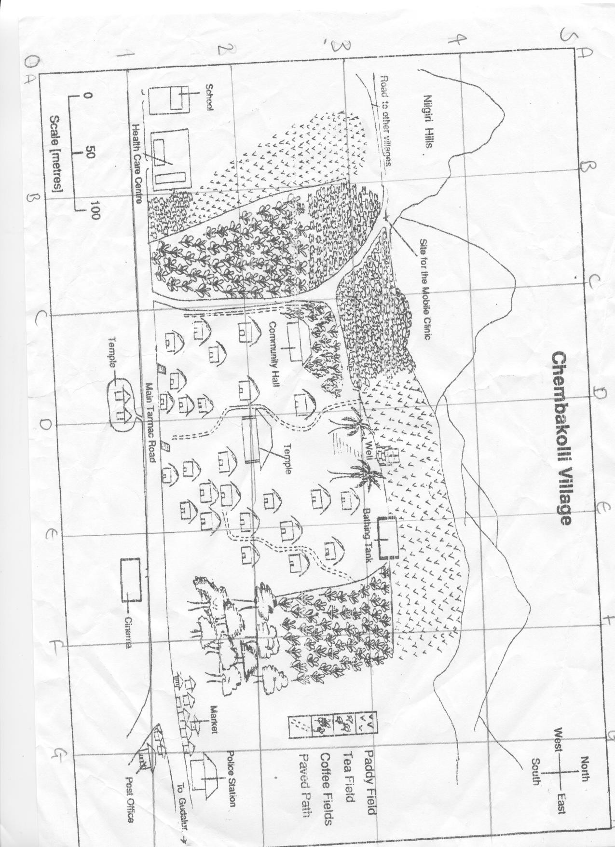

2.5.3 WALT ‘What’s where?’ Worksheet

WALT: What’s Where??

Answer the following questions using your ‘Chembakolli Village Map’

1. What feature is located in grid E4?

2. What feature is located in grid E0?

3. What feature is located in grid C3?

4. What feature is located in grid A2?

Using the scale on the map and a ruler

- Calculate the distance from the school to the bathing house?

- Calculate the distance from the bathing house to the cinema?

- Calculate the distance from the cinema to the police station?

- Calculate the distance from the police station to the community hall?

2.6 Lesson Plan Six

2.6.1 Lesson Plan- What are the homes of the children in Chembakolli like?

Enquiry Questions

- What are the homes of the children in Chembakolli like?
- What are the similarities and differences of the homes in Chembakolli like compared to Bramley?

Learning Objectives

- To use secondary resources
- To learn about similarities and differences between places
- Annotate pictures of features in a village
- To identify land-uses

Learning Outcomes

- Students are aware and able to discuss the main similarities and differences between homes in Bramley and Chembakolli.

Resources

- Interactive whiteboard
- Photos 8, 15, 20, 22 from the Chembakolli pack. (saved to floppy)
- Paragraph of card about homes in Chembakolli
- Key word list
- Plain paper
- Pencil Crayons

2.6.1 Lesson Plan- What are the homes of the children in Chembakolli like?

Introduction

- Using the interactive whiteboard look at photos 8 and 15 with the students
- The students note down, on their whiteboards, key words to describe the type of housing visible in the photos.
- Teacher gets feedback from the students and notes down the children’s responses.
- Use the action aid card describing housing in Chembakolli (located in the green India file)
- Using Photos 20 and 22 from the action aid pack, look at the inside of the houses and get the students to note down key words. Again, get feedback from the students and note down the children’s responses.

Main Activity

- Compare housing in Chembakolli to Bramley by completing two drawings. On a plain piece of A4 paper the students draw a picture of their own house and one of a typical Chembakolli house. Students then label the picture using key words that are attached in this lesson plan.

Plenary

- As a class, list the five most significant similarities and differences between homes in Chembakolli and Bramley.

(2.6.3 refer to CD ‘6’)

2.6.3 ‘WALT: Similarities and differences of homes in Chembakolli compared to Bramley’ worksheet

DRAW A PICTURE OF YOUR HOME IN BRAMLEY AND LABEL IT

DRAW A PICTURE OF A TYPICAL CHEMBAKOLLI HOUSE AND LABEL IT

2.6.4 Key words for lesson 6

Bamboo Chimneys

Fences/Hedges
Doors

Tiles
Veranda
Drain pipes

Thatched roofs
Wood

Glass windows

Brick

Patterned decorations
Mud

2.7 Lesson Plan Seven

2.7.1 Lesson Plan- What are the homes of the children in Chembakolli like? (Continuation of lesson plan 6)

Enquiry Questions

- What are the homes of the children in Chembakolli like?
- What are the similarities and differences of the homes in Chembakolli like compared to Bramley?
- What is the school in Chembakolli like?

Learning Objectives

- To use secondary resources
- To learn about similarities and differences between places
- Annotate pictures of features in a village
- To identify land-uses

Learning Outcomes

- Students are aware and able to discuss the main similarities and differences between homes in Bramley and Chembakolli.
- Students are aware and able to discuss the main similarities and differences between schools in Bramley and Chembakolli.

Resources

- Key word list (lesson plan 6)
- Shoeboxes
- Straws
- Card
- Glue
- Other material the teacher deems necessary
- Photos from floppy disc (lesson plan 6)
- Whiteboard

2.7.1 Lesson Plan 7 What are the homes of the children in Chembakolli like? (Continuation of lesson plan 6)

Introduction

- Re-cap last week’s lesson displaying the photos on the whiteboard
- Introduce photos of schools, found on the floppy disc attached to lesson plan 6, discuss the similarities and differences between Raynville and the school in Chembakolli.

Main Activity

- Make a model of a house in Chembakolli based on a shoebox with a roof made of card overlain with straw.

Plenary

Students show and talk about their models in front of the class using the keywords to describe the model. Key words should be displayed again on the whiteboard and are listed in lesson plan 6.

2.8 Lesson Plan 8

2.8.1 Lesson Plan - What is the main type of work in Chembakolli?

Enquiry Questions

- What is the land used for in Chembakolli?
- What jobs do men or women do in Chembakolli?
- What types of crops are grown in Chembakolli?

Learning Objectives

- To use secondary resources
- To identify land uses
- To begin to understand the relationship between economic activity and location

Learning Outcomes

- To become aware of economic activity
- To use photos and text to record different forms of land uses in and around the village

Resources

- Photos (floppy disc)- labelled ‘work in Chembakolli’ and located in green India file
- ‘The main type of work in Chembakolli’ passage giving facts on farming.

2.8.1 Lesson Plan- What is the main type of work in Chembakolli?

Introduction

- Using photos, on the accompanying floppy disc, ask the students to describe the work being done, establishing farming as the main work in the village as well as other types of working near the village.
- Also establish that the villages would have to travel to find other work.

Main Activity

- Working in groups of four the students go and read the passage on the following page which is stuck around the wall. They then come back to their table and recall one fact that they read to the rest of the group. In the end a mind map should have been constructed.

Plenary

- Get feedback on what each group know about farming.

(2.8.2 on accompanying CD ‘8’)

2.8.3 Farming in Chembakolli

Most families have a vegetable plot which provides food for the family. Crops grown in Chembakolli include bananas, potatoes, millets, okra, onions, tomatoes, herbs and spices. They also collect honey and grow tea, coffee and pepper to sell. Many women pick tea leaves and are paid about 50 rupees (equivalent to 70p) a day. The villagers also keep a few animals such as chickens and cows.

The villagers also collect forest plants which they use for food and medicine. Some villagers may work on large farms outside Chembakolli, these farms grow many different crops including rice and cotton.

2.9 Lesson Plan Nine

2.9.1 Lesson Plan- What is daily life like in the village?

Enquiry questions

- How is daily life different in Chembakolli?
- How does Chanda spend the day?
- When do people have to leave the village

Learning Outcomes

- To establish features of the Chembakolli and the surrounding area using secondary resources
- To realise the daily routine of a person from Chembakolli.

Learning Objectives

- To use secondary resources
- To identify local features
- To understand the lifestyle of a person from Chembakolli

Resources

- ‘Going Places’ worksheet
- Maps from previous lesson plans
- ‘Chanda’s Day’ worksheet

2.9.1 Lesson Plan- What is daily life like in the village?

Introduction

- Re-establish the location of Chembakolli by looking at maps, and note the surrounding towns and villages.
- Establish features of the surrounding area and village using the maps and key provided.

Main Activity

- Read ‘Going Places’ to add symbols to the map worksheet provided.
- If students complete this, read Chanda’s Day (Black India File), and begin writing a diary entry as if you were Chanda.

Plenary

- Read through answers to the ‘Going Places’ worksheet with the class and allow students to mark each others work.

2.9.2 ‘Going Places activity
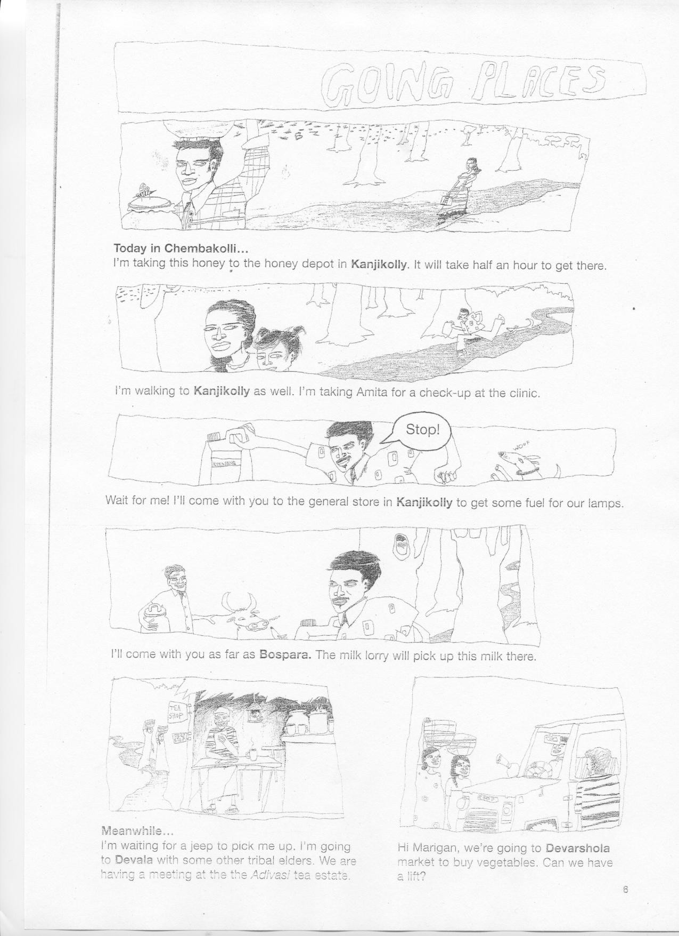

2.9.2 ‘Going Places activity

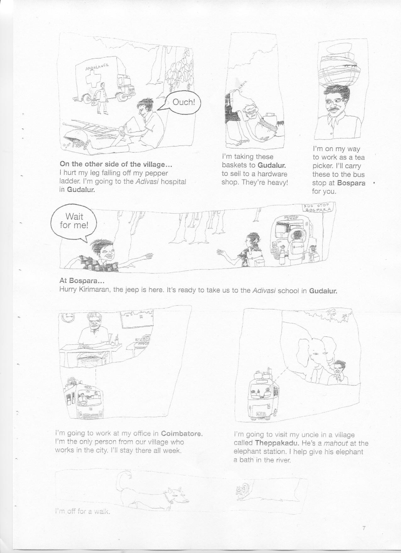

2.9.2 ‘Going Places activity

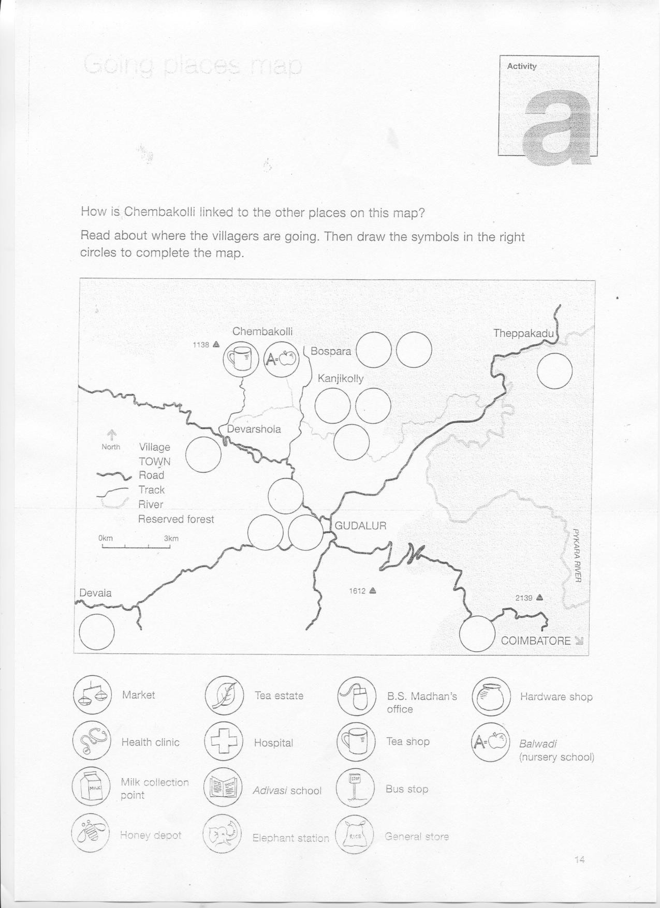

2.9.3 Chanda’s Day

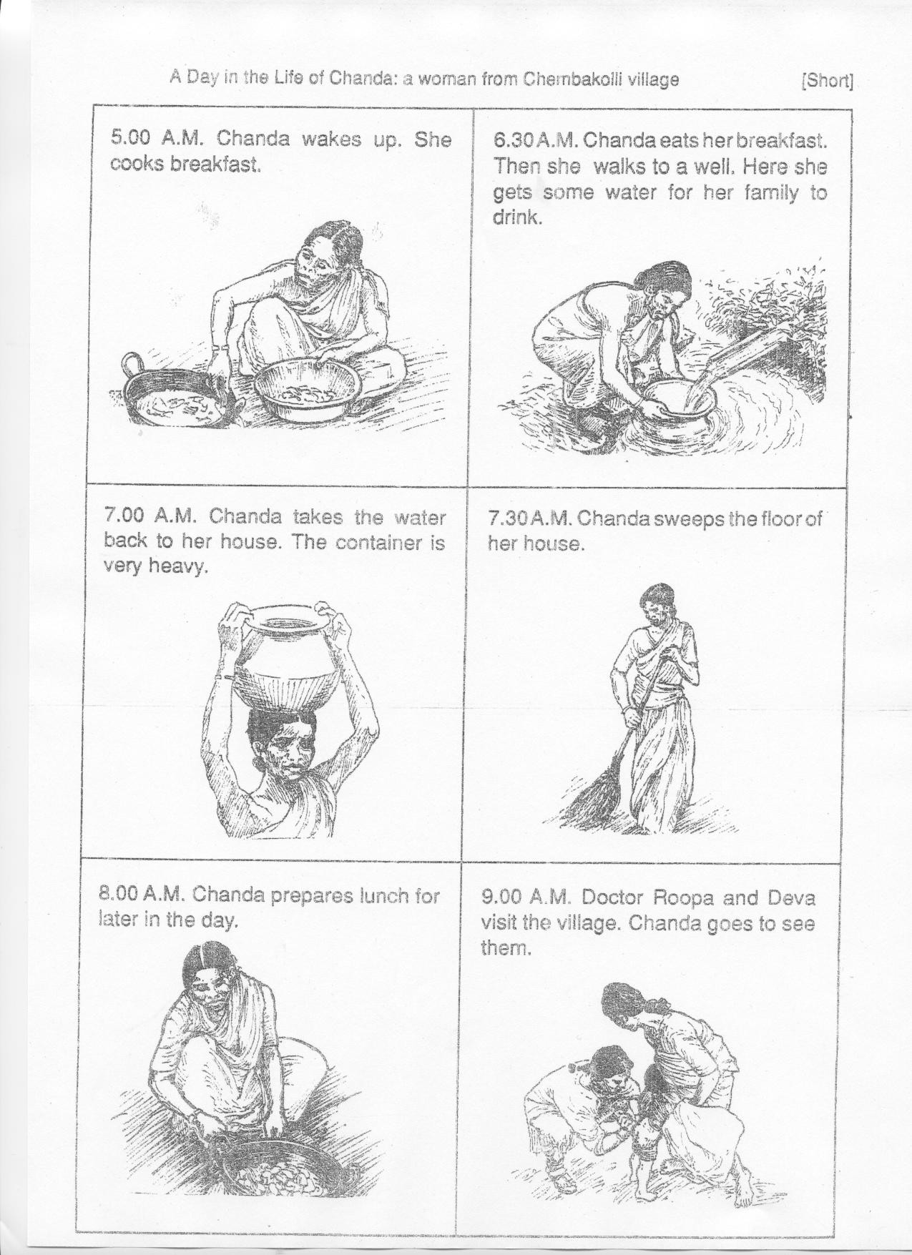

2.9.3 Chanda’s Day

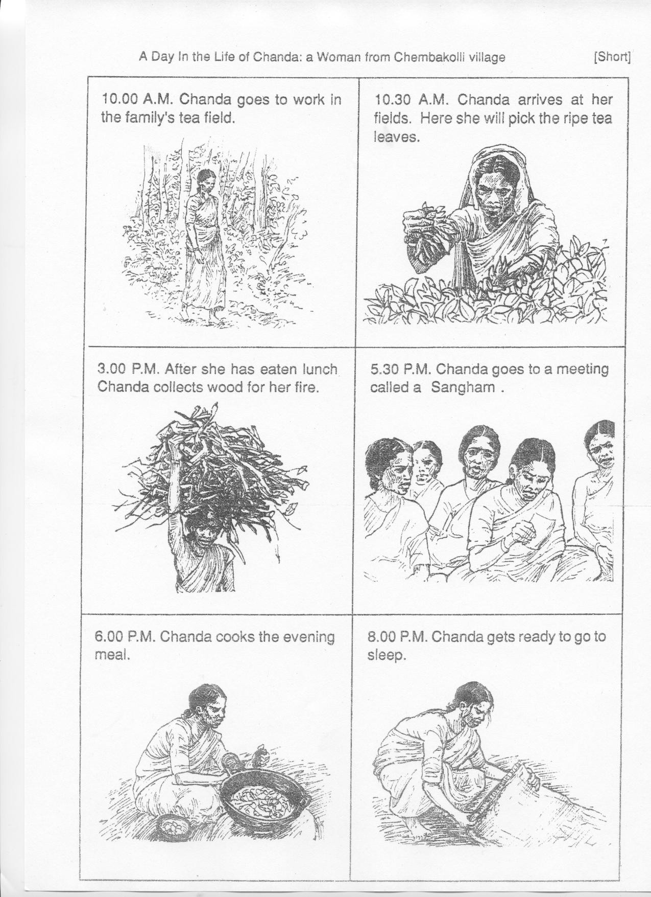

2.10 Lesson Plan Ten

2.10.1 Lesson Plan- How does your life compare to a child growing up in Chembakolli?

Enquiry Questions

- What have we learnt about Chembakolli?
- How does Chembakolli differ from Bramley?

Learning Objectives

- To use secondary resources
- To re-establish the location, lifestyle, features and land-uses in Chembakolli
- To establish differences between Chembakolli and Bramley
- To identify disadvantage and advantages of life in Chembakolli

Learning Outcomes

- To know the main features of Chembakolli and the surrounding area.
- To be aware of similarities and differences in two economically contrasting areas
- To understand the disadvantages and advantages of the lifestyle offered in Chembakolli

2.10.1 Lesson Plan 10- How does your life compare to a child growing up in Chembakolli?

Introduction

- Watch the video of Chembakolli
- Encourage students to notice any activities which would affect a child living in Chembakolli.

Main Activity

- Complete the worksheet, listing similarities and differences between Bramley and Chembakolli.
- To help completion of the worksheet use all photos and notes from previous lessons to remind the students of what they have already learnt.

Plenary

- Ask a number of students to list one advantage and disadvantage of living in Chembakolli.

2.10.2 WALT: Similarities and Differences between Bramley and Chembakolli

BRAMLEY CHEMBAKOLLI

3. Work Placement Co-Operative Placement Report

Initially, like most people, I was quite reserved about teaching in a school, as the only previous experience I had of working with children was coaching sports teams at a local high school. However, after an initial meeting with Rachel Burrage and other students taking part in the WPCP I felt more confident as we undertook several tasks covering the basics of what to expect and how to handle certain situations. The most significant part of this session to me was meeting my peers and discovering that we had similar concerns about our placements (Log 27/09/2005).

At the introductory meeting at Raynville Primary School with my link teacher, Linda West, I was appointed the task of preparing a number of lesson plans for a Year 5 class on India, in particular Chembakolli. Being allowed to plan this module was great for me as I have a passion for travel and had never been to India so researching information on this module was captivating (Log 11/11/2005).

I began observing Mr Keating’s Year 5 class in order to determine, the most appropriate teaching techniques, the academic abilities of the students, and if there were any special needs requirements. From my observations I found that the students were already enthusiastic about learning and had a well-balanced relationship with Mr Keating and that this was reflected in their learning and classroom behaviour. I also found that the class had a substantial range of academic abilities, from students who could explain subordinate clauses to their peers, to those who struggled to complete simple literacy tasks. Mr Keating’s teaching techniques focused on working interactively as a class or in groups. However, I felt that at times Mr Keating ignored the students who were less academically able and did not attempt to incorporate these students into the class activities (Log 15/11/2005). Mr Keating’s interactive approach did, however, seem successful at keeping the students’ attention and improving their understanding of the material. From my observations, I decided that it was important that the lesson plans were suitable for all abilities and hoped that I could structure them so all the pupils would become involved, breaking the apparent divide in the class (Log 15/11/2005)

I consider planning and producing the lesson plans a positive experience that I achieved a lot from. Not only because I developed numerous skills but I was genuinely pleased with the materials produced and I am excited about producing material that I think will be informative and practical, yet fun, and that will allow the class to work together despite the varying academic abilities (Log 27/03/200).

Apart from developing the lesson plans, the module allowed me to experience teaching as a practical exercise. I greatly enjoyed this aspect of the module, not only did it teach me about myself and develop my self-confidence, time keeping, and communication skills, but working with the students, encouraging them and offering them understanding and support, both academically and personally, was extremely fulfilling (Log 25/04/2006). The highlight of this experience was creating a class assembly about their field trip to Buckden. Having not attended the field trip myself, I sat down with the students and allowed them to recall their stories from the fieldtrip. We then, together, took these ideas and developed creative ways to re-tell them to the school. This was a challenge for me, as I am not an overly creative person, but the outcome was an assembly that the whole school enjoyed, and most importantly, the students enjoyed performing. The crucial aspect of this assembly for me, like the lesson planning, was that everyone could be involved in it. In order to do this we decided, not just to read the stories to the school, but to act the scenes out using gym equipment as props as well as making horse costumes (Log 27/03/2006).

The low point of this experience for me was the beginning of the placement where initially, I felt nervous and out of my depth and I did not participate fully in the class. Although I did eventually talk to both Mrs West and Mr Keating about this, I felt I let myself down for these few weeks and that I should have been more assertive earlier on (Log 29/11/2005). After hearing the presentations of my peers I now realise that, although I was given some teaching responsibilities, I wish I could have been more active and given more responsibility in the classroom. I also feel that I would have felt a lot more connected to the students if I had been given the opportunity to make wall displays, attend fieldtrips and generally had more interaction with the students. I feel that this stronger connection would have aided me in developing more appropriate lesson plans and given me the chance to ask the students how they like to learn and what they are interested in.

However, during in the second term I managed to arrange my timetable so I could attend geography lessons. These were taken by the head teacher, Mrs Edwards and, despite a general lack of interest that primary schools show towards geography as a subject, the students showed great enthusiasm for the Rivers module (14/02/2006). The lesson involved watching videos, having a class competition against their rival Year 5 class, and reading information sheets with the intention of designing leaflets and completing worksheets. The students responded well, not only to the interactive approach, but also to lessons where visual aids such as videos and photos were used (04/03/2006). My lesson plans for unit 10 heavily relied on visual aids in the format of slide shows, PowerPoint presentations, photographs and videos with various worksheets to complete.

Despite my initial apprehension in participating in this module I feel it was a constructive experience, developing numerous skills, working independently, making new connections and experiencing the profession. If I had the opportunity again there are some aspects of the experience I would do differently - I would develop more practical lesson plans rather than often depending on worksheets, I would have more confidence in my capabilities as I think students can sense when a person of responsibility lacks the necessary authority. Finally, I would ask if the module timetable could have been changed as I am disappointed that I could not witness my lesson plans in the classroom (25/04/2006).

4. Resources/ References

General:

Action Aid (2006) Life and Change in an Indian Village, Action Aid, Somerset (www.chemabakolli.com) (accessed from 08/10/2005-24/04/2006

BBC.co.uk (2005), MMVI (http://www.bbc.co.uk/) (accessed from 08/10/2005-24/04/2006)

Corn, J (2000) Primary Foundation Geography Ages 7-9, Scholastic, Warwickshire

Day, K (2005) Life and Change in an Indian Village, Action Aid, Somerset

Kneale, P (2006) Geographers into teaching- teaching material for school use, University of Leeds, Leeds (http://www.geog.leeds.ac.uk/courses/other/intoteaching/)

Mayes, M (2003) LCP Geography Mapping Activities- KS 2, LCP Ltd, Worksop

NOVA (2004) Aeroplane Template, WGBH Educational Foundation (http://www.pbs.org/wgbh/nova/teachers/activities/images/3015_wright_template.gif) (accessed 01/12/2005)

Phillips, G (1993) Junior School Atlas, Reed International Books Ltd, London

Skelton, N (1997) India and her neighbours- PCET Wallcharts, Pictorial Charts Educational Trust, London

The Standards Site (2006) Geography at key stages 1 and 2, Unit 10: A Village in India, Crown (http://www.standards.dfes.gov.uk/schemes2/geography/geo10/?view=get) (accessed 08/10/2005)

The World Factbook (2006) (http://www.cia.gov/cia/publications/factbook/geos/in.html#Intro), ISSN 1553-8133 (accessed 16/11/2005)

World Travel (2005) City Photos, Globe Media Ltd (http://www.wordtravels.com/Cities/India/Delhi/Photos) (accessed 20/11/2005)

Lesson Plan One:
Phillips, G (1993) Junior School Atlas, Reed International Books Ltd, London

Google (2005) Google Maps (http://maps.google.com/) (accessed 11/11/2005)

The World Factbook (2006) http://www.cia.gov/cia/publications/factbook/geos/in.html#Intro, ISSN 1553-8133

Lesson Plan Two:
(N.B Various Travel sites were used to ascertain the photos depicted on CD ‘2’)

Action Aid (2005) A Day in the life of Shakeel, Action Aid, Somerset (www.chemabakolli.com)

World Travel (2005) City Photos, Globe Media Ltd (http://www.wordtravels.com/Cities/India/Delhi/Photos) (accessed 20/11/2005)

BBC.co.uk (2005), MMVI (http://www.bbc.co.uk/) (accessed 20/11/2005)

Lesson Plan Three:
Google (2005) Google Maps (http://maps.google.com/) (accessed 11/11/2005)

Mayes, M (2003) LCP Geography Mapping Activities- KS 2, LCP Ltd, Worksop

NOVA (2004) Aeroplane Template, WGBH Educational Foundation (http://www.pbs.org/wgbh/nova/teachers/activities/images/3015_wright_template.gif) (accessed 01/12/2005)

Phillips, G (1993) Junior School Atlas, Reed International Books Ltd, London

Lesson Plan Four:
Action Aid (2006) Life and Change in an Indian Village, Action Aid, Somerset (www.chemabakolli.com)

Corn, J (2000) Primary Foundation Geography Ages 7-9, Scholastic, Warwickshire

Lesson Plan Five:
Action Aid (2006) Life and Change in an Indian Village, Action Aid, Somerset (www.chemabakolli.com)

Corn, J (2000) Primary Foundation Geography Ages 7-9, Scholastic, Warwickshire

Lesson Plan Six:
Action Aid (2006) Life and Change in an Indian Village, Action Aid, Somerset (www.chemabakolli.com)

Corn, J (2000) Primary Foundation Geography Ages 7-9, Scholastic, Warwickshire

Lesson Plan Seven
Action Aid (2006) Life and Change in an Indian Village, Action Aid, Somerset (www.chemabakolli.com)

Lesson Plan Eight
Action Aid (2006) Life and Change in an Indian Village, Action Aid, Somerset (www.chemabakolli.com)

Corn, J (2000) Primary Foundation Geography Ages 7-9, Scholastic, Warwickshire

Lesson Plan Nine
Corn, J (2000) Primary Foundation Geography Ages 7-9, Scholastic, Warwickshire

Phillips, G (1993) Junior School Atlas, Reed International Books Ltd, London

Lesson Plan Ten
Action Aid (2006) Life and Change in an Indian Village, Action Aid, Somerset (www.chemabakolli.com) (accessed 04/03/2006)

