GEOG2750 Earth Observation and GIS of the Physical Environment  Dr Steve Carver | School of Geography  University of Leeds

Practical 18. Hydrological modelling

Aims: This practical is designed to:
- Introduce you to hydrological modelling using GIS; and
- Introduce you to deriving catchment variables from DEMs.

Objectives: The steps involved in this practical are as follows:
- Follow flow chart (below) to correct the DEM and derive a stream network
- Compare derived stream network with 1:50,000 stream network
- Identify problem areas and possible causes

Note: This practical forms the basis of your third assessment. See the separate handout for further details.

Background
A DEM is provided for a small sub-basin of the Tyne Basin in Northumberland. You are expected to use the DEM together with appropriate ArcGRID commands to derive a stream network and compare this to the digitized 1:50,000 stream network and identify any problem areas and possible causes. The following flow chart is provided to help you.

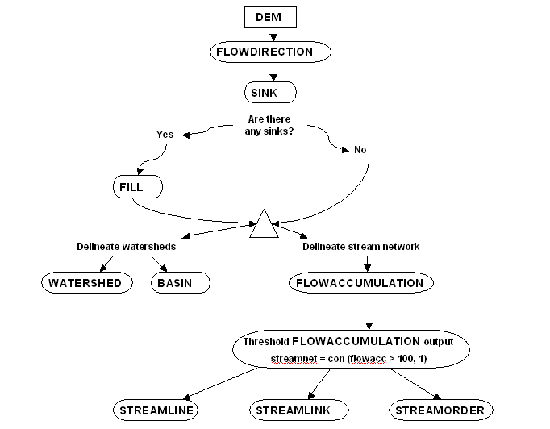

Preparing the data
The DEM and digitized stream network are provided in a zip file on the module web pages and need to be uncompressed and imported.

Task 1: Download the practical 18 zip file from the GEOG2750 web pages, uncompress and import the .asc and .e00 files. Display the DEM and stream network in ArcMap or GRID.

Creating a hydrologically correct DEM
Before using a DEM to derive a stream network it is necessary to identify if the DEM contains any localised minimum values or “sinks”. These sinks may have been introduced to the data in the process of creating the DEM through generalisation and as a result of scale and resolution. These need to be removed from the data to avoid creating lakes that do not exist in reality when deriving drainage networks. Sinks can be identified using the flowdirection and sink functions in ArcGRID as follows:

GRID: flowdir = flowdirection(dem)

Where: flowdir is the name of the output grid containing flow directions, and dem is the name of the input DEM.

Sinks can then be identified from the flow direction grid (flowdir) using the sink function as follows:

GRID: sinks = sink(flowdir)

Where: sinks is the name of the output grid containing those cells identified as sinks, and flowdir is the name of the flow direction grid calculated from the DEM using the flowdirection function (above).

Task 2: Use the flowdirection and sink functions to identify the location of sinks in the DEM provided and display these using either ArcMAP or Grid.

If a DEM is found to contain sinks then these should be removed before progressing with any analyses. Sinks can be removed using the fill command as follows:

GRID: fill dem dem_nosink

Where: dem is the name of the input DEM, and dem_nosink is the name of the output DEM with the sinks removed.

Task 3: Use the fill command to remove any sinks found above in task 2 and create a hydrologically correct DEM.

Deriving a stream network from a DEM
A stream network may be derived from a corrected DEM by calculating the flow direction across the DEM and then calculating how water accumulates by convergence. Where a large number of flows converge into one cell it is reasonable to assume that a stream will begin to form, so we can designate that cell and all its downslope neighbours as a “stream”. Using the flow chart (above) we can see that this is a three-stage process as follows:

- Re-calculate the flow direction using the hydrologically corrected DEM (sinks removed);
- Calculate flow accumulation; and
- Assign a threshold to the flow accumulation grid based on the minimum number of up stream cells at which it is considered a cell becomes a stream.

The flowaccumulation function works as follows:

GRID: flowacc = flowaccumulation(flowdir)

Where: flowacc is the name of the output grid containing the number of upstream cells for each cell in the grid, and flowdir is the name of the flow direction grid calculated using the flowdirection function from the DEM.

Once a flow accumulation grid has been calculated, a conditional function can be applied to this to reclassify the cells into those with a number of upstream cells greater than or equal to a specified threshold, and those with a lesser number. This can be done using the con function as follows:

GRID: streams = con(flowacc > 100, 1)

Where: streams is the name of the output grid containing cells designated as streams, flowacc is the name of the flow accumulation grid, 100 is the threshold applied, and 1 is the value applied to the streams (by default cells not meeting the threshold are given a value of zero). Or you can use Reclassify in ArcMap.

Task 4: Using flowdirection and flowaccumulation derive a stream network for the DEM provided. Display the resulting network in ArcMAP or Grid and compare this to the digitized 1:50,000 stream network.

You may notice certain mismatches between the derived and digitized networks. What might these be due to? One particular problem is choosing the correct threshold when reclassifying the flow accumulation grid. The smaller the threshold used then the greater the drainage density.

Task 5: Experiment with different thresholds to try to create a best match between the derived and digitized networks.

