School of Geography  University of Leeds  GEOG2750 |  | 2004/2005  Level 2  Louise Mackay
Practical 7 and Assignment 4:
Interpreting and explaining ERS2 SAR backscatter response

Week 8

Task: To use ERDAS Imagine to apply a speckle reduction filter to the ERS2 Synthetic Aperture Radar (SAR) image of North West England and North Wales used in practical session 6. To interpret and explain the different recorded backscatter values in the ERS2 image using knowledge gained from lectures 7 and 8 and associated reading. To aid you with this task you can employ the Landsat 5 Thematic Mapper image that covers the same area of North West England and North Wales, which you co-registered to the ERS2 Synthetic Aperture Radar image in practical 6.

Deadline: Wednesday 1st of December. Hand in your assignment to reception by 2pm. Remember to get a receipt.

Assignment Guidance:
- You should complete this assignment as an individual piece of work. Therefore, working in groups is not permitted. It is recommended that you start the assignment in the 2-hour practical session on Wednesday 24th of November. A demonstrator will be available to give assistance. However, as this assignment is assessed demonstrator assistance will be limited to addressing basic technical issues on the use of ERDAS Imagine and explaining the general concepts involved in the processing you have to perform for the assignment.
- An answer sheet for the assignment is provided on the last few pages of this handout. You can also download a separate version of this (called: Practical 7 Assignment 4 answer sheet) from the Nathan Bodington Geog2750 practical material room in order to format your assignment for printing and submission.
- To complete the assignment you will need to include a few diagrams of spatial models that you have developed in ERDAS Imagine and a copy of the final image. Unfortunately, the ISS PCs are not configured for printing from ERDAS Imagine. Thus, in order to produce these it is suggested that you use the Print Screen keyboard facility and paste your results into the assignment answer sheets. If you then select the pasted screen capture in your WORD document you can use the Picture toolbar that appears to crop and re-size your pictures of the spatial models and images. The Picture toolbar should automatically appear when you select a pasted graphic, or can be set to appear by selecting View->Toolbars->Picture. The Picture toolbar is shown below with the Crop tool highlighted.

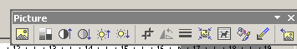
Crop tool for cropping unwanted areas from Pictures.

Introduction
In this assignment you will need to interpret and explain the backscatter recorded in an ERS2 image of North West England and North Wales for the main surface types present. The emphasis of the assignment is based on the quality of the explanation that you provided in respect to understanding the factors that control and influence the backscatter recorded by the ERS2 SAR sensor for the different surface types present.

Speckle Reduction
Before performing the interpretation of the ERS2 SAR image you should use ERDAS Imagine to reduce the amount of speckle present in the image, in order to aid its interpretation. To do this, start ERDAS Imagine and select the Radar menu icon:

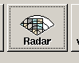

In the dropdown menu that appears select Radar Interpreter and then Speckle Suppression. This will open a menu dialog window shown below:

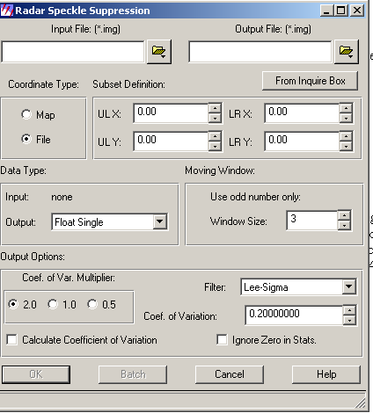

There are several speckle suppression filters available in ERDAS Imagine, which can be selected from the Filter menu option shown in the above dialog entry box. It is suggested for the purposes of this assignment that you select a median filter. However, you please feel free to experiment with the different filters to obtain the best speckle reduced image you can. This would be an image where speckle is successfully removed while the overall clarity of the image is not significantly impaired.

TASK – For the ERS2 SAR image of North West England and North Wales apply a speckle reduction filter and save this as a new ERDAS Imagine image.

The Interpretation Task

The main part of this assignment involves you recognizing the main surface types present in the ERS2 SAR image and providing an explanation as to the factors that influence the backscatter recorded for them by the ERS2 SAR sensor. To aid you in this task, you will require the following information.

ERS2 SAR Wavelength: C-band; 5.65cm.
ERS2 SAR mid-range depression angle: 23 degrees
ERS2 SAR Spatial resolution: 30meters
ERS2 SAR Polarization: VV
Date of acquistion: 19/6/1995 (approximately the same time of year as the Landsat 5 Thematic Mapper image).

Using the speckle reduced ERS2 SAR image you have produced, you need to recognize areas that correspond to the following main surface types present in the ERS2 SAR image of North West England and North Wales; areas of: Water; Sandbanks; Marshland; Built Up Urban; Pasture & Crops (vegetation); Woodland (vegetation); Bare soil.

For each of these surface types, you should provide a brief description of the relative backscatter response recorded for them – whether it is high, intermediate or low with respect to the rest of the image. You need to attempt to explain what the main factors are that are controlling the backscatter response recorded for each surface type. This explanation should include information on how backscatter varies (the variance of backscatter) within the image for each surface type and explanation of the factors that may be influencing this variability. For each surface type you should provide a small extract image example to aid you interpretation and explanation. To achieve this you can use the crop-tool in Microsoft Word as outlined above.

In order to aid your recognition of the different surface types above, you can also use the Landsat 5 Thematic Mapper image of North West England and North Wales that you co-registered to the ERS2 SAR image in practical session 6. As this image was acquired at approximately the same time of year as the ERS2 SAR image it will help you recognize the different vegetation and soil states present in the ERS2 SAR image.

NOTE: access the practical session 8 handout at the beginning of Week 10 from the Nathan Bodington Geog2750 practical material room prior to the Week 10 timetabled practical class. You can download the practical handout to your ISS folder, keep your downloaded practical handout document open or print off a copy for the practical session.

GEOG2750 Earth Observation & GIS of the Physical Environment Louise Mackay

Assignment 4 Answer Sheet School of Geography

Page 1 University of Leeds

Assignment 4
Interpreting and explaining ERS2 SAR backscatter response
Marked out of a total of 35 marks (5 marks each surface type).
Deadline: 2pm Wednesday 1st December 2004

Name:
Programme:

Water Example Extract

Water Backscatter Interpretation & Explanation:

GEOG2750 Earth Observation & GIS of the Physical Environment Louise Mackay

Assignment 4 Answer Sheet School of Geography

Page 2 University of Leeds

Sandbanks Example Extract

Sandbanks Backscatter Interpretation & Explanation:

GEOG2750 Earth Observation & GIS of the Physical Environment Louise Mackay

Assignment 4 Answer Sheet School of Geography

Page 3 University of Leeds

Marshland Example Extract

Marshland Backscatter Interpretation & Explanation:

GEOG2750 Earth Observation & GIS of the Physical Environment Louise Mackay

Assignment 4 Answer Sheet School of Geography

Page 4 University of Leeds

Built Up Urban Example Extract

Built Up Urban Backscatter Interpretation & Explanation:

GEOG2750 Earth Observation & GIS of the Physical Environment Louise Mackay

Assignment 4 Answer Sheet School of Geography

Page 5 University of Leeds

Pasture & Crops (vegetation) Example Extract

Pasture & Crops (vegetation) Backscatter Interpretation & Explanation:

GEOG2750 Earth Observation & GIS of the Physical Environment Louise Mackay

Assignment 4 Answer Sheet School of Geography

Page 6 University of Leeds

Woodland (vegetation) Example Extract

Woodland (vegetation) Backscatter Interpretation & Explanation:

GEOG2750 Earth Observation & GIS of the Physical Environment Louise Mackay

Assignment 4 Answer Sheet School of Geography

Page 7 University of Leeds

Bare Soil Example Extract

Bare Soil Backscatter Interpretation & Explanation:

