School of Geography  University of Leeds  GEOG2750 |  | 2004/2005  Level 2  Louise Mackay
Practical 4 – Assignment 2:
Evaluating the use of NDVI to derive vegetation status

Week 5

NOTE: you should have already accessed the practical session handout from the Nathan Bodington Geog2750 practical material room prior to the practical class and become familiar with the practical session content. Once you have downloaded the practical handout to your ISS drive, keep your downloaded practical handout document open or print off a copy for the practical session.

Task:
To derive from the Landsat 5 Thematic Mapper image of north west England and north Wales a Normalized Difference Vegetation Index (NDVI) data set. To critically compare this to a previously derived Soil Adjusted Vegetation Index (SAVI) in order to evaluate the ability of NDVI to characterize the status and variability of vegetation in the scene.

Deadline: Wednesday the 3rd of November. Hand in your assignment to reception by 2pm. Remember to get a receipt.

Assignment Guidance:
- You should complete this assignment as an individual piece of work. Therefore, working in groups is not permitted. It is recommended that you start the assignment in the 2-hour practical session on Wednesday 27th of October. A demonstrator will be available to give assistance. However, as this assignment is assessed demonstrator assistance will be limited to addressing basic technical issues on the use of ERDAS Imagine and explaining the general concepts involved in the processing you have to perform for the assignment.
- An answer sheet for the assignment is provided on the last few pages of this handout. You can also download a separate version of this (called: Practical 4 Assignment 2 answer sheet) from the Nathan Bodington Geog2750 practical material room in order to format your assignment for printing and submission.
- To complete the assignment you will need to include a few diagrams of spatial models that you have developed in ERDAS Imagine and a copy of the final image. Unfortunately, the ISS PCs are not configured for printing from ERDAS Imagine. Thus, in order to produce these it is suggested that you use the Print Screen keyboard facility and paste your results into the assignment answer sheets. If you then select the pasted screen capture in your WORD document you can use the Picture toolbar that appears to crop and re-size your pictures of the spatial models and images. The Picture toolbar should automatically appear when you select a pasted graphic, or can be set to appear by selecting View->Toolbars->Picture. The Picture toolbar is shown below with the Crop tool highlighted.

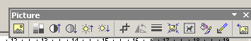

Crop tool for cropping unwanted areas from Pictures.

- The Assignment Data Set and Preparation

In this practical assignment you will use the original Landsat 5 Thematic Mapper image that you read into ERDAS Imagine in the first practical session in week 2. If you have been following the file naming conventions suggested, this data set will be named wir12345.img. For this data set you will need to create a Spatial Model that calculates the Normalized Difference Vegetation Index (NDVI). The second part of the assignment involves comparing your NDVI data set to a Soil Adjusted Vegetation Index (SAVI) data set of the same area in order to evaluate the ability of NDVI to characterize the status of vegetation for the area covered by the Landsat 5 Thematic Mapper image. The Soil Adjusted Vegetation Index can be downloaded from the Nathan Bodington practical material page, details for this are provided latter in this assignment hand out.

- The Assignment Tasks

The first stage of this assignment involves you using ERDAS Imagines Spatial Modeller to derive a Normalized Difference Vegetation Index (NDVI) for the Landsat 5 Thematic Mapper image. The information on how to calculate NDVI and the wavelengths (spectral bands) that are needed as input are provided in lecture 5. The Landsat 5 Thematic Mapper image comprises of 5 spectral bands, the individual band numbers of which correspond to the following wavelength ranges:

Band 1 0.45-0.52 micrometers.
Band 2 0.53-0.60 micrometers.
Band 3 0.63-0.69 micrometers.
Band 4 0.76-0.90 micrometers.
Band 5 1.55-1.75 micrometers.

Using earlier lecture material and practical handouts, all of which are available on the Geog2750 Nathan Bodington site, you need to find the two Landsat 5 Thematic Mapper spectral band numbers you will require to calculate the Normalized Difference Vegetation Index (NDVI).

Once you have the two band numbers required to calculate the NDVI from the Landsat 5 Thematic Mapper image, you need to develop an ERDAS Spatial Model to actually calculate this. In the last practical assignment you used the Spatial Modeller on a single spectral band. In this practical assignment you will need to use several spectral bands to calculate the NDVI.

The input data set for your spatial model to calculate NDVI will be the original wir12345.img data set. As this comprises of 5 spectral bands you will need to select the correct spectral bands and related arithmetic operations to perform in order to calculate the NDVI. As an aid to this process, I have included below an annotated template Spatial Model of the linkages between data inputs and operators for the calculation of NDVI. You should use this as the building block of your NDVI model.

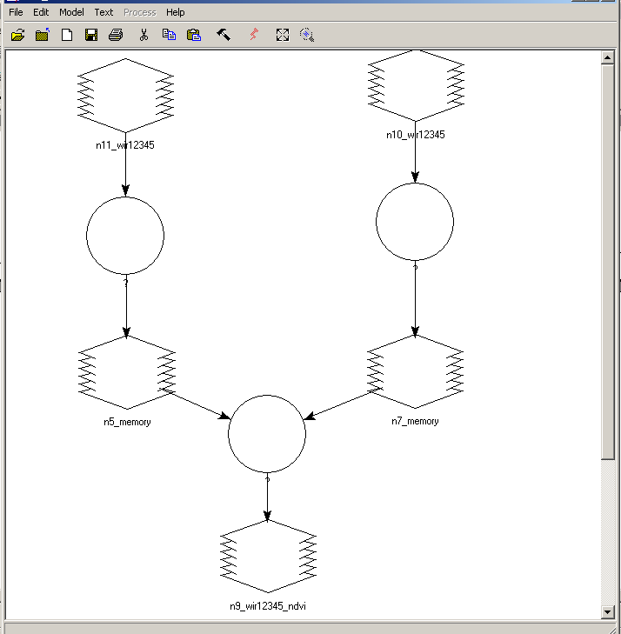
Select the Numeric operation (+,-,*, /) & the particular spectral bands to apply this to using the operator editor that appears when you select the operator icon. For example, it is possible to divide band 1 by band 2 by setting the expression to calculate to be:

$n11_wir12345(1)/ $n11_wir12345(2)

NOTE: This is not part of the NDVI calculation, it is presented as an aid to help you work out how to develop your NDVI model.
Temporary files – make sure you specify these as being Temporary Raster Only and set to be of FLOAT format not BINARY or INTEGER
The out NDVI data set. Make sure the output data type is SINGLE FLOAT. It is also helpful to set the Delete if Exists option to on so that each time you run the model the old NDVI data set is over written.

TASK 1: Using the Spatial Model template above use ERDAS Imagines Spatial Modeller to develop a model for the calculation of the NDVI for the Landsat 5 Thematic Mapper image covering north west England and north Wales. Remember to save your spatial model and call this wir12345_ndvi_model.gmd. I also suggest that you call your output NDVI data set wir12345_ndvi.img

TASK 2: Download from the Nathan Bodington Geog2750 practical material room and save in the folder you are using for this assignment the prior calculated Soil Adjusted Vegetation Index for the Landsat 5 Thematic Mapper image of the north west of England and north Wales. This can be accessed from the link SOIL ADJUSTED VEGETATION INDEX. Display the SAVI image (wir12345_savi.img) in ERDAS Imagine.

NOTE: access the practical session 5 handout at the beginning of Week 6 from the Nathan Bodington Geog2750 practical material room prior to the Week 6 timetabled practical class. You can download the practical handout to your ISS folder, keep your downloaded practical handout document open or print off a copy for the practical session.

GEOG2750 Earth Observation & GIS of the Physical Environment Louise Mackay

Assignment 2 Answer Sheet School of Geography

Page 1 University of Leeds

Assignment 2
Evaluating the use of NDVI to derive vegetation status
Marked out of a total of 35 marks.
Deadline – 2pm Wednesday 3rd of November 2004

Name:
Programme:

Deliverable 1 (5 marks): Provide a suitably cropped screen-capture of your ERDAS Imagine Spatial Model for calculating the Normalized Difference Vegetation Index (NDVI) from the Landsat 5 Thematic Mapper image wir12345.img. Ensure in your model that it is possible to read the different values and inputs for each stage of your model. You may achieve this by annotating it by hand.

Paste your Normalized Difference Vegetation Index spatial model on this page.

GEOG2750 Earth Observation & GIS of the Physical Environment Louise Mackay

Assignment 2 Answer Sheet School of Geography

Page 2 University of Leeds

Deliverable 2 (2 marks): Provide a suitably cropped screen-capture of your Normalized Difference Vegetation Index image.

Paste your image of the Normalized Difference Vegetation Index of the Landsat 5 Thematic Mapper image on this page.

GEOG2750 Earth Observation & GIS of the Physical Environment Louise Mackay

Assignment 2 Answer Sheet School of Geography

Page 3 University of Leeds

Question 1 (3 marks): Using ERDAS Imagine derive the overall minimum, mean and maximum Normalized Difference Vegetation Index (NDVI) values.

Overall Minimum NDVI | Overall Mean NDVI | Overall Maximum NDVI

Question 2 (5 marks, 150 word maximum): Using ERDAS Imagine describe and interpret the frequency distribution (histogram) of NDVI for the Landsat 5 Thematic Mapper image. Describe the changes that occur in terms of the frequency occurrence of pixels within the NDVI distribution. Do you think that certain surface types can be recognized as having a distinctive NDVI range ? If so what are these ?

Answer to Question 2:

GEOG2750 Earth Observation & GIS of the Physical Environment Louise Mackay

Assignment 2 Answer Sheet School of Geography

Page 4 University of Leeds

Question 3 (10 marks, 300 maximum): Display the Normalized Difference Vegetation Index image you have produced and the Soil Adjusted Vegetation Index wir12345_savi_dn.img that has been provided for you. On the basis of the material covered in lecture 5, the reading relating to lecture 5 and using the analysis tools of Imagine, such as cursor enquiry, Utility->Layer Info->statistics and the Histogram analysis tools describe and explain the differences that exist between the Normalized Difference Vegetation Index data set and the Soil Adjusted Vegetation Index data set. For example, what are the differences in the two distributions, how does the range of values for particular surface features (e.g., vegetation) differ. Provide quantitative values and use the image statistics within the Utility->Layer Info window to support your description and explanation.

NOTE: Be careful when comparing the histograms (frequency distributions) of the two data sets. The Y-axis are not directly comparable visually, as this axis on the two distributions have different absolute ranges but visually are scaled to have the same length. Use the mouse to interactively derive the frequency occurrence at different index (x-axis) values. Unfortunately, there is no way of altering this in Imagine.
Answer to Question 3:

GEOG2750 Earth Observation & GIS of the Physical Environment Louise Mackay

Assignment 2 Answer Sheet School of Geography

Page 5 University of Leeds

Question 4 (5 marks): List briefly 5 limitations of the Normalized Difference Vegetation Index (NDVI) for quantifying the status of vegetation using Earth observed multispectral satellite images.

Answer to Question 4:

Question 5 (5 marks): Using the material presented in lecture 5, and the information provided at the University of Arizona Terrestrial Biophysics and Remote Sensing Lab web-pages
(http://tbrs.arizona.edu/project/MODIS/evi.php and http://tbrs.arizona.edu/project) briefly describe in your own words five advantages of the Enhanced Vegetation Index (EVI) developed for the MODIS satellite sensor compared to the Normalized Difference Vegetation Index.

Answer to Question 5:

