School of Geography  University of Leeds |  | 2004/2005  Level 2  Louise Mackay
EARTH OBSERVATION AND GIS OF THE PHYSICAL ENVIRONMENT – GEOG2750
Week 10

Lecture 9: Earth Observed Digital Surface Models
Aims: This lecture introduces how active ranging Earth observation systems are used to produce Digital Surface Models (DSMs) and Digital Elevation Models (DEMs). It will cover coarse spatial resolution RADAR Altimetry and fine spatial resolution Laser Altimetry, and in particular LiDAR - Light Detection and Ranging.
Lecture 9 consists of the following topics:
- Digital Elevation Models and Digital Surface Models.
- RADAR Altimetry.
- Laser Altimetry.
- LiDAR – Light Detection and Ranging.
- Conclusion.
Work through each of the main topics in order. A reading list is supplied at the end of the lecture content or can be accessed at http://lib5.leeds.ac.uk/rlists/geog/geog2750.htm.

Begin Lecture 9 here

Digital Elevation Models and Digital Surface Models
Digital Elevation Models (DEMs) are a series of raster cells, the values of which represent the Earth’s surface topography (height). Digital Surface Models (DSMs) are a series of raster cells the values of which represent Earth surface topography and other extruding features – trees, buildings, etc. The production and analysis of DEMS and DSMs in physical geography applications is the subject of this lecture.
The following figures show examples of Digital Elevation Models. Figure 1 (on the left) is an Ordnance Survey Panorama DEM of 50x50m cell resolution covering a 10kmx10km extent of the Wharf Valley (Ilkley, West Yorkshire, UK). Figure 2 (on the right) is an Ordnance Survey 200m DEM of 200x200m cell resolution covering a 123kmx103km extent of the Yorkshire Dales.

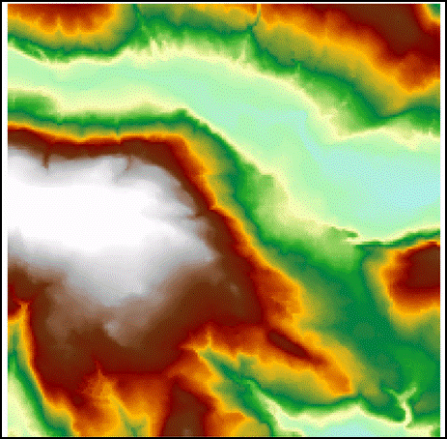 | 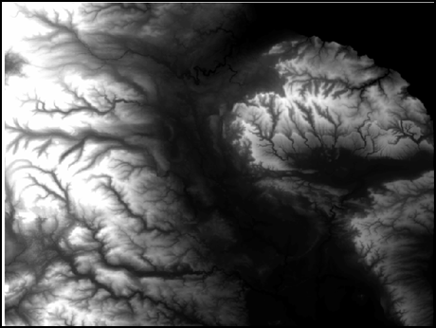
Figure 1 – 50mx50m cell DEM | Figure 2 – 200mx200m cell DEM

Question - What Physical Geography and Environmental Sciences applications can DEMs be employed in? You may be able to answer this question at the end of the lecture.

DEMs and DSMs can be produced from Earth Observation data from active sensors such as RADAR. RADAR sensors not only record the returned signal intensity (backscatter) but they also record the two-way travel time of the emitted EMR pulse. This two-way travel time can be converted to the distance to the Earth’s surface from the sensor. This in turn can be converted to a measurement of the height of the Earth’s surface at different locations. The two principle types of active sensor used for the production of DEMs and DSMs is that of RADAR altimetry and Light Detection and Ranging (LiDAR). Both of these forms of active sensor will be discussed in turn in this lecture.

RADAR Altimetry
In RADAR altimetry a radar pulse is emitted which reflects from the surface and is received at the sensor. The range-to-surface measurement (h) is Range=c*(TR-TT)/2; where c = the speed of light. This is subtracted from a precise satellite orbit (H) referenced to an ellipsoid (Figure 3 below) gives surface height above the reference ellipsoid. Subtracting the geoid height (hg - an approximation of sea level) from the surface height gives a surface height (hd) with respect to sea level.
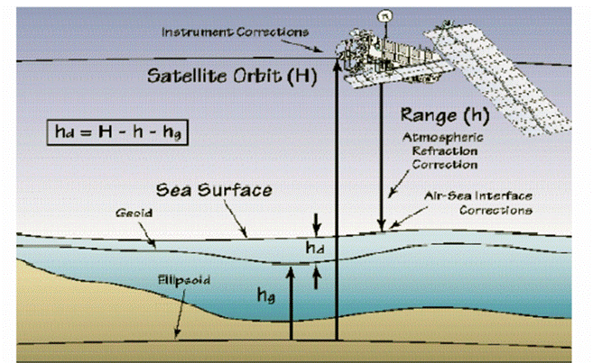
Figure 3 – Radar altimetry.
Action point: define the terms Geoid and Ellipsoid, with your definitions work through this figure (Figure 3) again to understand how the measurements are produced.

Applications of Satellite RADAR Altimetry
DEMs produced from RADAR altimetry have coarse spatial resolutions (~Km). DEMs at this resolution are applicable to studies of glaciological mass balance, calving, melting, etc (Figure 4 below). In other words coarse spatial resolution DEMs are suitable to the type of applications where change is noted over large spatial scales.
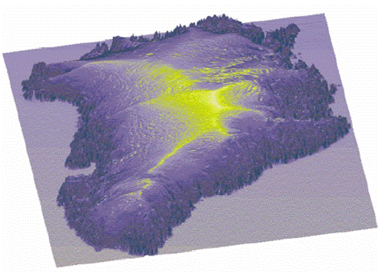
Figure 4- RADAR altimeter DEM of Greenland, source: University of Bristol Centre for Remote Sensing.
RADAR altimetry produced DEMs can also be used for taking coarse measurements of sea-surface topography (Figure 5 below).
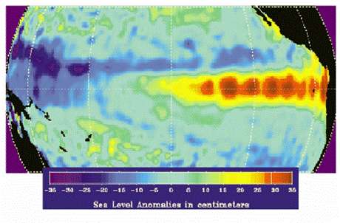
Figure 5 – RADAR altimeter sea-surface topography, source: Delft University of Technology.

Laser Altimetry
Airborne Laser Altimetry and LiDAR
An airborne laser altimetry sensor emits a laser pulse and records the time that the pulse takes to return to the sensor from the surface. Highly accurate onboard Global Positioning System (GPS) and Inertial Reference System (IRS) measurements allow the precise determination of the location and height of the aircraft. This information is combined with ground base-station GPS measurements of the absolute location and topographic height of point return times and can be converted to accurate Digital Surface Models – in a similar manner to RADAR Altimetry. The introduction of airborne altimetry sensors has revolutionised the acquisition of local to regional scale digital surface models - for example in the automatic capture of surface topography.
The basic concepts of Laser altimetry can be summarised in Figure 6 below.
Action point: read the detail in this figure to understand the LiDAR principle.
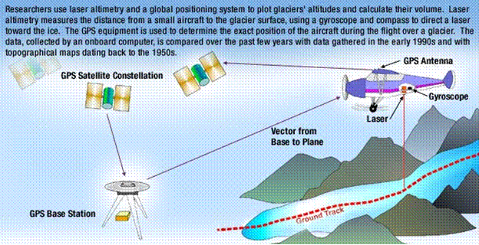
Figure 6 – The concepts of Laser altimetry data acquisition.

Airborne Laser altimetry is often used in glaciological applications. For instance, in mapping the thickness change of the Greenland ice sheet (Figure 7 right). | 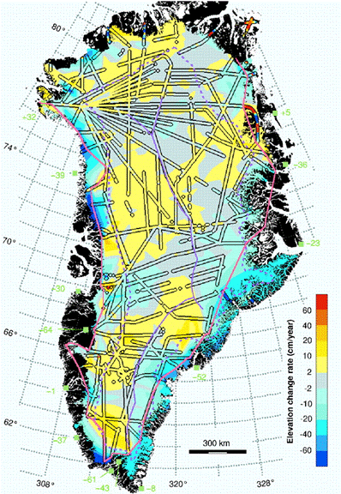
Figure 7 – Thickness change of Greenland ice sheet (Krabill et al., 2000.

LiDAR – Light Detection and Ranging.
LiDAR Earth Observation
A LiDAR sensor emits a near infrared (~900nm) laser pulse (5000-25000 per second). However, unlike laser altimetry, LiDAR acquires a swath (across-track) of returns that may also record multiple returns for the same location (Figure 8). This swath of returns produces a xyz data cloud of point measurements (Figure 9). In British LiDAR systems the points are acquired in the WGS84 ellipsoid and converted to Ordnance Survey National Grid. The LiDAR sensor data acquisition process is illustrated in Figures 8 and 9 below.
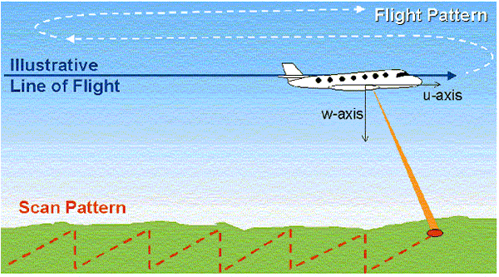
Figure 8 - LiDAR data acquisition

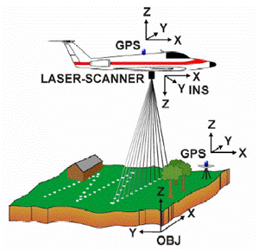
Figure 9 – LiDAR data acquisition.

LiDAR point clouds of derived heights need to be converted to a raster grid. This is performed using a procedure called spatial interpolation. Spatial interpolation is the procedure of estimating the unknown height value of a cell from a sample of the surrounding point heights. Interpolation in this manner allows raster DSMs of a particular spatial resolution (cell size) to be generated that represent a surface estimation of the continuous variability of topography. This process of interpolation from the point clouds is illustrated in Figure 10 below.
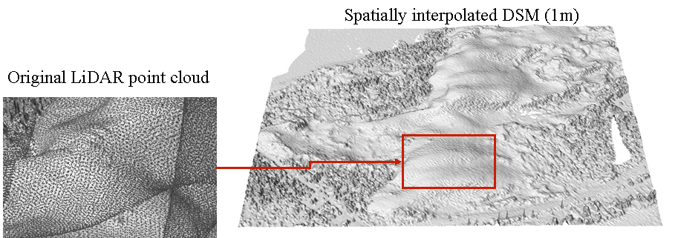
Figure 10 – LiDAR point cloud spatial interpolation.

LiDAR DSMs are widely used in hydrological applications by the UK Environment Agency. For example, flood inundation monitoring (Figure 11 below left) and flood routing across topography in the presence of surface features (Figure 12 below right). LiDAR DSMs are also used to monitor coastal erosion.
Action point: research and take note of a LiDAR coastal erosion project (this does not just have to be in the UK). Post a project URL to the class discussion board.
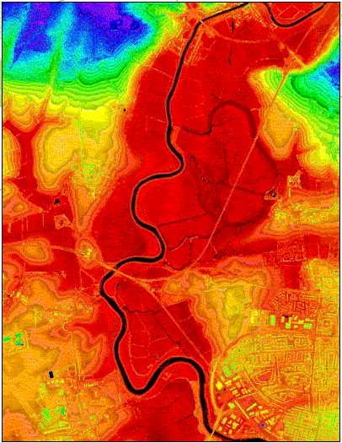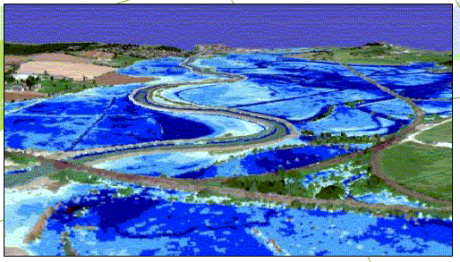
Figure 11 – Flood inundation monitoring. Figure 12 – Flood routing.
LiDAR DSMs (Digital Surface Models) represent topography and extruding surface features – buildings, vegetation, walls, etc. LiDAR DSMs are suitable for applications that only require a representation of topography (surface height). However, a DEM (Digital Elevation Model) is a representation of only topography and in some instances height information may be required from LiDAR data in the absence of alternatives. In order to obtain a DEM from LiDAR data, surface extrusions need to be removed from LiDAR DSMs (Figure 13 below). Take note: this particular exercise will be undertaken for this week’s practical assignment.
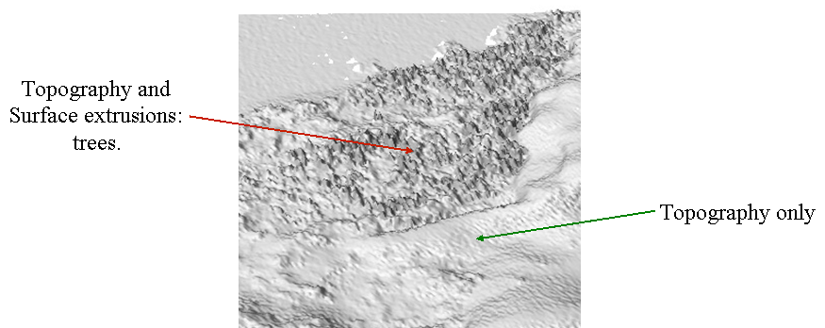
Figure 13 – Surface extrusions present in DSMs require removal to produce DEMs.

The following series of figures (Figure 14 to 19) provide an example of an approach using colour aerial photography and LIDAR DSM data to produce a DEM. The two data sets used in this conversion approach are 2m Environment Agency LiDAR DSM (Figure 14) and 55cm colour aerial photography (Figure 15).

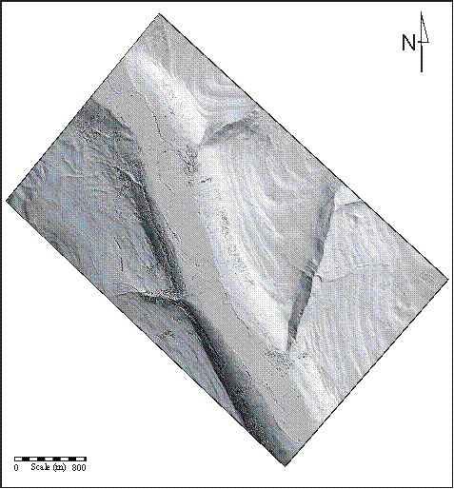 | 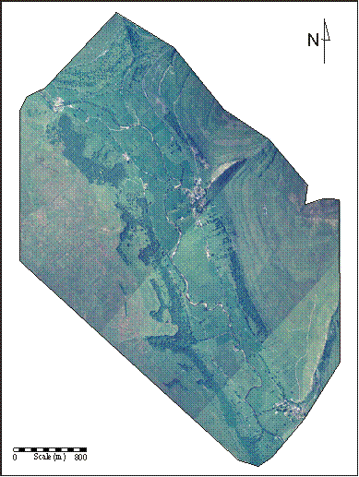
Figure 14 – 2m Environment Agency LiDAR DSM. | Figure 15 – 55cm colour aerial photography.

Firstly the aerial photograph is classified to a land cover (Figure 16), each extruding class (e.g. A=woodland, B=buildings) are extracted as a mask. All the pixels in each mask are assigned a typical extrusion value e.g., a woodland pixel has a pixel value of 2 (i.e., for 2m). The extrusion value mask (Figure 17) is then subtracted from the DSM.

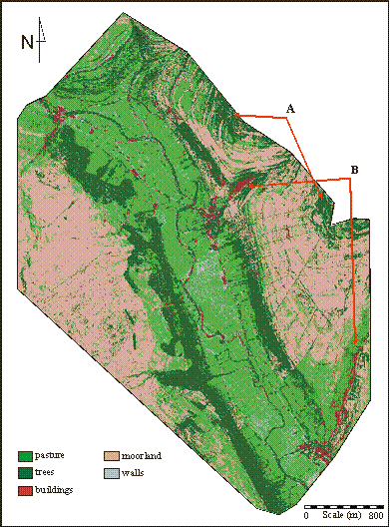 | 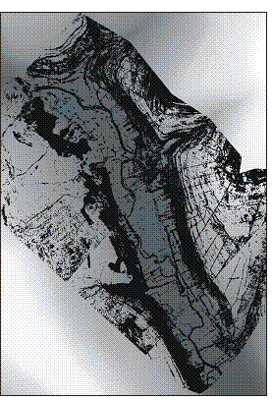
Figure 16 – Classified aerial photography | Figure 17 – Extrusion mask.

A before and after image of a LiDAR DSM (Figure 18 top) prior to correction to a LiDAR DEM (Figure 18 bottom) using the above approach is illustrated in Figure 18 below left. An image of the pixels corrected (shown in white) during the procedure is also shown in Figure 19 (below right).
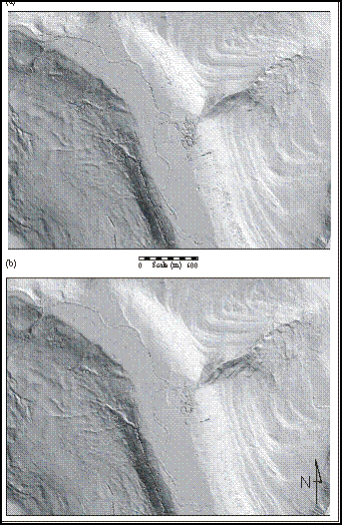 | 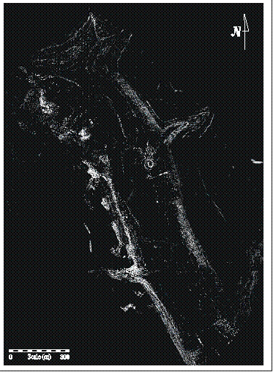
Figure 18 – Uncorrected LiDAR DSM (top) and corrected LiDAR DEM (bottom). | Figure 19 – Image of corrected pixels (white).

Action point: Using all three of these figures, can you identify areas in the uncorrected DSM (Figure 18 top) that have been corrected?

Conclusion
DEMs and DSMs can be acquired by the following active sensors:
– Coarse scale satellite RADAR Altimetry.
– Fine scale single transect laser Altimetry.
– Full swath LiDAR.
DEMs and DSMs have the ability to provide regular information on how the Earth’s topography is being modified – e.g. ice sheet changes. LiDAR provides a very powerful means of capturing fine spatial scale digital surface models BUT in some cases DSMs need to be converted to digital elevation models. LiDAR has many uses in GIS for characterising Earth surface topography and use in Earth surface process models.

Why is this lecture important?
This lecture builds on Lectures 7 and 8 to further cover the use of active Earth observation systems. It also introduces one of the most common ways that topographic surfaces can be acquired for use within GIS analysis.

Reading list:
Few Earth observation text books include a detailed coverage of RADAR/Laser Altimetry and LiDAR. Thus, this lecture’s recommend reading comprises of a series of introductory journal articles to the basic concepts of their use and also a series of journal papers that highlight the use of these two ranging systems within specific environmental applications.
- Baltsavias, E.P. 1999. Airborne laser scanning: basic relations and formulas. ISPRS Journal of Photogrammetry and Remote Sensing, 54, 199-214.
- Baltsavias, E.P. 1999. A comparison between photogrammetry and laser scanning. ISPRS Journal of Photogrammetry and Remote Sensing, 54, 83-94.
- Bamber, J.L., Ekholm, S. and Krabill, W.B., 1998. The accuracy of satellite radar altimeter data over the Greenland ice sheet determined from airborne laser data, Geophysical Research Letters., v. 25, p. 3177-3180.
- Bamber, J.L. and Muller, J.P. 1998. Derivation of a global land elevation data set from satellite radar altimeter data for topographic mapping. Journal of Geophysical Research. v. 103, p.159-32,168.
- Ekholm, S. Bamber, J.L., and Krabill, W. B. 2002 The use of airborne laser data to calibrate satellite radar altimetry data over ice sheets, Journal of Geodynamics. 34, 377-390.
- Huising, E.J. and Gomes Pereira, L.M., 1999. Errors and accuracy estimates of laser data acquired by various laser scanning systems for topographic applications. ISPRS Journal of Photogrammetry and Remote Sensing, 53, 245-61.
- Krabill W, Abdalati W, Frederick E, Manizade S, Martin C, Sonntag J, Swift R, Thomas R, Wright W, Yungel J, 2000. Greenland ice sheet: High-elevation balance and peripheral thinning, SCIENCE, 289 (5478): 428-430.
- Irish, J.L. and Lilycrop, W.J., 1999. Scanning laser mapping of the coastal zone: the SHOALS system. ISPRS Journal of Photogrammetry and Remote Sensing, 54, 123-9.
- Ritchie, J.C., 1996. Remote sensing applications to hydrology: airborne laser altimeters. Hydrological Sciences Journal, 41, 625-36.
- Ritchie, J.C., Grissinger, E.H., Murphey, J.B., Garbrecht, J.D., 1994. Measuring channel and gully cross-sections with an airborne laser altimeter. Hydrological Processes, 8, 237-43.
- Wehr, A. and Lohr, U., 1999. Airborne laser scanning – an introduction and overview. ISPRS Journal of Photogrammetry and Remote Sensing, 54, 68-82.

Content developer: Louise Mackay, School of Geography, University of Leeds.

