School of Geography  University of Leeds |  | 2004/2005  Level 2  Louise Mackay
EARTH OBSERVATION AND GIS OF THE PHYSICAL ENVIRONMENT – GEOG2750
Week 9

Lecture 8: Understanding Active SAR Microwave Earth Observed Images
Aims: This lecture builds on Lecture 7 to cover the issues that control the backscatter recorded by active microwave SAR sensors. Using the image acquisition principles introduced in Lecture 7, issues such as dielectric properties, surface roughness and image acquisition angular parameters will be investigated in relation to how they influence SAR image backscatter. The lecture will also consider the typical distortions present in SAR images that may hinder their interpretation and understanding.
Lecture 8 consists of the following topics:
- Recap of Lecture 7 – Principles of SAR Acquisition
- Understanding Active Microwave SAR Images
Controls on recorded backscatter
SAR image distortions
3. New approaches to employing SAR Images
4. Conclusion
Work through each of the main topics in order. A reading list is supplied at the end of the lecture content or can be accessed at http://lib5.leeds.ac.uk/rlists/geog/geog2750.htm.

Begin Lecture 8 here

Recap of Lecture 7 – Principles of SAR Acquisition
Satellite active microwave sensors acquire images for only a single wavelength/frequency. They do not acquire multispectral microwave images.
Typical active microwave wavelengths are:
- P-band = 30-100cm = 1.0-0.3 GHz.
- L-band = 15-30cm = 2.0-1.0 GHz.
- S-band = 7.50-15cm = 4.0-2.0 GHz.
- C-band = 3.9-7.50cm = 8.0-4.0 GHz.
- X-band = 2.40-3.75cm = 12.5-8.0 GHz.
- K-band(s) = 0.75-2.40cm = 40-12.5 GHz (rarely employed).
The imagining geometry of active microwave sensors can be summarised in the following figure (this figure was described fully in Lecture 7).
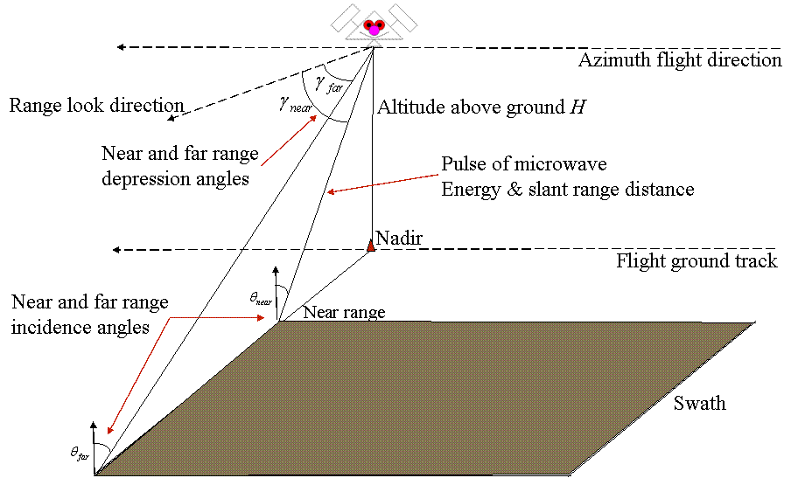
Figure 1 - imaging geometry of active sensors.
Synthetic Aperture Radar
Recapping the basics:
Synthetic aperture systems employ a short antenna BUT simulate a very long one (up to 100m) to attain high spatial resolution images. SAR works by using the fact that the sensor is moving relative to the target (Figure 2 below). This introduces changes in the frequency of the microwave energy backscatter from a target depending where on the sensor azimuth path a target is illuminated. These changes in frequency can be used to synthesise multiple returns for an object acquired at different locations on the azimuth path to form a single backscatter image.
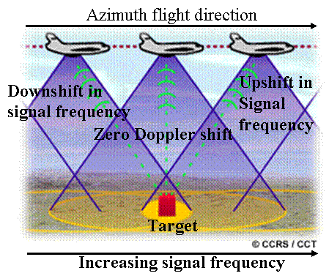

Figure 2 – SAR image acquisition.

Note: You only need to understand the basics of SAR for this course; an introduction to the principles of image acquisition of SAR is sufficient for a Level 2 course.

Understanding Active Microwave SAR Images
Backscattering Cross-Section
For any illuminated location SAR sensors record the intensity (Amplitude) of the microwave energy returned to the sensor. This is termed the backscattering cross section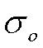. The backscattering cross section is proportional to the incident and returned intensities:
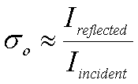This is often also quoted logarithmically in dB:
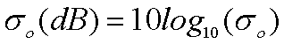.
The following figure (Figure 3) shows an example of Synthetic Aperture Radar image of recorded backscatter for an agricultural area.
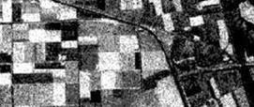
Figure 3 – SAR image of an agricultural area.

Controls on recorded backscatter
The backscatter recorded is a function of various physical controls: dielectric constant, surface roughness, surface conditions and SAR wavelength. These will be the main focus of this lecture and will now be addressed in turn.
Electrical - Dielectric Constant
The dielectric constant describes the ability of materials to absorb, reflect and transmit microwave energy. The dielectric constant increases with moisture content (Figure 4 below). The amount of backscatter from a surface increases with an increase in dielectric constant. Subsequently microwave backscatter of most natural vegetation surfaces increases with greater moisture content. This can be seen in Figure 5 below where area A (water logged field) has a higher recorded backscatter than that of area B (dry field).
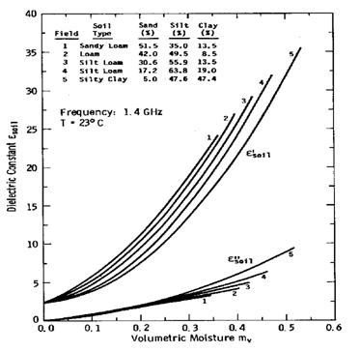
Figure 4 – Dielectric constant changes with moisture content

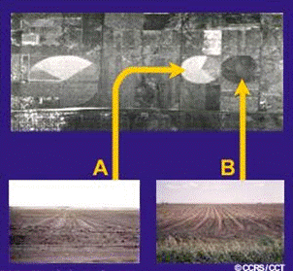
Figure 5 – The effect on image backscatter of different moisture content

Surface Roughness
Surface roughness also controls the amount of backscatter recorded. The degree of surface roughness is a function of wavelength (λ), incidence angle (θ) and the variability of surface height (standard deviation, S_{h}) and is characterised in terms of the Rayleigh criterion:
- Smooth if 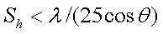
– Rough if 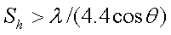

Smooth surfaces act as specular reflectors and hence have low backscatter. Conversely rough surfaces act as corner reflectors and hence have high backscatter (Figure 6 below). An example image of high and low backscatter is shown in Figure 7 below.

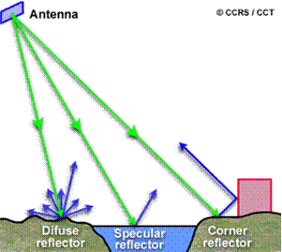 | 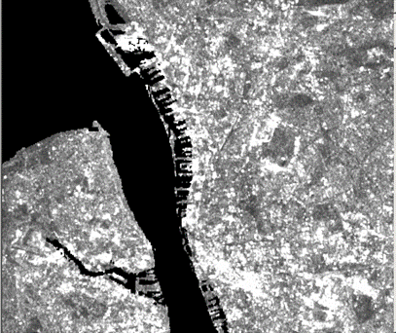
Figure 6 – Diffuse, specular and corner reflectors | Figure 7 – High and low backscatter returns in a SAR image

Note: In Figure 7 high backscatter returns are bright (white tones) and low backscatter returns are dull (grey tones and black).

The effect of surface roughness can also be seen here in Figure 8 for a fluvial environment. In this instance when the surface roughness of the water increases (due to windy conditions) from top to bottom the backscatter recorded increases. As the roughness of the water surface increases the water body is more difficult to distinguish from the surrounding land. | 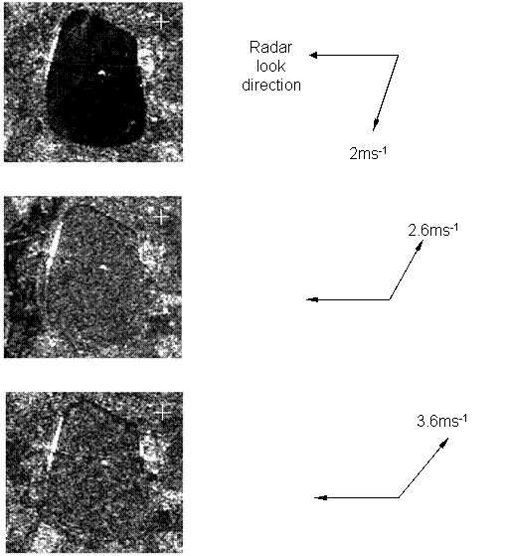
 | Figure 8 – ERS-1 imagery, Farmor Reservoir, Oxfordshire.

The Nature of the Actual Surface
Depending on surface conditions, backscatter may actually be from the sub-surface. For instance, very dry soil can allow several meters of radar penetration, whereas wet soil allows penetration in the top few centimetres of the surface only. Similarly, vegetation biomass influences backscatter. For instance, low biomass on the surface allows high penetration into the soil-substrate, whereas high biomass on the surface allows very low penetration so much so that backscatter only occurs from the surface vegetation. The effect of increasing surface biomass on backscatter is shown in Figure 9 right. | 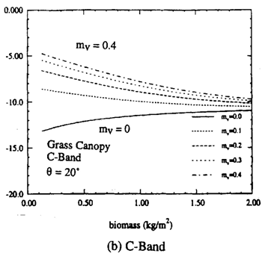
 | Figure 9 – Biomass effects on recorded backscatter

Controls on Recorded Backscatter
In summary - a combination of characteristics of the surface, its roughness, dielectric constant and sensor properties (e.g., incidence angle) all affect the amount of recorded backscatter. The combined effects of these characteristics on recorded backscatter are illustrated in Figure 10 right. | 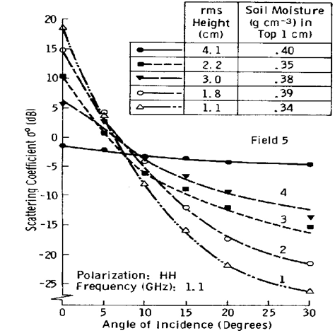
 | Figure 10 – Controls on recorded backscatter.
Note: understanding the effects of these controls on surface feature backscatter return will be the focus of this week’s practical, so take time to understand the above section.
Action point: Prior to this week’s practical take time to read the Lillesand and Kiefer reference and a choice of 1 or 2 others (see reading list) which show various examples of the backscatter response of land cover types in SAR images.
The wavelength of the SAR sensor also controls recorded backscatter. For example, in Figure 11 (below left) a C-band (3.9-7.50cm) wavelength is used. In Figure 12 (below right) a L-band (15-30cm) wavelength is used. The degree of backscatter between these two images is markedly different.
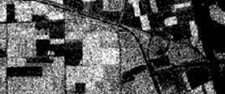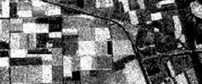
Figure 11 - C-band (3.9-7.50cm) Figure 12 - L-band (15-30cm)

The microwave wavelength of the sensor is an important influence over recorded backscatter. For instance, a stronger backscatter is recorded for vegetation at shorter wavelengths (higher frequency). This is illustrated in Figure 13 (wavelength 25cm) and Figure 14 (wavelength 3cm) below, where recorded backscatter varies as a function of wavelength.

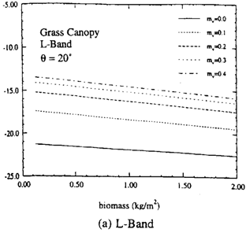 | 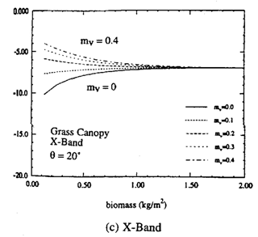
Figure 13 – 25cm wavelength | Figure 14 – 3cm wavelength

SAR Image distortions
SAR images are affected by image distortions: foreshortening, layover effects, radar shadow and speckle. The effect of each of these distortions will now be illustrated. You are advised to consult the additional reading material for a further description of these image distortions.

Foreshortening
When the slope facing the antenna is less steep than the long range depression angle of the beam the radar pulse reaches the base of the feature/obstacle first. The slopes of the feature will not be presented in true size but compressed in the resulting image. The foreshortening effect gets more pronounced as the slope becomes perpendicular to the depression direction of the pulse.

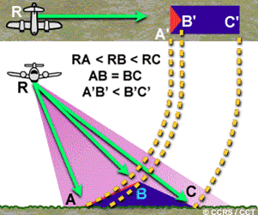 | 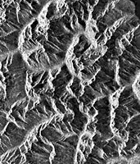
Figure 15 - Principles of foreshortening | Figure 16 - A SAR image with foreshortening

Layover Effects
When a vertical feature is encountered by a radar pulse, the top of the feature is reached first. Return signals from the top will reach the antenna before the returns from the feature's base. This will cause a vertical feature to "layover" the closer features, making it appear to lean towards the nadir.
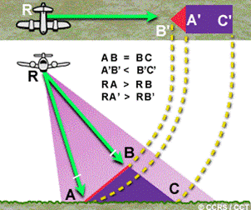 | 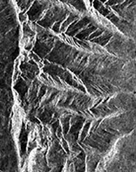
Figure 17 - Principles of layover | Figure 18 - A SAR image with layover

Radar Shadow
When a slope faces away from the aircraft and is steeper than the depression angle, the area of non-illumination extends beyond the sloped area masking down-range features in a radar shadow (Lillesand and Kiefer, 2000).
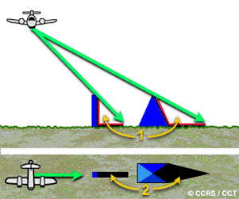 | 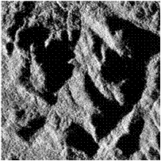
Figure 19 - Principles of radar shadow | Figure 20 - A SAR image with radar shadow

Speckle
Speckle appears as a grainy "salt and pepper" texture in an image. This is caused by random interference from the multiple scattering returns that will occur within each resolution cell, producing random bright and dark areas in the radar image.
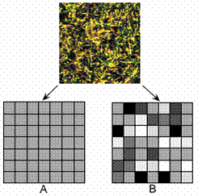 | 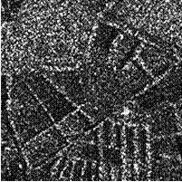
Figure 21 - Random interference in the cell | Figure 22 - A radar image with speckle

Speckle Reduction Methods
In order to clearly identify objects within an image, it may be necessary to clean up the image through speckle reduction.
Speckle reduction can be achieved in two ways.
(i) By multi-look processing – multiple measurements of an object’s (pixels) backscatter from different locations, this is achieved on-board the sensor (Figure 23 below left).
(ii) By spatial filtering – calculating the average (often median) value of adjacent pixels to average out speckle (Figure 24 below right).

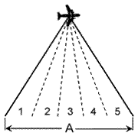 | 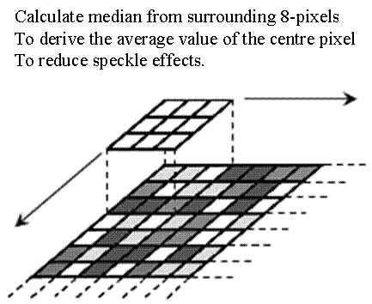
Figure 23- Multilook processing for speckle removal | Figure 24 – Spatial filtering for speckle removal

Speckle Reduction Methods – Spatial Averaging
The effect of spatial averaging to reduce speckle can be seen in the following figures. Figure 25 (left) is an original SAR Image with speckle, Figure 26 (right) is a SAR image after application of a 3x3 median filter.
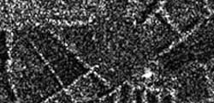 | 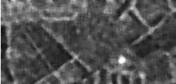
Figure 25 – SAR image with speckle | Figure 26 – Speckle removal by median filtering

Note: although the speckle has been reduced from the image, the spatial averaging has had a smoothing effect on the image features; as a user of such data you may decide the use of a median filter is not required, especially if you are interested in linear features.

New approaches to employing SAR Images
The use of multi-polarized SAR images is just one of the more recent developments in the use of SAR. SAR sensors emit microwave energy where the electric field is orientated (polarized) either horizontally (H) or vertically (V). Some sensors can record both vertically and horizontally polarized backscatter (hence multi-polarized). A few can also recorded the backscatter from changes in polarization. In Figure 27 below (with associated description of the polarizations) the polarizations of the waveform are illustrated.

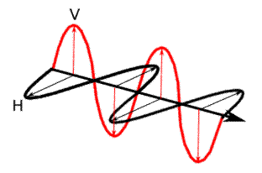 | HH - for horizontal transmit and horizontal receive,  VV - for vertical transmit and vertical receive,  HV - for horizontal transmit and vertical receive, and  VH - for vertical transmit and horizontal receive.
Figure 27 – Waveform polarizations

Different polarisations give potentially different backscatter values for the same object. In the case of vegetation, HH polarised microwaves can have a greater penetration depth than VV polarised microwaves (Figure 28). As a result, HH polarised microwaves can produce higher backscatter returns to that of VV polarised microwaves (Figure 29).
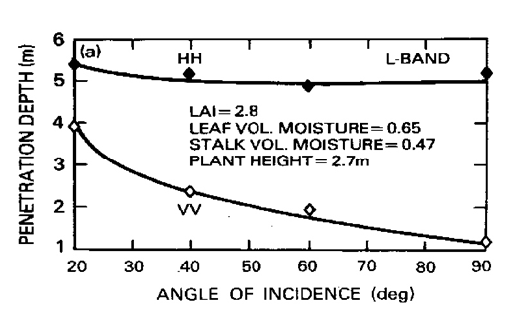
Figure 28 –Penetration depth of backscatter for HH and VV polarized wavelengths.

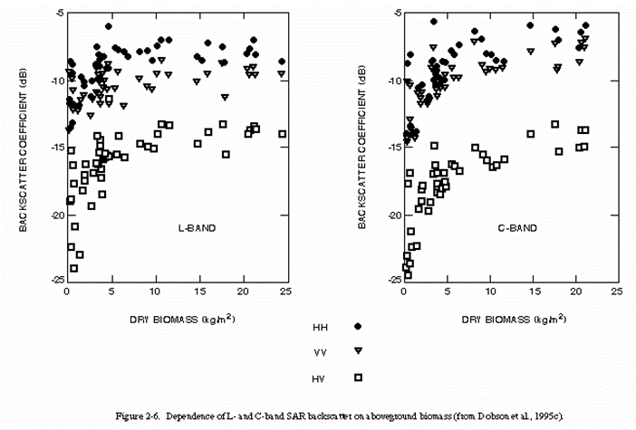
Figure 29 – Backscatter recorded from dry biomass for plain and cross-polarized wavelengths.

You can see the effect of different polarisations on vegetative backscatter return in Figures 30 and 31 below which show the recorded backscatter from different polarisations for the Avon-Severn confluence.

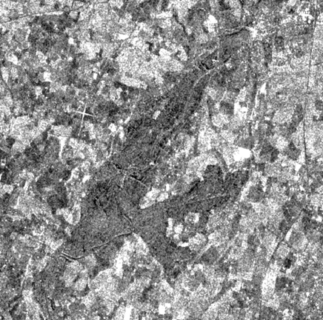 | 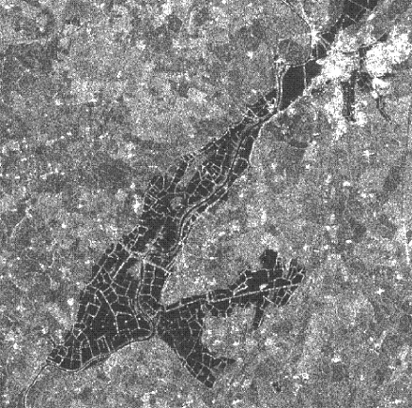
Figure 30 – ERS-2 HH | Figure 31 – RADARSAT VV

Conclusion
Backscatter response of active microwave SAR images is quite complex, due to:
– Dielectric properties;
– Surface roughness; and,
– Image acquisition parameters.
The interpretation of active microwave SAR is further complicated by: topographic effects (foreshortening, shadow, layover) and by speckle. By taking into account the above issues it is possible to understand and relate recorded backscatter to surface types and conditions. Additionally, as SAR images can be acquired in nearly all weather conditions and at night they are a very powerful means by which to monitor the Earth's surface.

Why is this lecture important?
This lecture builds on the material presented in lecture 7, to investigate in detail how different surface types and their respective states influence the backscatter recorded by SAR sensors.

Reading list:
For a basic introduction to understanding the backscatter response recorded by SAR sensors you should read either:
- Campbell, J.B., 1996. Introduction to Remote Sensing. Taylor and Francis (London). Chapter 7, pages 220-236.or
- Lillesand, T.M., and Kiefer, R.W., 2000. Remote Sensing and Image Interpretation. John Wiley and Sons (Chichester). Chapter 8, pages 632-687.
The following journal papers provide a wide coverage of the use of SAR images for the mapping and monitoring of the Earth’s surface, particularly vegetation and soil:
- Ahern, F. J., D. G. Leckie, and J. A. Drieman (1993). Seasonal changes in relative C-band backscatter of northern forest cover types. IEEE Trans. Geosci. Rem. Sens., vol. 31, pp. 668-680.
- Beaudoin, A., T. LeToan, S. Goze, E. Nezry, A. Lopes, E. Mougin, C. C. Hsu, H. C. Han, J. A. Kong, and R. T. Shin (1994). Retrieval of forest biomass from SAR data. Int. J. Rem. Sens., vol. 15, pp. 2777-2796.
- de Grandi, G. F., G. C. Lemoine, H. de Groof, C. Lavalle, and A. J. Sieber (1994). Fully polarimetric classification of the Black Forest MAESTRO 1 AIRSAR data. Int. J. Rem. Sens., vol. 15, pp. 2755-2775.
- Dobson, M. C., L. E. Pierce, K. Sarabandi, F. T. Ulaby, and T. Sharik (1992a). Preliminary analysis of ERS-1 SAR for forest ecosystem studies. IEEE Trans. Geosci. Rem. Sens., vol. 30, No. 2, pp. 203-211.
- Dobson, M. C., F. T. Ulaby, T. Le Toan, A. Beaudoin, E. S. Kasischke, and N. C. Christensen (1992b). Dependence of radar backscatter on conifer forest biomass. IEEE Trans. Geosci. Rem. Sens., vol. 30, pp. 412-415.
- Dobson, M. C., F. T. Ulaby, and L. E. Pierce (1995a). Land-cover classification and estimation of terrain attributes using synthetic aperture radar. Rem. Sens. Environ., vol. 51, No. 1, pp. 199-214.
- Dobson, M. C., and F. T. Ulaby (1986). Preliminary evaluation of the SIR-B response to soil moisture, surface roughness and crop canopy cover. IEEE Trans. Geosci. Rem. Sens., vol. 24, No. 4, pp. 517-526.
- Engman, E.T., N. Chauhan (1995). Status of microwave soil moisture measeremnts with remote sensing. Rem. Sens. Environ., vol. 51, pp 189-198.
- Foody, G. M., M. B. McCulloch, and W. B. Yates (1994). Crop classification from C-band polarimetric radar data. Int. J. Rem. Sens., vol. 15, pp. 2871-2885.
- Griffiths G.H. and Wooding M.G. (1996) Temporal monitoring of soil moisture using ERS-1 SAR data. Hydrological Processes, 10(9), 1127-1138
- Kasischke, E. S., N. L. Christensen, Jr., E. Haney, and L. L. Bourgeau-Chavez (1994). Observations on the sensitivity of ERS-1 SAR image intensity to changes in aboveground biomass in young loblolly pine forests. Int. J. Rem. Sens., vol. 15, pp. 3-16.
- Lemoine, G. G., G. F. de Grandi, and A. J. Sieber (1994). Polarimetric contrast classification of agricultural fields using MAESTRO 1 AIRSAR data. Int. J. Rem. Sens., vol. 15, pp. 2851-2869.
- Lin D. S., E. F. Wood, K. Beven and S. Saatchi (1994). Soil moisture estimation over grass-covered areas using AIRSAR. Int. J. Rem. Sens., vol. 15, No. 11, pp. 2323-2343.
- Lu Z. and Meyer D.J. (2002). Study of high SAR backscattering caused by an increase of soil moisture over a sparsely vegetated area: implications for characteristics of backscattering. International Journal of Remote Sensing, 23(6), 1063-1074.
- Pope, K. O., J. M. Rey-Benayas, and J. F. Paris (1994). Radar remote sensing of forest and wetland ecosystems in the Central American tropics. Rem. Sens. Environ., vol. 48, pp. 205-219.
- Pope, K.O., Rejmankova, E., Paris, J.F. and Woodruff, R. (1997). Detecting seasonal flooding cycles in Marshes of the Yucatan Peninsular with SIR-C polarimetric radar imagery. Remote Sensing the Environment, 59, 157-166.
- Ulaby, F.T., P.C., Dubois, J. van Zyl (1996). Radar mapping of surface soil moisture. Journal of Hydrology, vol 184, pp 57-84.
- Wang, J. R., E. T. Engman, J. C. Shiue, M. Rusek, C. Steinmeier (1986). The SIR-B observations of microwave backscatter dependence on soil moisture, surface roughness and vegetation covers. IEEE Trans. Geosci. Rem. Sens., vol. 24, No. 4, pp. 510-516.
NOTE: access the practical session 8 handout at the beginning of Week 10 from the Nathan Bodington Geog2750 practical material room prior to the Week 10 timetabled practical class. Keep your downloaded practical handout document open or print off a copy for the practical session.

Content developer: Louise Mackay, School of Geography, University of Leeds.

