School of Geography  University of Leeds |  | 2004/2005  Level 2  Louise Mackay
EARTH OBSERVATION AND GIS OF THE PHYSICAL ENVIRONMENT – GEOG2750
Week 8

Lecture 7: Principles of Microwave Earth Observation
Aims: This lecture aims to introduce you to the key basic concepts of how microwave images are acquired of the Earth’s surface. It covers briefly on passive microwave remote sensing and then focuses on the key concepts of how active microwave images are acquired, particularly Synthetic Aperture Radar (SAR) images. Topics covered included the geometry of image acquisition, issues over the different spatial resolutions of active microwave images and the different forms of signal recorded by active remote sensing devices.
Lecture 7 consists of the following topics:
- Introduction to Microwave Electromagnetic Radiation.
- Principles of Passive Microwave Remote Sensing.
- Principles of Active Microwave Remote Sensing – Synthetic Aperture Radar (SAR)
- Conclusion.
Work through each of the main topics in order. A reading list is supplied at the end of the content or can be accessed at http://lib5.leeds.ac.uk/rlists/geog/geog2750.htm.

Begin Lecture 7 here

Introduction to Microwave Electromagnetic Radiation
Previously we have focused on the use of optical multispectral images for Earth observation. However, multispectral images of the reflectance of the Earth's surface are influenced by the Earth’s atmosphere which attenuates and adds to surface radiance. In the presence of clouds the atmosphere is opaque to solar EMR. Alternatively, microwave electromagnetic radiation can penetrate the Earth’s atmosphere. Microwave EMR penetrates the atmosphere and is not influenced by cloud cover, haze and dust. Microwave wavelengths are less prone to atmospheric scattering which affects optical wavelengths, however, microwave EMR can be influenced by very heavy rainfall.
Note: As microwave images can be acquired under nearly all weather conditions they are an attractive means by which to study the Earth’s surface. In this lecture you will be introduced to microwave images as an alternative to optical images for Earth observation.
The microwave portion of the electromagnetic spectrum ranges from 1mm through to 1m – this would be considered a large wavelength range. Remember the diagram of the EM spectrum from your first lecture (Figure 1 below), you can compare the microwave and optical regions.
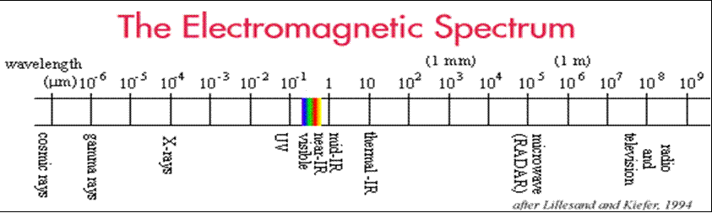
Figure 1: The electromagnetic spectrum (Lillesand T.M. and Kiefer R.W., 2000. Remote Sensing and Image Interpretation. Wiley (Chichester). p4).
Different wavelengths within this microwave range are employed depending on the type of microwave Earth observation being conducted.
There are two main types of microwave Earth observation: Passive and Active.
Passive: This type of microwave Earth observation records the naturally occurring microwave electrometric radiation of the Earth’s surface and atmosphere. This type is not commonly employed in Earth surface studies so we will only be covering an introduction to this type of microwave sensing.
Active: Active sensors provide their own microwave radiation to illuminate the target. This has become a very popular means by which to acquire data about the Earth’s surface and will be our focus over the next two lectures.

Principles of Passive Microwave Remote Sensing
Passive microwave Earth observation senses the naturally occurring microwave electromagnetic radiation – both from the surface and atmosphere. It uses wavelengths of between 0.15cm-30cm. Unfortunately at these wavelengths the electromagnetic radiation emitted has a low radiant exitance so a large sensor instantaneous field of view is required in order to record emitted energy. Due to this passive sensors have very low spatial resolutions (kilometres) - this is one of their main disadvantages.
Figure 2 below illustrates the variety of ways microwave radiation is emitted and hence can be recorded by passive sensors.
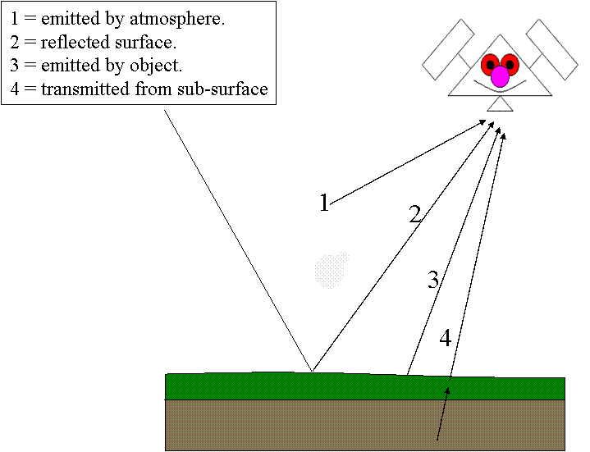
Figure 2: An illustration of the atmosphere, surface, object and sub-surface contributions to microwave radiation.
Passive Earth observation has numerous applications, for instance:
- Global surface brightness temperature.
- Geological mapping applications.
- Soil studies – soil temperature, soil moisture.
- Outside surface studies – oceanography, atmospheric sciences.

In Figure 3 below we can see an example of one such product produced from passive microwave data. In this instance NOAA 16 data has been used to produce a global composite of surface brightness temperatures.
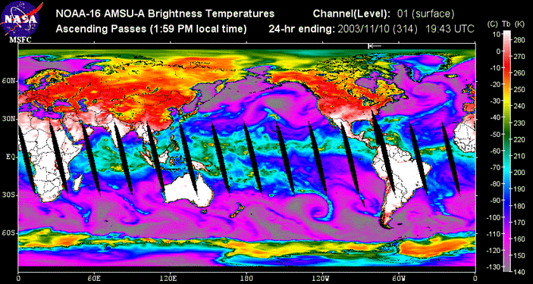For Figure 3 above see http://pm-esip.msfc.nasa.gov/amsu/index.phtml.
As we are just covering passive sensing briefly refer to your reading for a more detailed description of passive microwave sensing.

Principles of Active Microwave Remote Sensing – Synthetic Aperture Radar (SAR)
Active microwave Earth observation is also known as RADAR (RAdio Detection And Ranging). This type of microwave imaging is termed active because they transmit there own microwave energy (pulses) at a particular wavelength (single frequency) for a particular duration of time - known as pulsed coherent radar, as illustrated in Figure 4.
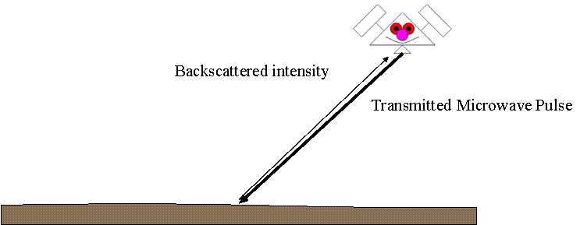Figure 4: An illustration of the transmitted pulse and its backscatter return in an active system.
Active radar sensors record the intensity of the transmitted microwave energy backscattered to the sensor. The most common form of active microwave radar sensors used are called Synthetic Aperture Radars (SAR).
Active microwave wavelengths tend to be divided into typical wavelength regions or bands:
P-band = 30-100cm = 1.0-0.3 GHz.
L-band = 15-30cm = 2.0-1.0 GHz.
S-band = 7.50-15cm = 4.0-2.0 GHz.
C-band = 3.9-7.50cm = 8.0-4.0 GHz.
X-band = 2.40-3.75cm = 12.5-8.0 GHz.
K-band(s) = 0.75-2.40cm = 40-12.5 GHz (rarely employed).
Note: in active sensors frequency (in Hertz) can also be used to describe a band range.
Note: satellite active microwave sensors acquire images for only a single wavelength/frequency. They do not acquire multispectral microwave images. However, recent airborne sensors can acquire multi-frequency images – for example NASA’s Jet Propulsion Laboratory AIRSAR system; C, L and P-band.

Figure 5 (below) summarises the geometry of active microwave imaging.
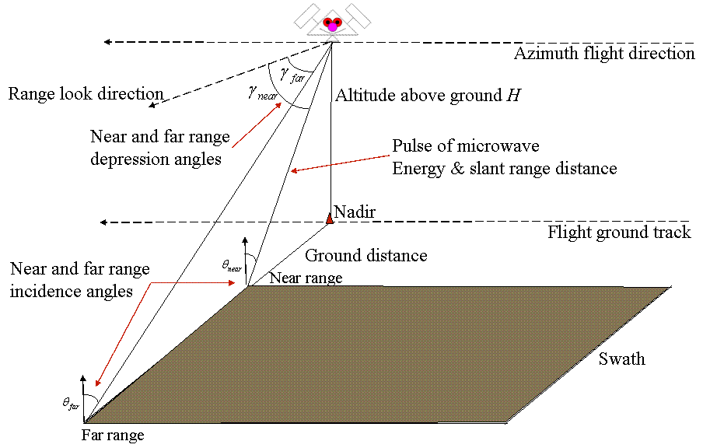
Figure 5: The geometry of an active microwave system.

In Figure 5 we can see that the active sensor is a side-looking one where the microwave active pulse and image swath subtends from the sensor in the range direction (perpendicular to the sensor's azimuth flight direction). In this instance azimuth pertains to a flight direction relative to 0 degrees North. The swath of an active sensor has a geometry which is related to the flying height of the sensor (from nadir) and the angles of depression of the swath edge closest to the sensor (near range) and the swath edge furthest from the sensor (far range) in the range look direction. Similarly the swath edges have associated near range and far range incidence angles.

In active microwave imaging energy is transmitted from an antenna for a short time period (microseconds), see Figure 6 to the right. The energy moves radially outwards for a time period, until it interacts with an object. The antenna is then switched from emit to receive mode. Some proportion of the microwave energy is scattered back towards the antenna which records the intensity of the returned microwave energy and the 2-way travel time. | 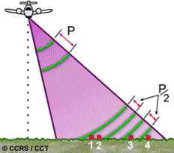

Synthetic Aperture Radar

Synthetic aperture systems employ a short antenna BUT simulate a very long one (up to 100m) to attain high spatial resolution images. This form of imaging works by using the fact that the sensor is moving relative to the target (Figure 7 right). This introduces changes in the frequency of the microwave energy backscatter from a target depending where on the sensor azimuth path a target is illuminated. These changes in frequency can be used to synthesize multiple returns for an object acquired at different locations on the azimuth path to form a single backscatter image. | 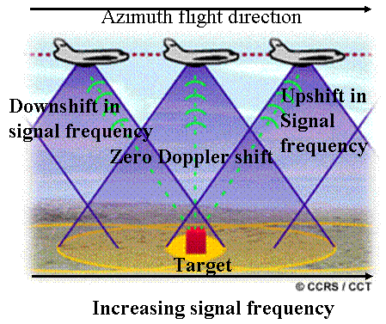

Synthetic aperture radar azimuth resolution depends on: the angular beam width of the antenna and the Doppler effect. Unlike real aperture systems (Figure 8) SAR systems have no dependence on ground range distance. Synthetic aperture radar images have a constant azimuth spatial resolution in the range direction (Figure 9) and have higher azimuth spatial resolutions.

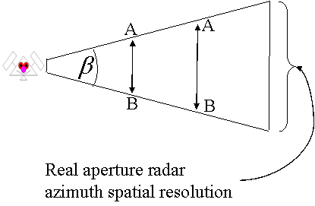 | 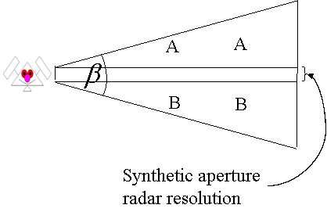
Figure 8: Real aperture spatial resolution | Figure 9: SAR spatial resolution

Synthetic aperture radar slant range (across-track) resolution depends on: the duration of the microwave pulse and the depression angle of any slant range point on the swath. Note: Longer pulses mean lower range spatial resolution and ground range resolution varies inversely with the depression angle. In principle larger depression angles = lower spatial resolution. For example in Figure 10 to the right range resolution for A will be better than for B for the same pulse duration. For pulse duration of 0.1 milliseconds and A=40 and B=65 degrees the range resolutions will be: A = 19.58m, and B = 35.5m. | 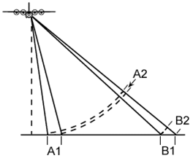

In synthetic aperture radar imaging slant-range scale distortion occurs. This is because SAR sensors are side looking images varying in scale in the slant range. This distortion (look at Figure 11 below) needs to be corrected in order to get the true ground range distance between features and their true ground range extent. In this particular image this type of distortion is clearer in the bottom left-hand corner, where the dark line (a road) has an unnatural curvature.
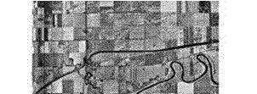Figure 11
Look at the same scene in Figure 12 when the slant-range scale distortion has been corrected. Note how the once curved road in the bottom left-hand corner is now straighter.
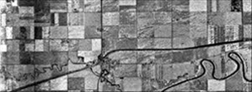 Figure 12

Action point: using the internet, library references and the reading list, make a list of Synthetic Aperture Radar systems currently used in microwave sensing. Add a link to an Earth observation project using SAR data to the Nathan Bodington discussion board. This will help to understand the types of applications that SAR data are used for.

What do SAR Sensors Record?
For any illuminated location SAR sensors record the intensity (amplitude) of the microwave energy returned to the sensor: this is termed the backscattering cross section which is proportional to the incident and returned intensities:
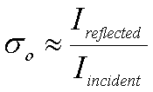This is often also quoted logarithmically in dB:

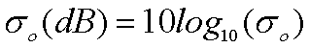

SAR sensors also record changes in polarization. SAR sensors emit microwave energy where the electric field is orientated (polarized) either horizontally (H) or vertically (V) (see Figure 13 below). Some SAR sensors can record the changes that occur in the polarization of microwave energy which potentially provides different information about targets. A SAR sensor can be characterised by one of four possible polarizations:
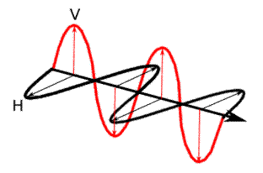
HH - for horizontal transmit and horizontal receive,
VV - for vertical transmit and vertical receive,
HV - for horizontal transmit and vertical receive, and
VH - for vertical transmit and horizontal receive.

Conclusion
One key advantage of microwave sensors to that of optical sensors is that they are not affected by the atmosphere. Of the two forms of microwave Earth observation (passive and active) active sensing, which creates its own source of microwave energy, is the most commonly employed. This type of sensor records the backscatter returned from the surface to the sensor. Understanding the key basic principles of how active microwave images are acquired, particularly SAR, is important as this has a significant influence on the images produced and in turn influences how we interpret them. Next week we will build upon this lecture to move towards understanding active microwave images, particular SAR images.

Why is this lecture important?
This lecture provides a basis for the material covered in Lecture 8, which covers how active SAR microwave images of the Earth's surface can be interpreted and discusses how different aspects of the image acquisition process influences the signal recorded by active SAR sensors.

Reading list:
As this lecture aims to provide you will the key basic concepts of how microwave images are acquired you should read one of the following general introductions to active microwave image acquisition to support the material covered in the lecture:
- Campbell, J.B., 1996. Introduction to Remote Sensing. Taylor and Francis (London). Chapter 7, pages 201-220; or
- Lillesand, T.M., and Kiefer, R.W., 2000. Remote Sensing and Image Interpretation. John Wiley and Sons (Chichester). Chapter 8, pages 616-632.
Additionally, the Canadian Centre for Remote Sensing has an excellent on-line tutorial covering the basic concepts involved in active microwave image acquisition. The URL for this is:
http://www.ccrs.nrcan.gc.ca/ccrs/learn/tutorials/stereosc/chap5/chapter5_1_e.html.
NOTE: access the practical session 7 handout at the beginning of Week 9 from the Nathan Bodington Geog2750 practical material room prior to the Week 9 timetabled practical class. You can download the practical handout to your ISS folder, keep your downloaded practical handout document open or print off a copy for the practical session.

Content developer: Louise Mackay, School of Geography, University of Leeds.

