School of Geography  University of Leeds |  | 2004/2005  Level 2  Louise Mackay
EARTH OBSERVATION AND GIS OF THE PHYSICAL ENVIRONMENT – GEOG2750
Week 4

Lecture 4: Radiometric, Atmospheric and Geometric Pre-Processing of Optical Earth Observed Images

Aims: This lecture will introduce you to the most common forms of processing that need to be performed before Earth observation images can be used quantitatively to characterise and map the Earth’s terrestrial environment. It covers the stages involved in converting (inverting) digital Earth observed multispectral images back to estimates of at-surface reflectance. It also considers the most commonly employed approach for the correction of geometric errors and registration of Earth observed images to digital map data sets used in many GIS applications.
Lecture 4 consists of the following topics:
- Why pre-process remotely sensed digital images.
- Radiometric calibration.
- Atmospheric correction approaches.
- Geometric correction and image registration.
- Conclusion – Pre-processing top-tips.
Work through each of the main topics in order. A reading list is supplied at the end of the content or can be accessed at http://lib5.leeds.ac.uk/rlists/geog/geog2750.htm.

Begin Lecture 4 here

Why pre-process remotely sensed digital images?
Rarely are remotely-sensed images provided where they can be directly applied to an environmental application. For example, emitted radiance from a surface travels through the atmosphere; this process can both attenuate and add to sensor radiance. Geometric distortions also result from flightline orientation or orbit characteristics. An image may exhibit all of these undesirable features which often depend on the supplier’s level of pre-processing. In certain cases they must be removed before inferring or estimating properties about the Earth’s surface:
- Such as when comparing quantitatively images, estimated properties or cover types acquired at different dates and/or
- When wishing to derive properties that can only be estimated from the Earth’s surface reflectance characteristics.
NOTE: it is therefore necessary to apply Radiometric Calibration and Atmospheric Correction.

Radiometric calibration
Radiometric Spectral-Band Calibration
A remotely sensed image comprises of a series of spectral bands, the pixels of which each have a digital number (DN). Pixel DN is a linearly transformed representation of at-sensor radiance for a discrete resolved area of the Earth’s surface (Figure 1). However, some studies and pre-processing operations need at-sensor radiance. So the radiance-to-DN procedure of image acquisition for each spectral wavelength must be inverted (Figure 2).
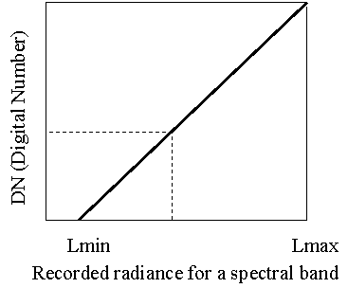 | 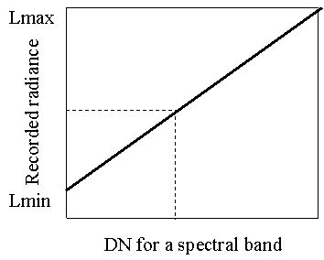
Figure 1: DN-to-radiance | Figure 2: Radiance-to-DN

To summarise the relationship between radiance (L) and pixel DN look at Figure 3 to the right. As pixel DN is a simple linear transformation of radiance (Figures 1 and 2), the slope and offset of this linear transformation (which is specific for each spectral band, each sensor and initial calibration) can be used to calculate radiance (L) and inversely used to calculate pixel DN. Note the dimensions of at-sensor radiance. You can use the reading list to check the unit of measurement for the symbols you are not familiar with.  Points to Note:  (i) The gain and offset values are unique for each spectral band acquired by a particular sensor.  (ii) These are often provided with the images and for common sensors can be found in the main texts.  (iii) However, these values change over the life span of a sensor - so make sure you have the most recent.  (iv) Be aware that there are two definitions of both gain and offset: | 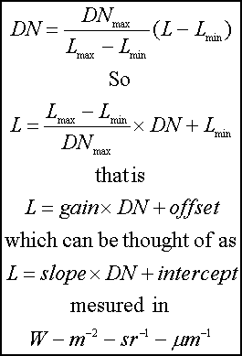
Radiance-to-DN and one for the DN-to-radiance.

At-Sensor Spectral Reflectance

It is possible to convert at-sensor radiance to apparent at-sensor spectral reflectance - required before atmospheric correction.  At sensor-reflectance involves taking into account temporal changes in solar illumination due to Earth-Sun geometry. As can be seen by Figure 4 to the right the Earth-Sun geometry changes with time of year. | 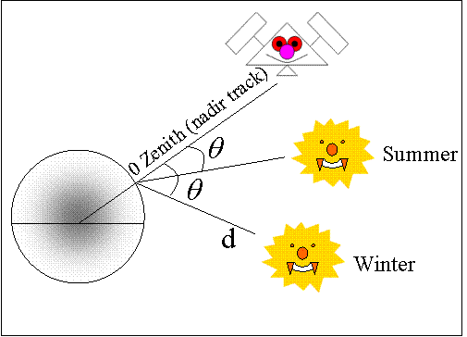
 | Figure 4: Earth-Sun geometry seasonal changes.

Atmospheric correction approaches
At-sensor reflectance still has atmospheric scattering effects present.
In some studies atmospheric effects may have to be removed by deriving ratios of different spectral-bands. This can be undertaken in two ways: by using reflectance in physical-based environmental models; or by using reflectance as the basis of change detection over time.
The aim of atmospheric correction is to derive a good estimate of the true at-ground upwelling radiance (reflectance). Approaches commonly employed in remote sensing for atmospheric correction are:
- Complex physical modelling – this can be undertaken using specialised software packages.
- Semi-empirical modelling - this can be undertaken using specialised software packages.
- Empirical estimation approaches - based on image data relationships.
Each of these approaches will now be considered in turn.

Complex Physical Modelling
Physical modelling is based on a mathematical understanding of atmospheric radiation transfer theory and atmospheric scattering. Physical modelling requires detailed estimates of atmospheric state i.e. optical thickness and atmospheric aerosols. The models are data intensive, require field data, validation and are computationally intensive.
Data collection:  This can be undertaken using an automatic sun tracking photometer (see Figure 5 right) which measures optical thickness and atmospheric aerosols. | 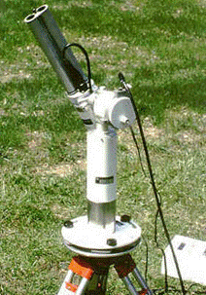 | Validation:  This can be undertaken by using ground-based collection of reflectance using a spectrometer (Figure 6 right). | 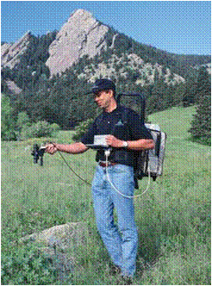

Semi-Empirical Modelling
This approach uses the same complex models but for a significantly reduced set of input parameters. In the simplest case, correction can be based on an estimate of atmospheric visibility and standard atmospheric constants for latitude/longitude/date. However, quite different results can be obtained for different estimates e.g., atmospheric visibility. For example, the following figures (Figures 7 and 8) show the change of Pixel to Surface reflectance for different estimates of atmospheric visibility.
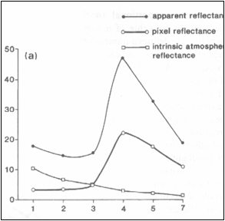 | 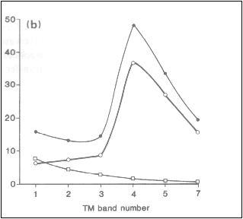
Figure 7: 5Km visibility Figure 8: 20km visibility
In these two figures you may notice that pixel reflectance is decreased with low atmospheric visibility.

Empirical Estimation Approaches
Empirical estimation approaches use only the image data to remove atmospheric effects. They only correct for atmospheric path radiance which is at-sensor radiance contributed by atmospheric scattering. Additionally, such approaches only account for Rayleigh atmospheric scattering.
Correction procedure:  (i) The image must have pixels of expected zero reflectance in the visible and NIR (Figure 9 right).  (ii) Linearly regress each visible band against near infrared for these pixels.  (iii) The X-axis offset is considered to be an expression of path radiance.  (iv) Subtract the X-axis offset from the visible band. | 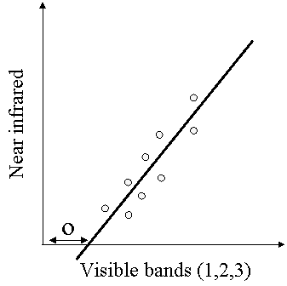
Note: You will apply this approach in your atmospheric correction practical. | Figure 9: Zero reflectance in the visible and NIR.

Geometric correction and image registration
Geometric Correction
Images are rarely provided in the correct projection, coordinate system and free of geometric distortions. Geometric distortions occur due to Earth rotation during acquisition and due to Earth curvature.
In order to combine images with other digital map data-sets they must be transformed from the acquisition coordinate system (rows/cols) to that of the digital map data sets.
For well defined orbital geometry parameters this can be achieved using predefined transformations (see Mather p76-78) which model the aspect, skew and rotational distortions of a sensor. These terms are defined as follows:
- Aspect ratio - unequal across-track and along-track pixel scale.
- Skew - image skew with respect to Earth’s north/south axis.
- Rotation - column coincident pixels do not have same longitude.
However, not all possible causes of geometric distortion can be modelled using these predefined transformations - therefore a more general approach is required e.g., using ground control data.
Correction using Ground Control
Correcting for geometric distortions using ground control is a multi-step process that involves the following procedures:
- Recognising in the image and map enough locations which are the same in order to accurately express the distortion present.
- Using these locations to calculate the transformation between the image and the map.
- Actually performing the transformation to the new coordinate system for each pixel to generate a new image.
- Calculating the actual DN that should be assigned to each pixel in the new image.
- Estimating how well the procedure has actually performed.
We will now cover these important steps of geometric correction.

Correction using Ground Control
Ground control correction is based on recognising points known in a map on the image to model distortion and define an empirical transformation between the image and the map as represented by Figure 10 below. Where the left-hand map represents digital map data where ground points are recognised and used to model distortion from reciprocal points on the image data on the right.
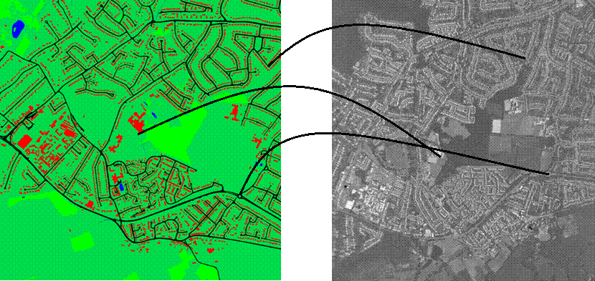
Figure 10: An illustration of the use of ground control points from verification data (left) to geo-correct image data (right).

Correction using Ground Control
There are a certain number of points to remember when recognising and choosing ground control points (GCPs):
- They should be distinct features in both the map and image.
- They should have clear boundaries and regular geometry.
- Good GCPs would be house corners, road intersections, field corners etc.
- Bad GCPs would be water bodies, natural vegetation, oval or circular features.
How many GCPs should you use?
- The minimum is the number required to estimate the transformation coefficients - see later.
- General rule of thumb - the more the better.
- Try to avoid excessive clustering and leaving unsampled areas.
- Always ensure that you have GCPs close to the image boundary.
- Sample more intensively in areas where you think there may be considerable distortion of high spatial frequency.

Least Squares Approximation
Given a set of ground control of known map (Easting,Northings) and related image (column,row) we need to estimate the transformation between the two co-ordinate sets. We can express this as a least squares estimation problem as summarised in Figure 11 below:
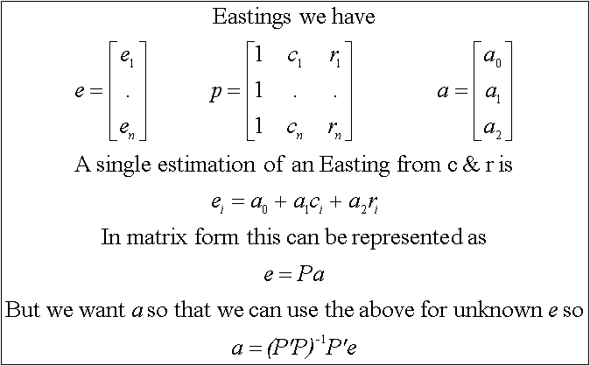
Figure 11: Least squares estimation summarised in matrix notation.
The previous derivation in Figure 11 is a first-order polynomial which corrects for scaling, rotation and shearing. Higher-order polynomials (c and r raised to a power) can also be used to correct for warping (bending).

Assessing Geometric Accuracy
The co-ordinates resulting from a transformation are an estimate and need to be checked for their degree of accuracy. Accuracy is normally expressed for each control point and overall root mean square. For example, in Table 1 below control points 1 and 2 have been evaluated for the degree of error they exhibit in both the X and Y direction, producing an individual point error which then contributes to the overall RMS error of the transformation. High RMS values (> 1 pixel) can indicate to the user how inaccurate the transformation is and whether the chosen GCPs were adequate, the process can then be repeated with additional/different GCPs in order to decrease the point and total error.

Note: a high RMS error for a particular point can indicate to the user a GCP that could be removed or replaced.

Table 1: RMS point and total error for a 2 point example
Point | Error X | Error y | Point Error
1 | -1.542023 | 1.346588 | 2.047226
2 | -0.960491 | 1.837280 | 2.073196
RMS = 1.909580 (pixel)
Note: This example in Table 1 is only for known points; it tells us nothing about unknown locations.

Resampling
Once the least squares coefficients have been derived and the (x,y) calculated for a pixel, a DN must be assigned to it. This is done by a reverse least squares estimation. However, the resulting col/row of an X/Y is likely not to be an integer as the corrected pixel lies across two or more pixels in the raw image (as illustrated in Figure 12 below). So we need to estimate the new DN value by interpolation this is called resampling.
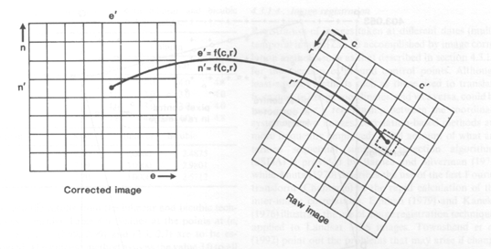
Figure 12: Pixel interpolation after geometric correction.

Resampling
Three interpolation routines can be used for resampling the image.
(i) Nearest neighbour:
- In this procedure a pixel is selected that is nearest to the estimated col/row of the reverse least squares:
- The advantage of this approach is that it retains the original image histogram (distribution).
- The disadvantage of this approach is that visually the resulting images can be "blocky".
(ii) Bilinear:
- This approach uses the four surrounding neighbours with equal weighting.
- Assumes that the pixel value lies on a planar surface.
- The disadvantages of this approach are that it modifies the original histogram and can give a blurred image.
(iii) Bicubic:
- This approach uses the 16 nearest pixels to estimated col/row (unequal weighting).
- This approach is computationally the most intensive.
- Although there is considerable modification of the original histogram, this approach produces the best visual results.

The Result - but not quite the end!
The corrected image is likely to need clipping to remove null buffering and derive a sub-image of known geographic origin, such a procedure would be necessary on Figure 13 below.
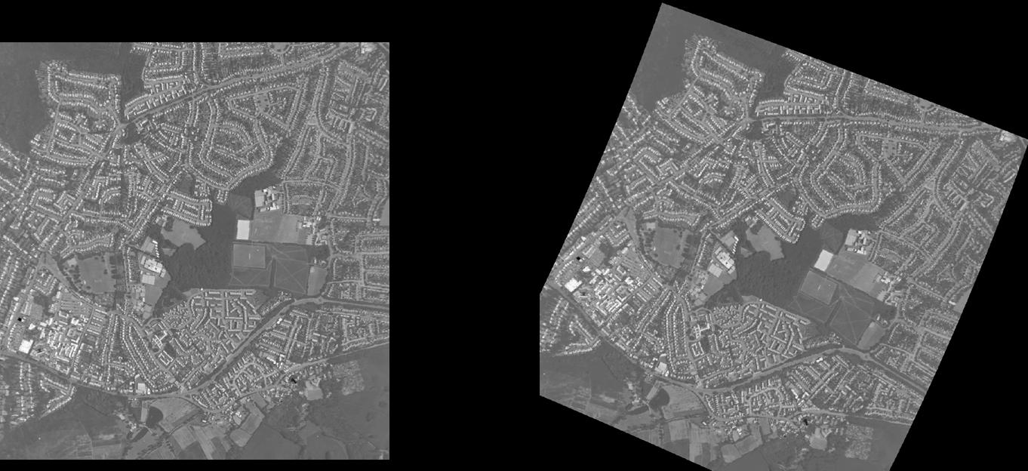
Figure 13: After pre-processing the image may need clipping to a cover a specific study area.

The Result and the End
The following figure (Figure 14) represents ATM data that has been geometrically corrected using a second-order least squares polynomial, using 32 ground control points resulting in a RMS of 1.9 pixels, nearest neighbour resampling and clipped to match OS Landline (the left-hand figure). The final image after this pre-processing is illustrated on the right.
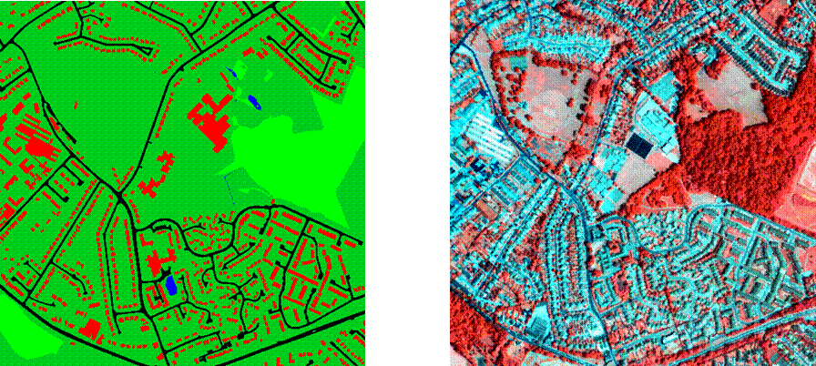
Figure 14: An ATM pre-processed image (right), with digital land cover data (left).

Conclusion – Pre-processing top-tips
Before starting a project always:
- Derive as much information from the vendor on what has been done to the image supplied to you.
- Check carefully the header and all files supplied with the image.
- Visually check the image for visual atmospheric effects e.g., visible haze can occur in the blue spectral-band.
Evaluate your needs:
- If not performing change detection or ratios you do not need to correct for atmospheric effects.
- If producing an image for visual overlay with map data then select bicubic resampling BUT never for quantitative analysis.
Know your algorithms:
- Be aware of the implications, assumptions and limitations of a particular approach - for example, what a particular approach is correcting.

Why is this lecture important?
This lecture follows on from Lecture 3 to show how at-sensor radiant flux (radiance) characterised as Earth observed multispectral digital images can be processed to attain estimates of at-surface reflectance. It essentially covers the inverse procedure of image acquisition introduced in Lecture 3. The material presented on the geometric correction and registration of Earth observation images links to latter material within the Earth observation component of the on-line course, as well as providing an insight into the processing required so that Earth observed images and information derived from then can be used in association with other digital map data sets within GIS applications.

Reading list:
Reading on radiometric and atmospheric pre-processing of optical Earth observation images:
Textbooks:
- Lillesand, T.M., and Kiefer, R.W., 2000. Remote sensing and image interpretation. Chapter 7, pages 477-482 (Gives a short general coverage of only radiometric pre-processing).
- Campbell, J.B., 1996. Introduction to remote sensing. Chapters 10, pages 292-299 (Again a rather general description but readable).
- Mather, P.M., 1999. Computer processing of remotely-sensed images. Chapter 4, pages 87-95 (Excellent readable coverage, including terrain correction which is not covered in the lecture).
Journal Articles:
- Chavez, P.S., 1988. An improved dark-object subtraction technique for atmospheric scattering correction of multi-spectral data. Remote Sensing of Environment, 24, 459-479.
- Chavez, P.S., 1996. Image based atmospheric corrections revisited and improved. Photogrammetric Engineering and Remote Sensing, 62, 1025-1036.
- Duggin, M.J., 1985. Factors influencing the discrimination and quantification of terrestrial features using remotely-sensed radiance. International Journal of remote Sensing, 6, 3-28.
- Hill, J., and Aifadopoulou, D., 1990. Comparative analysis of Landsat-5 TM and SPOT HRV-1 data for use in multiple sensor approaches. Remote Sensing of Environment, 34, 55-70.
- Markham, B.L., and Barker, J.L., 1987. Thematic Mapper bandpass solar exoatmospheric irradiances. International Journal of Remote Sensing, 8, 517-523.
- Popp, T., 1995. Correcting atmospheric masking to retrieve the spectral albedo of land surfaces from satellite measurements. International Journal of Remote Sensing, 16, 3843-3508.
- Price, J.C., 1994. An update on visible and near infrared calibration of satellite instruments. Remote Sensing of Environment, 24, 419-422.
- Teillet, P.M., and Fedosejevs, G., 1995. On the dark target approach to atmospheric correction of remotely-sensed data. Canadian Journal of Remote Sensing, 21, 374-387. (By inter-library loan).
Reading on geometric correction pre-processing of optical Earth observed images:
Textbooks:
- Lillesand, T.M., and Kiefer, R.W., 2000. Remote sensing and image interpretation. Chapter 7, pages 473-477 (A very short general coverage).
- Campbell, J.B., 1996. Introduction to remote sensing. Chapters 10, pages 301-309 (A readable description of geometric correction).
- Mather, P.M., 1999. Computer processing of remotely-sensed images. Chapter 4, pages 75-87 (Excellent readable coverage, including orbital geometry models not covered in the lecture.).
Journal Articles:
- Kardoulas, N.G., Bird, A.C., and Lawan, A.I., 1996. Geometric correction of SPOT and Landsat imagery: a comparison of map and GPS-derived control points. Photogrammetric Engineering and Remote Sensing, 62, 1173-117.
- Mather, P.M., 1995. Map-image registration using least–squares polynomials. International Journal of Geographical Information Systems, 9, 543-554.
- Morad, M., Chalmers, A.I., and O,Regan, P.R., 1996. The role of root mean square error in the geo-transformation of images in GIS. International Journal of Geographical Information Systems, 10, 347-353

NOTE: access the practical session 4 handout at the beginning of Week 5 from the Nathan Bodington Geog2750 practical material room prior to the Week 5 timetabled practical class. You can download the practical handout to your ISS folder, keep your downloaded practical handout document open or print off a copy for the practical session.

Content developer: Louise Mackay, School of Geography, University of Leeds.

