School of Geography  University of Leeds |  | 2004/2005  Level 2  Louise Mackay
EARTH OBSERVATION AND GIS OF THE PHYSICAL ENVIRONMENT – GEOG2750
Week 2

Lecture 2: Electromagnetic Radiation Interactions with the Earth's Surface
Aims: This lecture introduces you to the electromagnetic radiation used in Earth observation for the acquisition of images of the Earth’s surface. It covers the general characteristics of electromagnetic radiation, the units of measurements, and the sources. The second part of the lecture focuses on the solar electromagnetic radiation used in Earth observation and on the solar electromagnetic reflectance characteristics of a range of natural Earth surface features.
Lecture 2 consists of the following topics:
- Electromagnetic radiation basics for Earth observation.
- Sources of electromagnetic radiation.
- Solar electromagnetic radiation interactions at the Earth’s surface.
- Reflectance characteristics of Earth surface types.
- Conclusion.
Work through each of the main topics in order. A reading list is supplied at the end of the content or can be accessed at http://lib5.leeds.ac.uk/rlists/geog/geog2750.htm.

Begin Lecture 2 here

Electromagnetic radiation basics for Earth observation
This lecture begins by briefly recapping on the topics introduced in the first lecture. As mentioned in Lecture 1 Earth observation sensors record electromagnetic radiation (energy) just as humans record electromagnetic radiation in the form of visible light produced by solar illumination. However, environmental Earth observation sensors can measure solar light and other forms of electromagnetic radiation.
All electromagnetic radiation is inherently similar - composed of two periodic harmonic sine waves (electric and magnetic) which intersect at the same position on the wave phase cycle, as illustrated in Figure 1 below.

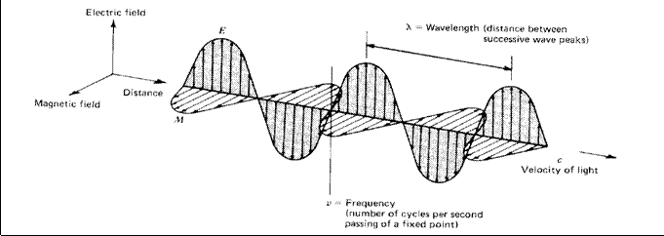
Figure 1: The electromagnetic waveform (Lillesand T.M. and Kiefer R.W., 2000. Remote Sensing and Image Interpretation. Wiley (Chichester). p4).

All electromagnetic radiation, in a vacuum, travels at a certain velocity - the speed of light:
c = (2.99 x 10⁸m/sec).
The velocity of electromagnetic radiation can be obtained from its wavelength (λ – Greek symbol lambda) and frequency (v):

c = v x λ
As velocity is a constant, we can characterise different forms of electromagnetic radiation in terms of its wavelength or frequency, which are inversely related:

λ = c/v
In general electromagnetic radiation is characterised in terms of wavelength (λ). Visible light wavelengths are measured in the micrometer or micron scale (1 x 10⁻⁶ m). While high frequency wavelengths such as x-rays are measured in the nanometer scale (1x10⁻⁹ m).
The Electromagnetic spectrum is used to characterise all the different forms of electromagnetic radiation in terms of their wavelength. We often assign certain characteristic names to particular ranges of this spectrum termed spectral regions which are useful terms within remote sensing. For example, visible light falls within the spectral range of 0.4 to 0.7 microns (µm). This can be broken down further into wavelength ranges that consist of the coloured components of visible light:
- Blue visible light - 0.4 to 0.5 µm or 400 to 500 nm.
- Green visible light - 0.5 to 0.6 µm or 500 to 600 nm.
- Red visible light - 0.6 to 0.7 µm or 600 to 700 nm.
As the spectrum is continuous and not discrete the boundaries between spectral ranges are not clearly defined and in fact overlap. See Figure 2 below to identify the different spectral ranges that produce the electromagnetic spectrum.

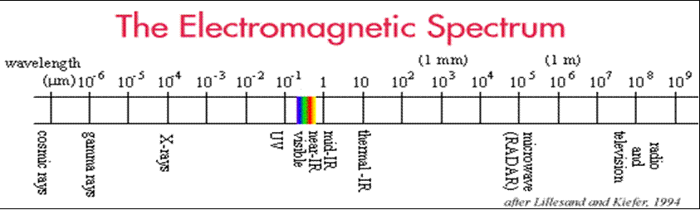
Figure 2: The electromagnetic spectrum (Lillesand T.M. and Kiefer R.W., 2000. Remote Sensing and Image Interpretation. Wiley (Chichester). p4).

Key point: the electromagnetic spectrum provides a general framework for grouping electromagnetic regions.
Electromagnetic Radiation Basic Particle Theory
Electromagnetic radiation consists of many discrete units called photons or quanta. The energy carried by a waveform (Q) is defined for a single photon in Joules (J) as:
Q = h*v, where h is Planck's constant (6.626 x 10⁻³⁴ Joule seconds).
This can be defined simply as - the capacity of electromagnetic radiation to do work is directly proportional to its frequency. Wavelength and the energy of a photon is related by:

Q = c*h/λ.

As this is an inverse relationship short wavelengths carry more energy. The implication for Earth observation is that at longer wavelengths it is more difficult to detect a discernible energy signal (if you think this through you should be able to understand why).

Sources of electromagnetic radiation.
All matter above absolute zero (0° Kelvin or -273°C) emits electromagnetic radiation. Environmental Earth observation has a number of obvious sources of electromagnetic radiation that it can use:
- Solar emitted - the Sun.
- Terrestrially emitted - the Earth.
- Instrument emitted - from the actual sensor.
But we need to understand which particular wavelengths should be used in relation to each of these. This requires:
- Understanding of their exitance characteristics;
- Understanding of their interactions with the Earth's atmosphere (Lecture 3)and
- Understanding of their interactions with the Earth's surface.
We will now address point 1 and 3 in turn.
Exitance Properties
In remote sensing we measure radiant exitance from a surface. Total exitance (M) is a function of the absolute temperature of an object and is expressed, for a blackbody, by the Stefan-Boltzmann Law:
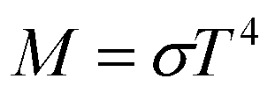
Where M is the total spectral exitance from the surface of a body (Wm⁻²) and is the Stefan-Boltzmann constant of 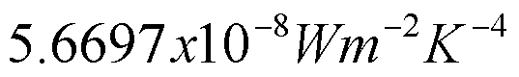.
In principle the Stefan-Boltzman Law means that the hotter a body the higher the radiant exitance from a body. The spectral (wavelength) peak of maximum exitance also changes as a function of temperature and is given by Wien’s displacement law:
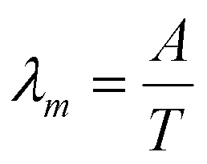Where A is a constant of 2898 µK.
Key point: the temperature of a body is a major control on the amount of radiance emitted from a surface.

Note: A blackbody is an idealised radiator that totally absorbs and re-emits all energy incident upon it. In reality most objects behave as a greybody, far from this ideal.
Figure 3 below shows the spectral exitance curves for blackbodies at the approximate temperatures of the Sun and the Earth. The dotted line representing the solar exitance is greater than that of the solid line representing the Earth exitance. This maximum occurs at the visible light regions of the electromagnetic spectrum. However, this figure does not explain the effect of the Earth's atmosphere on the Earth's radiant exitance.
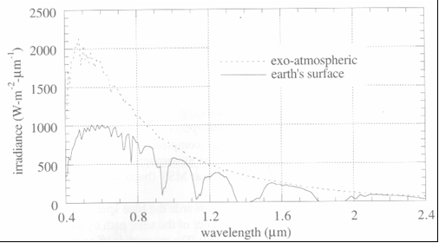
Figure 3: Spectral exitance of Sun and Earth blackbody temperatures.
In the following figures the effect of the Earth's atmosphere is more apparent. In Figure 4 the dashed line represents the rate of transfer of solar Electromagnetic radiation onto a surface and the solid line represents the terrestrial radiance received after travelling through the Earth's atmosphere. As you can see the difference in the magnitude of these curves shows that the atmosphere greatly effects the transmission of electromagnetic radiation. This relationship can be further complicated with changing atmospheric conditions. The curves produced here have been done so with an idealised atmospheric situation.
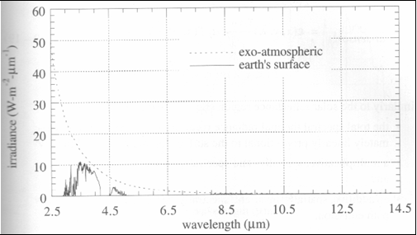
Figure 4: Earth surface and exo-atmospheric irradiance curves.

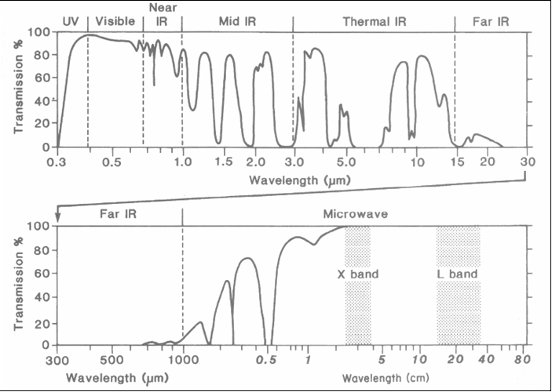
As can be seen in Figure 5 below reflectance up to 3 microns is strongly controlled by solar emitted radiation. Above 3 microns the proportion of radiation from the Earth and Sun is similar (as seen above in Figure 4), once travelled through the atmosphere the Earth's electromagnetic radiation starts to dominate what we record with Earth observation sensors. Beyond 3 microns thermally emitted EMR from the Earth's surface predominates.

Figure 5: Transmission regions within the EM spectrum.

A key point to remember from this figure is that the transmission of the atmosphere varies at different wavelength regions and therefore controls which wavelengths can be successfully recorded.
In the visible light regions the transmission of the atmosphere is relatively high, in some cases as high as 90% (look at the Y-axis). Moving into the mid infrared region the atmosphere becomes opaque (low transmission) for some small wavelength regions. In the region of 15 microns to 1 cm atmospheric absorption is very high and generally can not be used in Earth observation.
Key point: Due to the changing transmission and absorption properties of the atmosphere at different wavelengths, not all electromagnetic regions can be used in Earth observation.
In fact there are 3 broad groups of wavelength ranges that can be used in Earth observation.
- Solar:
  - Visible – 0.4-0.70 microns:
  - Blue visible – 0.40-0.52 microns.
  - Green visible – 0.52-0.60 microns.
  - Red visible – 0.60-0.70 microns.
  - Near infrared – 0.75-0.9 microns.
  - Middle infrared between 1.50-1.70 & 2.00-2.34 microns.
- Thermal infrared (Earth emitted):
  - 3.55-3.90 & 10.50-12.50 microns.
- Microwave:
  - Earth emitted microwave (passive systems) – 10,000-300,000 microns = 1cm-30cm.
  - Active microwave (sensor supplied) – 10,000-1,000,000 microns = 1cm-1m.
Key point: In general Solar Earth observation involves recording the electromagnetic radiation reflectance of surface features at different wavelengths between 0.4-2.34 micrometers (optical up to mid infrared).

Solar electromagnetic radiation interactions at the Earths surface.
Let’s now focus onto the solar electromagnetic radiation surface interactions that can occur. Solar electromagnetic radiation reaching the Earth’s surface:
- Can be Absorbed by the Earth's surface materials.
- Can be Transmitted through the surface materials.
- Can be Reflected by the surface materials.
Figure 6 below illustrates these three energy components.
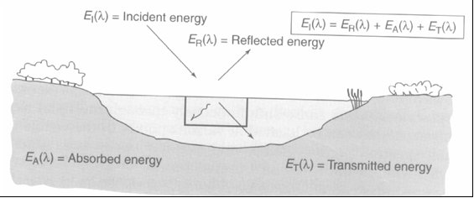
Figure 6: The energy component system.

The main point to note from Figure 6 is that the amount of energy reflected from a surface feature is not just a direct output from the amount of energy incident upon the surface, but is affected by the amount of energy that is transmitted and absorbed from the surface feature.
In Earth observation we are interested in measuring the amount of energy that is reflected back from a surface to the recording sensor. In terms of an energy balance relationship reflectance can be expressed as:
E_{r}(λ) = E_{i}(λ) - [E_{t}(λ) +E_{a}(λ)]

Where E_{r}(λ) is reflected energy, E_{i}(λ) is incident energy, E_{t}(λ) is transmitted energy and E_{a}(λ) is absorbed energy (all for a specific wavelength - λ).
For Earth observation it is easier to measure reflectance in terms of the proportion of incident electromagnetic radiation that is reflected for a particular wavelength or range of wavelengths, this is termed spectral reflectance (Ρ_{λ} – Greek symbol Rho):

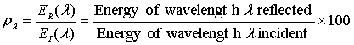
In remote sensing reflectance is also described with respect to the direction of the returned energy. In general, two extremes exist in terms of the type of surface reflectance that occurs for solar electromagnetic radiation:
- Specular - where the angle of reflection equals the angle of incidence.
- Diffuse (or Lambertian) - where reflectance is equal in all directions.
An illustration of these two extreme types of directional reflectors is presented in Figure 7 below.
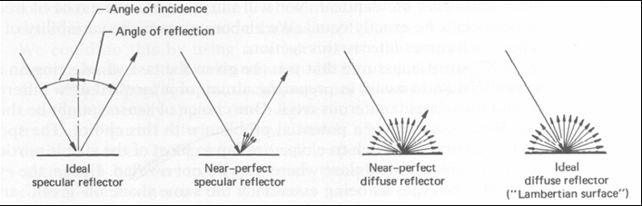
Figure 7: The geometry of diffuse and specular reflectors.
Note: in this diagram you can see what we mean in Earth observation when we refer to incidence and reflectance angle (or direction).
In reality most natural surface features have a surface reflectance that lies somewhere between true specular and diffuse. The range of reflectance (specular to diffuse) that occurs naturally has implications on how we record certain surfaces and how we use (geometrically) certain sensors.

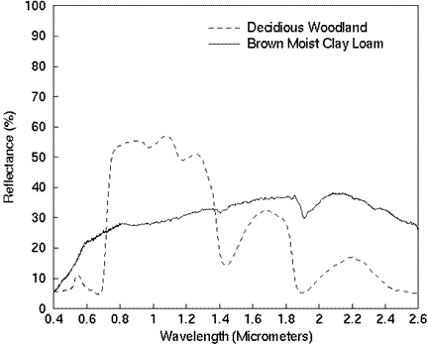 | To distinguish & classify different Earth surface features using Earth observation they need to exhibit different reflectance.  Looking at the reflectance curves of a Woodland and Clay soil sample in Figure 8 to the left:  What wavelengths would you use to distinguish woodland from soil?  What wavelengths would you not use to distinguish woodland from soil?
Figure 8: Woodland and Clay loam reflectance

Note: the general aim of Earth observation is to distinguish between different land cover classes, in order to do this we need to understand how reflectance changes with wavelength.

Reflectance characteristics of Earth surface types.
Key point: A lot of the work in Earth observation is based on understanding the reflectance characteristics of different land cover types. We are now going to briefly look at the reflectance characteristics of some example land cover types investigated in Earth observation.
1. Vegetation
The majority of work in Earth observation has focused on characterising vegetation, in order to assess different properties of vegetation, such as vegetative health, biomass, and chlorophyll content. The distinguishing characteristics of vegetation are very high reflectance in the near infrared region and relatively low visible red reflectance as can be seen on Figures 9 and 10 below. This high reflectance in the near infrared region is due to the physical structure of a plant leaf. The spongy mesophyll of the leaf scatters a high amount of near infrared radiation, this type of radiation is not strongly absorbed and so the vegetation reflects a high degree of near infrared radiation compared to other electromagnetic radiation.

In Figure 9 below left the spectra of Lawn grass is shown, compare this with the spectra of woodland in Figure 10 below right.
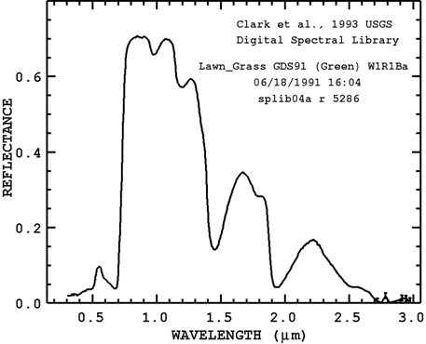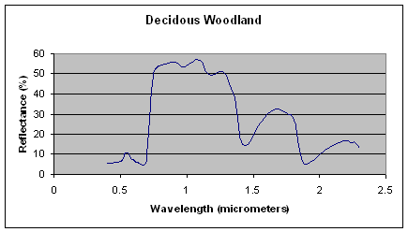
Q - What do you notice about the reflectance curves for the Lawn grass and woodland example?
A - You should notice that reflectance is different at the leaf level and at the canopy level.
Explanation: The reflectance of healthy vegetation at the leaf level in the optical regions is very low but generally slightly higher in the green light region.
At the canopy level the optical reflectance reduces overall as we get some shadow occurring within the canopy, but the drop in NIR (near infrared) in relative terms is not as large as the optical reflectance decrease. This is due to a high degree of scattering within the canopy structure called multiple layer scattering, which is not occurring at the surface leaf. A large proportion of NIR radiation is transmitted through a leaf therefore multiple layers of leaves (a canopy) produce a high degree of scattering of NIR radiation and this produces in turn a relatively higher degree of NIR reflectance than a single leaf.
Note: In order to understand this concept further read Campbell (1996), Chapter 16, Plant Sciences; or this Mississipi State University resource: http://www.geospatial.msstate.edu/publications/vegitationproperties.pdf.

2. Soil
Q - By looking at the reflectance patterns of the two soil types in Figures 11 and 12 below, what do you observe?
Q - What characteristics of soils do you think are important to their reflectance?
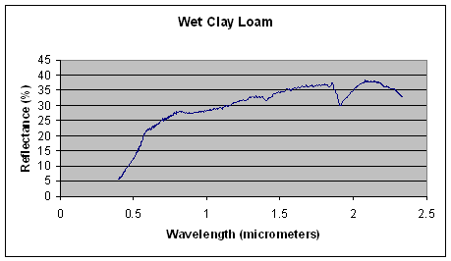
Figure 11: Wet clay loam reflectance.
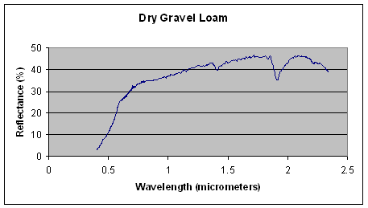
Figure 12: Dry gravel loam reflectance
A - Moisture content, mineral content and texture are important soil reflectance controls. In order to understand this concept further read the University of Calgary soil reflectance resource: http://www.ucalgary.ca/UofC/faculties/SS/GEOG/Virtual/Remote%20Sensing/rssoils.html.

3. Water & Snow
Q - By looking at the reflectance patterns of water and snow in Figures 13 and 14 below, what do you observe? (Note: the Y-axes have different scales).
Q - What do you think controls the reflectance of water and snow?
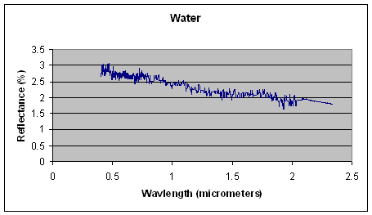

Figure 13: Water reflectance.
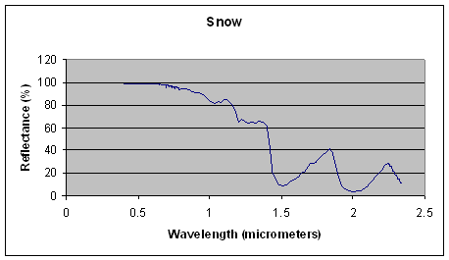
Figure 14: Snow reflectance.
Note: In order to answer these questions and understand this concept further read the UCSB optical properties of snow resource: http://www.crseo.ucsb.edu/hydro/aviris/optics.html.

Action point: make notes on the controls (physical, biological and chemical) that affect the reflectance of all of these Earth surface types, this will help you with your practical classes and will be tested in your assignments.

Conclusion
Earth observation involves recording the electromagnetic radiation interactions that occur at the Earth’s surface. Radiation can be supplied in three ways:
- By the Sun (solar).
- By the Earth (emitted).
- By a sensor (active).
Solar Earth observation measures:
- The solar reflectance characteristics of surface features.
- Electromagnetic radiation with wavelengths of between 0.4-2.3 micrometers.
Solar Earth observation relies on:
- Different surface features having different reflectance characteristics – for classification.
- A surface feature/type exhibiting a change of reflectance due to change in bio-physical or chemical status – for property estimation.
Lecture 2 - Essential Reference Terms
 See the reading list for new terms introduced in this lecture.

Why is this lecture important?
This lecture provides the understanding and knowledge required in order to appreciate how Earth observation of the solar part of the electromagnetic spectrum can be used to distinguish and evaluate the condition and state of different Earth surface features. It also provides a basis for understanding how Earth observation images are acquired by satellite sensors for the solar part of the electromagnetic spectrum - a topic covered in Lecture 3.

Reading list:
Reading on Electromagnetic Radiation within Earth observation:
- Swain, P.H., and Davis, S.M., 1978, Remote Sensing the Quantitative Approach. Chapter 2, pages 22-42 (an excellent coverage of the basic principles, good mathematical coverage although may become hard going if you do not have a good mathematical background).
- Lillesand, T.M., and Kiefer, R.W., 2000. Remote sensing and image interpretation. Chapter 1, pages 1-52 (general coverage of background principles but readable, little maths and any used is presented at an easily understandable level).
- Campbell, J.B., 1996. Introduction to Remote Sensing. Chapters 1 & 2, pages 1-39 (less detailed but similar coverage to the previous text plus chapter 1 gives a good history/rationale of remote sensing).
- Mather, P.M., 1999. Computer processing of remotely-sensed images. Chapter 1, pages 1-27 (Sound introductory material presented in a readable manner, not much maths, any used is explained by examples).
- Gibson, P.J., 2000. Introductory remote sensing: principles and concepts. Chapters 1 + 2, pages 1-35 (Rather general but does give some very good examples on the main concepts. Chapter 1 is a good review of the history of remote sensing).
Reading on the Solar Electromagnetic Reflectance Characteristics of Natural Surface Features:
- Verstraete, M.M., and Pinty, B., 1992. Extracting surface properties from satellite data in the visible and near infrared wavelengths. In Mather, P.M., (ed) TERRA 1: Understanding the terrestrial environment – the role of Earth observation from space. Taylor and Francis (London), pp 203-209. (short chapter covering the reflectance characteristics of natural surface features).
- Lillesand, T.M., and Kiefer, R.W., 2000. Remote sensing and image interpretation. Chapter 1, pages 12-27 (discusses the reflectance characteristics of vegetation, soil & water).
- Campbell, J.B., 1996. Introduction to remote sensing. Chapter 2, pages 39-44 (short general introduction to reflectance).
- Campbell, J.B., 1996. Introduction to remote sensing. Chapter 16, pages 454-460. (Introduction to vegetation reflectance).
- Gibson, P.J., 2000. Introductory remote sensing. Chapter 2, 22-34 (a nice introduction to general reflectance characteristics of Earth surface features with good examples).
- Mather, P.M., 1999. Computer processing of remotely-sensed images. Chapter 1, pages 17-27 (sound description of the different reflectance characteristics of surface features).

NOTE: access the practical session 2 handout at the beginning of Week 3 from the Nathan Bodington Geog2750 practical material room prior to the Week 3 timetabled practical class. You can download the practical handout to your ISS folder, keep your downloaded practical handout document open or print off a copy for the practical session.

Content developer: Louise Mackay, School of Geography, University of Leeds.

