School of Geography  University of Leeds |  | 2004/2005  Level 2  Louise Mackay
EARTH OBSERVATION AND GIS OF THE PHYSICAL ENVIRONMENT – GEOG2750
Week 11

Lecture 10: The Role of Earth observation in Environmental GIS
Aims: This lecture considers the relationship between Earth observation and Geographical Information systems. It covers the benefits of using Earth observed data in Geographical Information Systems and also a number of key considerations in its use. This lecture also briefly covers the main sources of Earth observation data available for academic use and provides information on how to access these.
Lecture 10 consists of the following topics:
- The complimentary and disparate nature of Earth Observation & GIS.
- Examples of integrated processing.
- Sources of RS data & considerations.
- Conclusion.
Work through each of the main lecture topics in order. A reading list for this lecture is supplied at the end of the lecture content or can be accessed at http://lib5.leeds.ac.uk/rlists/geog/geog2750.htm.



Begin Lecture 10 here

The complimentary and disparate nature of Earth Observation & GIS
Earth Observation involves acquiring data about the Earths surface without being in contact with the surface. GIS (Geographical Information Systems) can be defined as: “A powerful set of tools for collecting, storing, retrieving at will, transforming and displaying spatial data from the real world” (Burrough & Macdonald, 1998). So in theory the two technologies are complimentary: Earth observation is a powerful way to acquire data about the Earth and GIS is a powerful way to analyse and process data about the Earth.
Question - If Earth Observation and GIS can be considered complimentary, why are separate and distinctive software packages required for processing and analysis of GIS data?
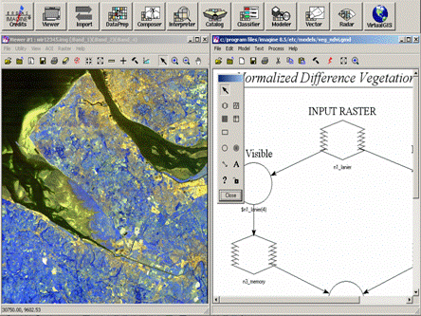 | 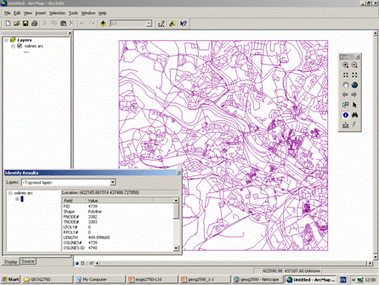
Figure 1 - ERDAS Imagine | Figure 2 - ESRI ArcGIS (ArcMap)

Separate and distinctive software packages are required for many reasons. Most importantly the data sets used in EO and GIS analysis can be very different. GIS analysis nearly always employs directly the variable(s) of interest – topography, land cover, soil moisture etc. In contrast Earth observed images represent: surface spectral reflectance of solar EMR; microwave surface/near-surface backscatter; RADAR/Laser derived topography. In all but the RADAR/Laser data these are surrogate variables that require further inference, e.g., reflectance to imply surface state or land cover, backscatter to imply surface state or land cover.
Earth observed data sets need to be processed in order to either infer information or estimate properties of interest. For example, the Center for Ecology & Hydrology 1990 & 2000 land cover data set involved the classification of Landsat Thematic Mapper images (as shown in Figure 3 right).
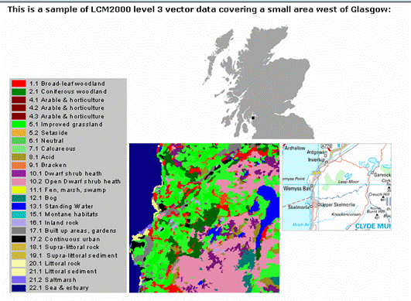
Figure 3 – Land cover data from Landsat TM images.

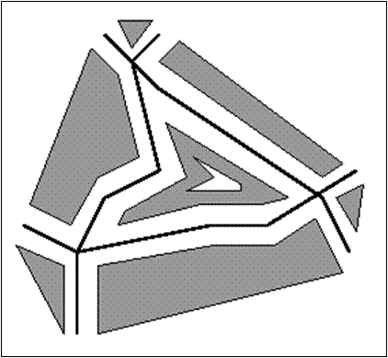
EO and GIS software packages need to be distinctive as EO and GIS applications often require different types of analysis. Most forms of GIS analysis are based on the SPATIAL analysis of data sets. For example, the use of buffer analysis to capture and characterise proximity relationships (e.g., Figure 4 right).
Figure 4 – Spatial analysis.

GIS analysis can also use overlay procedures to infer new information or properties about a location (e.g., Figure 5 below).
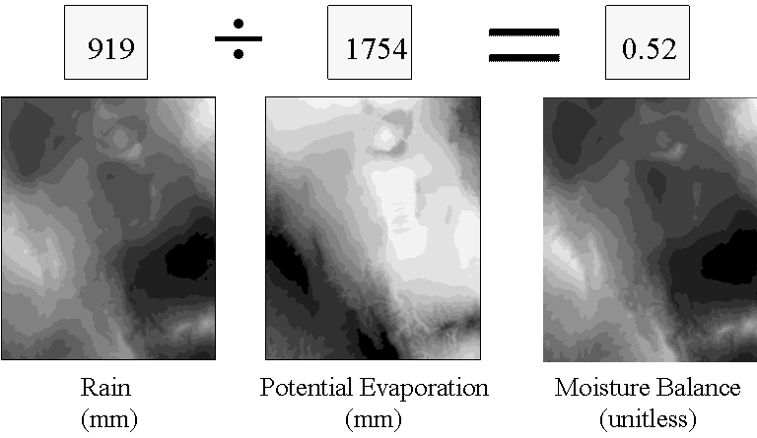
Figure 5 – Overlay analysis.

In comparison, in Earth observation the analysis emphasis is very much on the spectral response recorded for individual pixels.
Some Remote Sensing packages offer limited GIS functionality, e.g., ERDAS Imagine simple raster GIS analysis. | 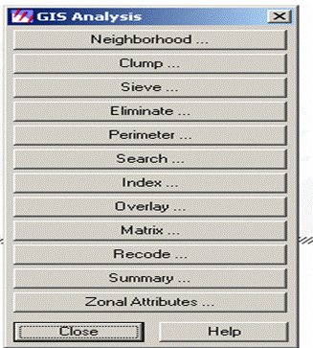 | Some GIS packages offer limited Remote Sensing functionality, e.g., IDRISI & ArcGIS Grid module. | 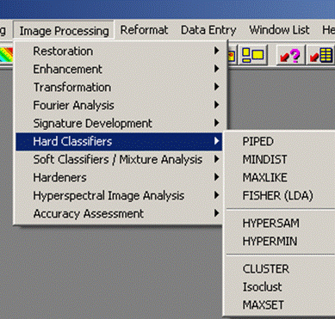
Figure 6 – Simple GIS analysis Figure 7 – Simple RS functionality

From an Earth observation perspective GIS packages are limited in terms of:
– Handling of complex image formats – Radiometric and atmospheric correction – Handling and processing of hyperspectral images – Handling and processing of Synthetic Aperture RADAR images.
From a GIS perspective EO packages are limited in terms of:

– The ability to structure and store data in a proper Database format – The handling of discrete vector geographical entities (points, lines, polygons) – Proximity and overlay analysis, particularly vector-based – The ability to query in a spatial manner– The ability to produce reports and be used as a decision making tool.
Although Earth Observation & GIS are distinct with respect to data and analysis they are also complimentary.
Earth observation is:
- The only way to acquire spatially complete surface data sets of many environmental systems for GIS analysis.
- The only means by which it is possible to acquire multi-scale data for an area (1m-10km’s) for use in GIS.
- The only means by which it is possible to acquire regular repeatable data for large study areas for time series analysis in GIS.
GIS facilitates:
- The analysis of information & properties derived from such data.
- This can be done in a spatial manner.
- Allows the changes in pattern and sometimes process to be characterised.
The good complimentary use of EO & GIS requires that in this process information on data lineage and metadata – such as data error, accuracy and precision are retained and passed on.

Examples of integrated processing
Some specialised packages have attempted to integrate Earth observation and GIS functionality. For example through the use of map boundaries data to aid image classification – so called per-field classification; through the use of GIS data sets to aid image classification in the form of extra discriminatory layers – e.g., topography, soil type etc; and/or, through the combination of both map data boundaries and GIS data sets to aid image classification – so called CLEVER mapping (e.g., Figure 9).
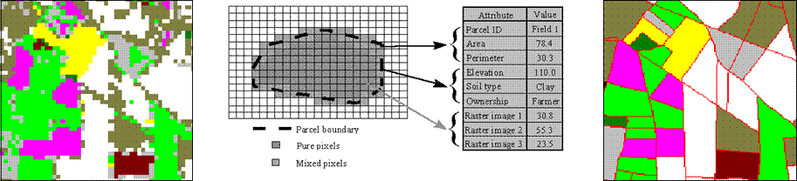
Figure 8 – An example of CLEVER mapping.

Sources of RS data & considerations
In the UK Educational EO data can be sourced from the Manchester University spatial data service MIMAS. MIMAS data consists of UK wide coverage of Landsat 5 TM, SPOT-HRV panchromatic and ERS SAR data for the early 1990’s. Data can be downloaded directly in ERDAS Imagine format. MIMAS can be accessed at the following site: http://www.mimas.ac.uk/spatial.
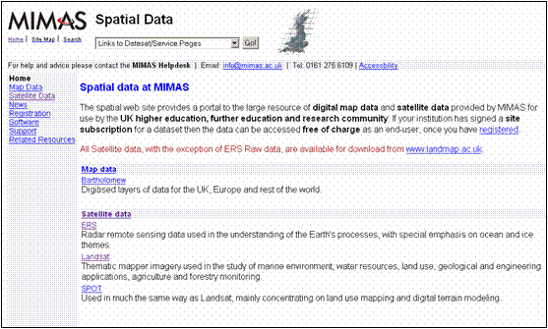
Figure 9 – MIMAS spatial data access page.

UK LANDMAP provides complete UK coverage of ERS (1&2) SAR data and Landsat 7 ETM Data. Also available is a UK wide 25m spatial resolution DEM. Landmap contains more recent data than MIMAS (ERS-2 & Landsat 7 ETM). LANDMAP can be accessed at the following site: http://landmap.ac.uk.
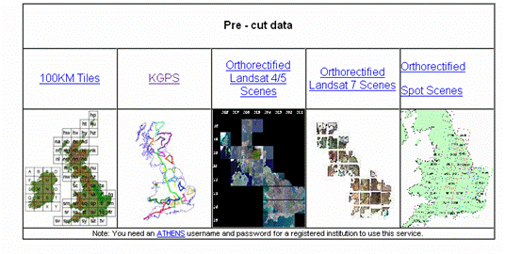 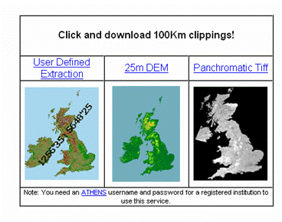
Figures 10 & 11 – LANDMAP data sets and access page.

UK NERC Dundee Receiving Station provides a time series of AVHRR for the UK. The station also provides NASA EOS TERRA MODIS & MISR UK images. Images are free but you must register. The NERC Dundee Receiving Station can be accessed at the following site: www.sat.dundee.ac.uk.
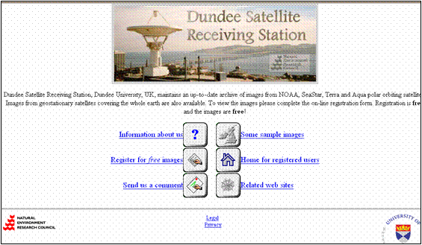
Figure 12 – Dundee Satellite Receiving Station homepage.
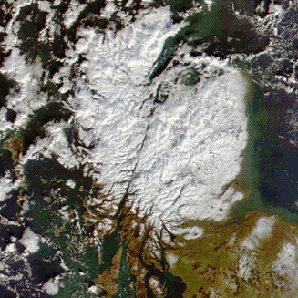
Figure 13 – Example data available from NERC Dundee Receiving Station.

The UK Environment Agency provides some LiDAR Data of the UK for educational purposes only. The UK EA can be accessed at the following site: http://www.environment-agency.gov.uk/science/219121/monitoring/.
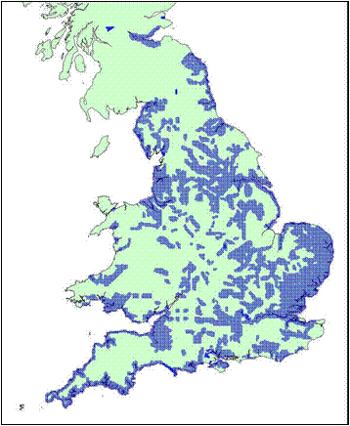 | 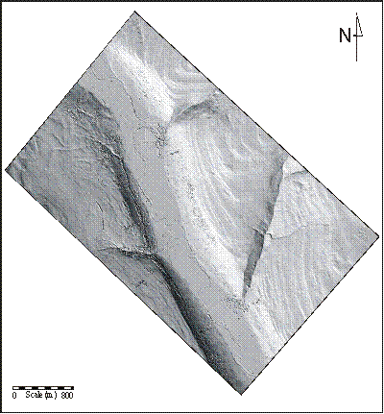
Figure 14 – EA LIDAR coverage in blue. | Figure 15 – Example LIDAR data.

Non-UK EO Data can be obtained from various locations: Many Earth Observation data WWW gateways now exist. Some with free data, others where data is charged for. Keep searches simple. For NASA data, use its Earth Observing System Data Gateway: http://edcimswww.cr.usgs.gov/pub/imswelcome/.
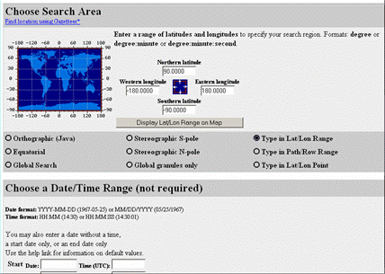
Figure 16 – Search the web for data, you may find what you need for free!

ERS & ENVISAT EO data covering Europe can be obtained from the European Space Agency. For ESA ERS & ENVISAT data, Eurimage acts as the main data seller. Eurimage can be accessed at the following site: http://www.eurimage.com. Most data has a cost which varies by instrument but is sometimes free for academic research. For UK ERS SAR data use Landmap.
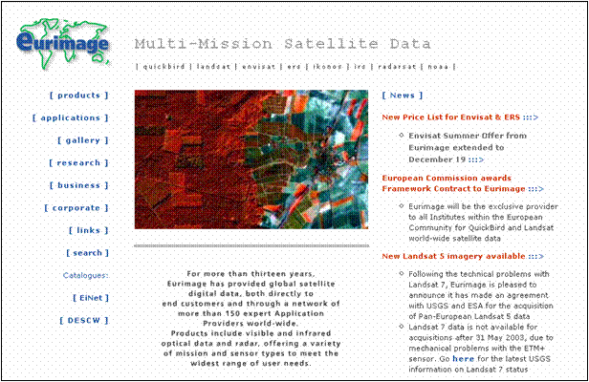
Figure 17 – Eurimage homepage.

Choosing Data Considerations
These are points to be aware of when choosing data:
Consider the properties you require & try to match image type (optical or microwave) to its suitability to detect these.
Consider carefully the time of year you require data for – is there a seasonal influence, what dates are other data sets available for.
Consider the time of day – low sun angle can be both a positive and negative depending on application.
Always find out level of pre-processing related parameters – geometric, radiometric and atmospheric.
Consider carefully your spatial resolution requirements. AVHHR (1km) will not allow you to map UK field crop patterns!
Consider your analysis requirements – will a standard package suffice or will you require a specialised package.

Conclusion
This Earth observation course has introduced you to the main components involved in using Earth observed images in environmental applications. You should now be able to:
- Recognise and choose the appropriate parts of the electromagnetic spectrum suitable for the acquisition of Earth observed images.
- Understand the basic principles of the acquisition of optical Earth observed images.
- Implement the standard geometric, radiometric and atmospheric corrections applied to optical Earth observed images (practical only).
- Select and implement empirical approaches to surface property estimation using optical Earth observed images.
- Perform a complete image classification including evaluation of training separability and classification accuracy (practical only).
- Understand the main issues involved in the acquisition of SAR microwave images and use these to interpret recorded SAR backscatter.
- Utilise and process LiDAR images for the characterisation of topography in GIS applications.

Why is this lecture important?
This lecture provides a framework by which you can evaluate the suitability of employing Earth observed images within Geographical Information Systems for environmental applications.

Reading list:
- Adinarayana, J., and Krishna, R., 1996. Integration of multi-sensed images for improved land use classification of a hilly watershed using geographical information systems. International Journal of Remote Sensing. 17, 1679-1688.
- Aplin, P., Atkinson, P.M., and Curran, P.J., 1999. Per-field classification of land use using the forthcoming very fine spatial resolution satellite sensors: problems and potential solutions. In Atkinson, P.M., and Tate, N.J., (eds) Advances in remote Sensing and GIS. 219-239.
- Carbone, G.J., Narumalani, S., King., M., 1996. Application of remote sensing and GIS technologies with physiological crop models. Photogrammetric Engineering and Remote Sensing. 62, 171-179.
- Cowen, D.J., Jensen, J.R., Bresnahan, P.J., Ehler, G.B., Graves, D., Huang, X., Wiesner, C., and Mackay, H.E., 1995. The design and implantation of an integrated geographic information system for environmental applications. Photogrammetric Engineering and Remote Sensing. 61, 1393-1404.
- Ehlers, M., Edwards, G., Bedard, Y., 1989. Integration of remote sensing with geographic information systems: a necessary evolution. Photogrammetric Engineering and Remote Sensing. 55, 1619-1627.
- Ehlers, M., 1990. Remotes sensing and geographic information systems: towards integrated spatial information processing. IEEE Transactions on Geoscience and Remote Sensing. 28, 763-766.
- Hinton, J.C., 1996. GIS and remote sensing integration for environmental applications. International Journal of Geographical Information Systems. 10, 877-890.
- Hinton, J.C., 1999. Image classification and analysis using integrated GIS. In Atkinson, P.M., and Tate, N.J., (eds) Advances in remote Sensing and GIS. 207-218.
- Janssen, Jaarsma, M., van der Linden, E., 1990. Integrating topographic data with remote sensing for land cover classification. Photogrammetric Engineering and Remote Sensing. 56, 1503-1506.
- Pedley, M.I., and Curran, P.J., 1991. Per-field classification: an example using SPOT-HRV imagery. International Journal of Remote Sensing. 12, 2181-2192.
- Wilkinson, G.G., 1996. A review of current issues in the integration of GIS and remote sensing data. International Journal of Remote Sensing. 61, 299-305.

Content developer: Louise Mackay, School of Geography, University of Leeds.

