School of Geography  University of Leeds |  | 2004/2005  Level 2  Louise Mackay
EARTH OBSERVATION AND GIS OF THE PHYSICAL ENVIRONMENT – GEOG2750
Week 1

Lecture 1: Introduction to Earth Observation
Aims: This lecture provides an introduction to Earth observation for physical geography, through a general coverage of image acquisition and analysis. It also provides a context for the remainder of the Earth observation lectures by discussing, in general terms, the scientific challenges of using Earth observed images for physical geography and the different types of Earth observed data that will be investigated.
Lecture 1 consists of the following topics:
- What is Earth observation?
- Why use Earth observation in physical geography?
- From data to information: an example.
- Understanding Earth observed images: an introduction.
- Types of Earth observed data.
- Conclusions.
Work through each of the main topics in order. A reading list is supplied at the end of the content or can be accessed at http://lib5.leeds.ac.uk/rlists/geog/geog2750.htm.

Begin Lecture 1 here

What is Earth observation?

Earth observation provides a means for acquiring data about the Earth that can be useful to the Geographical scientist. Earth observation is a form of Remote Sensing, which is defined as:
"The science of obtaining information about an object through the analysis of data acquired by a device that is not in contact with the object" Lillesand & Kiefer (2000). In this course we are interested in the remote sensing of the Earth: termed Earth Observation. This is also known as environmental remote sensing or terrestrial remote sensing.

(Figure 1: An early form of Earth observation!)
Earth observation has two components:
- The acquisition of data about the Earth’s surface.
- The derivation of information about the Earth’s surface from an analysis of such data.
Note: In this course DATA pertains to the observations originally collected by a sensor which provides the raw material that can be grouped, manipulated or summarised in some way as INFORMATION. Examples will be given later in this lecture.
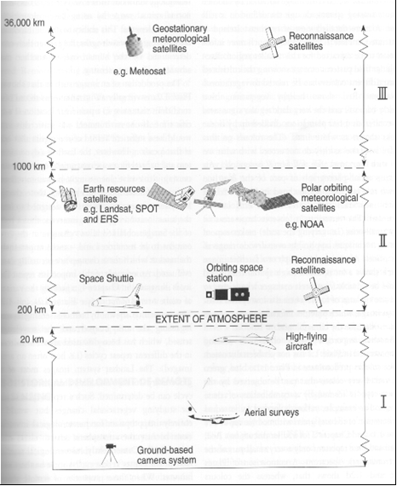
Earth observation involves the acquisition of images of the Earth’s surface by means of sensors which are mounted on a recording platform.
As can be seen in Figure 2 to the left, the recording platform may be an aircraft - airborne remote sensing.
Or the recording platform may be a satellite orbiting the Earth - satellite remote sensing. Increasingly, the images acquired are recorded in a digital format and stored on computers.

Figure 2: Gibson, P.J., 2000. Introductory Remote Sensing. Routledge (London). p3.
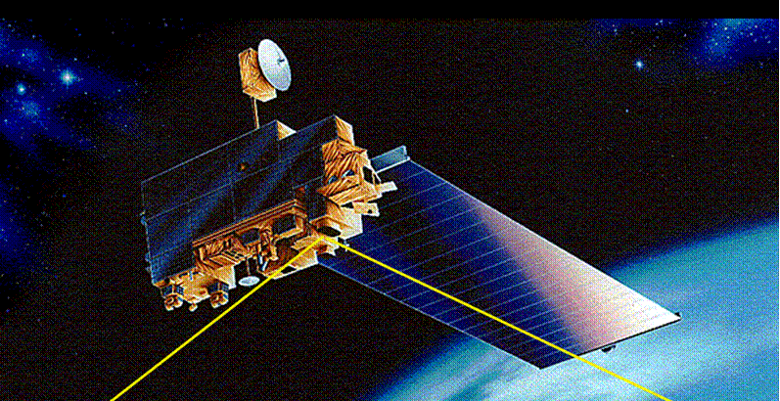
Earth observation sensors are often mounted on satellite platforms that orbit the Earth acquiring data continuously.
For example NASA’s EOS TERRA platform in Figure 3 to the right consists of 5 sensors, orbiting every 16 days to provide a complete coverage of the globe (a snip to buy at $4.0 Billion).
(Figure 3: The EOS TERRA platform)
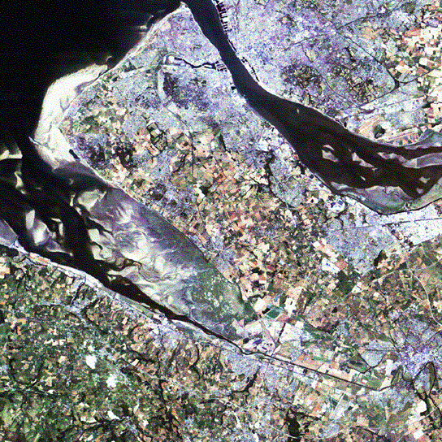
An Earth observed image is not just a picture of the Earth’s surface but can be analysed further to produce useful information.
Looking at this image of the Earth's surface on the right, what features can you recognise?
If you have recognised features in the image, ask yourself how you did so.
(Figure 4: Landsat TM of the Wirral Estuary, NE England)
This is your first step to interpreting an Earth observed image.

Why use Earth observation in physical geography?
Geographers require field-based observations in order to understand the environment they study. Compared to field-based geography, Earth observation has quite distinct advantages in acquiring environmental data. Taking our image from above as an example we can see that this image has a large and complete spatial coverage. In order to acquire this image we have had no surface constraints or obstacles that the geographical field scientist may encounter. Satellite sensors also offer a repeatable coverage, in practice the Landsat 5 image above of the Wirral Estuary will be re-recorded every 18 days, allowing a time series of data to be produced. A recording satellite sensor produces an objective measurement, and over large areas like this is affordable.
These characteristics of Earth observation are advantageous to the labour intensive field survey. However, the data we collect from Earth observation sensors requires extensive pre-processing in order to become useful information on the physical landscape.....this will be dealt with in detail in later lectures.
Note: Large spatial coverage | Complete spatial sampling | Independent of surface constraints | Repeatability | Objective measurement | Affordable.

Earth observation does have some limitations:
The limitation of Earth observed images is that they are only a surrogate variable about the objects of interest. An image does not directly provide the physical properties about the area of Earth’s surface it is acquired over but is an indirect measurement of the actual physical properties of interest. In order to derive the information required the recorded measurements must be inverted (backward transformed) by:
- Inference - using the recorded measurements to infer the objects present over some area of the Earth’s surface or
- Estimation - using the recorded measurements to obtain direct estimates of the properties of the objects present over some area of the Earth’s surface.

From data to information: some examples.
In the following series of figures we can see some of the datasets that are produced from Earth observed data. Programmes which take EO data and produce datasets pertaining to reflectance, vegetation cover, tree cover, land cover etc., are vital in the production of local, regional, continental and global products on the physical & biological status of the Earth's surface. Look at the following examples in Figures 5and 6 of information sets produced from composite Earth observation data:

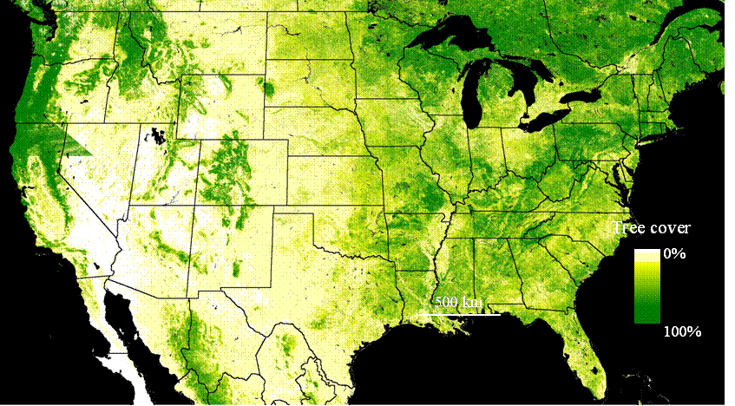
Figure 5: Percent tree cover map of the U. S. from 250 meter MODIS data using maximum NDVI composite for summer 2000 acquisitions.
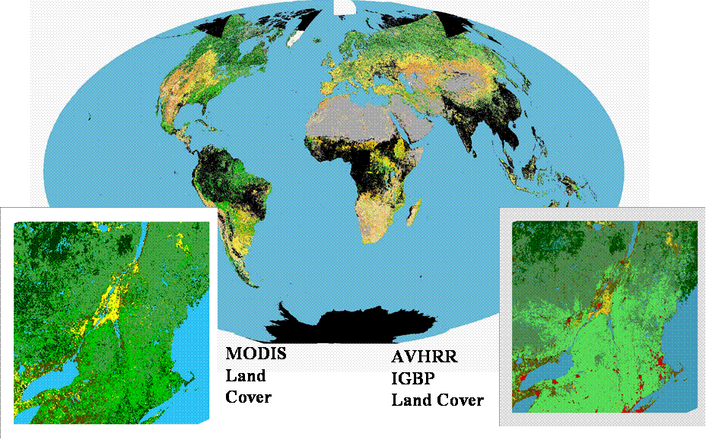
Figure 6: TERRA MODIS Global Land Cover map from two 16 Day Periods.

Understanding Earth observed images: an introduction.
In order to infer information or estimate properties about objects present in an image we need to understand:
- The physical property that Earth observation is actually measuring.
- The sources and magnitude of this physical property.
- How this physical property is modified before measurement.
- How this physical property interacts with the Earth’s surface.
- How this physical property is manipulated to produce a digital image of the Earth's surface.
NOTE: By understanding these concepts (which we cover in later lectures) we can begin to use computers to process and analyse Earth observed images in order to infer information & estimate properties about the Earth’s surface. Remember: that's why we as Geographical scientists wish to use Earth Observation.

What do Earth observation sensors actually record?
Earth observation sensors record electromagnetic radiation that is emitted from a surface. In later lectures you will be introduced to the various components that affect emitted radiation from a surface before it reaches a recording sensor.
All objects above 0 degrees Kelvin emit energy. This energy is composed of two sinusoidal waveforms, electrical and magnetic; a representation of this waveform is presented in Figure 7 below.
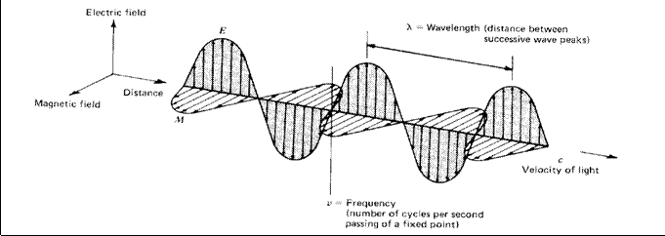
Figure 7: The electromagnetic waveform (Lillesand T.M. and Kiefer R.W., 2000. Remote Sensing and Image Interpretation. Wiley (Chichester). p4).
The energy emitted from a surface feature varies with intensity resulting in energy of various wavelengths. The representation of emitted electromagnetic energy of varying wavelengths is the electromagnetic spectrum seen here in Figure 8 below. Note the different regions of the spectrum that you recognise and how they are distinguished by their wavelength. For example the visible light region consists of small wavelengths (micron scale) compared to that of microwave and radio waves (centimetre scale).
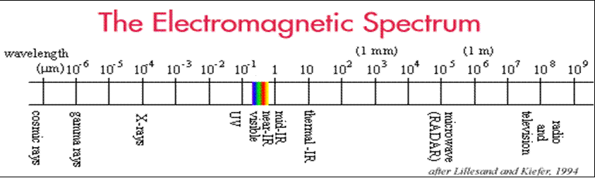
Figures 8: The electromagnetic spectrum (Lillesand T.M. and Kiefer R.W., 2000. Remote Sensing and Image Interpretation. Wiley (Chichester). p4).

Earth observation sensors record the energy radiated from a surface. However, the key assumption of Earth observation is that different surface features (vegetation, soils, geology, water bodies etc) reflect, scatter or emit different amounts of electromagnetic radiation. The difference in radiation that is recorded by a sensor then allows surface features to be distinguished.

For example the reflectance (proportion of incident electromagnetic radiation reflected back from the Earth’s surface) for woodland and soil at different wavelengths within the solar part of the electromagnetic spectrum is quite dissimilar.  Note: the shape and magnitude for both the woodland (dotted line) and soil (solid line) curves in Figure 9 right are very different. | 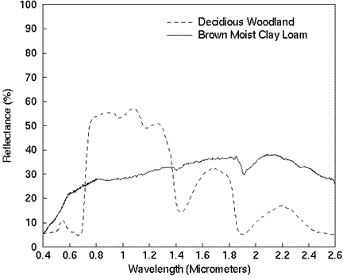
 | Figure 9 from: Lillesand, T.M., and Kiefer, R.W., 2000. Remote sensing and image interpretation. Wiley (Chichester). p17.)
Such differences may be a result of their different:
- bio-physical properties,
- chemical composition and
- surface geometry (roughness).
These are properties that we may wish to estimate.

Types of Earth observed data.
In this section the various types of image data that will be covered in the Earth observation lectures are introduced.

Optical Multispectral Images (Lectures 3-6)
Earth observation sensors record a proportion of solar electromagnetic radiation reflected from the Earth’s surface. Sensors can also acquire multiple images of the same area of the Earth’s surface but for different discrete portions of the electromagnetic spectrum, the resulting images are termed multispectral.
For example, look at the 3 individual bands for the Landsat 5 image of the Wirral Estuary below (Figure 10), in this figure you can see that the images are slightly different as each image represents a different region of the Electromagnetic spectrum, in this instance blue light, green light and red light respectively.
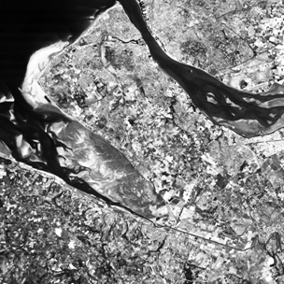 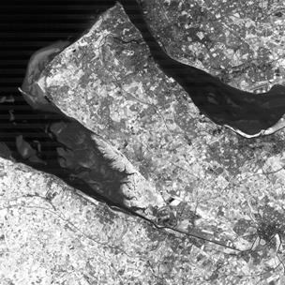 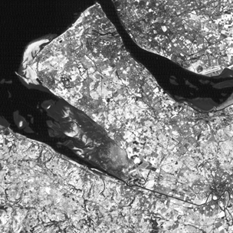Figure 10: Blue, Green and Red bands of the Wirral Estuary Landsat TM image.
This type of image data (optical and multispectral) is the most commonly used in environmental studies. This type of data will be covered in Lectures 3 to 6.

Microwave Images (Lectures 7-8)
In this course we will also be covering the acquisition and use of two types of microwave image data -Active and Passive microwave data.
Active microwave sensors such as the Synthetic Aperture Radar (SAR) transmit their own microwave energy (pulses) at a particular wavelength (single frequency) for a particular duration of time - known as pulsed coherent radar. They receive the reflected (back-scattered) signal of these transmitted energy pulses, an example of which is shown right (Figure 11). | 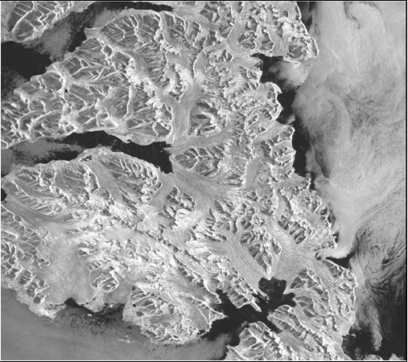
 | Figure 11: A SAR image of Svalbard glaciers.

Passive microwave sensors record the amount of microwave electromagnetic radiation that is emitted by the Earth’s surface. Passive systems tend to be used less than active systems, but are important in geological applications.
This type of data will be covered in Lectures 7 and 8.

LIDAR Images (Lecture 9)
LIDAR - stands for light detection & ranging. It is an active sensor carried onboard an aircraft. The LIDAR sensor emits a laser pulse (as shown in Figure 12 below) and records the time for the pulse to return to the sensor. As the velocity of the laser pulse is known the distance between the aircraft and the ground is calculated. In turn this can be further processed to derive the absolute elevation of the Earth's surface.
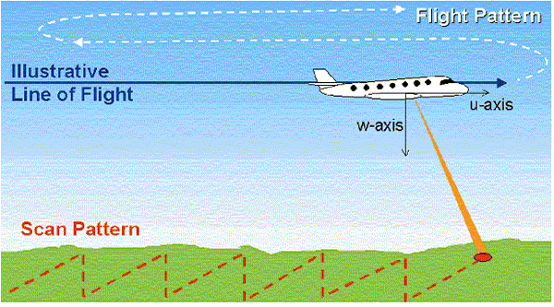
Figure 12: LIDAR data acquisition.
This type of image data will be covered in Lecture 9.

LIDAR DSM Images (Lecture 10)
LIDAR images can be used to represent the height of the Earth’s surface in the form of a Digital Surface Model (DSM). DSM's have many applications in hydrology and also Earth surface analysis within GIS. The two images below (Figure 13) show how LIDAR data has been used to visualise river flood impact.
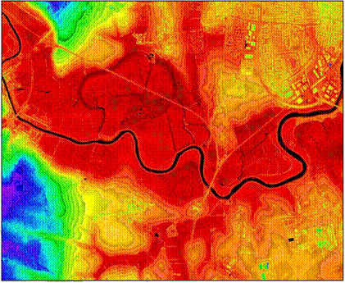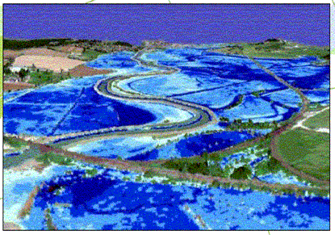
Figure 13: Example DSM floodplain images.

This type of data will be covered in Lecture 10.

Conclusions
Earth observed images are the only way that complete spatially extensive samples of the Earth’s surface can be acquired at regular time intervals. But they are data not information and need to be processed to infer information or estimate properties of interest. In order to do this well we must understand:
- How electromagnetic radiation interacts with the Earth’s surface,
- How different types of Earth observed images are acquired; and,
- How these different types of images can be processed by computers.

Why is this lecture important?
This lecture provides a framework for the material covered in the remainder of the Earth observation lectures. Later lectures will investigate in greater depth the material covered, to provide a more detailed knowledge and understanding of the principles of Earth observation in physical geography.

Reading list:
(Listed as a suggested order of preference).
- Barnsley, M.J., 1999. Digital remotely-sensed data and their characteristics. In, Geographical Information Systems, vol. 1, Principles and technical Issues, pages 451-466 (Nice overview of general application of remote sensing and background concepts, not an equation in sight !).
- Lillesand, T.M., and Kiefer, R.W., 2000. Remote sensing and image interpretation. Chapter 1, pages 1-52 (general coverage of background principles but readable, little maths and any used is presented at a easily understandable level).
- Campbell, J.B., 1996. Introduction to Remote Sensing. Chapters 1 & 2, pages 1-39 (less detailed but similar coverage to the previous text plus chapter 1 gives a good history/rationale of remote sensing).
- Mather, P.M., 1999. Computer processing of remotely-sensed images. Chapter 1, pages 1-27 (Sound introductory material presented in a readable manner, not much maths, any used is explained by examples).
- Gibson, P.J., 2000. Introductory remote sensing: principles and concepts. Chapters 1 + 2, pages 1-35 (Rather general but does give some very good examples on the main concepts. Chapter 1 is a good review of the history of remote sensing).
If you are unsure about computer memory terminology - bits, bytes, base 2 powers then read:
- Mather, P.M., 1999. Computer processing of remotely-sensed images. Chapter 3, pages 49-66 (particularly 51-53).

NOTE: access the practical session 1 handout at the beginning of Week 2 from the Nathan Bodington Geog2750 practical material room prior to the Week 2 timetabled practical class. You can download the practical handout to your ISS folder, keep your downloaded practical handout document open or print off a copy for the practical session.

Content developer: Louise Mackay, School of Geography, University of Leeds.

